Tab 1
Report: Downscaling strategies
D2.4: Report documenting methodologies used to downscale and bias-correct reanalysis products and seasonal climate forecasts.

Team Identification
Team Members | Emily Ball, Alba Llabrés-Brustenga, Javier Corvillo
Team Organisation / Institution | Barcelona Supercomputing Center
Team Country | Spain

Purpose of this document:
This document reports on downscaling strategies and bias-correction methods for reanalyses and seasonal climate predictions used within the HARMONIZE project, across project hotspot sites in Colombia, Brazil, Peru, and the Dominican Republic.

Project overview
The main goal of the HARMONIZE project is to develop cost-effective and reproducible digital tools for decision-makers in climate change hotspots in Latin America & the Caribbean, including cities, small islands, highlands, and the Amazon rainforest. HARMONIZE collates existing multi-source climate, environmental, socio-economic and health data, and collects new longitudinal ground-truth data using drone technology and low-cost weather sensors, to calibrate and downscale coarser-resolution Earth Observation, climate reanalysis and forecast datasets in areas most relevant for disease transmission. The HARMONIZE digital toolkits, including clim4health, allow local researchers and users, including national disease control programs, to link, interrogate and use multi-scale spatiotemporal data, to understand the links between environmental change and infectious disease risk in their local context, and to build robust early warning and response systems in low-resource settings.

Contents
Summary of Report 2
1. Introduction 2
2. Downscaling and bias correction methods 3
2.1. Interpolation 3
2.2. Interpolation + bias correction 4
2.3. Interpolation + linear regression 4
2.4. Interpolation + Logistic regression 4
2.5. PP-Analogs 5
3. Verification and quality assessment strategies 5
4. Application to HARMONIZE hotspot sites 6
4.1. Tolima and Valle, Colombia 6
4.1.1 Temperature 6
4.1.2 Precipitation 10
4.1.3 Temperature downscaling using weather station data 13
4.2. Brazil 18
4.2.1 Temperature 18
4.2.2 Precipitation 21
4.3. Peru 25
4.3.1 Temperature 26
4.3.2 Precipitation 29
4.4. Dominican Republic 32
4.4.1 Temperature 33
4.4.2 Precipitation 36
5. Report Summary 38
6. References 39
7. Appendix 40
7.1. Tolima and Valle, Colombia 41
7.2. Brazil 43
7.3. Peru 44
7.4. Dominican Republic 47

Summary of Report
Climate change impacts weather via changes to temperature, precipitation and humidity, along with increased frequency and intensity of extremes, which, in turn, exacerbate the risk of infectious disease epidemics. Mitigation actions on health impacts need accurate spatial climatic information sufficiently in advance to plan the interventions, therefore the use of seasonal forecasts is highly suitable due to their temporal horizon. However, the spatial resolution of the raw seasonal forecasts from the global models is too coarse for the needs of the health sector, which works with administrative units at different levels. In order to accurately forecast outbreaks of climate sensitive infectious diseases, it is necessary to obtain climate predictions at a fine spatial scale. This report details methods of spatially downscaling seasonal forecasts, available at a monthly temporal resolution, either to reanalysis data or to locally obtained weather station data. Seasonal predictions of temperature are downscaled to reanalysis data in hotspots of the HARMONIZE project, and the skill of the predictions under each method is assessed. Additionally, in one hotspot region, precipitation is also explored to demonstrate downscaling methods for different variables, as well as downscaling to point locations where observational data has been obtained from weather stations.

Introduction
Extreme climatic events exacerbate the risk of infectious disease epidemics, but there are substantial challenges for health users in accessing climate datasets and assessing their quality, as well as in obtaining data at a relevant spatio-temporal resolution for decision-making. These include a lack of training in suitable sources of climate data, where to access them, and how to spatially and temporally harmonise climate data with epidemiological data. Furthermore, health impact studies typically require climate data at a fine spatial resolution, meaning that downscaling and bias correction are often required to obtain data at a relevant spatial scale and to overcome potentially large biases, which can present a challenge for health users unfamiliar with these steps.

Downscaling and bias correction methods
Within this section we will describe the different statistical downscaling methodologies explored in this report. All analyses were performed using the R package clim4health, which is a package being developed as part of the HARMONIZE project. clim4health is designed to be an easy-to-use tool for seasonal forecast post-processing in the context of health impact assessments and research. The downscaling methodologies available in clim4health are based upon those in the R package CSDownscale (package under review; https://gitlab.earth.bsc.es/es/csdownscale), and the verification measures from those in the R package s2dv (seasonal-to-decadal verification; BSC-CNS et al., 2025).

Interpolation
The simplest method of downscaling presented is to interpolate coarse-scale gridded data, either to a finer-scale grid or to a point location. Various interpolation methods, based on different mathematical approaches, can be applied: conservative, nearest neighbour, bilinear or bicubic. Conservative regridding preserves the integral of the source field across grids (Jones, 1990; Rajulapati et al., 2021); this is a particularly useful interpolation method for handling variables with physical constraints such as precipitation, which may not take negative values. Depending on whether the quantity over each source cell has a constant value or varies linearly, conservative regridding is calculated using either a first or second order numerical scheme, respectively. A nearest neighbour regridding considers the values of the nearest neighbours on the source grid, possibly weighted by their distance to the target point, and associates these to each target grid point (Valcke et al., 2022). The bilinear approach uses a linear interpolation in two directions considering the four nearest grid cells of original data, smoothing the data field so that the resulting output has reduced maxima and minima (Accadia et al., 2003, Rajulapati et al., 2021). Similarly, bicubic interpolation considers the sixteen nearest grid cells of the original data to generate polynomial cubic splines in two directions (Xiang et al., 2022). Bicubic interpolation may result in values outside the range of the original data; for some variables, such as temperature, this is acceptable. However, both the bilinear and bicubic interpolation methods may not always preserve the physical integrity of the variable to interpolate, making neither approach ideal when handling precipitation as the target variable.

These interpolation methods do not use any sort of training or reference data when regridding. As a result, some statistical post-processing may be necessary after the interpolation process in order to reduce any potential sources of biases or uncertainties related to either the original forecast or the regridding process. We detail some possible approaches in the following sections.

Interpolation + bias correction
This method relies on an initial interpolation, performed as in Section 2.1. Following this, a bias adjustment of the interpolated values is performed. Bias adjustment techniques include simple bias correction, calibration or quantile mapping. The simple bias correction technique assumes the data is well approximated by a Gaussian distribution, and adjusts the mean and standard deviation of the forecast data to match that of the reference. As this method is limited by the assumption of normality, it may not be appropriate for variables of interest that do not follow a Gaussian distribution such as precipitation (Torralba et al., 2017). The calibration technique similarly obtains predictions with interannual variance equivalent to that of a reference dataset, ensuring reliable probabilities by performing a variance inflation of the ensemble spread (the method is known as Error-in-Variable Model Output Statistics, or EVMOS, defined in Vannitsem, 2009). The quantile mapping approach may take several forms. A commonly used approach, particularly for bias correcting precipitation forecasts, is the Empirical Quantile Mapping (EQM) method, based on the empirical cumulative distribution functions (CDFs) of the forecast and reference data sets. The transfer function from the forecast CDF to the reference CDF is obtained to bias-correct the forecast data; this method can capture the average evolution of, and variability in, precipitation while adjusting all statistical moments (Li et al., 2021).

Interpolation + linear regression
This method relies on an initial interpolation, performed as in Section 2.1. Later, a linear-regression with the interpolated values is fitted using the higher-resolution observations as predictands, and then applied with model data to correct the interpolated values. Possible methods of regression are basic, large-scale and a nearest neighbour (or stencil) method. The basic method fits a linear regression using high resolution observations as predictands and the interpolated model data as predictor. The regression equation is applied to the interpolated model data to correct the interpolated values. The large-scale method fits a linear regression with large-scale predictors (e.g. teleconnection indices) as predictors and high-resolution observations as predictands. The resulting linear regression is then applied to the interpolated model values (Frank et al., 2016). Finally, the nearest neighbour method uses a linear regression with the nine nearest neighbours as predictors and high-resolution observations as predictands, without the need for a pre-interpolation process. However, instead of constructing a regression model using all nine predictors, we transform the predictors into a set of components that capture 95% of the variance in the data. This is done using a technique called principal component analysis, which is applied to the data of neighboring grids to reduce the dimension of the predictors (Wilks, 2011b).

Interpolation + Logistic regression
This method relies on an initial interpolation, performed as in Section 2.1. Later, a sigmoid function relates anomalies of the large-scale forecasts directly to the probabilities of observing above normal/normal/below normal conditions at the local scale. Therefore, as opposed to other methods described beforehand, logistic regression downscaling does not produce an ensemble of forecasts, but rather their associated probabilities (Tatli, 2015). Possible methods are to use the ensemble mean anomalies as predictors in the logistic regression, or to use both the ensemble mean anomalies and the ensemble spread as predictors (where the ensemble spread is computed as the standard deviation of all the members) in the logistic regression, or to consider all the members ordered decreasingly as predictors in the logistic regression. The logistic regression method is a statistical method with few parameters to train, and only benefits from local information, but it has shown good performance. This method is often not useful for health end users as health impact models typically require ensemble predictions as input, such that the health model output is probabilistic. Logistic regression will not be explored further in this report.

PP-Analogs
A Perfect Prognosis (PP) method based on the popular analog technique (Lorenz 1969), which infers the downscaled forecast from a set of analog situations selected from daily historical observational data. The search of the analogous fields is performed using the Euclidean distance, which estimates the similarity between large-scale forecast fields and their counterparts from historical reanalysis data. This approach is also known outside the climate community as an implementation of the k-nearest neighbours (K-NNs) algorithm, treating each grid point as an input feature and yielding predictions for multiple variables simultaneously. In this report, the Analogs method is not shown as we use monthly mean data, where the Analogs method requires daily.

Verification and quality assessment strategies
To ensure that skilful predictions are being produced, it is essential to assess the quality of the downscaled climate predictions. To do this, there are multiple methods, each giving different results and highlighting aspects of the forecast skill. In this report, the Continuous Ranked Probability Skill Score (CRPSS) and Brier Skill Score (BSS) are presented, along with the Root Mean Squared Error (RMSE). The CRPSS can be used to assess whether a forecast presents an improvement or worsening with respect to a reference forecast, with respect to the whole distribution of the forecast (Wilks, 2011a). The CRPSS ranges between minus infinity and 1: positive values indicate that the forecast has higher skill than the reference forecast, while a negative value means that it has lower skill. It is a useful metric for skill assessments as it evaluates the whole distribution of the forecast. The BSS is calculated using the Brier Score, a measure of the mean-square error of probability forecasts for a dichotomous (two-category) event, such as the occurrence/non-occurrence of precipitation. The Brier Score is normalised by the Brier Score of a reference forecast, such as the climatology, to obtain the BSS (Hamill and Juras, 2007). As is the case for the CRPSS, if the BSS is positive it indicates that the forecast has higher skill than the reference forecast. In this report, the tails of the distribution are considered by evaluating the BSS at the 10th and 90th percentiles of the distribution, to assess whether the forecast skilfully predicts such extremes (i.e. successful predictions of temperatures over the 90th percentile). Finally, the RMSE presents the square root of the average of the squared differences between hindcast and observation values (Wilks, 2011a), and is a measure of forecast accuracy. The lower the value, the smaller the errors, so contrary to the skill scores explained above, RMSE should be minimised. Large errors contribute more to the RMSE because of its squared nature initially. The reference forecast used in the calculation of all verification metrics will be the climatology taken from historical observations.

Application to HARMONIZE hotspot sites
Within this report, seasonal climate predictions will be downscaled using high-resolution reference data, and the skill of the downscaling methods will be assessed for use in health impact models. The variables of focus will be monthly-mean daily-mean temperature, along with monthly total precipitation. Additionally, for the Colombian hotspot region where we have continuous weather station data for over twenty years in many locations, the temperature values of the forecast datasets will be downscaled to weather station locations to demonstrate the methodology for downscaling to point locations. Reanalyses are used as the main reference data in this report, rather than weather station data, as they can provide more complete observational coverage in areas where the quality of observational records has been traditionally scarce, including in some of the hotspot regions.

The reanalysis data used herein is ERA5-Land (Muñoz-Sabater, 2019) from the European Centre for Medium-range Weather Forecasts (ECMWF), which is available at 0.1°x0.1° resolution (~9km). It is chosen because of its long temporal coverage (1950-present) and relatively high spatial resolution available. The seasonal forecasts used will be ECMWF’s System 51 (SEAS5.1) 51-member ensemble (available from CCCS CDS). Monthly mean temperature and monthly total precipitation are extracted.

In this report, for consistency across all hotspot sites, hindcasts initialised in January with 3 months lead time (January, February, March) are extracted from 1981-2016, downscaled, and assessed for their quality. This methodology should be applied to the relevant month of the year and lead time depending on the researcher’s area of interest. Additionally, alternative seasonal forecast models to SEAS5.1 can be explored to assess forecast model uncertainty.

Tolima and Valle, Colombia
Initially, we used gridded ERA5-Land reanalysis data as our reference to downscale both temperature and precipitation forecasts from SEAS5.1 in the Tolima and Valle departments of Colombia.

4.1.1 Temperature
In this section, temperature forecasts are downscaled and calibrated using ERA5-Land as the reference dataset.
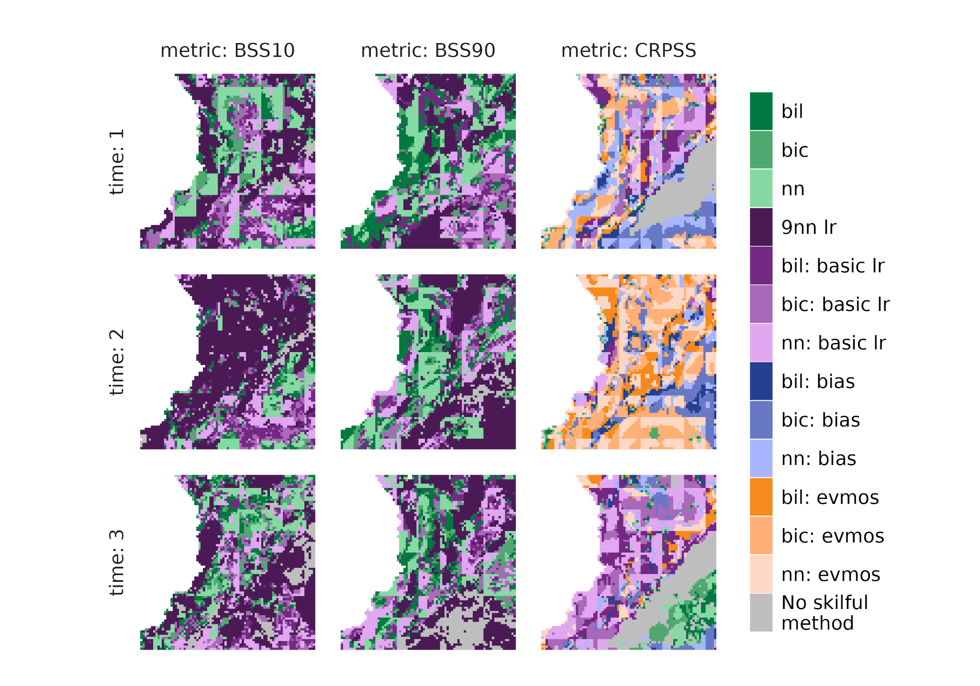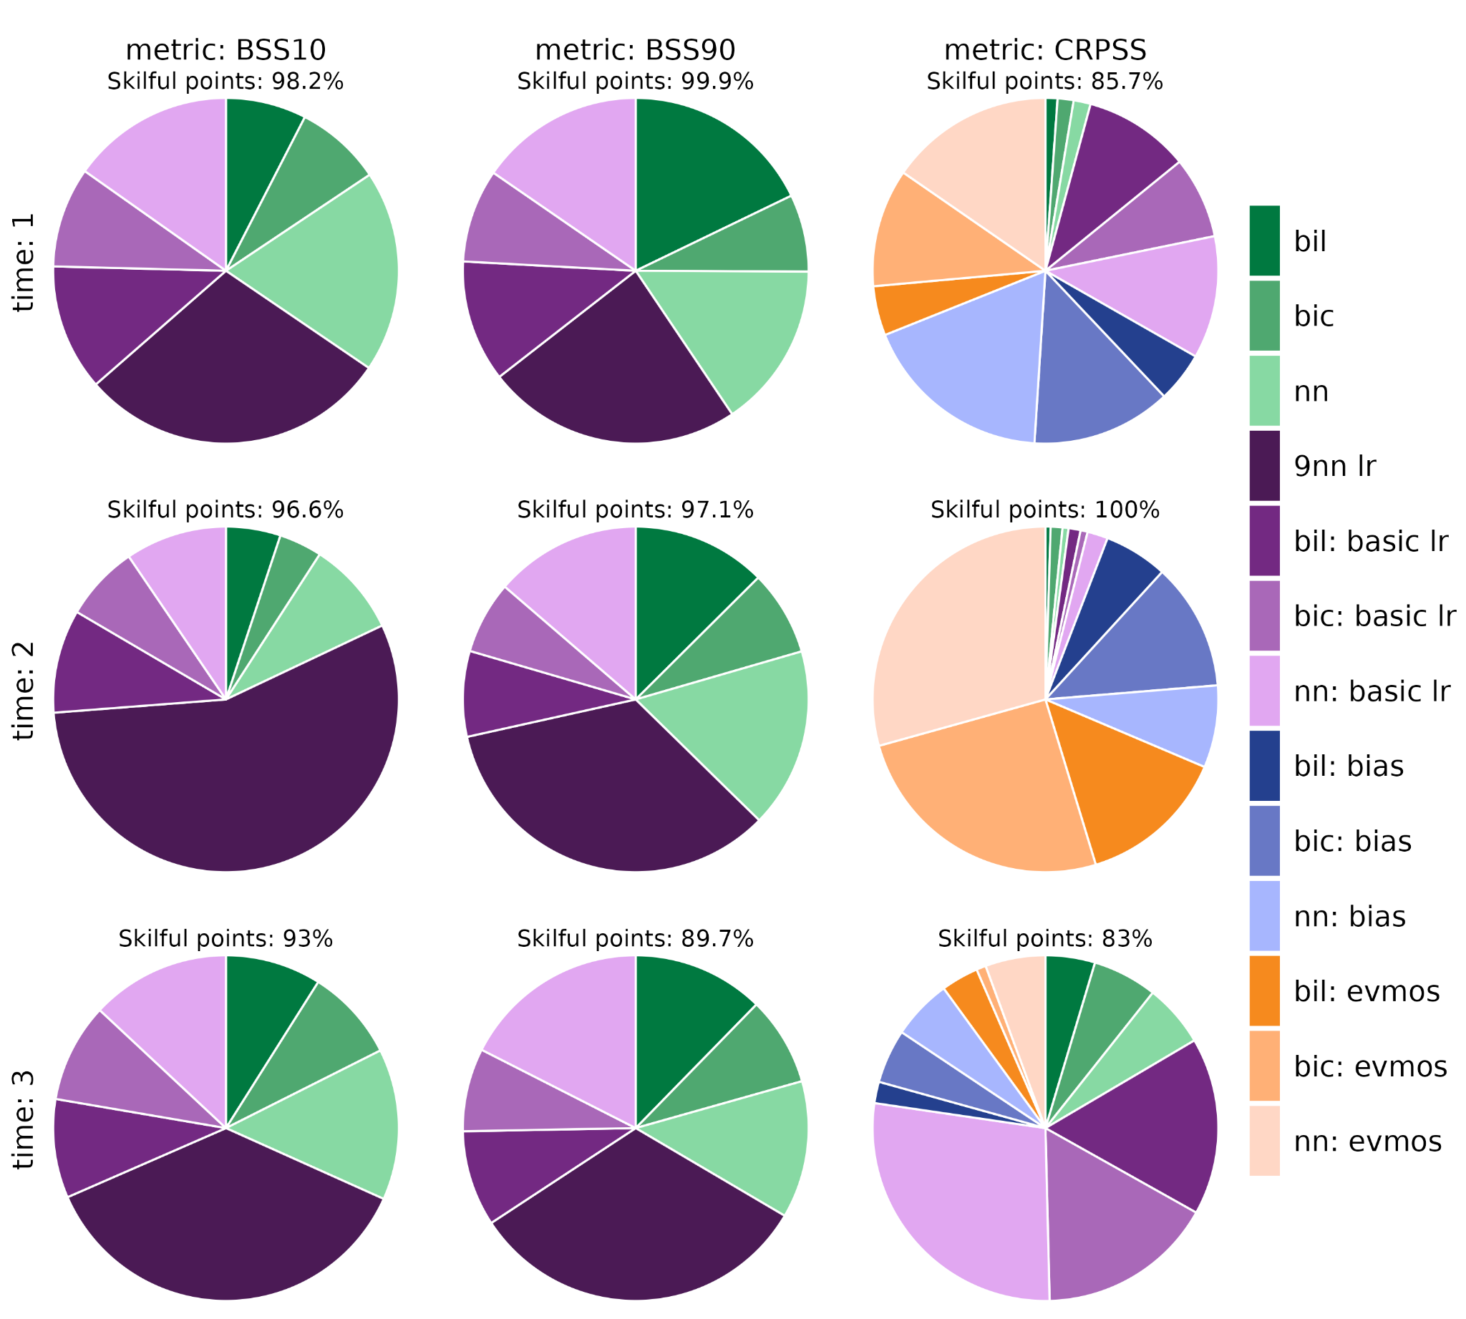
Figure 1: the most skilful downscaling method for temperature across the Colombian hotspot region, for hindcasts initialised in January 1981-2016 and 3 lead times corresponding to January, February, and March. The most skilful method is that which maximises the given skill score at a given grid cell. (top) All grid cells. If all methods have skill less than 0, the grid cell is grey. (bottom) The percentage of grid cells for which each method is the most skilful. The percentage of skilful cells is also shown.

Figure 1 considers the skill of the ECMWF SEAS5.1 seasonal forecast monthly mean daily mean temperature when downscaled and bias-adjusted using ERA5-Land observations in the Colombian hotspot region. For the different skill metrics and forecast lead times, different downscaling methods result in the most skilful model (Figure 1). Overall, it can be seen that the most skilful statistical downscaling method at predicting extremes (BSS10 and BSS90) is the ‘9 nearest neighbour’ linear regression for all lead times (Figures 1, 2).

Note that the bilinear, bicubic and nearest neighbor methods may consistently exhibit better skill values along the edges of the original forecasting grid, thus resulting in skill comparisons from Figure 1 onwards having a “grid-like” appearance in some instances. This could be explained by the fact that there is a higher likelihood of encountering sparse points along the grid borders of the original forecasting grid. Because these sparse points may be used to interpolate the forecast data to the fine-grid resolution, the nearest neighbour and other similar interpolation methods may exhibit higher skill simply because these methods inherently rely on the available model outputs more directly than others (e.g. the conservative interpolation method).
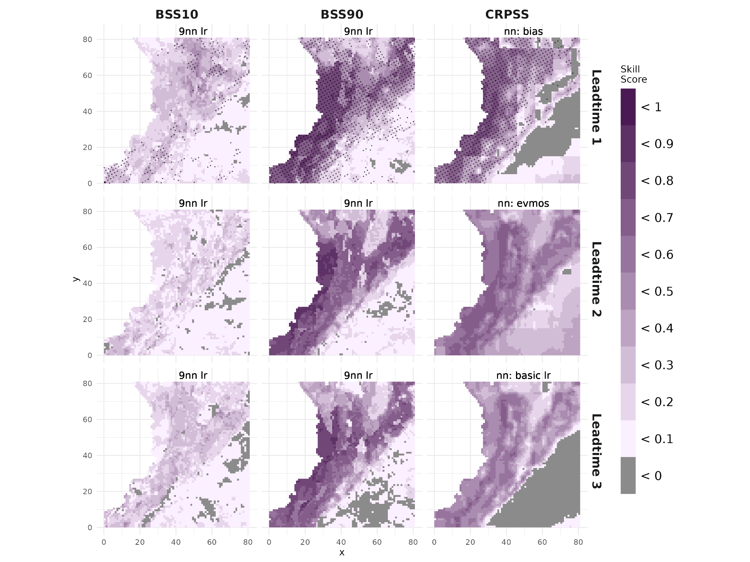
Figure 2: the skill score of the “best-performing downscaling” method for each skill score and each lead time. The “best-performing” method is that which maximises the given skill score for the most grid cells. The skill score is stippled where it is statistically significant at the level p < 0.05.

Figure 2 shows the value of the best-performing downscaling method for temperature predictions across the Colombian hotspot region. Overall, BSS90 is high at all lead times over much of the region, although not significant beyond lead time one (January). CRPSS is also high across lead times, largely in the north west of the region. However, while using the 9 nearest neighbour linear regression yields a positive BSS10 value across lead times, it is a relatively weak improvement over climatology and is skilful only at the first lead time for few grid cells.
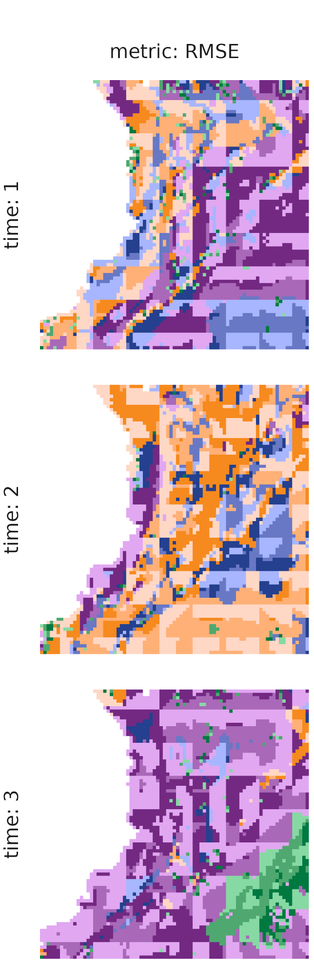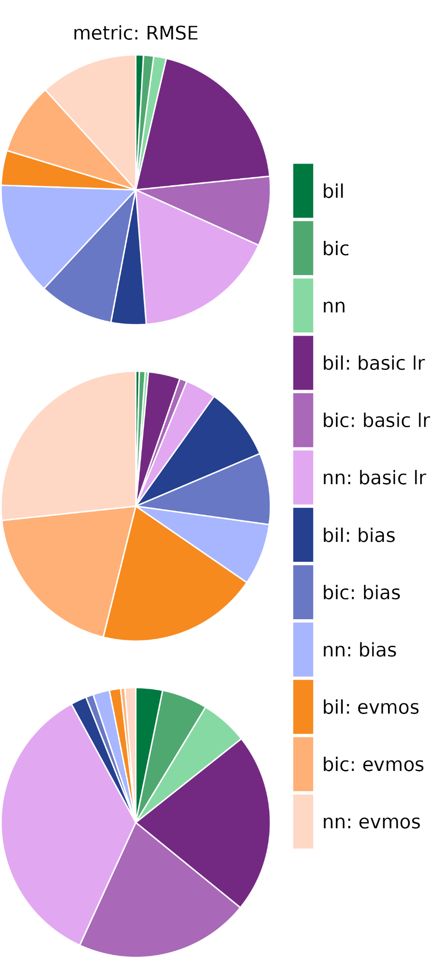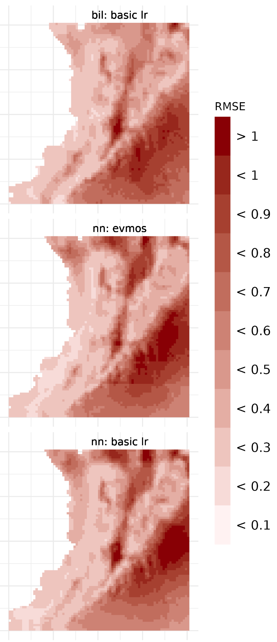
Figure 3: (left) the downscaling method that minimises RMSE for temperature. (centre) the percentage of grid cells for which each downscaling method minimises the RMSE. (right) the RMSE for the downscaling method which reduces RMSE the most for a given lead time.

Finally, we consider the RMSE of the hindcasts downscaled using the different methods. Again, we see that the chosen models in general have a low RMSE over the north west of the region, but biases are large to the south east (Figure 3). For the given lead times, the method which reduces the RMSE the most differs, although we would recommend a linear regression technique at lead times one and 3 (January and March), but the EVMOS bias adjustment at lead time two (February).

4.1.2 Precipitation
In this section, precipitation is downscaled using ERA5-Land precipitation as the reference dataset. Note that the selection of different interpolation and calibration methods are different from the methods applied for downscaling temperature, in order to both preserve the physical constraints of precipitation and take into account its distribution function.

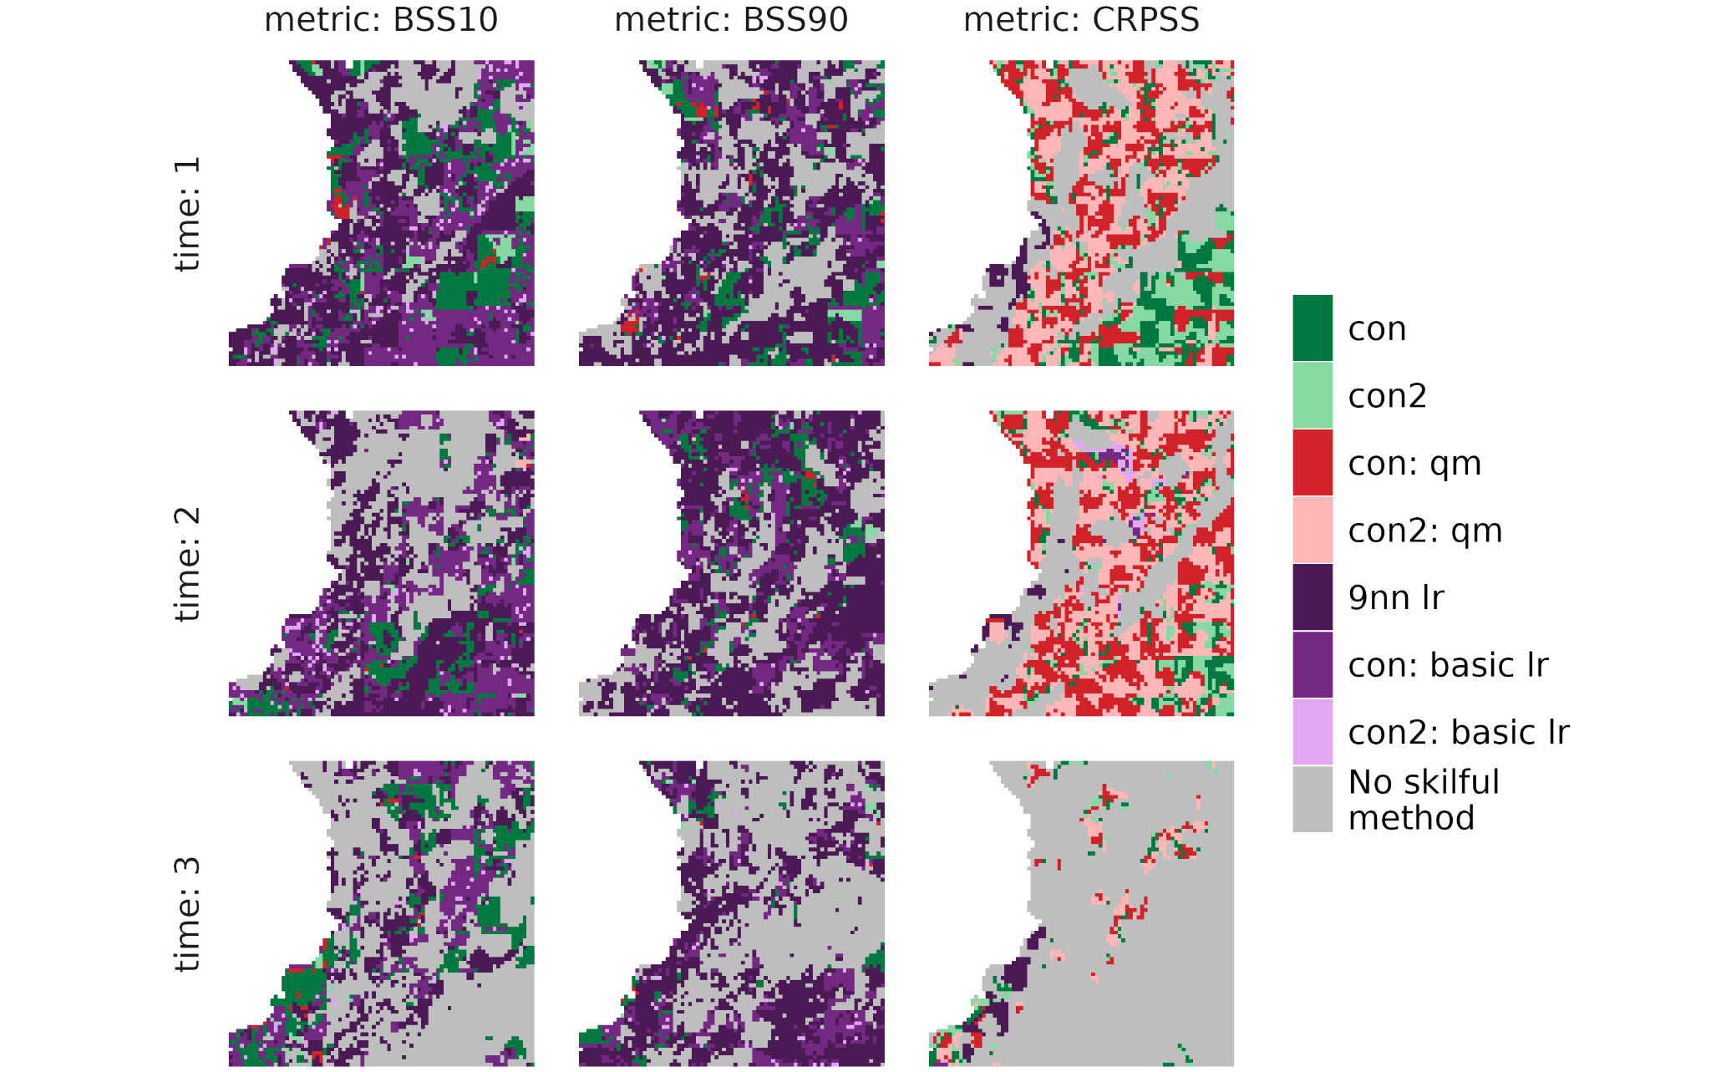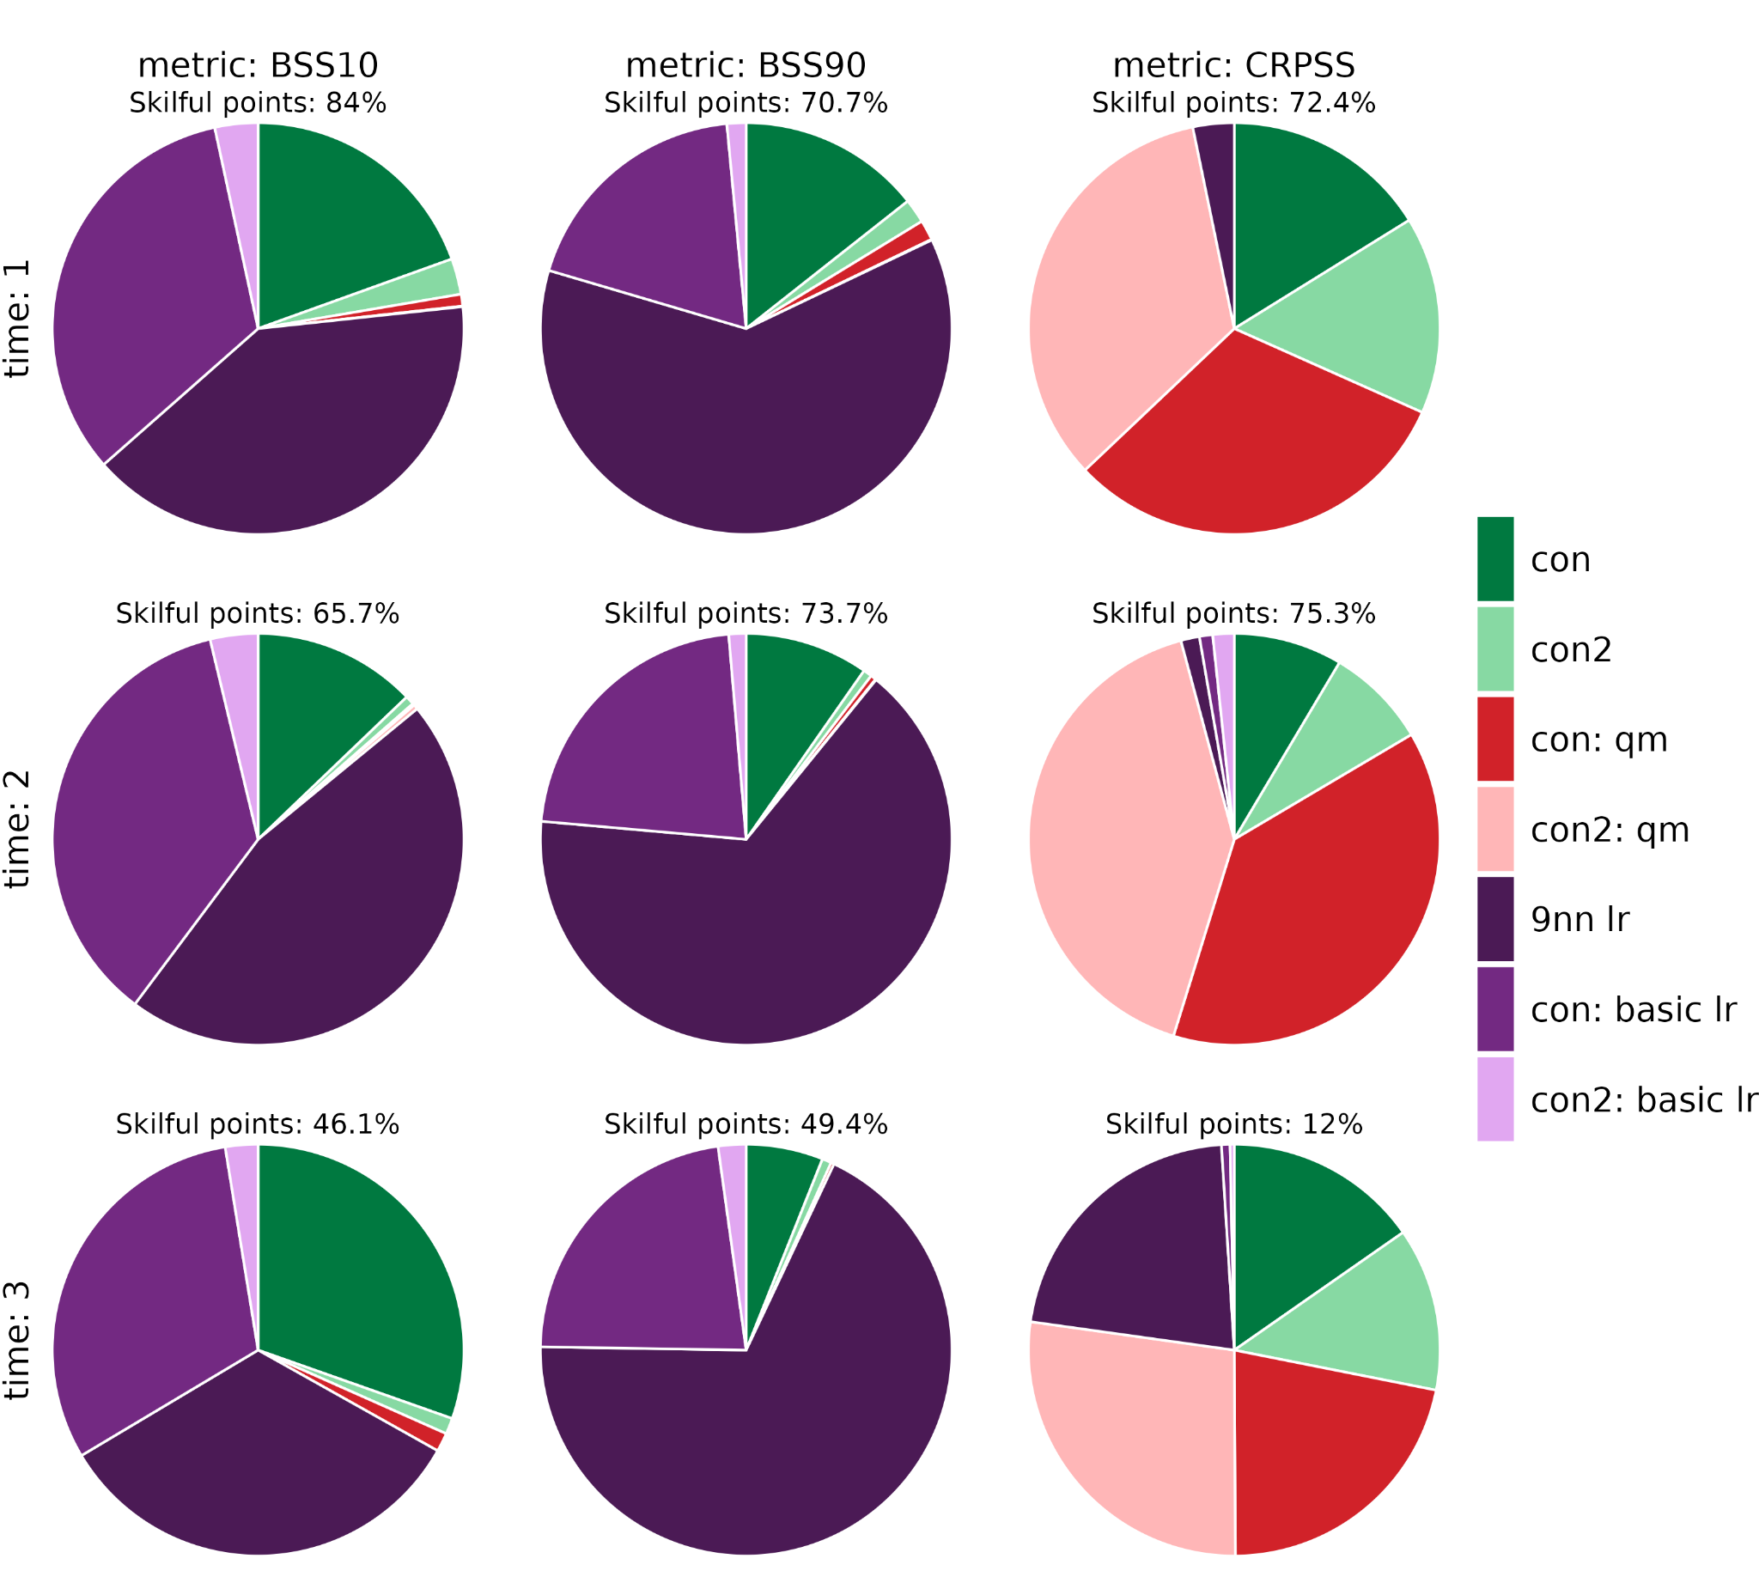
Figure 4: as in Figure 1, but with precipitation as the variable to downscale.

Figure 4 shows that the model less skilfully predicts precipitation in the region. A maximum of 84% of grid cells are skilfully predicted by any model (BSS10 at lead time one), and by lead time three, fewer than 50% of the grid cells are skilfully predicted by any model. Downscaling methods using linear regressions produce the most skilful models in terms of BSS10 and BSS90, but if CRPSS is to be maximised, the best choice of model may be an interpolation plus quantile mapping.

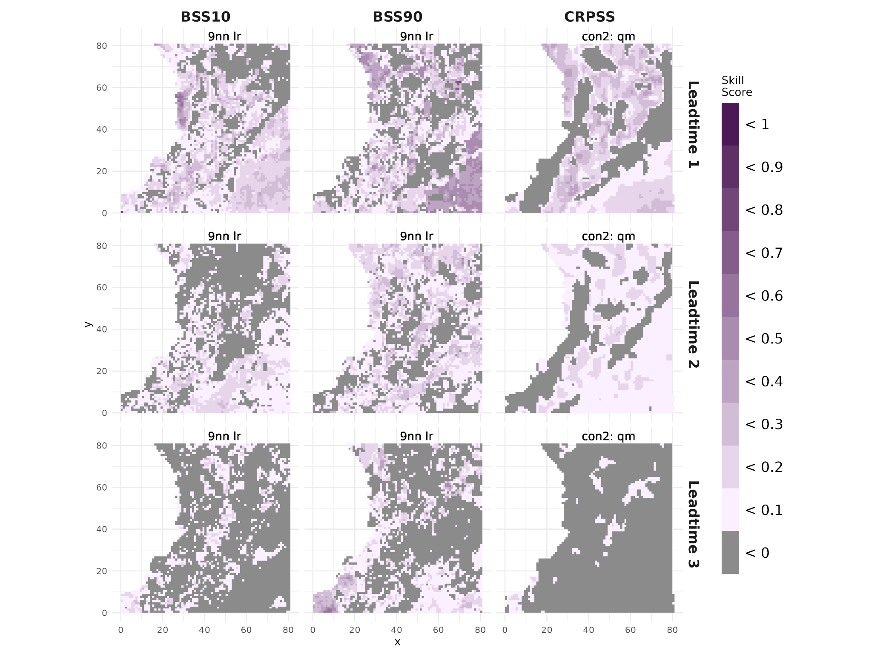
Figure 5: as in Figure 2, but with precipitation as the variable to downscale.

The 9 nearest neighbour linear regression provides additional skill in forecasting extremes compared to climatology, although this is only significant at lead time one (Figure 5).
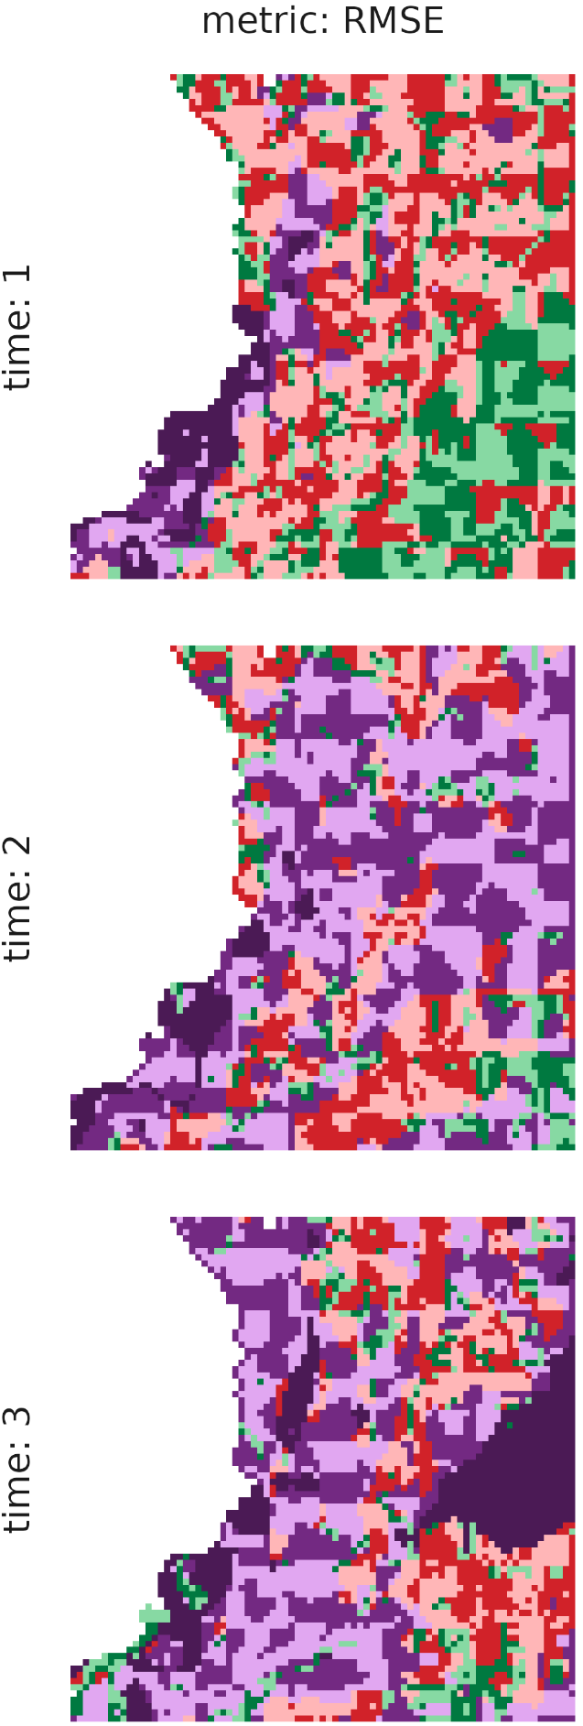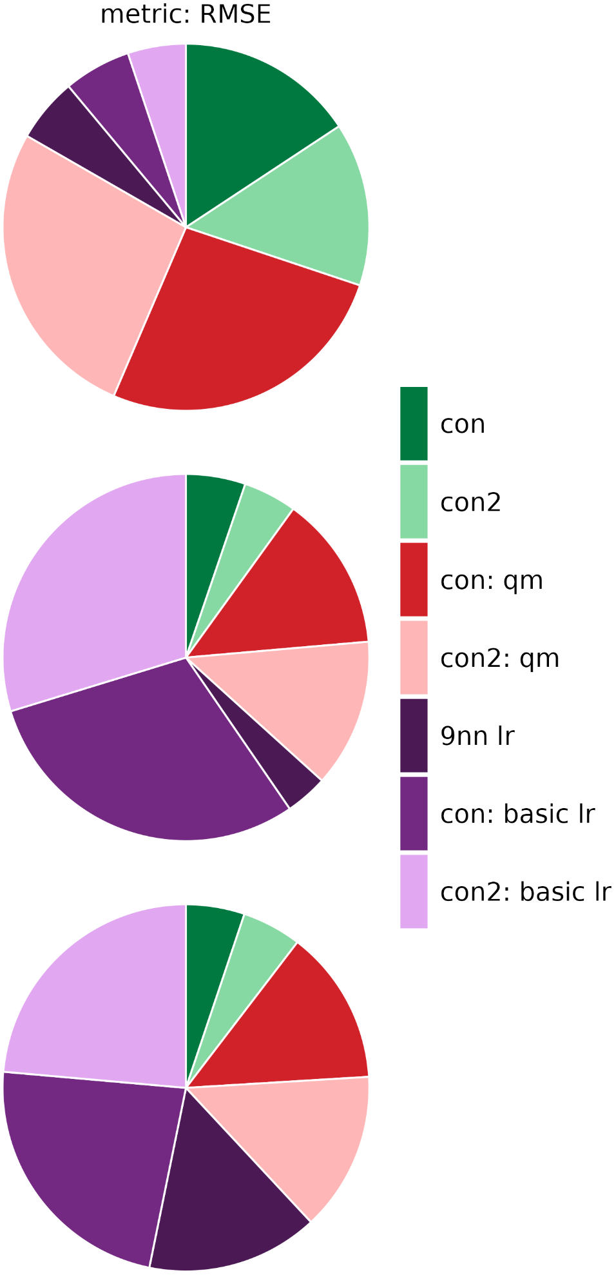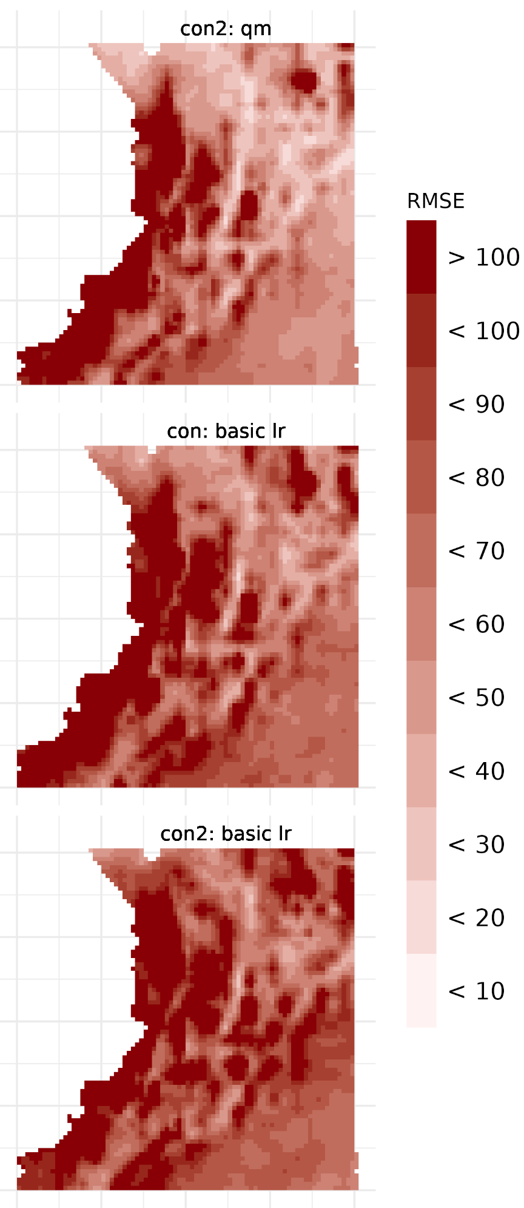
Figure 6: as in Figure 3, but with precipitation as the variable to downscale.

In terms of the RMSE, this is minimised by a conservative regridding plus quantile mapping at the first lead time (January), and by a conservative regridding plus basic linear regression at lead times two and three. However, the absolute value of the RMSE is quite large at all lead times, particularly in the coastal region.

4.1.3 Temperature downscaling using weather station data
Reanalyses such as ERA5-Land provide competent maps of observed climate variables without gaps, however, they are not exempt from biases and, often, the choice of weather stations as reference is preferred in case reliable long records of such stations are available in the location of interest. In this section we consider a network of local weather stations as the reference dataset to explore the downscaling of temperature. Local weather station data is provided across the Tolima and Valle departments in Colombia, with each station recording different variables and having different temporal coverage (Figure 7a, b). We identify 40 stations with at least 20 years of both temperature and precipitation data, shown in Figure 7c, and then downscale hindcast data to these locations.

In addition to the length of the station record, its quality is essential to ensure reliable downscaled results. The quality of the measurements is entrusted to the weather station manager, however, errors can occur through the data acquisition chain, from digitalisation to storage or display errors. Consequently, a basic quality control of the acquired data is extremely desirable; there is no standard procedure for such quality control but some guidelines are provided by (World Meteorological Organization, 2008), namely:
- Internal consistency checks to control the consistency between variables, e.g. maximum temperature being over minimum temperature
- Climatological checks to flag suspicious outliers, i.e., values too high above a plausibility threshold
- Temporal checks to control the rate of change from one observation to the next one.

Figure 8 shows a comparison of the station and ERA5-Land temperature; largely, ERA5-Land captures observed temperature well, although it underpredicts temperatures in some cases (e.g. stations 26095320 or 26105350) and overpredicts in others (e.g. station 21255110).

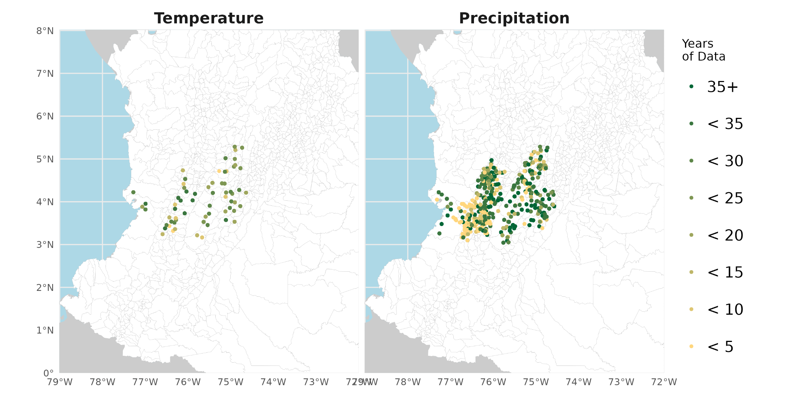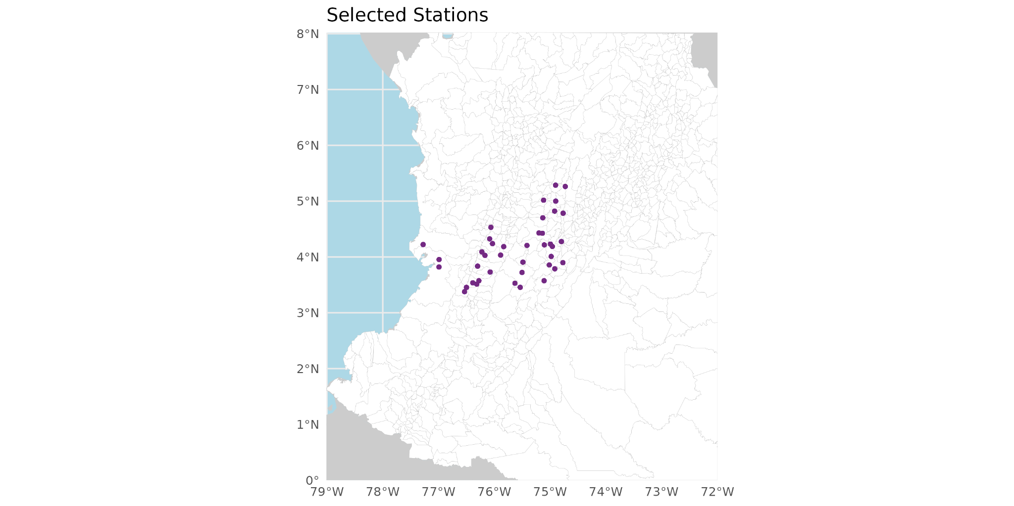
Figure 7: weather stations in Tolima and Valle along with the years of data available for a) temperature and b) precipitation. c) shows the stations with at least 20 years of both temperature and precipitation data selected for downscaling.

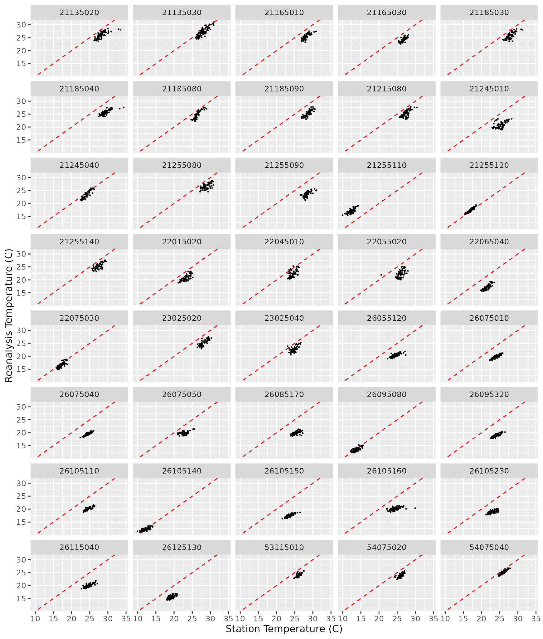
Figure 8: Temperature recorded in the 40 selected stations in Tolima and Valle, compared with temperature in the nearest gridcell in the reanalysis (ERA5-Land).

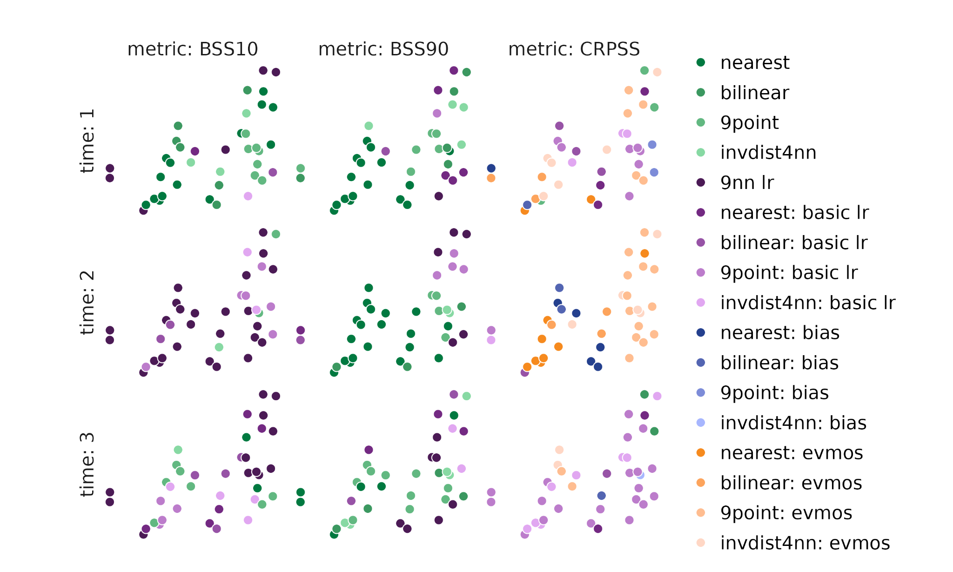
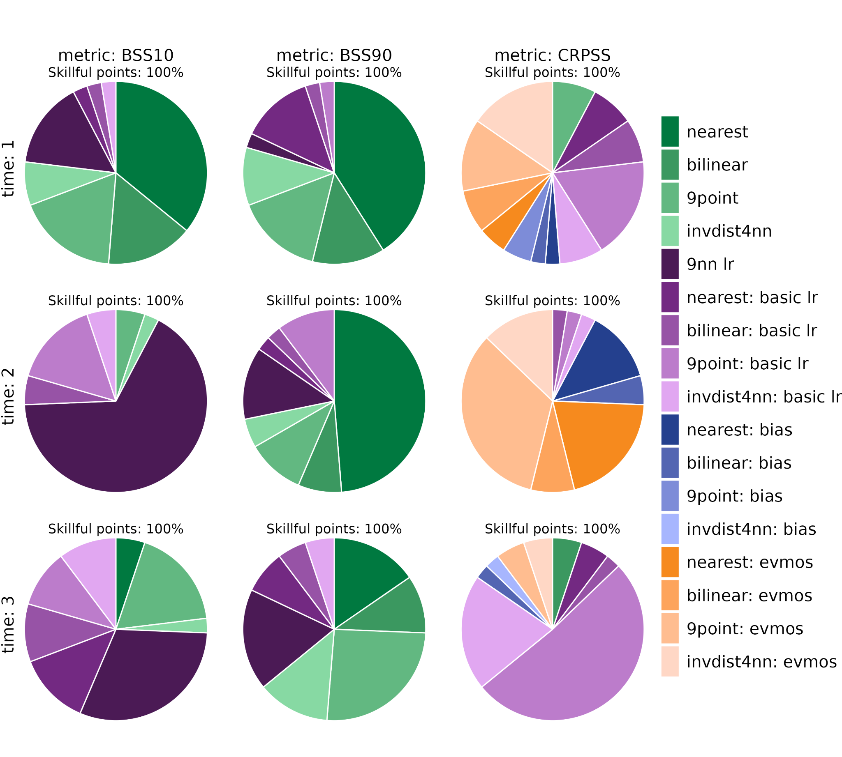
Figure 9: the most skilful downscaling method for temperature across Colombia, for hindcasts initialised in January 1981-2016 and 3 lead times corresponding to January, February, and March. (top) All weather station locations. If all downscaling methods have skill less than 0, the point is grey. (bottom) The percentage of locations for which each downscaling method is the most skilful. The percentage of skilful locations is also shown.

Figure 9 shows the most skilful downscaling method to the locations of the selected weather stations, for temperature. Overall, a simple interpolation often produces the most skilful model across locations, particularly when considering hot temperature extremes.

For temperature predictions in the Colombian region studied, with seasonal predictions initialised in January and using ERA5-Land as the reference dataset, we recommend 9-nearest-neighbour linear regression as the most skilful downscaling and bias adjustment technique for temperature across the region studied, particularly when looking at temperature extremes. For predictions of precipitation, the 9 nearest neighbour method is also recommended, although if interested in skilfully predicting the entire precipitation distribution, we recommend using a second-order conservative regridding with a quantile mapping bias adjustment.

Brazil
We perform the same analysis for the hotspot regions in Brazil, downscaling and verifying seasonal predictions of temperature and precipitation in the region 4-10ºS and 33-39ºW, using ERA5-Land data as the reference.

4.2.1 Temperature

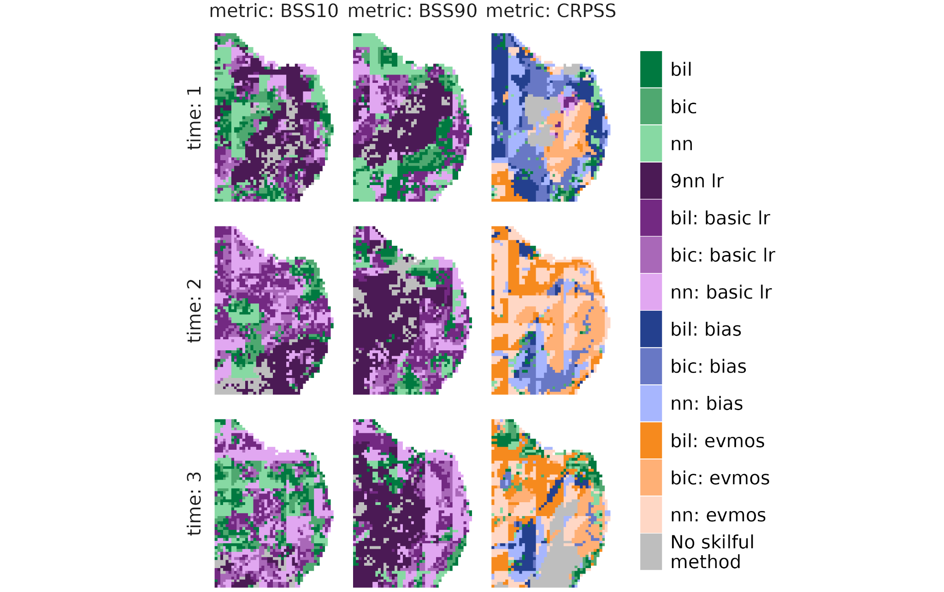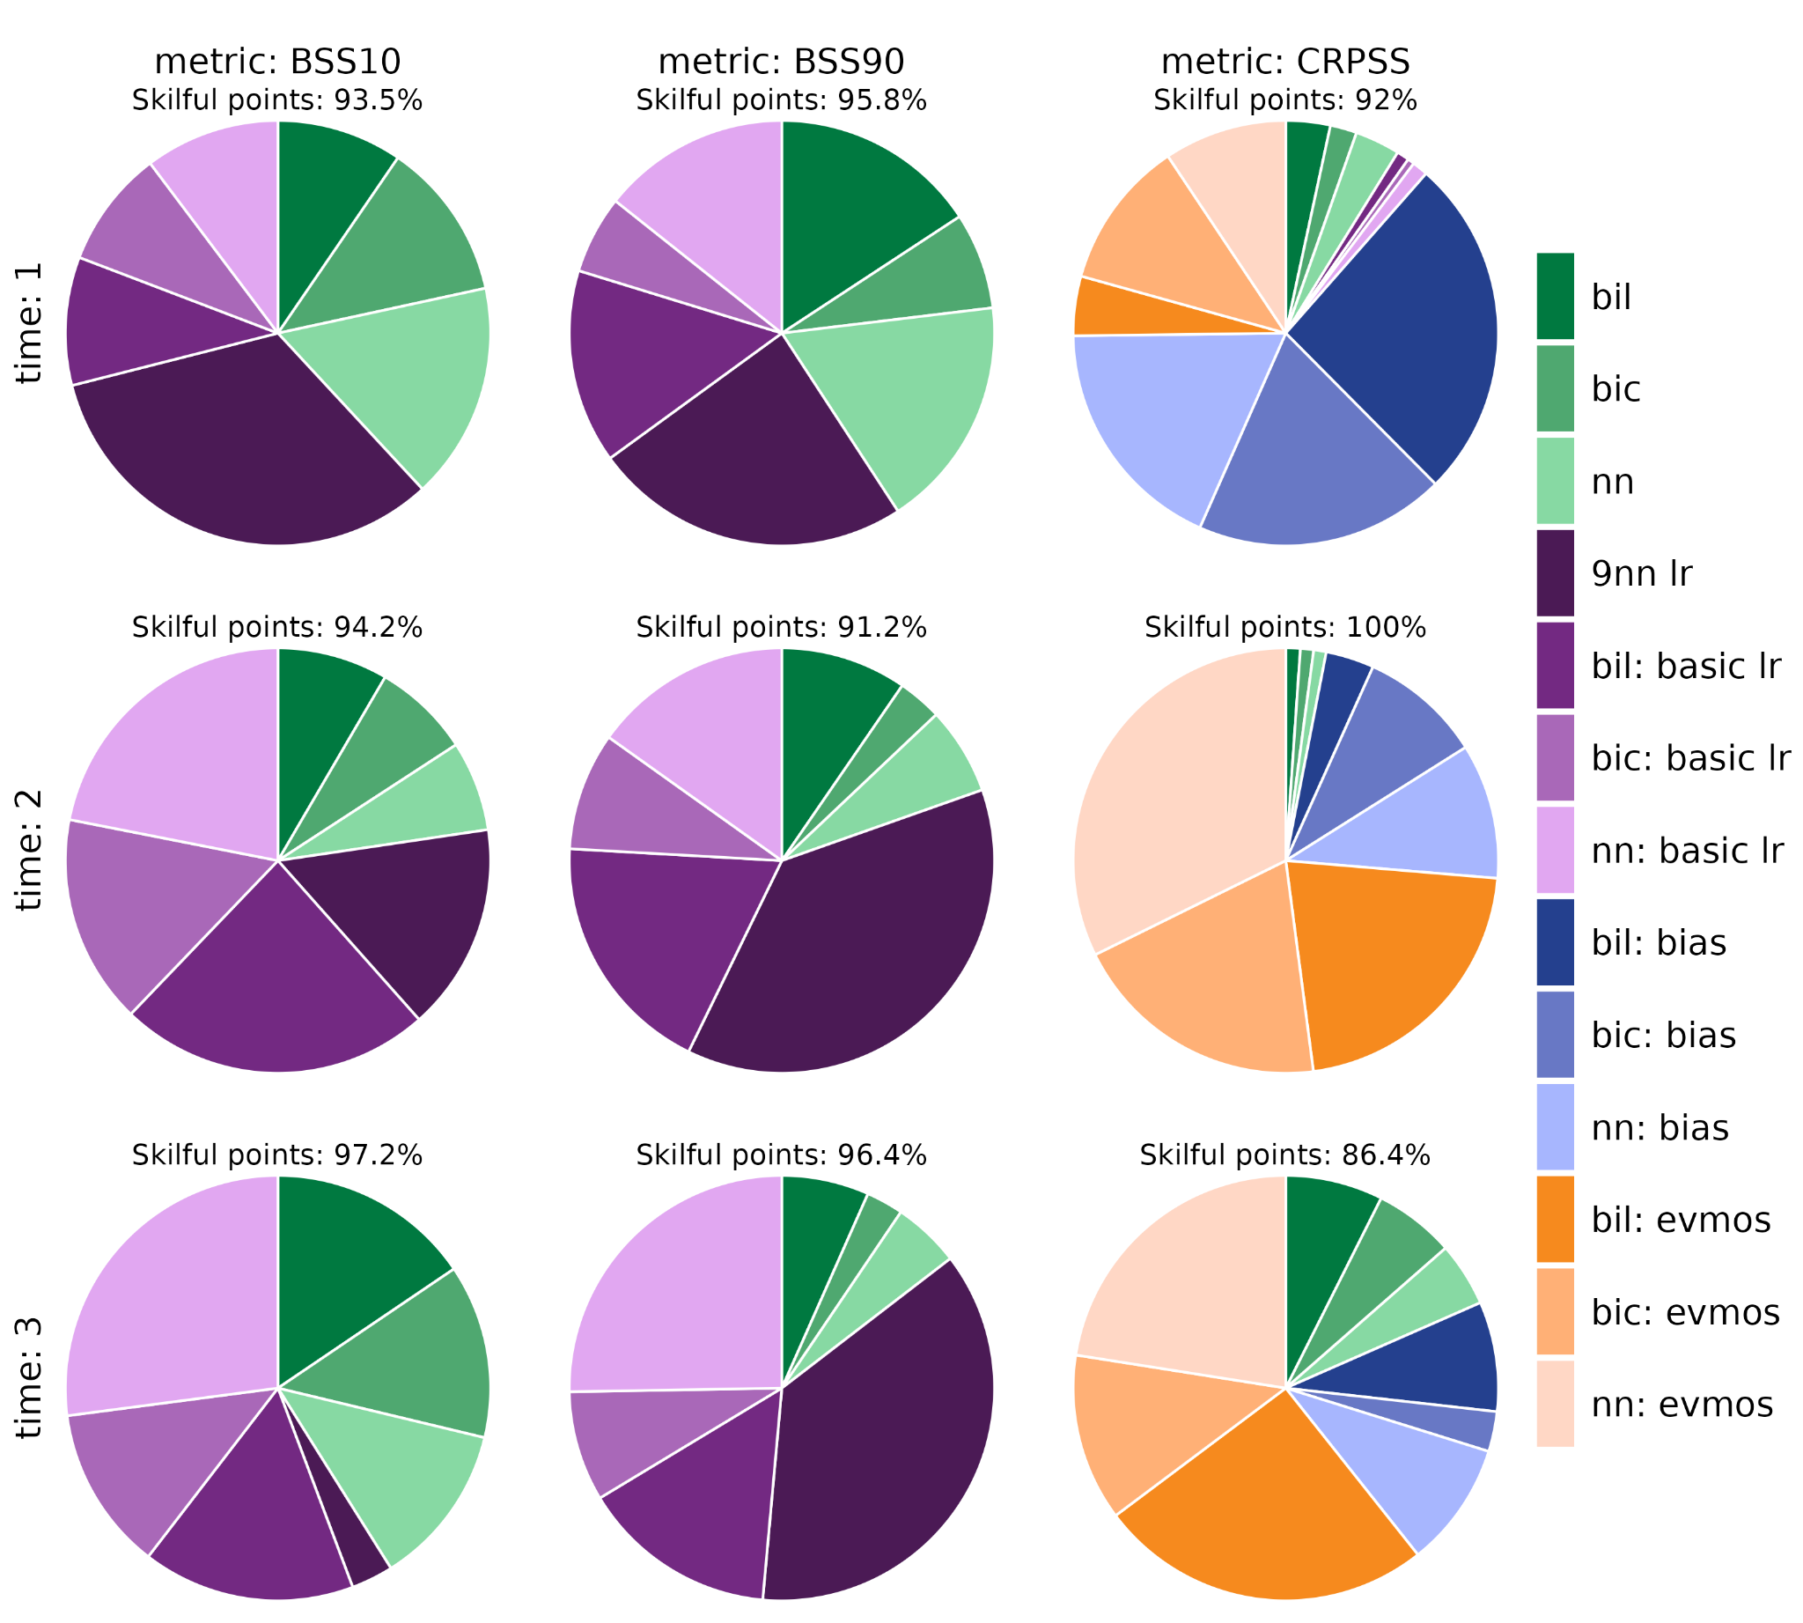
Figure 10: as in Figure 1, but across the Brazilian hotspots region.

In the Brazilian hotspots region, the linear regression methods in general are the most skilful according to the BSS10 and BSS90 metrics (Figures 10, 11). CRPSS is maximised with interpolation plus bias correction techniques (in general, we would recommend the use of the EVMOS correction in this region, although if interested in only lead time one, the simple bias correction).

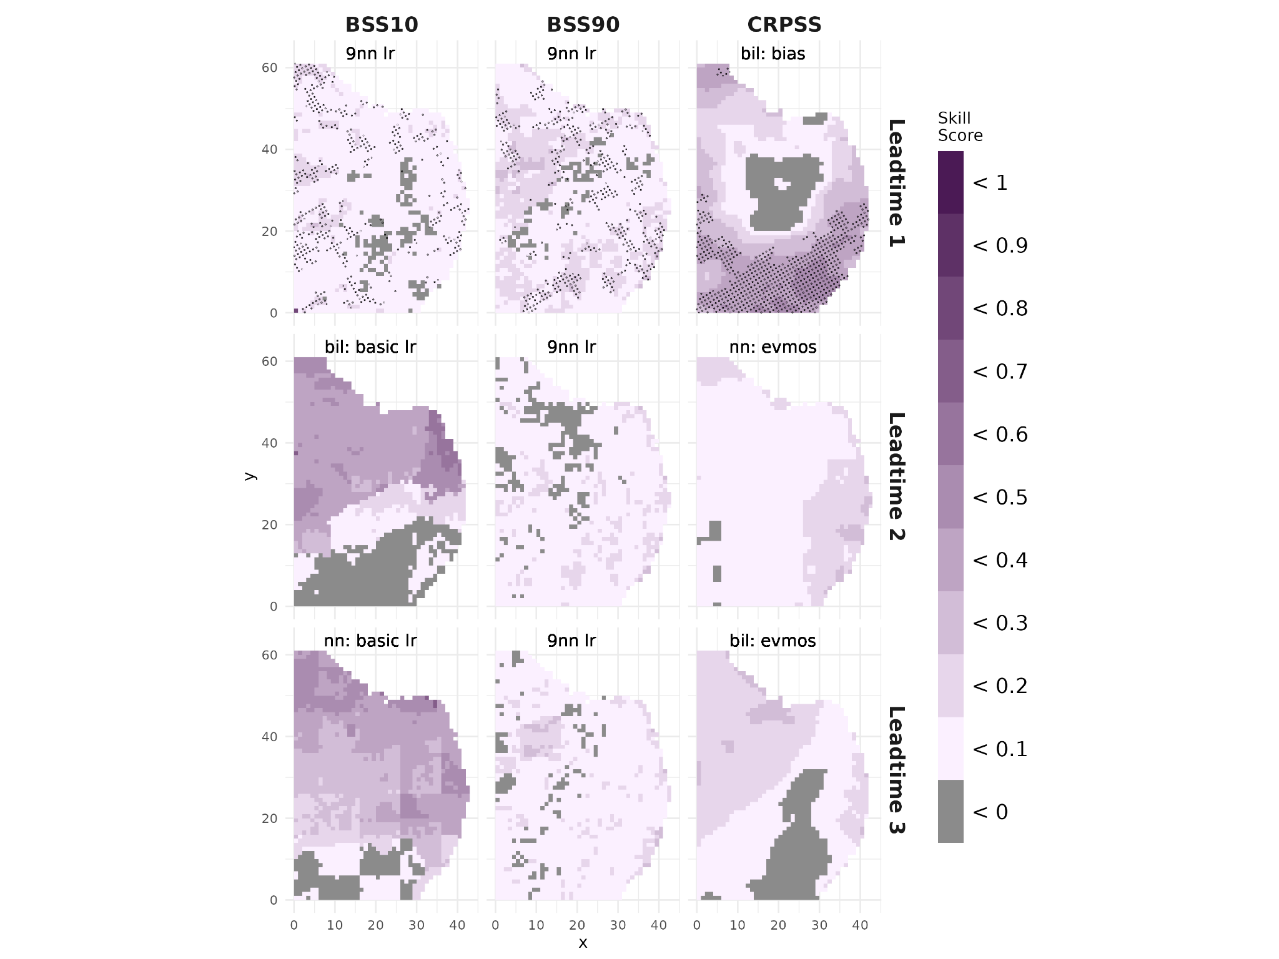
Figure 11: as in Figure 2, but across the Brazilian hotspots region.

Over this region, the skill at forecasting cold extremes (BSS10) is improved compared to the climatology, particularly in the northernmost regions at lead times two and three, although this is not statistically significant (Figure 11). CRPSS is high, and statistically significant, largely in the south of the region only at lead time one.

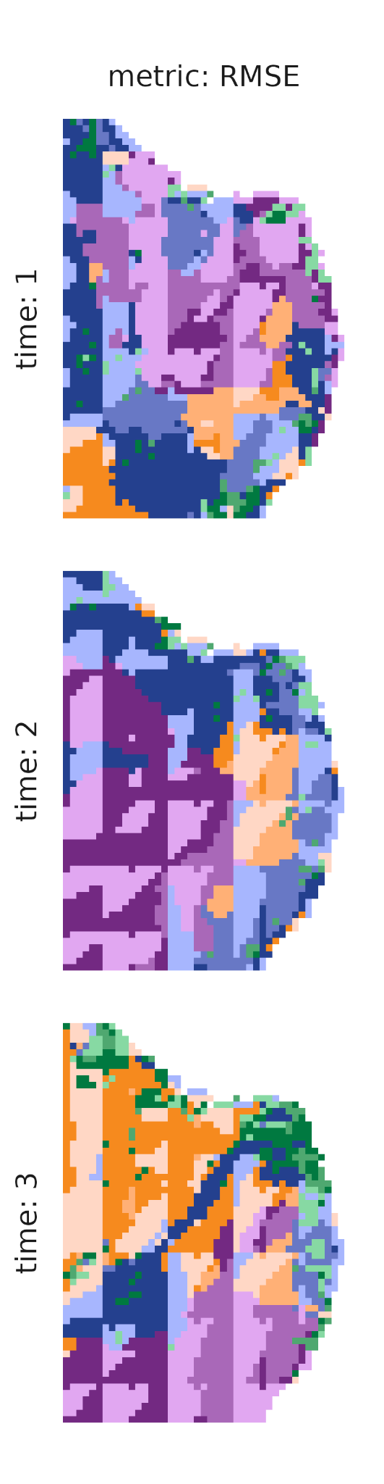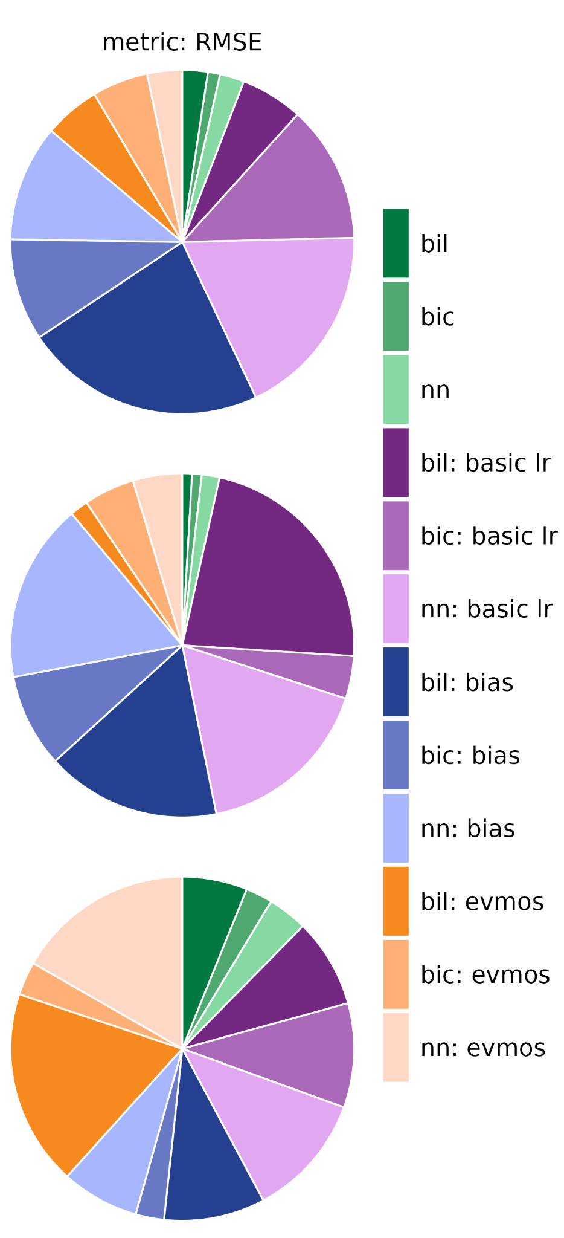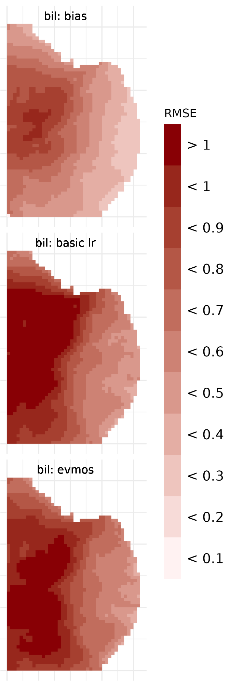
Figure 12: as in Figure 3, but across the Brazilian hotspots region.

We note from the analysis of the RMSE over the region containing the Brazilian hotspots that the RMSE is large at all lead times, particularly in the west of the region (Figure 12). Overall, a bilinear interpolation plus a calibration following tends to minimise RMSE, but at longer lead times the RMSE is large. Bilinear interpolation plus a simple bias adjustment performs well at lead time one, when considering both the whole distribution (CRPSS) and the RMSE.

4.2.2 Precipitation
We now consider precipitation downscaled over the Brazilian hotspots region, using ERA5-Land as the reference.
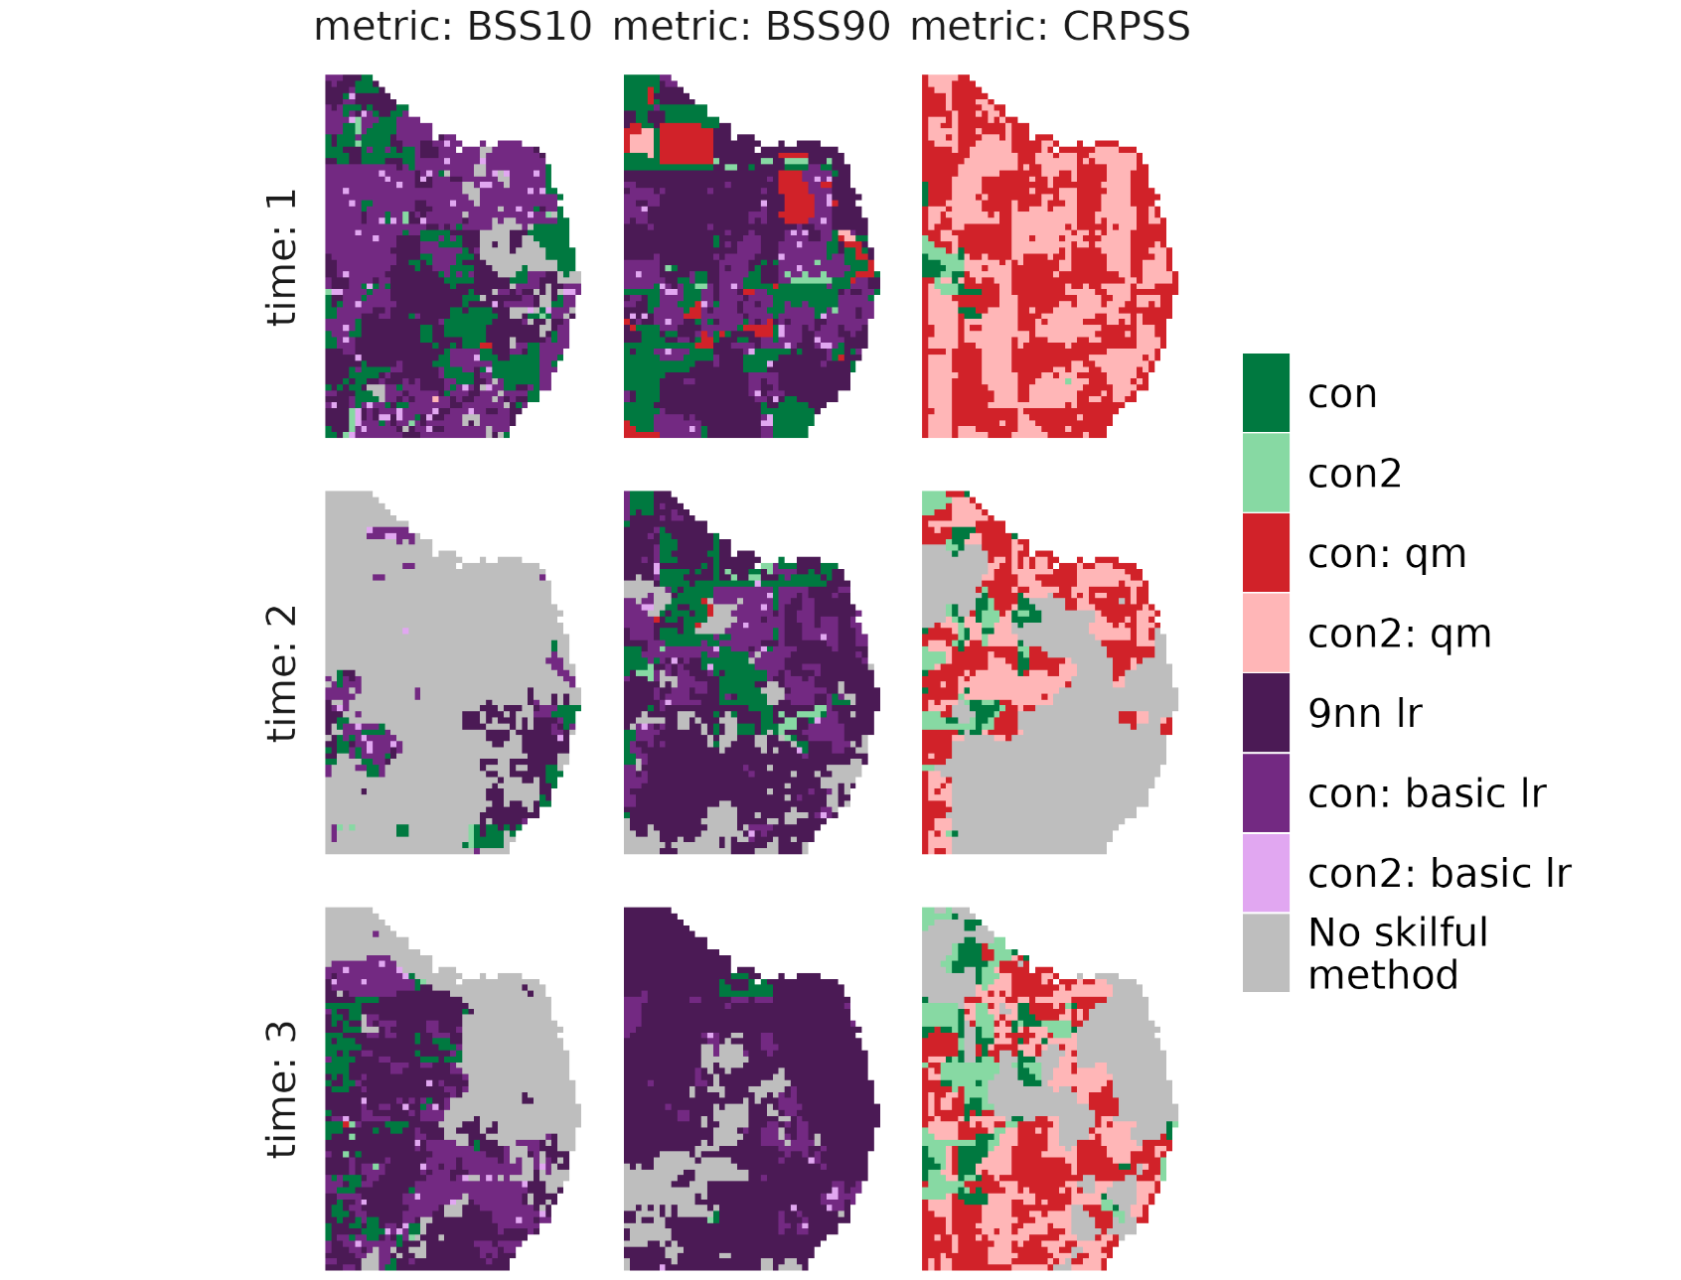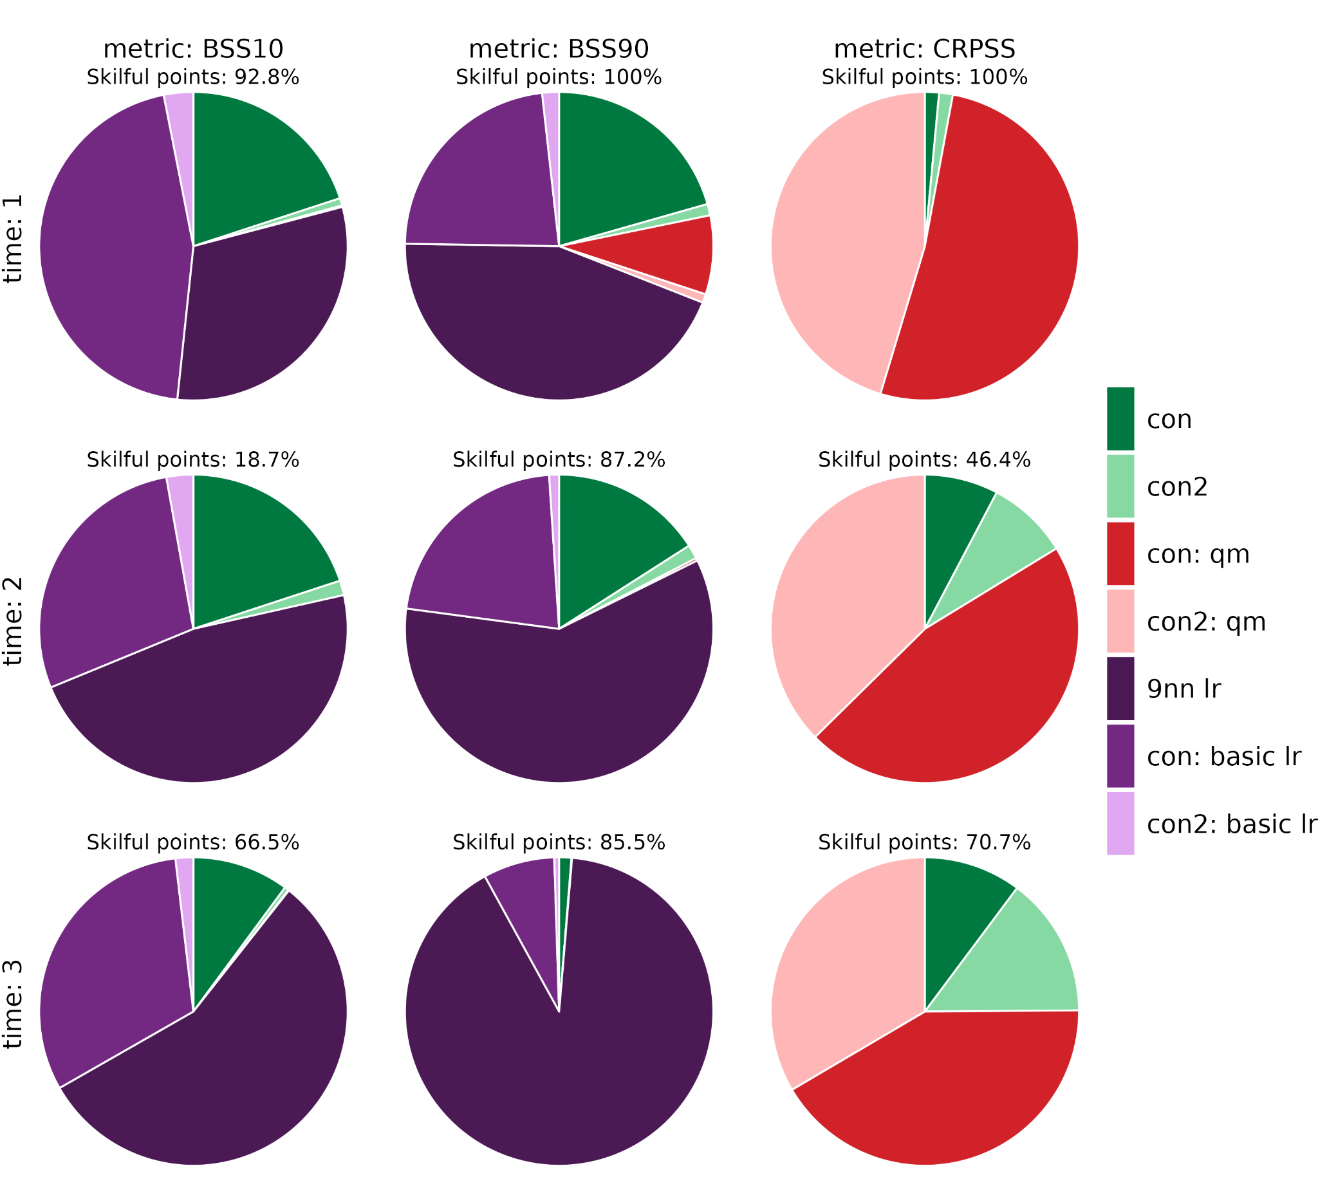
Figure 13: as in Figure 1, but with precipitation as the variable to downscale across the Brazilian hotspots region.

Figure 13 shows that overall linear regressions produce the most skilful model for predicting precipitation extremes (BSS10, BSS90), but a conservative remapping plus quantile mapping most skilfully predicts the entire precipitation distribution (CRPSS). In Figure 14, we can see that at lead time one, there is generally added skill from using the most skilful downscaled model compared to the climatology, but this is not the case at the second lead time.

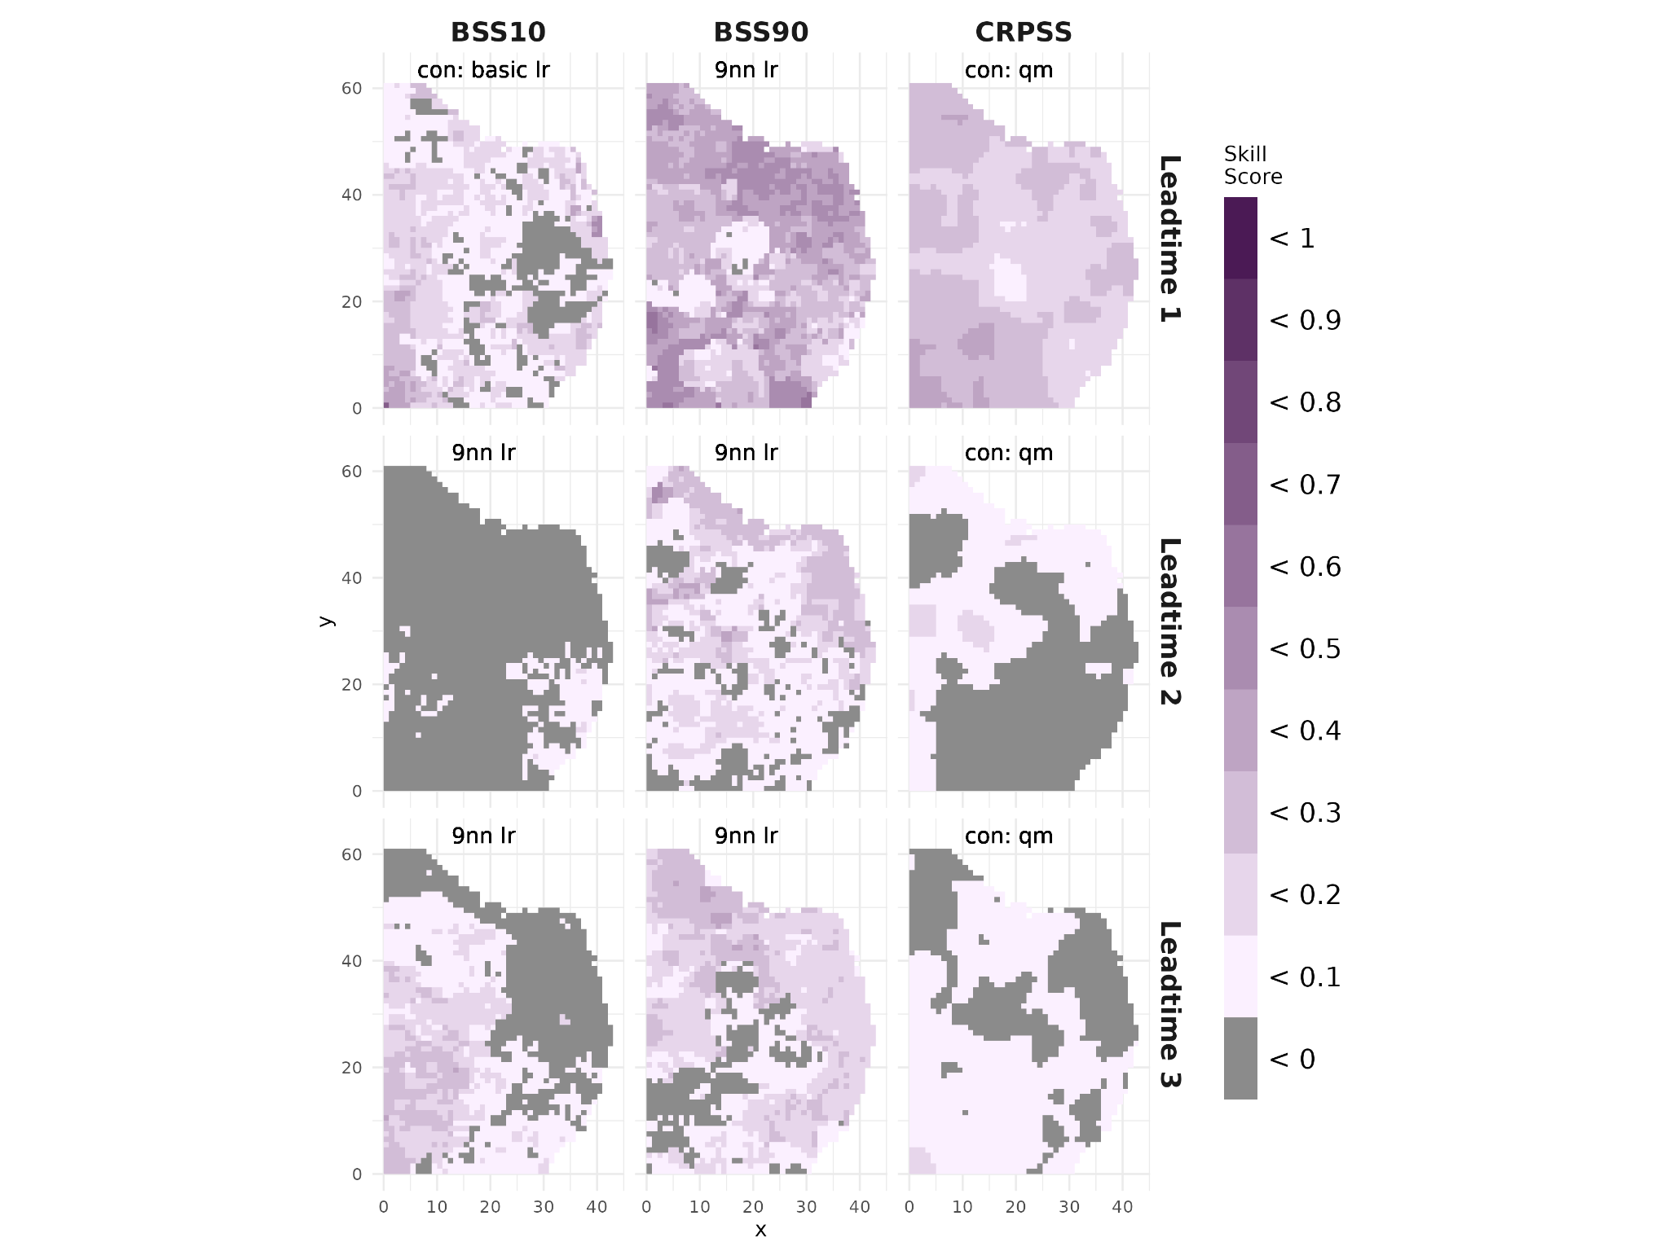
Figure 14: as in Figure 2, but with precipitation as the variable to downscale across the Brazilian hotspots region.
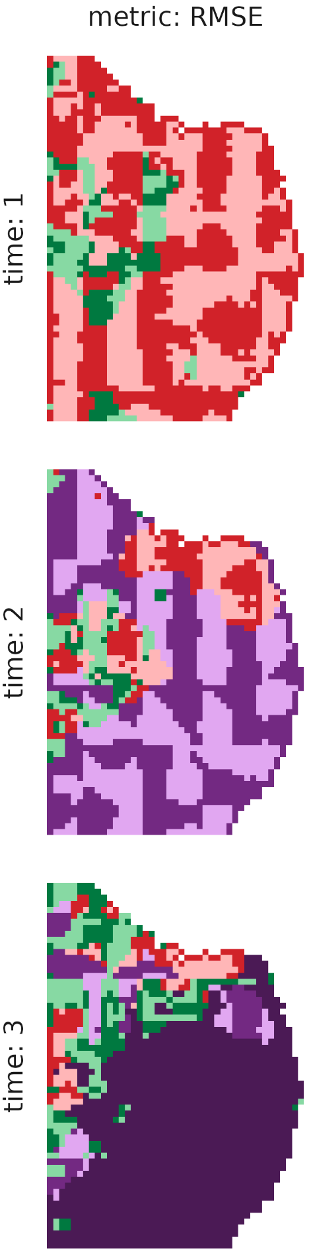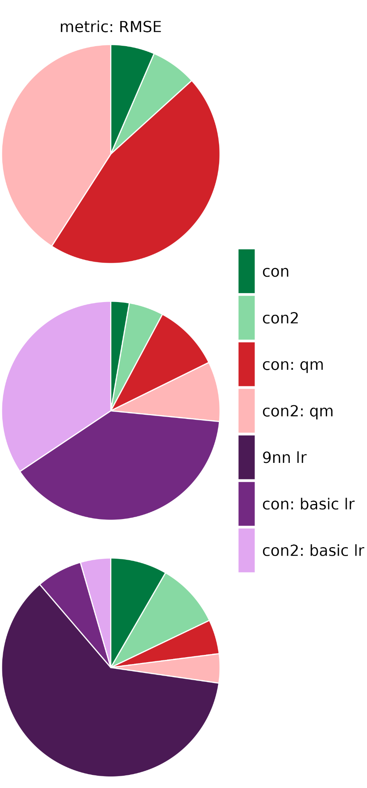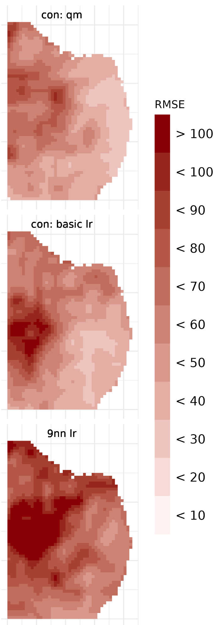
Figure 15: as in Figure 3, but with precipitation as the variable to downscale across the Brazilian hotspots region.

Finally, considering the RMSE also shows that a quantile mapping method will minimise the RPSS at the first lead time, although linear regression techniques minimise the RMSE at lead times two and three. We note that a larger bias occurs inland over larger lead times.

In the Brazilian hotspots region, given seasonal predictions initialised in January, linear regression techniques are recommended if interested in forecasting temperature extremes, although EVMOS bias adjustment may provide a more skilful prediction if interested in predicting the whole temperature distribution. For precipitation, the 9 nearest neighbour linear regression is recommended for exploring wet extremes, but a conservative regridding with a quantile mapping bias adjustment is suggested for most skilfully predicting the entire distribution.

Peru
We also explore the statistical downscaling approaches for temperature and precipitation forecasts covering the Peruvian hotspot, in the area 1-6ºS, 70-76ºW, using ERA5-Land data as the reference.

4.3.1 Temperature
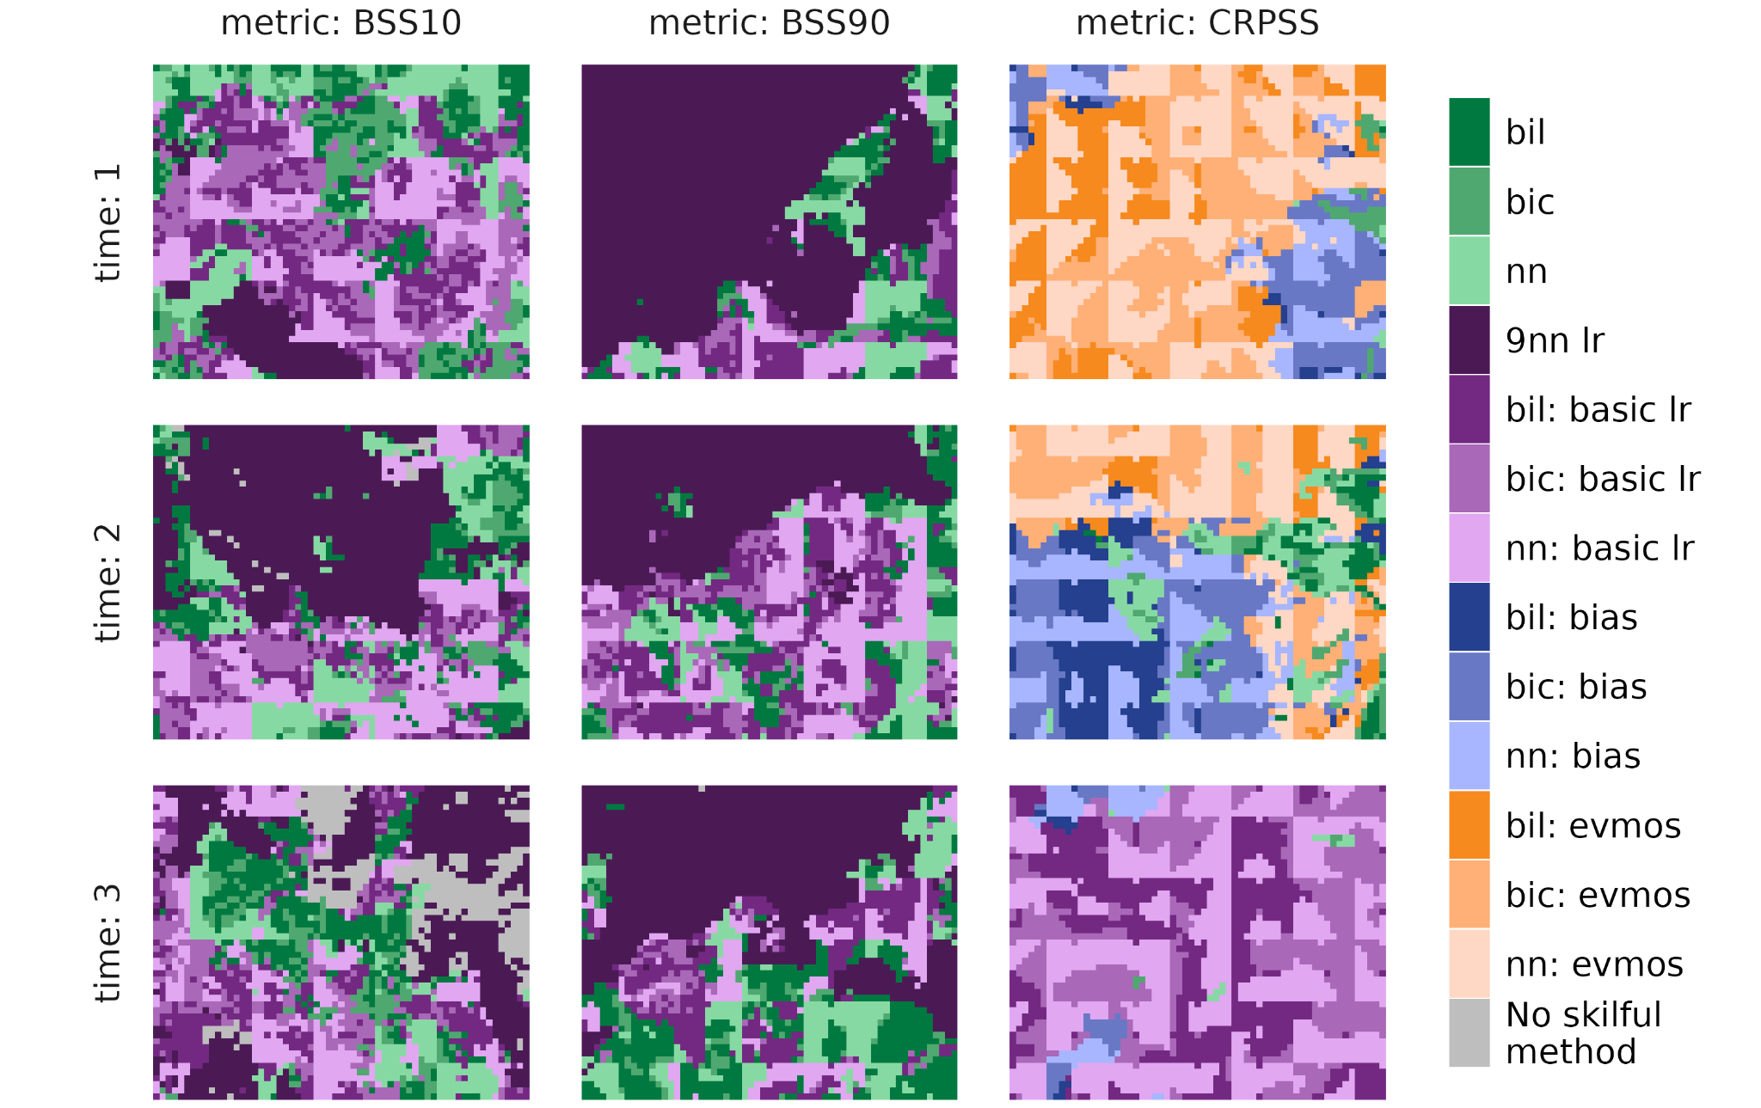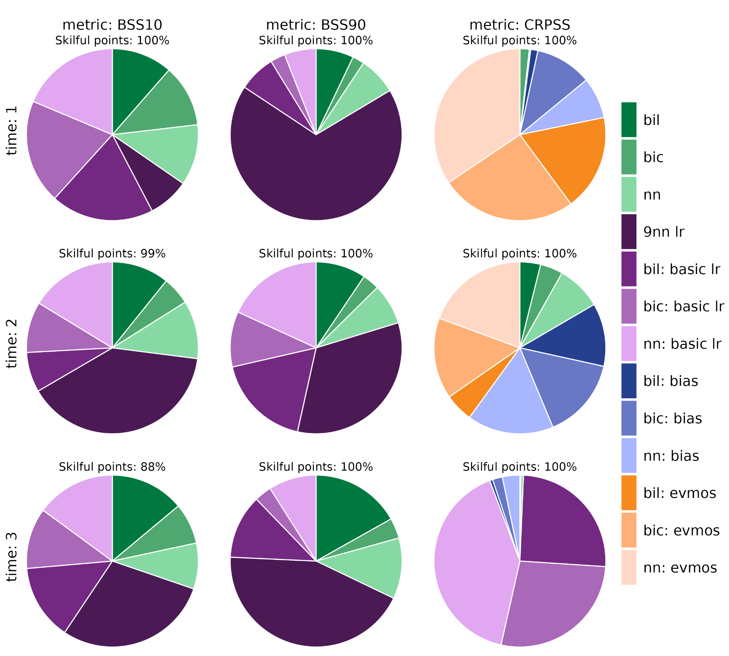
Figure 16: as in Figure 1, but across the Peruvian hotspot region.

In the region of the Peruvian hotspot, BSS10 and BSS90 are largely maximised when using linear regression techniques to downscale the seasonal temperature forecast. CRPSS is also maximised using these methods at lead time 3 (March). If interested in forecasting hot extremes, a 9 nearest neighbour linear regression performs well across all lead times, particularly in the northernmost regions (Figure 16, 17).

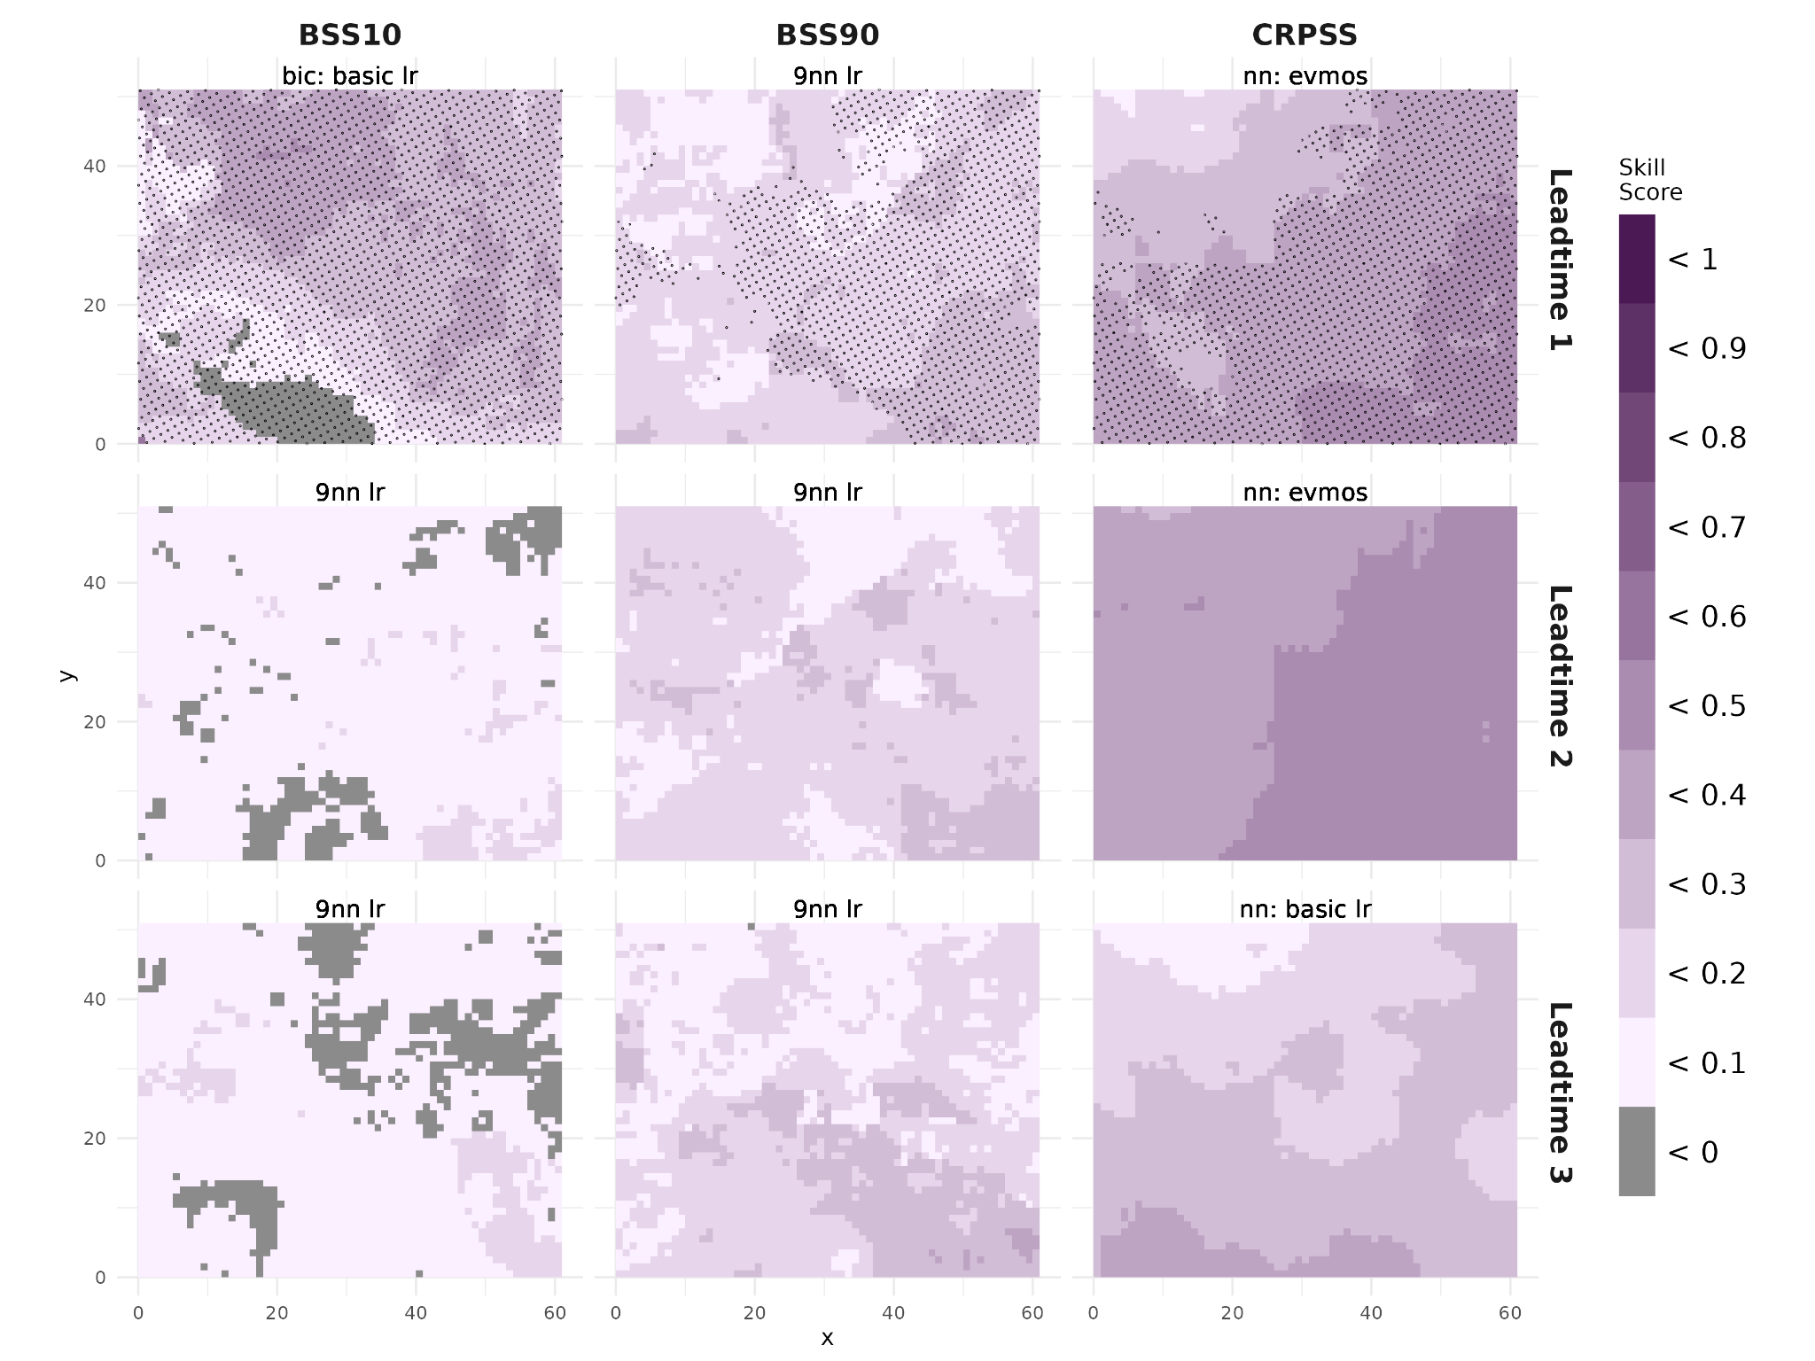
Figure 17: as in Figure 2, but across the Peruvian hotspot region.

For the Peruvian downscaled hindcasts, the skill is only significant at lead time one (Figure 17). For example, whilst the 9nn linear regression is the downscaling method that provides the best skill for BSS10 at lead times two and three (February and March), the magnitude of the skill remains below 0.2 and is not significant in any location, suggesting only a mild improvement in skill over using the climatology. A nearest neighbour interpolation plus EVMOS bias adjustment performs well in terms of the CRPSS for lead times one and two (January and February), although the results are not statistically significant in the case of the latter (Figure 17).
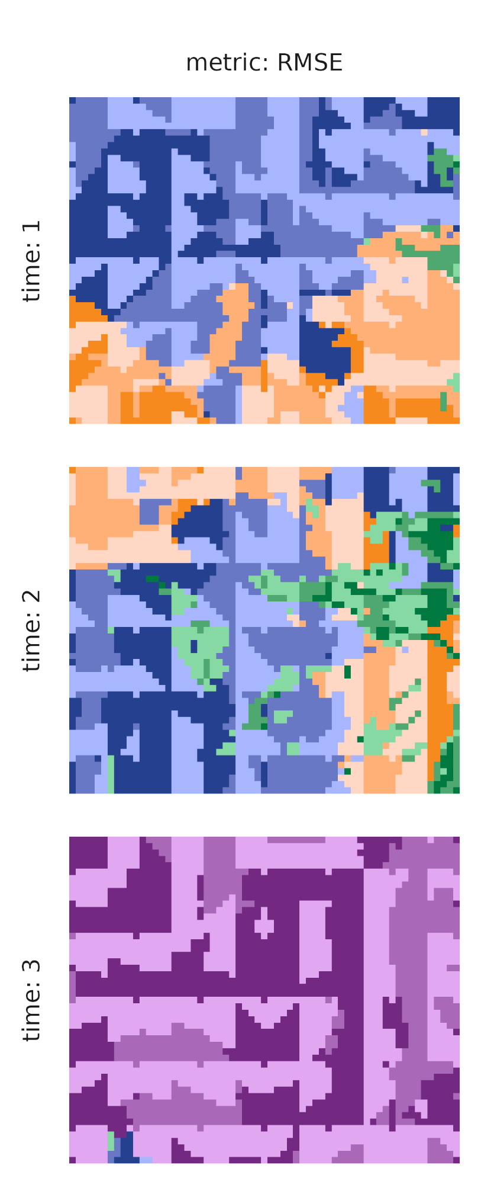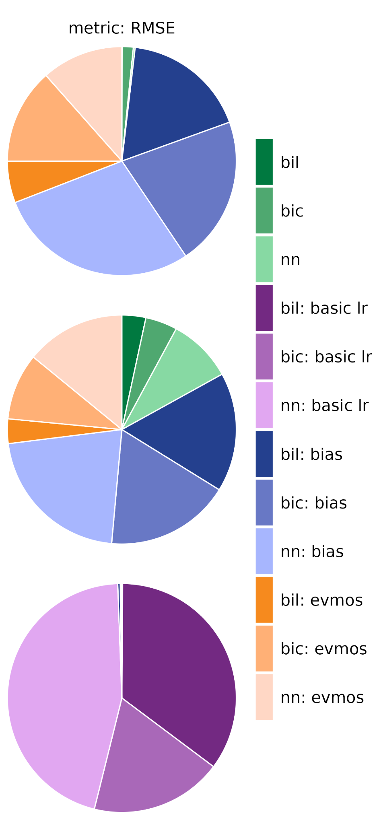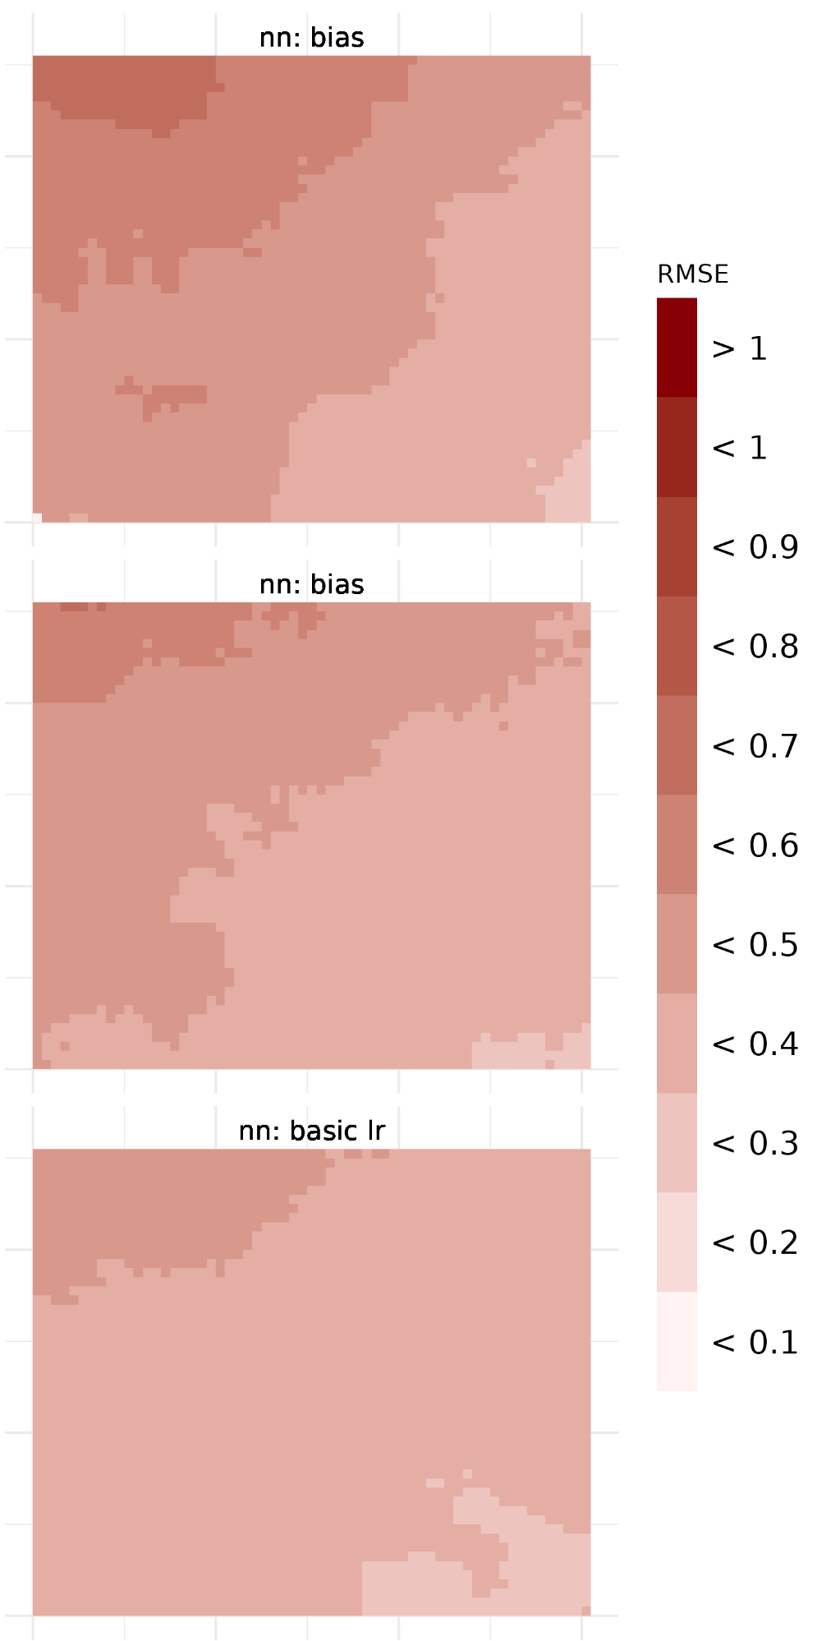
Figure 18: as in Figure 3, but across the Peruvian hotspot region.

Regarding the skill assessment of RMSE, a nearest-neighbour interpolation will generally produce the downscaled hindcast with the lowest RMSE (Figure 18). At lead times one and two (January and February), a simple bias adjustment performs best, while at lead time three (March) linear regressions tend to be more accurate. We also note that in the Peruvian region, RMSE tends to be lower in the south-east of the region, but increases towards the north-west.

4.3.2 Precipitation
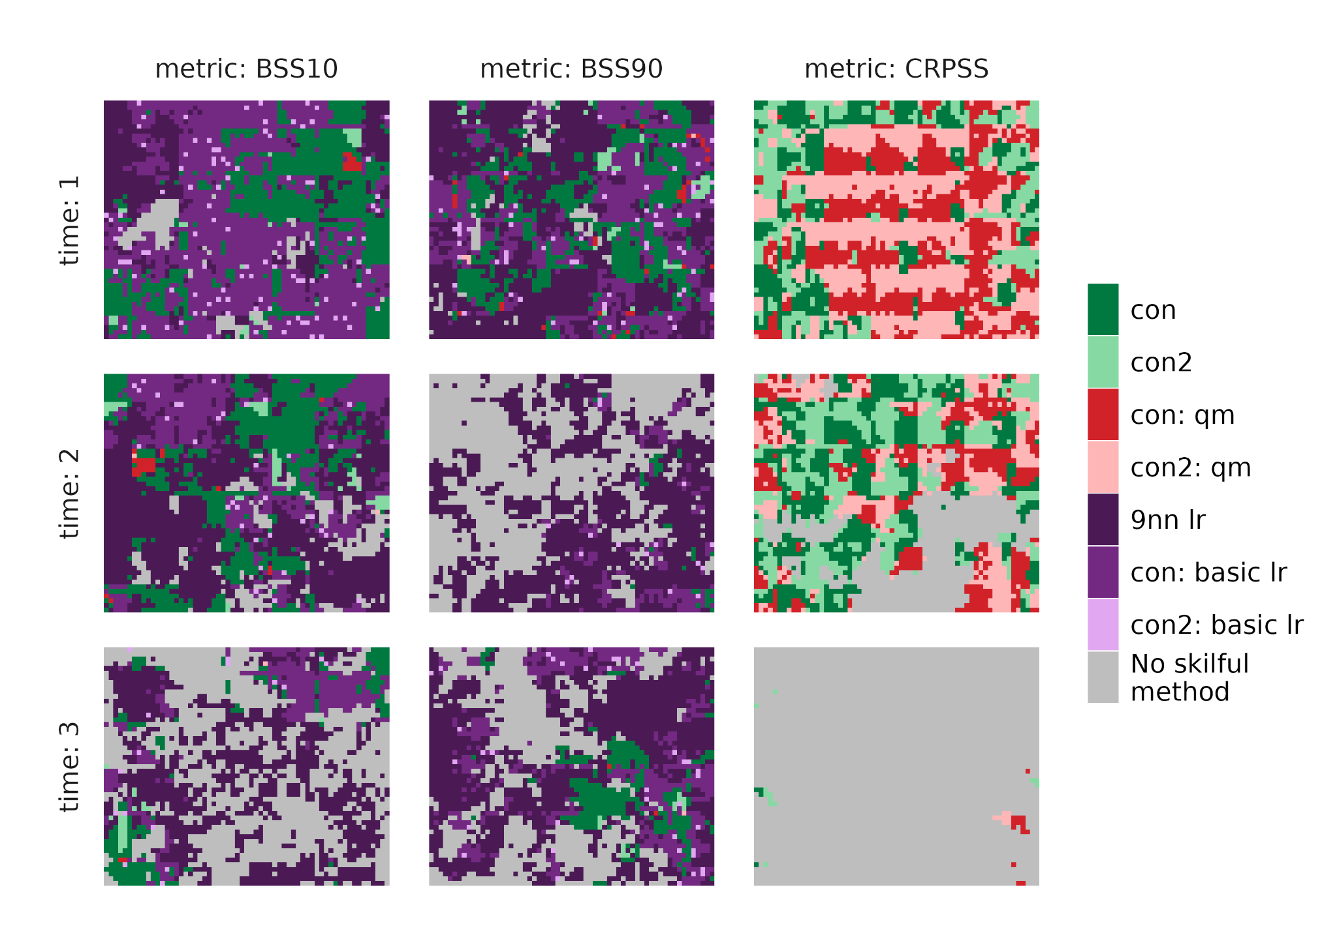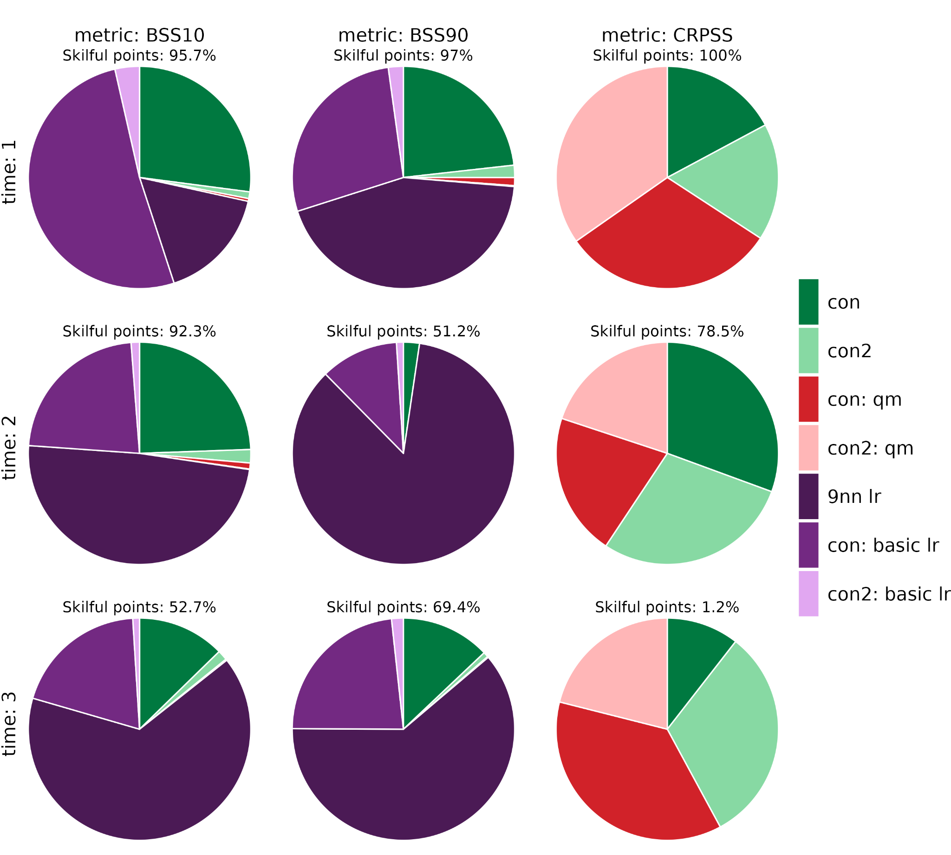
Figure 19: as in Figure 1, but with precipitation as the variable to downscale across the Peruvian hotspot region.

Considering the seasonal prediction forecast across the Peruvian hotspot regions, we see that the 9 nearest neighbour linear regression generally produces the most skilful model for predicting extremes (Figure 19), except at lead time one for BSS10. There is additional skill in predicting extremes using a linear regression model compared to the reference at all lead times, although the amount of skilful grid cells reduces as lead time increases. Quantile mapping techniques and conservative regriddings without any calibration produce the most skilful models for predicting the entire distribution, although at lead time three, there are very few skilful grid cells (Figure 19, 20).

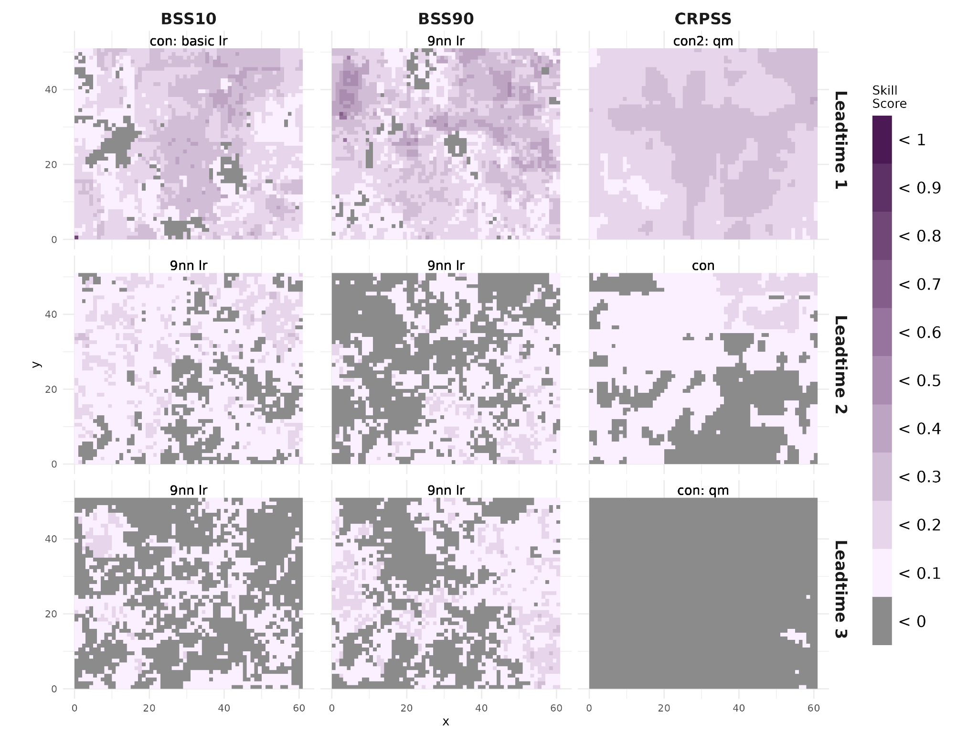
Figure 20: as in Figure 2, but with precipitation as the variable to downscale across the Peruvian hotspot region.
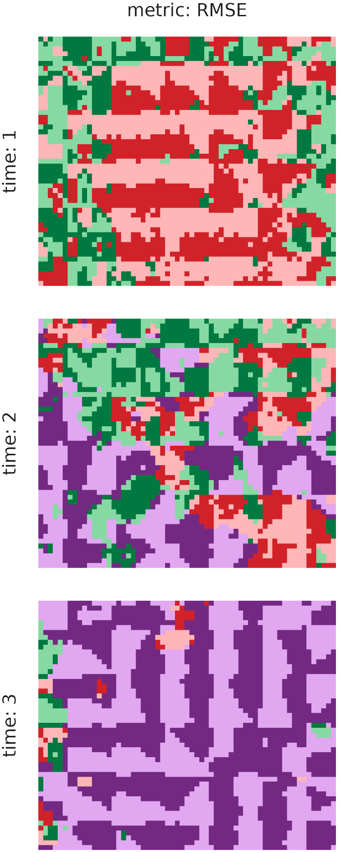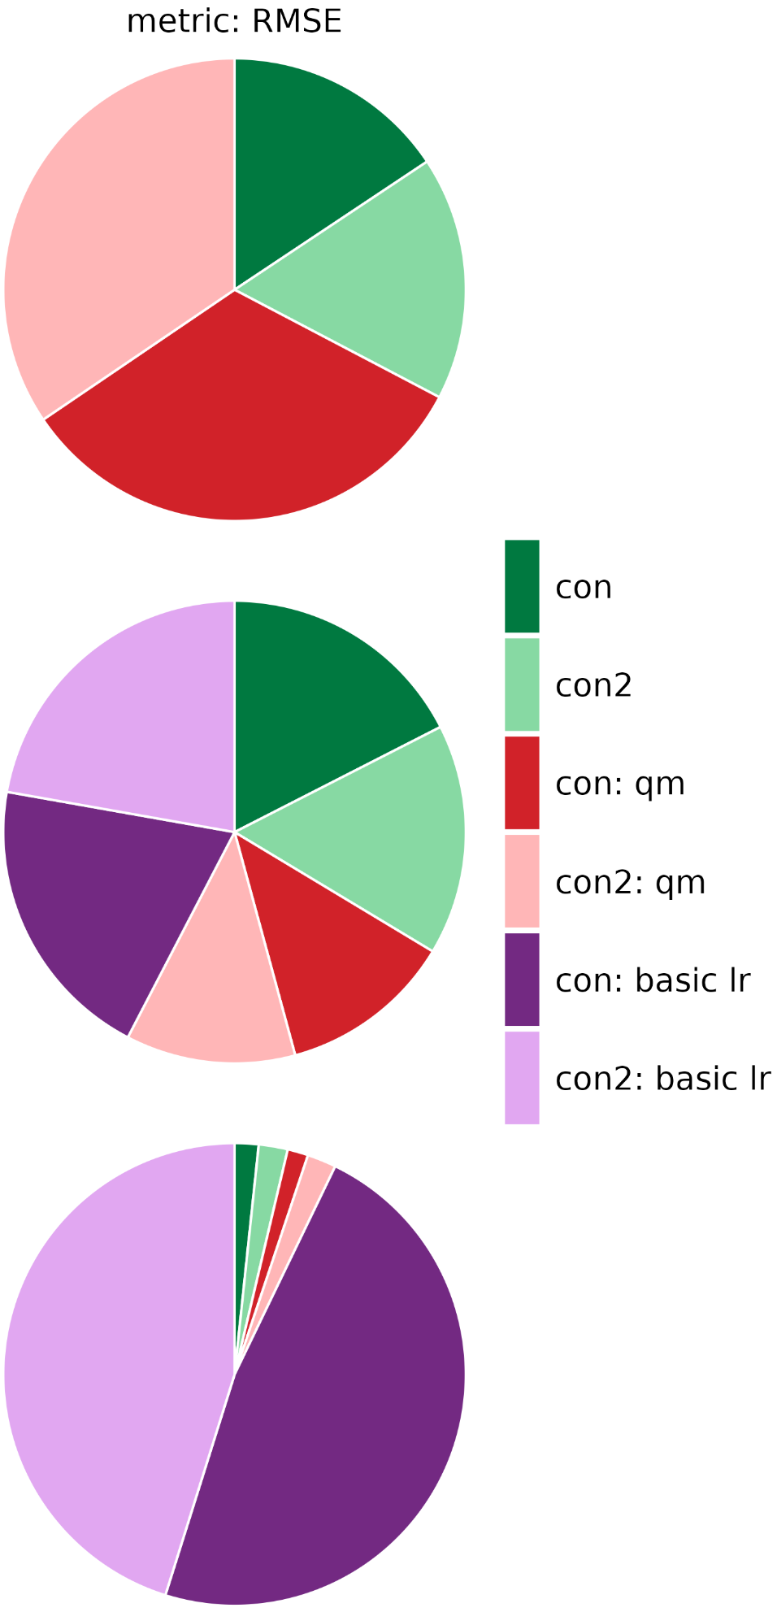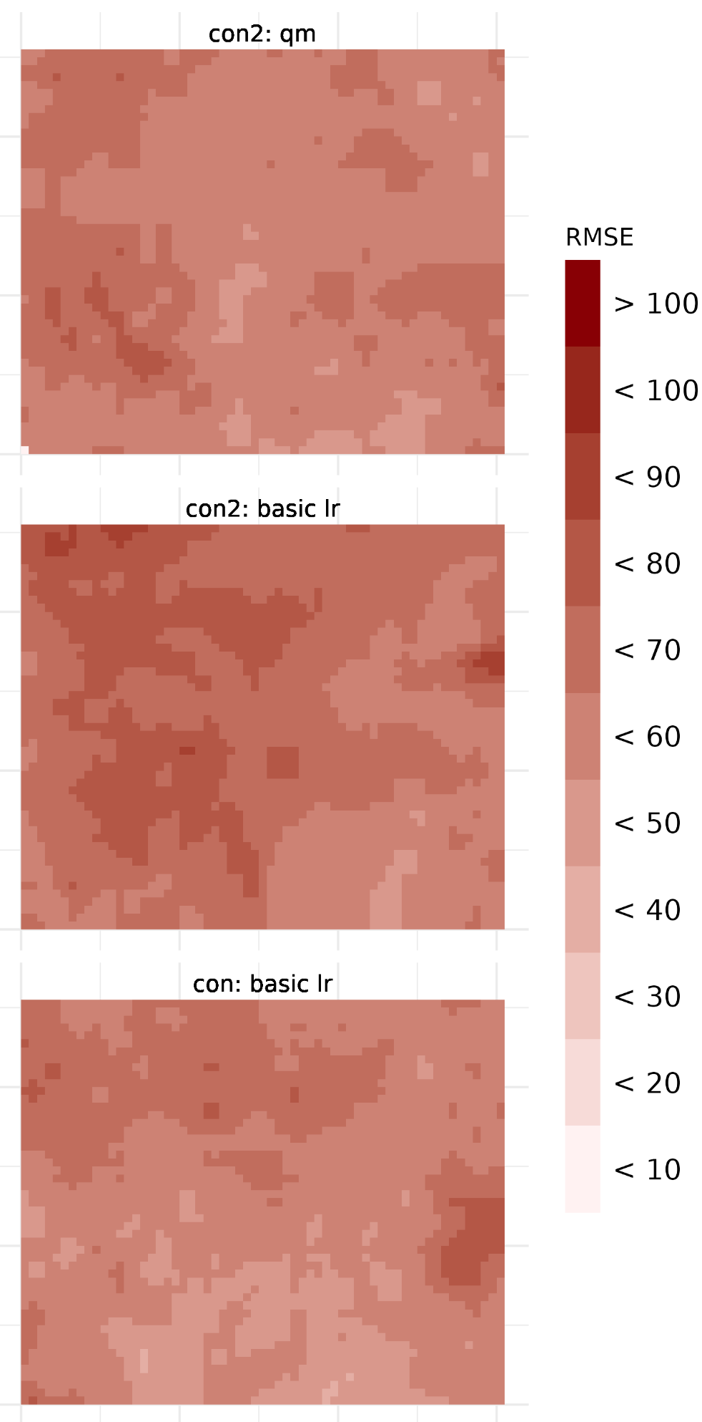
Figure 21: as in Figure 3, but with precipitation as the variable to downscale across the Peruvian hotspot region.

Over the Peruvian hotspot region, depending on the lead time, RMSE is minimised by different methods. At the first lead time (January), a conservative regridding plus quantile mapping minimises the RMSE, whilst at lead time two (February), all methods minimise the RMSE for a reasonable percentage of grid cells. Finally, at lead time three (March), a conservative remapping plus basic linear regression performs the best across the majority of the region (Figure 21). Note that whilst the 9 nearest neighbour linear regression method is the most skilful in terms of BSS10 and BSS90 in this region, it does not perform as well as other methods in either CRPSS or RMSE.

In the region over the Peruvian hotspot, given seasonal forecasts initialised in January, the 9 nearest neighbour linear regression is able to most skilfully predict hot temperature extremes at all lead times, although again EVMOS bias adjustments perform best when considering the whole distribution. For precipitation, either a 9 nearest neighbour linear regression or conservative remapping plus basic linear regression produces the most skilful model at predicting extremes. To skilfully predict the entire distribution, quantile mapping performs best, although at lead time three fewer than 2% of grid cells provide additional skill compared to climatology.

Dominican Republic
Finally, we assess the performance of downscaling methods applied to temperature and precipitation forecasts across the Dominican Republic, using ERA5-Land data as the reference.

4.4.1 Temperature
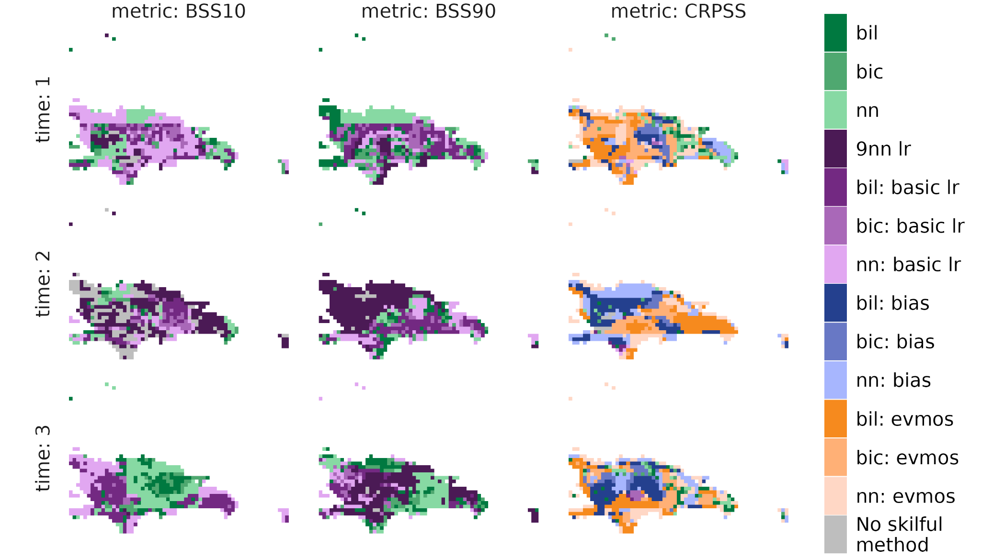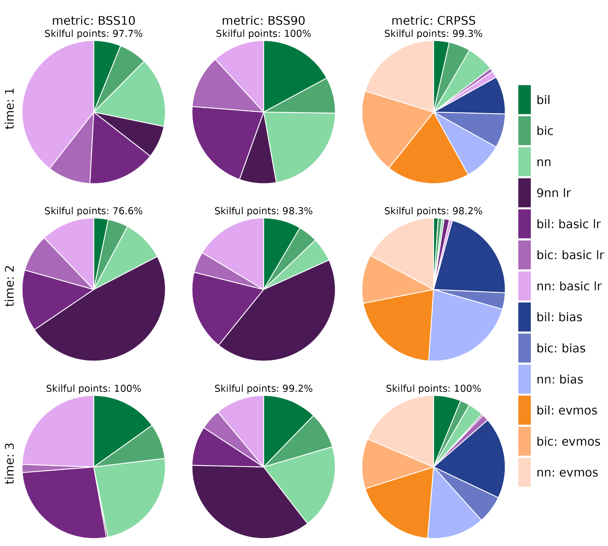
Figure 22: as in Figure 1, but across the Dominican Republic.

In the Dominican Republic, hot and cold extremes are most skilfully predicted by models downscaled either with a simple interpolation or by interpolation plus linear regression (Figure 22). The CRPSS is maximised by interpolation plus an EVMOS bias adjustment.

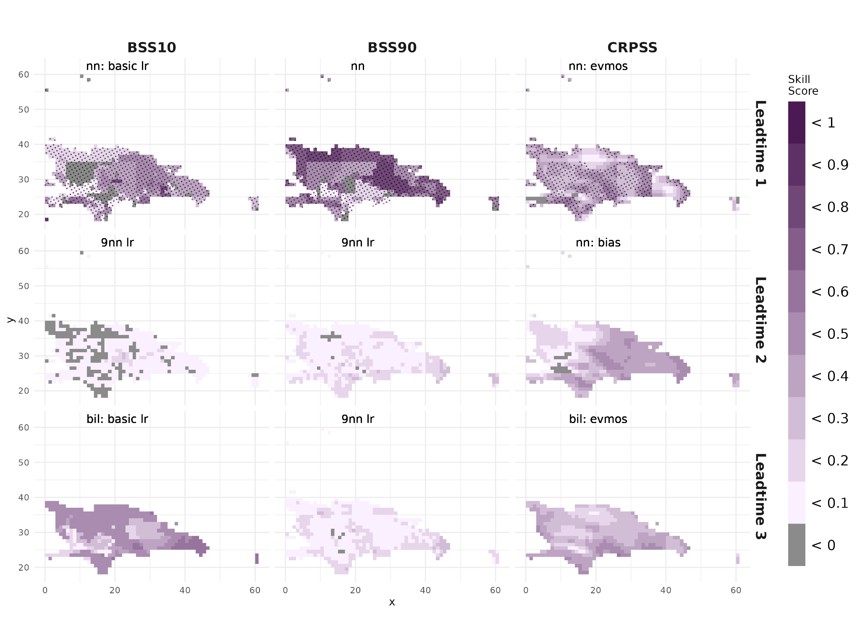
Figure 23: as in Figure 2, but across the Dominican Republic.

The skill scores are only significant at lead time one for the seasonal forecasts initialised in January (Figure 23). However, in general, the downscaled seasonal forecasts provide additional skill compared to the climatology, particularly when considering CRPSS as the forecast verification metric.
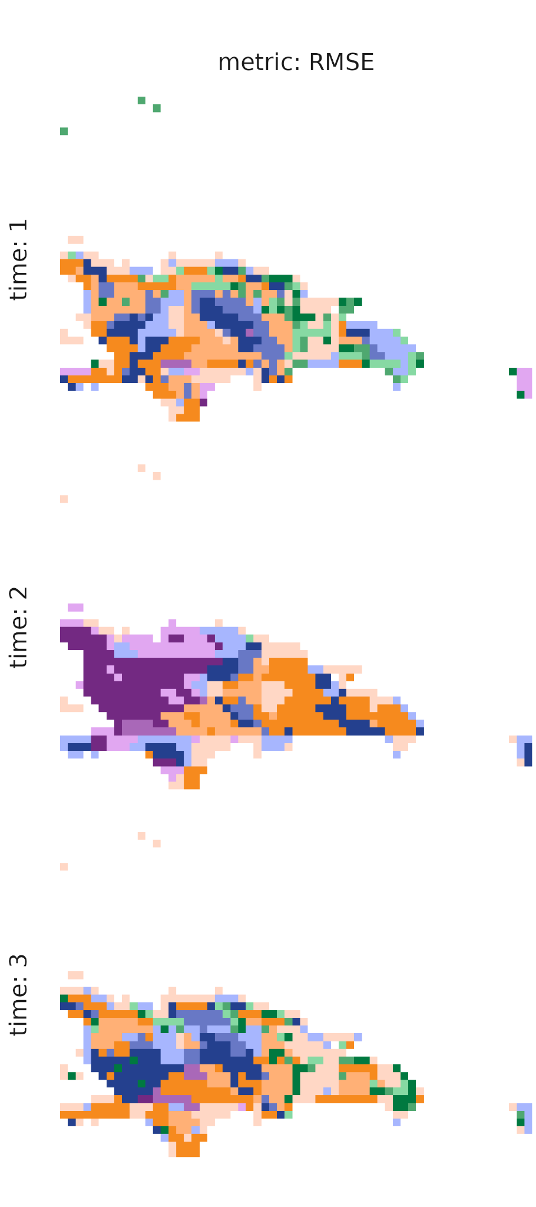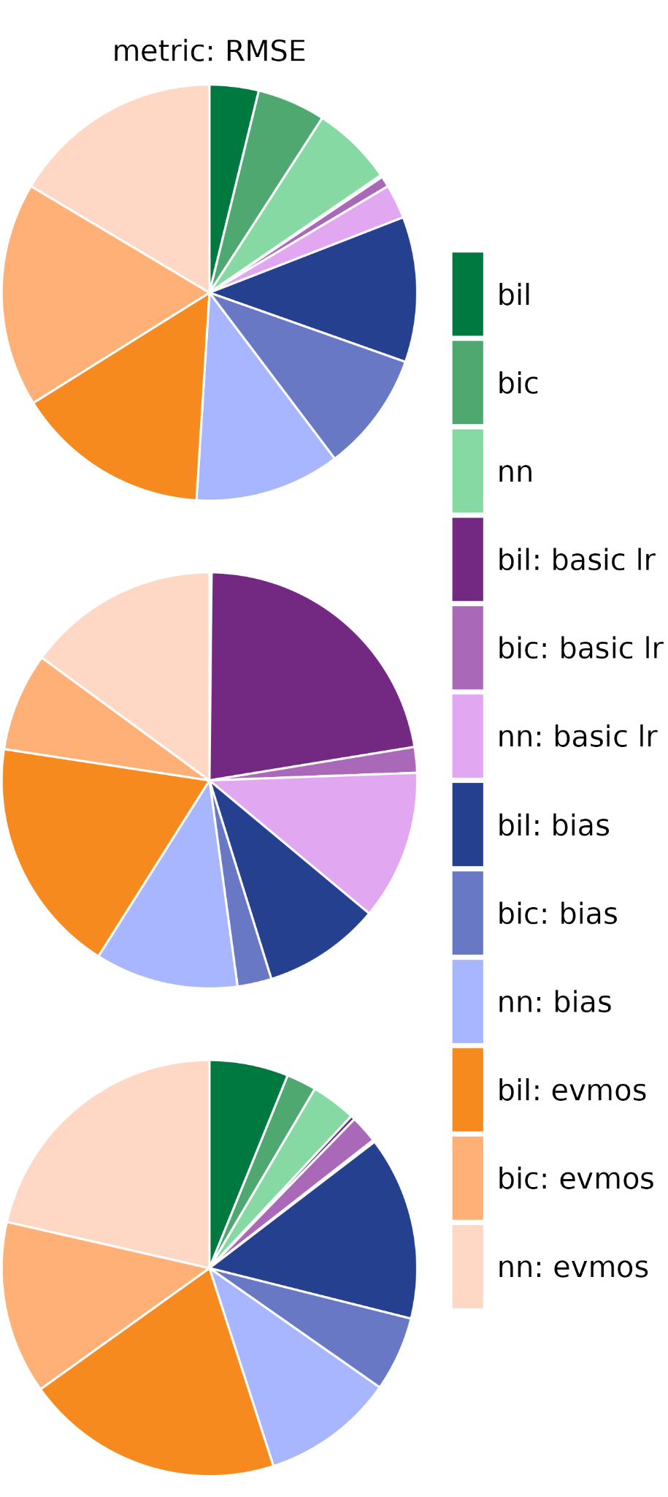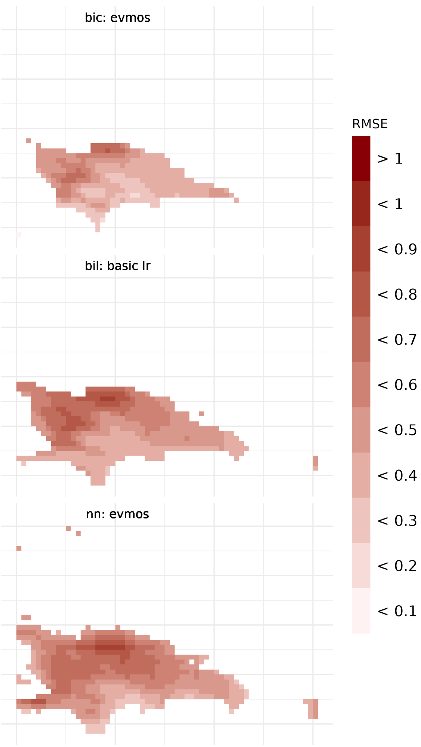
Figure 24: as in Figure 3, but across the Dominican Republic.

Finally, we consider the RMSE of the seasonal forecasts over the Dominican Republic. Overall the RMSE is relatively low, and is minimised by interpolation plus EVMOS bias adjustment methods (Figure 24).

4.4.2 Precipitation
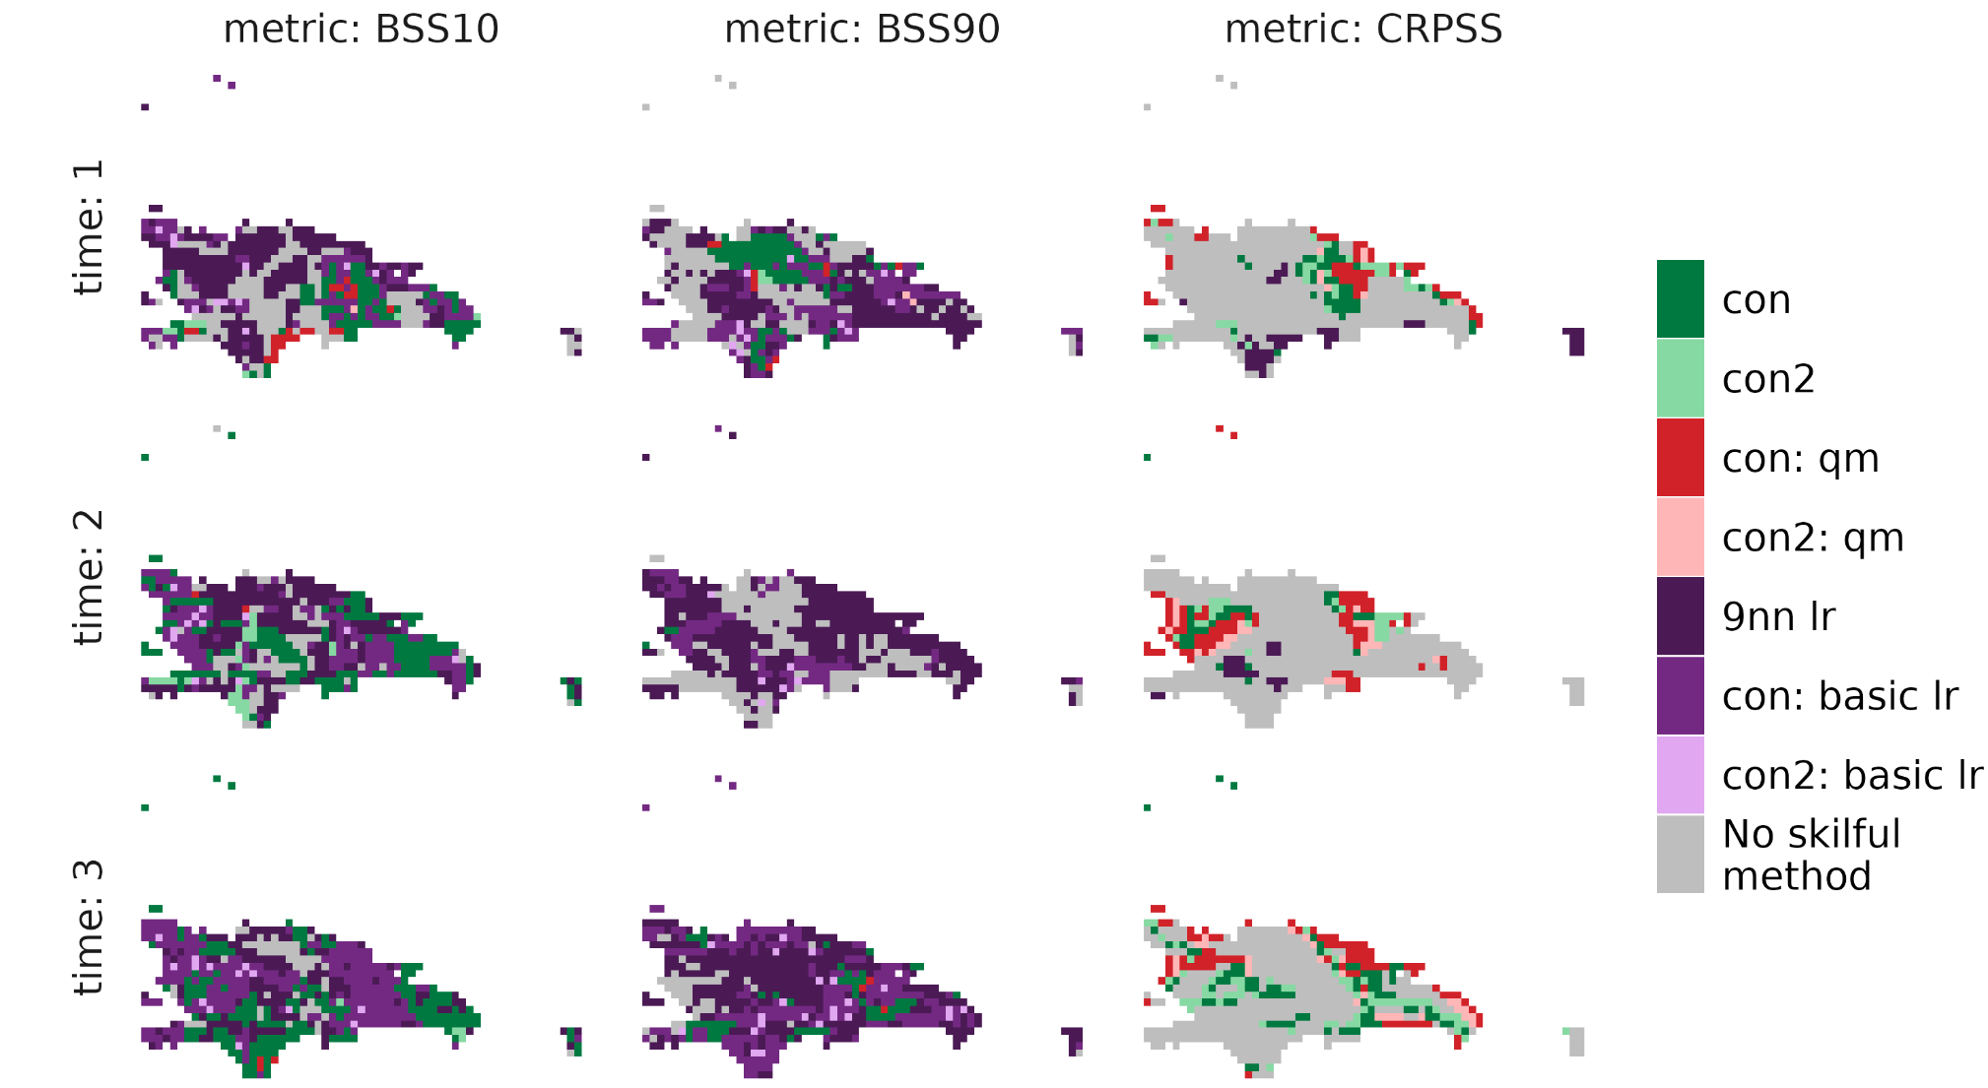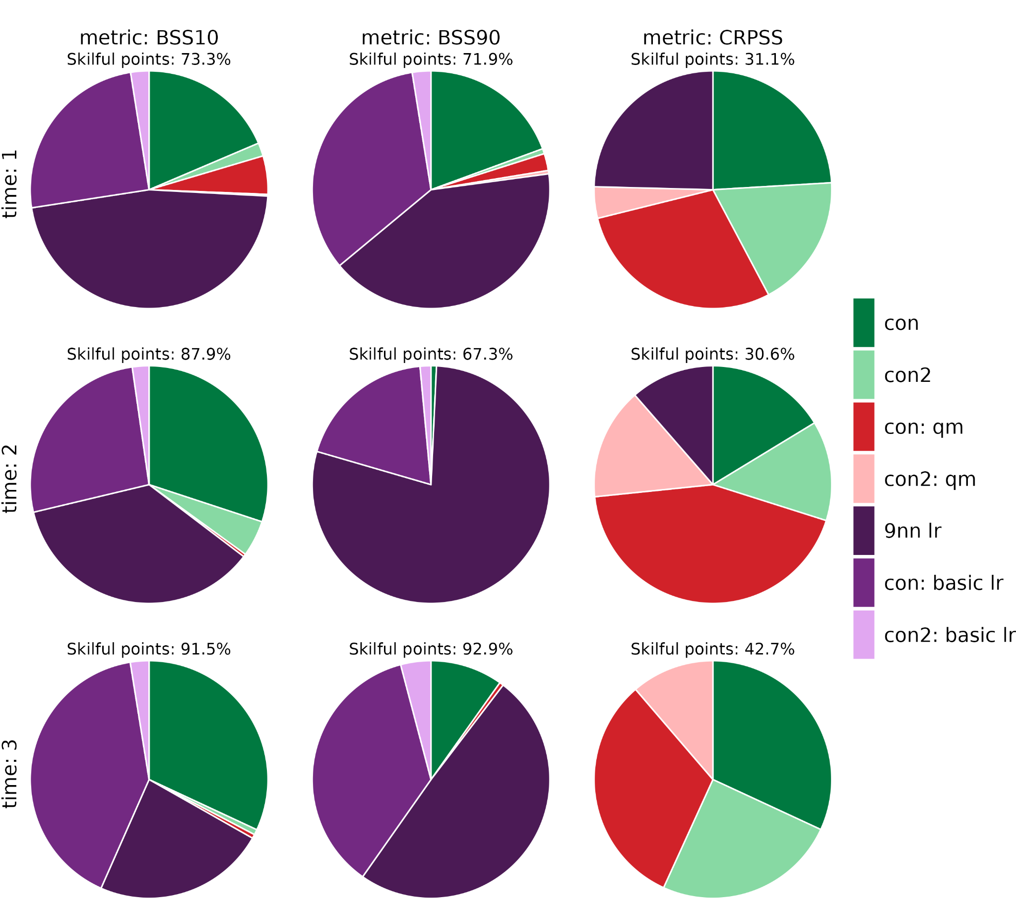
Figure 25: as in Figure 1, but with precipitation as the variable to downscale across the Dominican Republic.

In the Dominican Republic, the most skilful models at predicting precipitation extremes involve linear regressions (Figure 25). In particular, if interested in predicting wet extremes (BSS90), it is recommended to use the 9 nearest neighbour linear regression, which produces the most skilful grid cells in terms of BSS90 at all lead times.

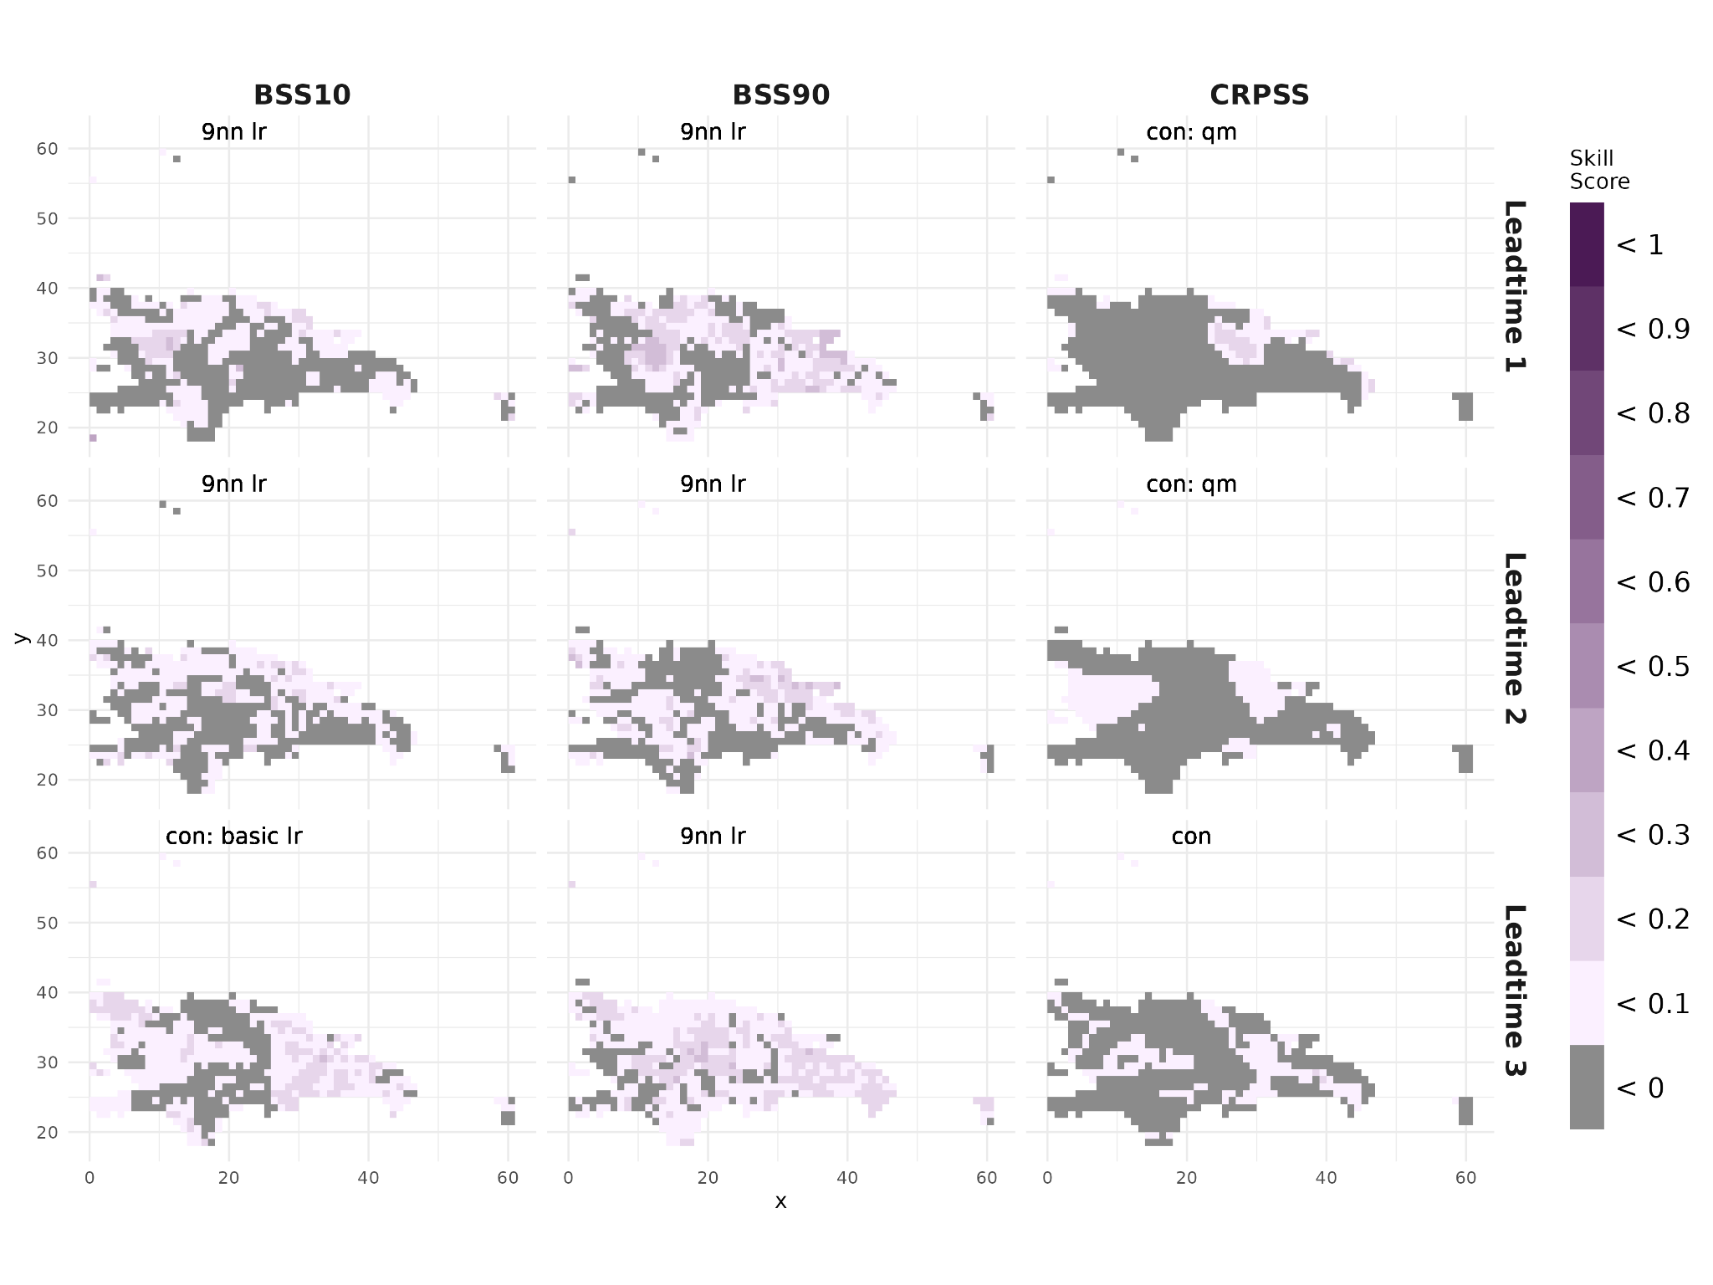
Figure 26: as in Figure 2, but with precipitation as the variable to downscale across the Dominican Republic.

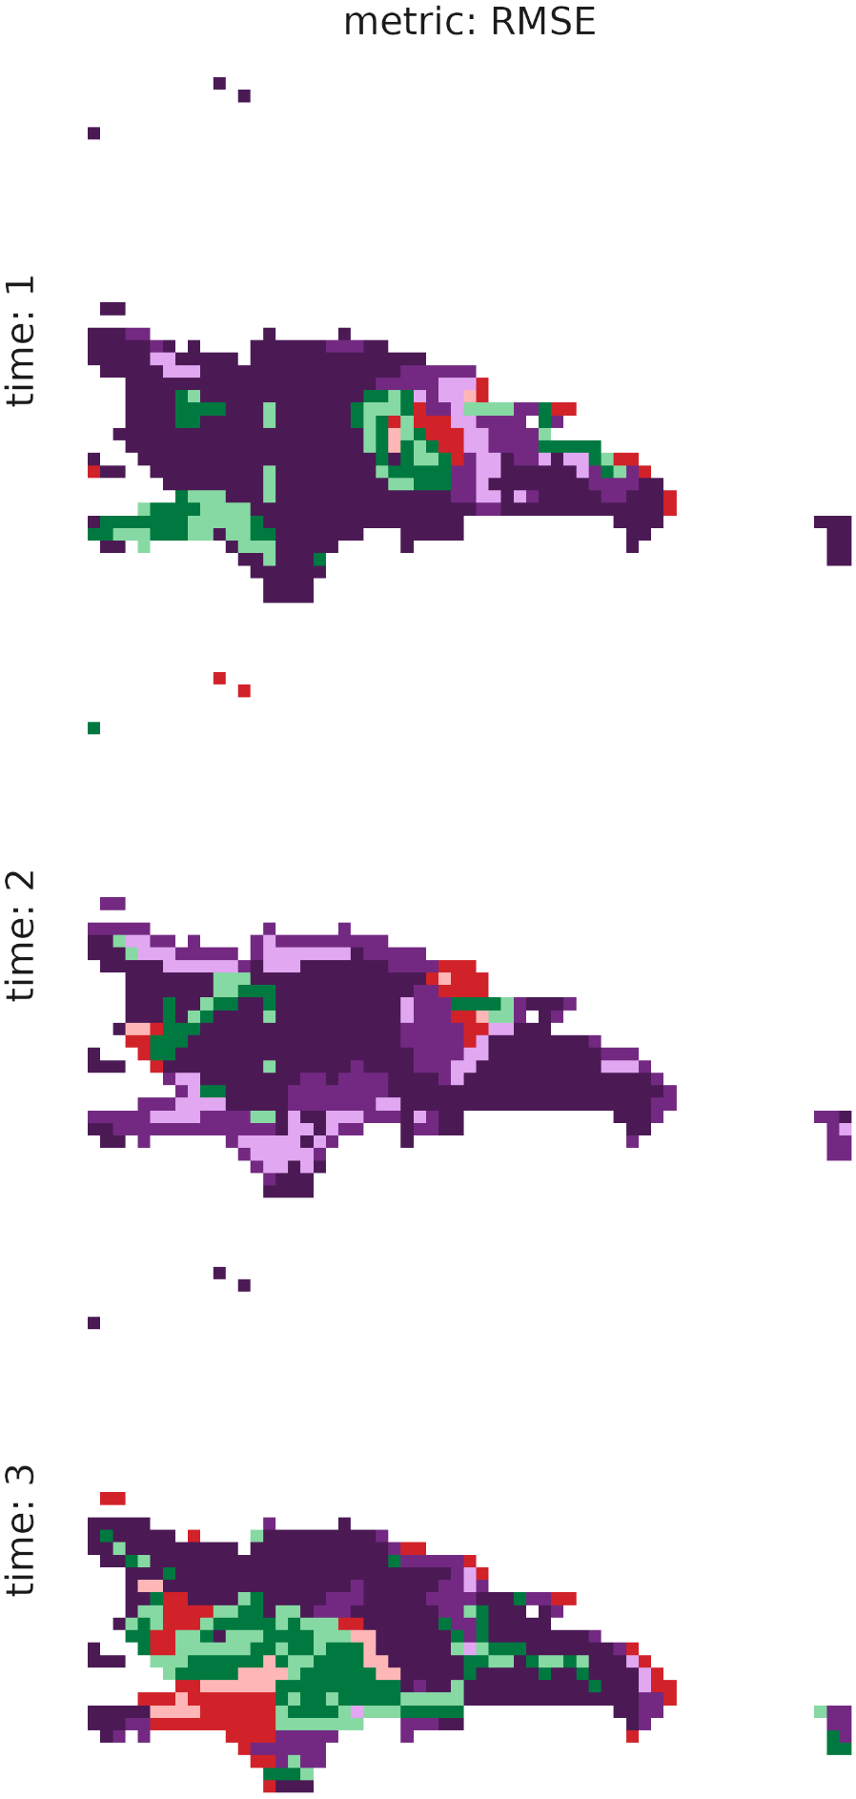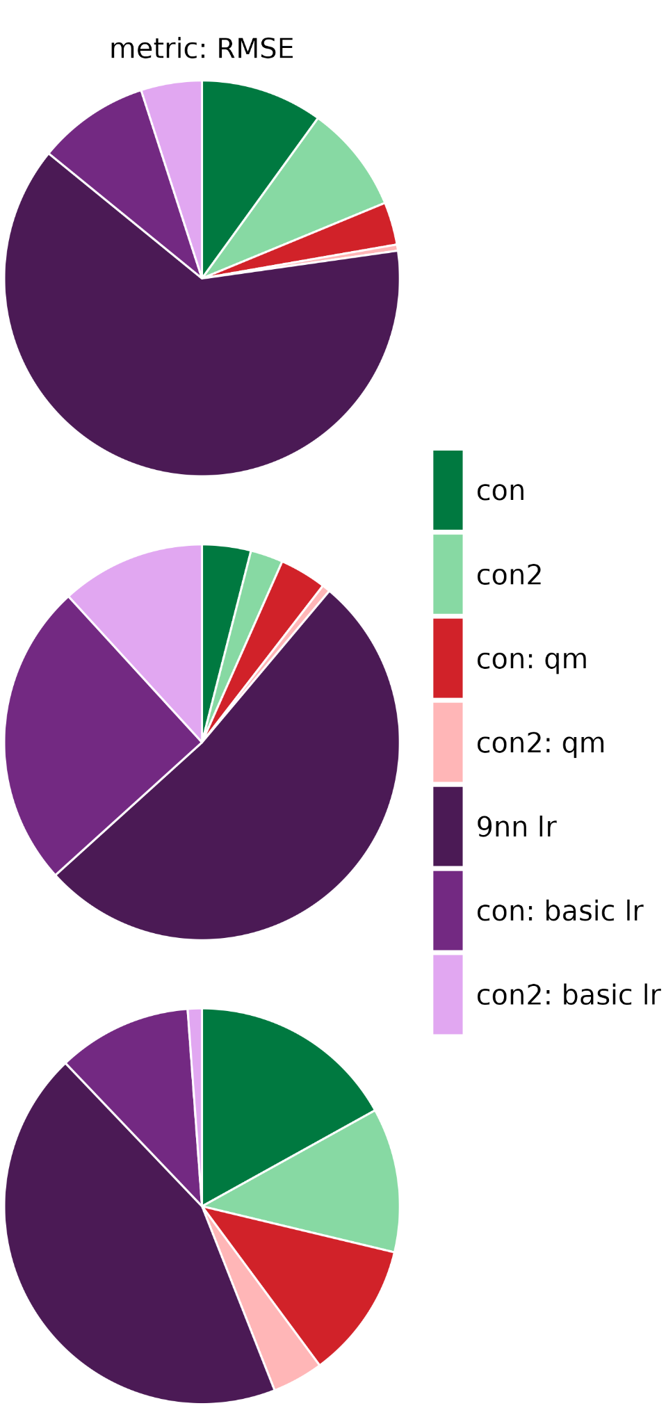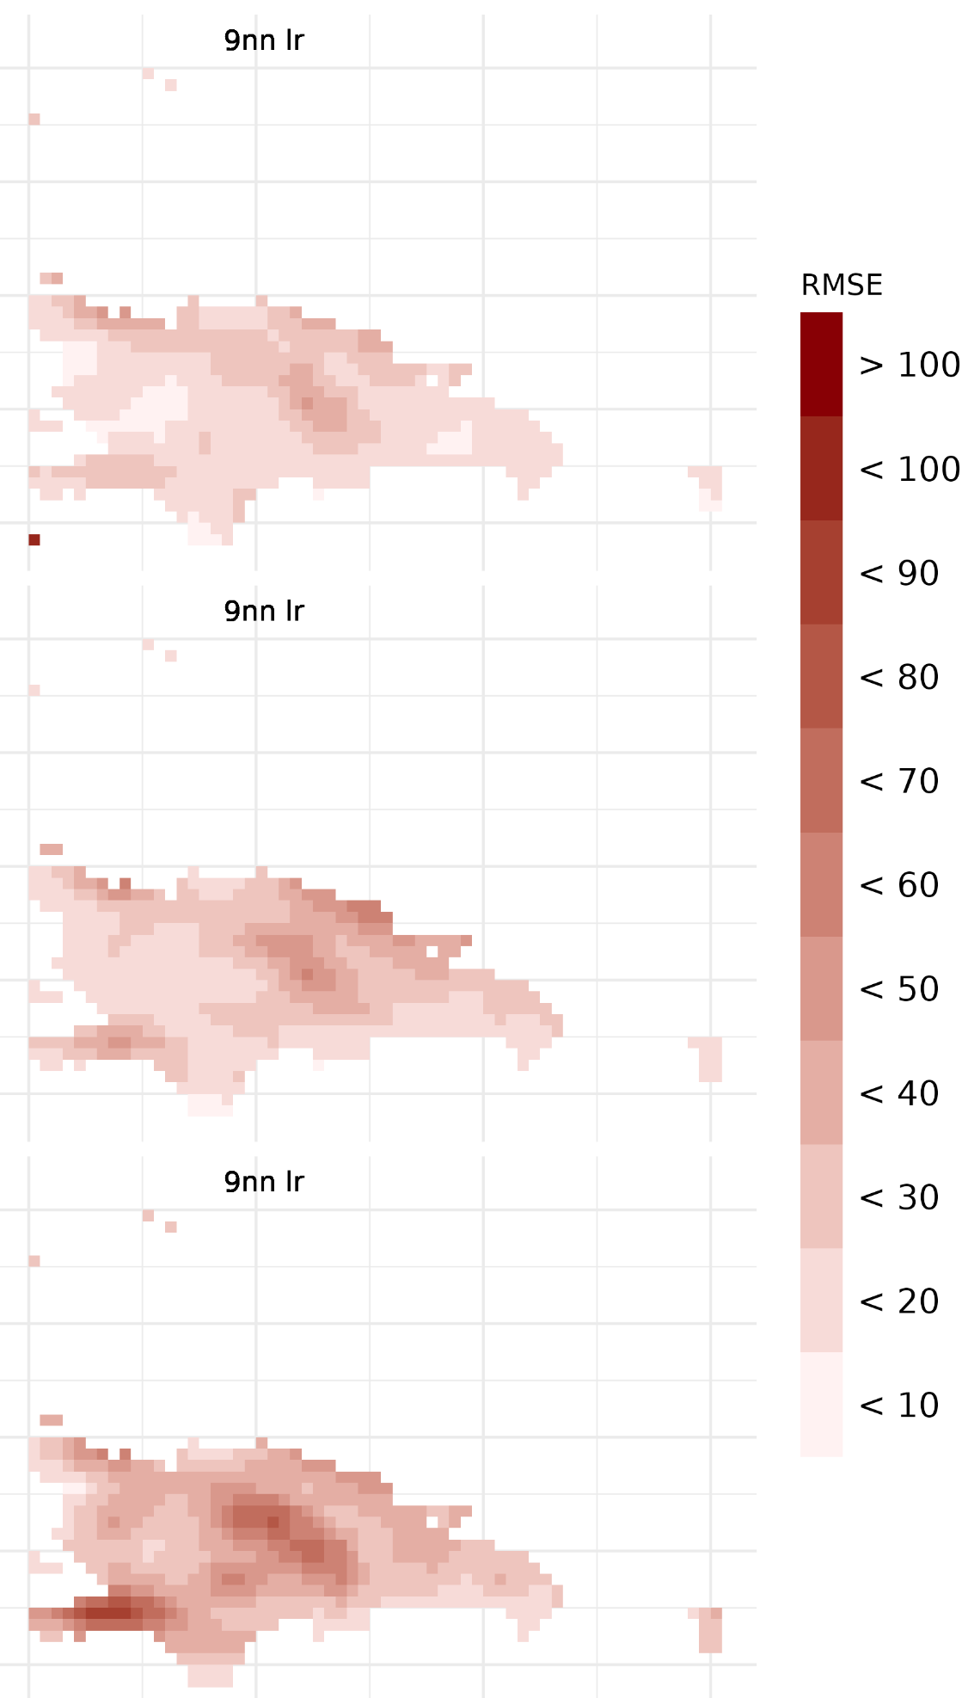
Figure 27: as in Figure 3, but with precipitation as the variable to downscale across the Dominican Republic.

Additionally, the 9 nearest neighbour linear regression minimises RMSE across the Dominican Republic at all lead times (Figure 27). The RMSE at each lead time is relatively small compared to the other hotspot locations.

Overall, for the Dominican Republic, given seasonal predictions initialised in January, a linear regression is also recommended for predicting temperature extremes but again the EVMOS bias adjustments produce the most skilful predictions in terms of the whole temperature distribution. For precipitation, the 9 nearest neighbour linear regression convincingly minimises the RMSE and maximises BSS10 and BSS90 at all lead times.

Report Summary
Analysis of downscaling seasonal forecast data using a reanalysis dataset as the reference in locations across the HARMONIZE project hotspot sites has shown different model skill in the different locations. The clim4health package, which has been developed as part of the HARMONIZE project, has been used in this report to demonstrate the methodology of statistical downscaling and forecast verification in the context of the HARMONIZE project hotspot locations, to show how a skill assessment might be performed. Note that these skill assessments have been performed only for seasonal forecasts initialised in January for the months of January, February and March - if seasonal forecast data is required for other time periods, a separate skill assessment should be performed to assess the most skilful postprocessing technique for the given region. For each region and for each lead time, it remains important to analyse the skill of the different statistical downscaling methods, considering also the different skill scores and verification metrics that are most important for the prediction that the user needs.

References
Accadia, Christophe, Stefano Mariani, Marco Casaioli, Alfredo Lavagnini, and Antonio Speranza. ‘Sensitivity of Precipitation Forecast Skill Scores to Bilinear Interpolation and a Simple Nearest-Neighbor Average Method on High-Resolution Verification Grids’. Weather and Forecasting. Weather and Forecasting 18, no. 5 (2003): 918–32. https://doi.org/10.1175/1520-0434(2003)018%253C0918:SOPFSS%253E2.0.CO;2.
BSC-CNS, An-Chi Ho, Nuria Perez-Zanon, et al. S2dv: Seasonal to Decadal Verification. V. 2.2.1. Released 3 November 2025. https://cran.r-project.org/web/packages/s2dv/.
‘ERA5-Land Hourly Data from 1950 to Present’. Accessed 3 December 2025. https://cds.climate.copernicus.eu/datasets/reanalysis-era5-land?tab=overview.
Frank, Alvaro, Diego Fabregat-Traver, and Paolo Bientinesi. ‘Large-Scale Linear Regression: Development of High-Performance Routines’. Applied Mathematics and Computation 275 (2016): 411–21. https://doi.org/10.1016/j.amc.2015.11.078.
Hamill, Thomas M., and Josip Juras. ‘Measuring Forecast Skill: Is It Real Skill or Is It the Varying Climatology?’ Quarterly Journal of the Royal Meteorological Society 132, no. 621C (2006): 2905–23. https://doi.org/10.1256/qj.06.25.
Jones, Philip W. ‘First- and Second-Order Conservative Remapping Schemes for Grids in Spherical Coordinates’. Monthly Weather Review. Monthly Weather Review 127, no. 9 (1999): 2204–10. https://doi.org/10.1175/1520-0493(1999)127%253C2204:FASOCR%253E2.0.CO;2.
Li, Xiaomeng, Huan Wu, Nergui Nanding, Sirong Chen, Ying Hu, and Lingfeng Li. ‘Statistical Bias Correction of Precipitation Forecasts Based on Quantile Mapping on the Sub-Seasonal to Seasonal Scale’. Remote Sensing 15, no. 7 (2023): 1743. https://doi.org/10.3390/rs15071743.
Lorenz, Edward N. ‘Atmospheric Predictability as Revealed by Naturally Occurring Analogues’. Journal of the Atmospheric Sciences. Journal of the Atmospheric Sciences 26, no. 4 (1969): 636–46. https://doi.org/10.1175/1520-0469(1969)26%253C636:APARBN%253E2.0.CO;2.
Rajulapati, Chandra Rupa, Simon Michael Papalexiou, Martyn P. Clark, and John W. Pomeroy. ‘The Perils of Regridding: Examples Using a Global Precipitation Dataset’. Journal of Applied Meteorology and Climatology. Journal of Applied Meteorology and Climatology 60, no. 11 (2021): 1561–73. https://doi.org/10.1175/JAMC-D-20-0259.1.
‘Seasonal Forecast Monthly Statistics on Single Levels’. Accessed 3 December 2025. https://cds.climate.copernicus.eu/datasets/seasonal-monthly-single-levels?tab=overview.
Tatli, Hasan. ‘Downscaling Standardized Precipitation Index via Model Output Statistics’. Atmósfera 28, no. 2 (2015): 83–98. https://doi.org/10.1016/S0187-6236(15)30002-3.
Torralba, Verónica, Francisco J. Doblas-Reyes, Dave MacLeod, Isadora Christel, and Melanie Davis. ‘Seasonal Climate Prediction: A New Source of Information for the Management of Wind Energy Resources’. Journal of Applied Meteorology and Climatology. Journal of Applied Meteorology and Climatology 56, no. 5 (2017): 1231–47. https://doi.org/10.1175/JAMC-D-16-0204.1.
Valcke, Sophie, Andrea Piacentini, and Gabriel Jonville. ‘Benchmarking Regridding Libraries Used in Earth System Modelling’. Mathematical and Computational Applications 27, no. 2 (2022): 31. https://doi.org/10.3390/mca27020031.
Van Schaeybroeck, B., and S. Vannitsem. ‘Post-Processing through Linear Regression’. Nonlinear Processes in Geophysics 18, no. 2 (2011): 147–60. https://doi.org/10.5194/npg-18-147-2011.
Vannitsem, S. ‘A Unified Linear Model Output Statistics Scheme for Both Deterministic and Ensemble Forecasts’. Quarterly Journal of the Royal Meteorological Society 135, no. 644 (2009): 1801–15. https://doi.org/10.1002/qj.491.
Wilks, D.S. ‘Forecast Verification’. In International Geophysics, vol. 100. Academic Press, 2011 (a). https://doi.org/10.1016/B978-0-12-385022-5.00008-7.
Wilks, D.S. ‘Principal Component (EOF) Analysis’. In International Geophysics, vol. 100. Academic Press, 2011 (b). https://doi.org/10.1016/B978-0-12-385022-5.00012-9.
World Meteorological Organization. Guide to Meteorological Instruments and Methods of Observation. World Meteorological Organization, 2023.
Xiang, Ru, Hui Yang, Zhaojin Yan, Abdallah M. Mohamed Taha, Xiao Xu, and Teng Wu. ‘Super-Resolution Reconstruction of GOSAT CO2 Products Using Bicubic Interpolation’. Geocarto International 37, no. 27 (2022): 15187–211. https://doi.org/10.1080/10106049.2022.2096699.

Appendix
In this appendix, we briefly discuss the quality of weather station data in the HARMONIZE hotspot regions. For demonstration purposes, examples are given of potential biases or limited data quality, but a full quality control is not performed.

Tolima and Valle, Colombia
In the Tolima and Valle region of Colombia, we have sufficient years of station data for both temperature and precipitation to perform a robust statistical downscaling for both variables. The results for precipitation are presented below.

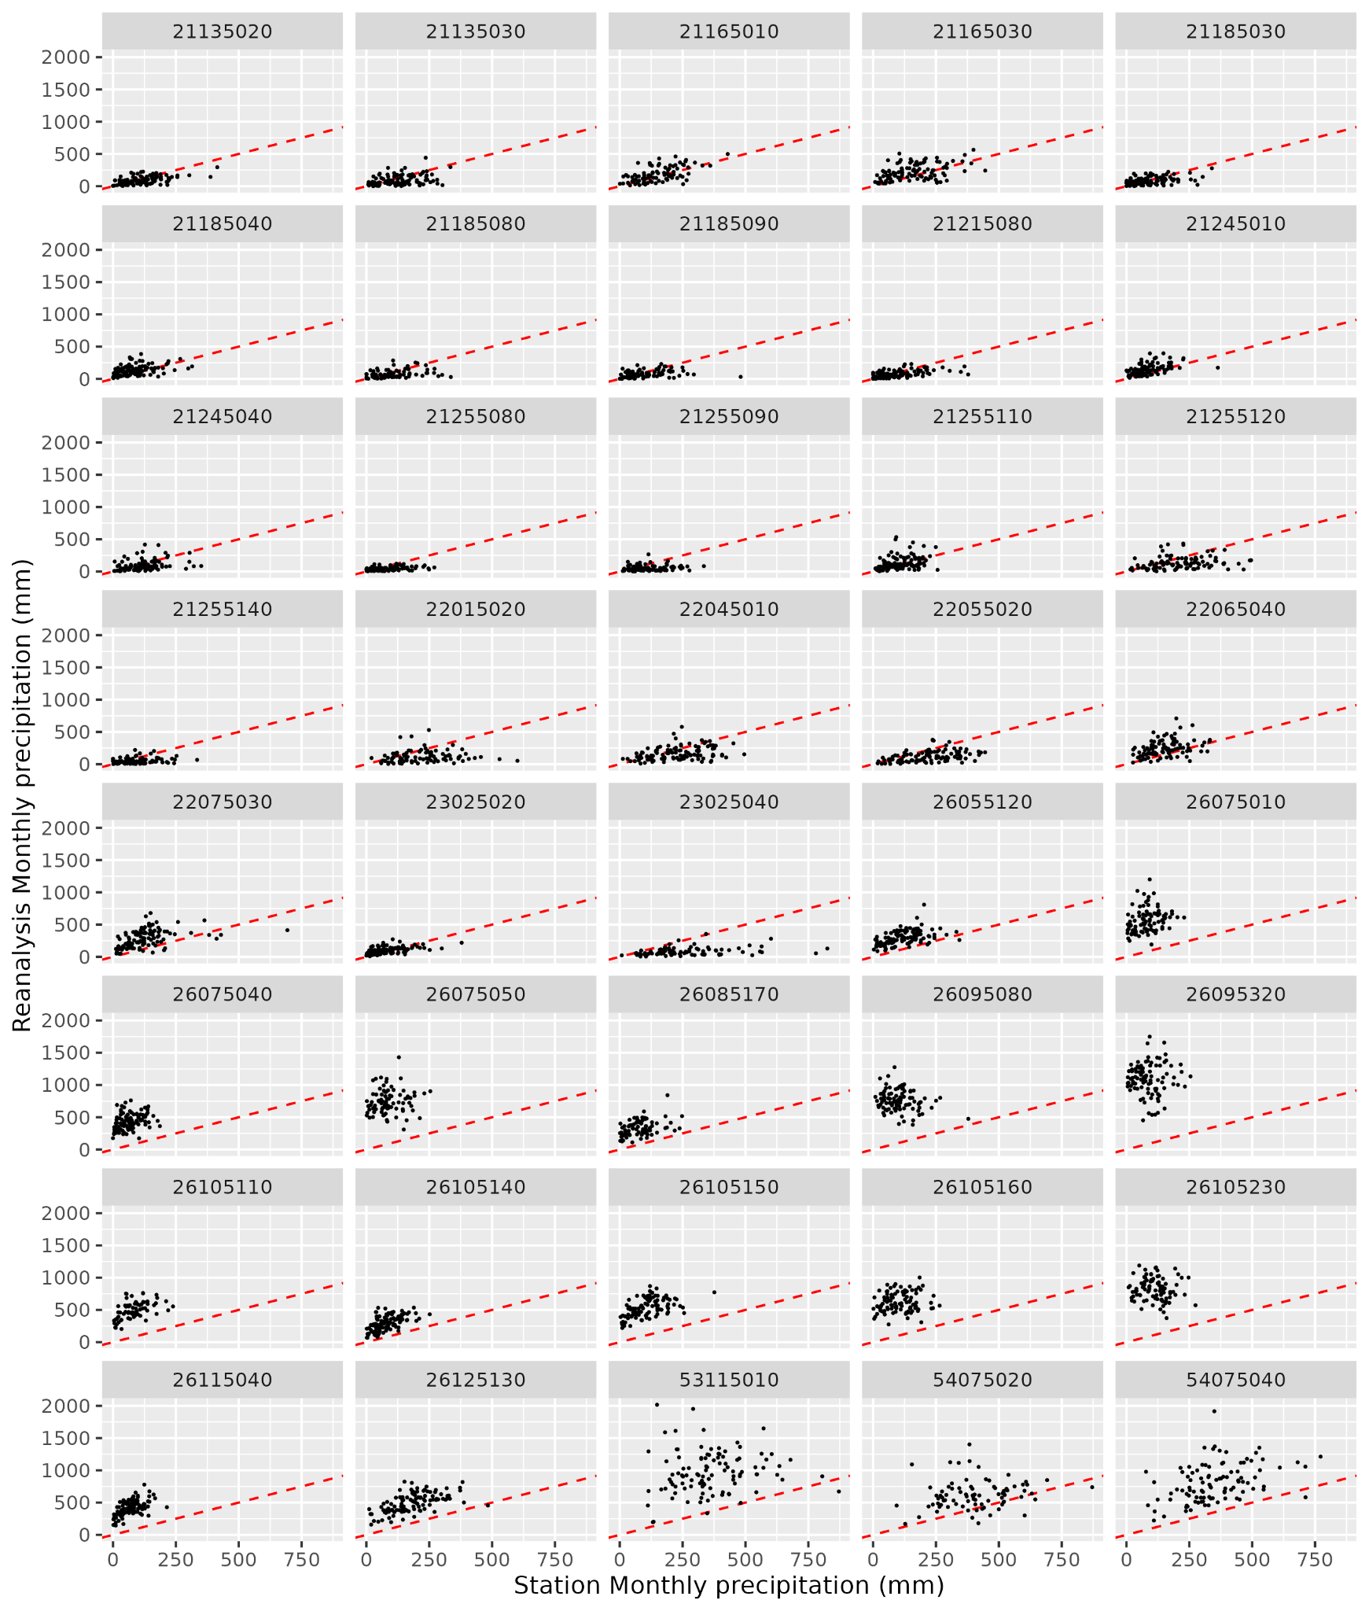
Figure 28: Precipitation recorded in the 40 selected stations in Tolima and Valle, compared with precipitation in the nearest gridcell in the reanalysis (ERA5-Land).

For precipitation, ERA5-Land overpredicts the total monthly precipitation in several stations (e.g. stations 26095320, 26105320, or 53115010).
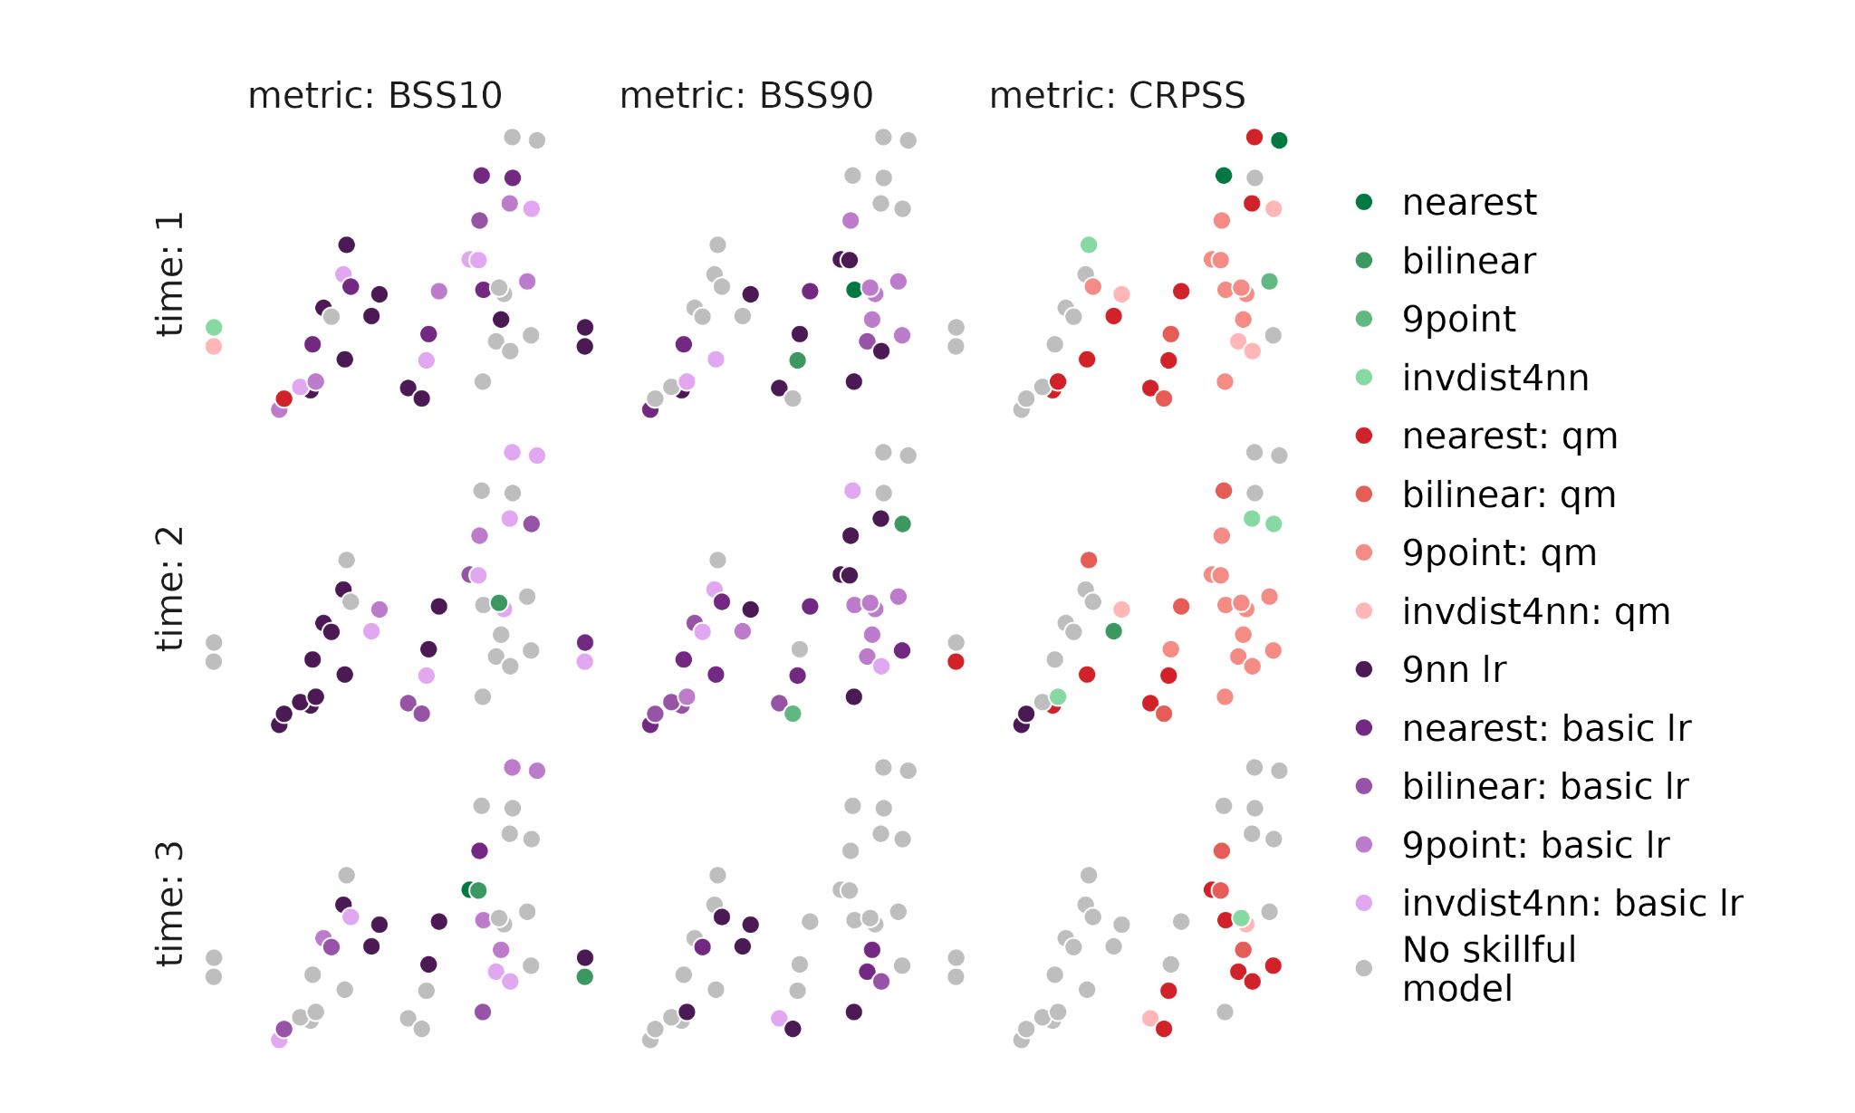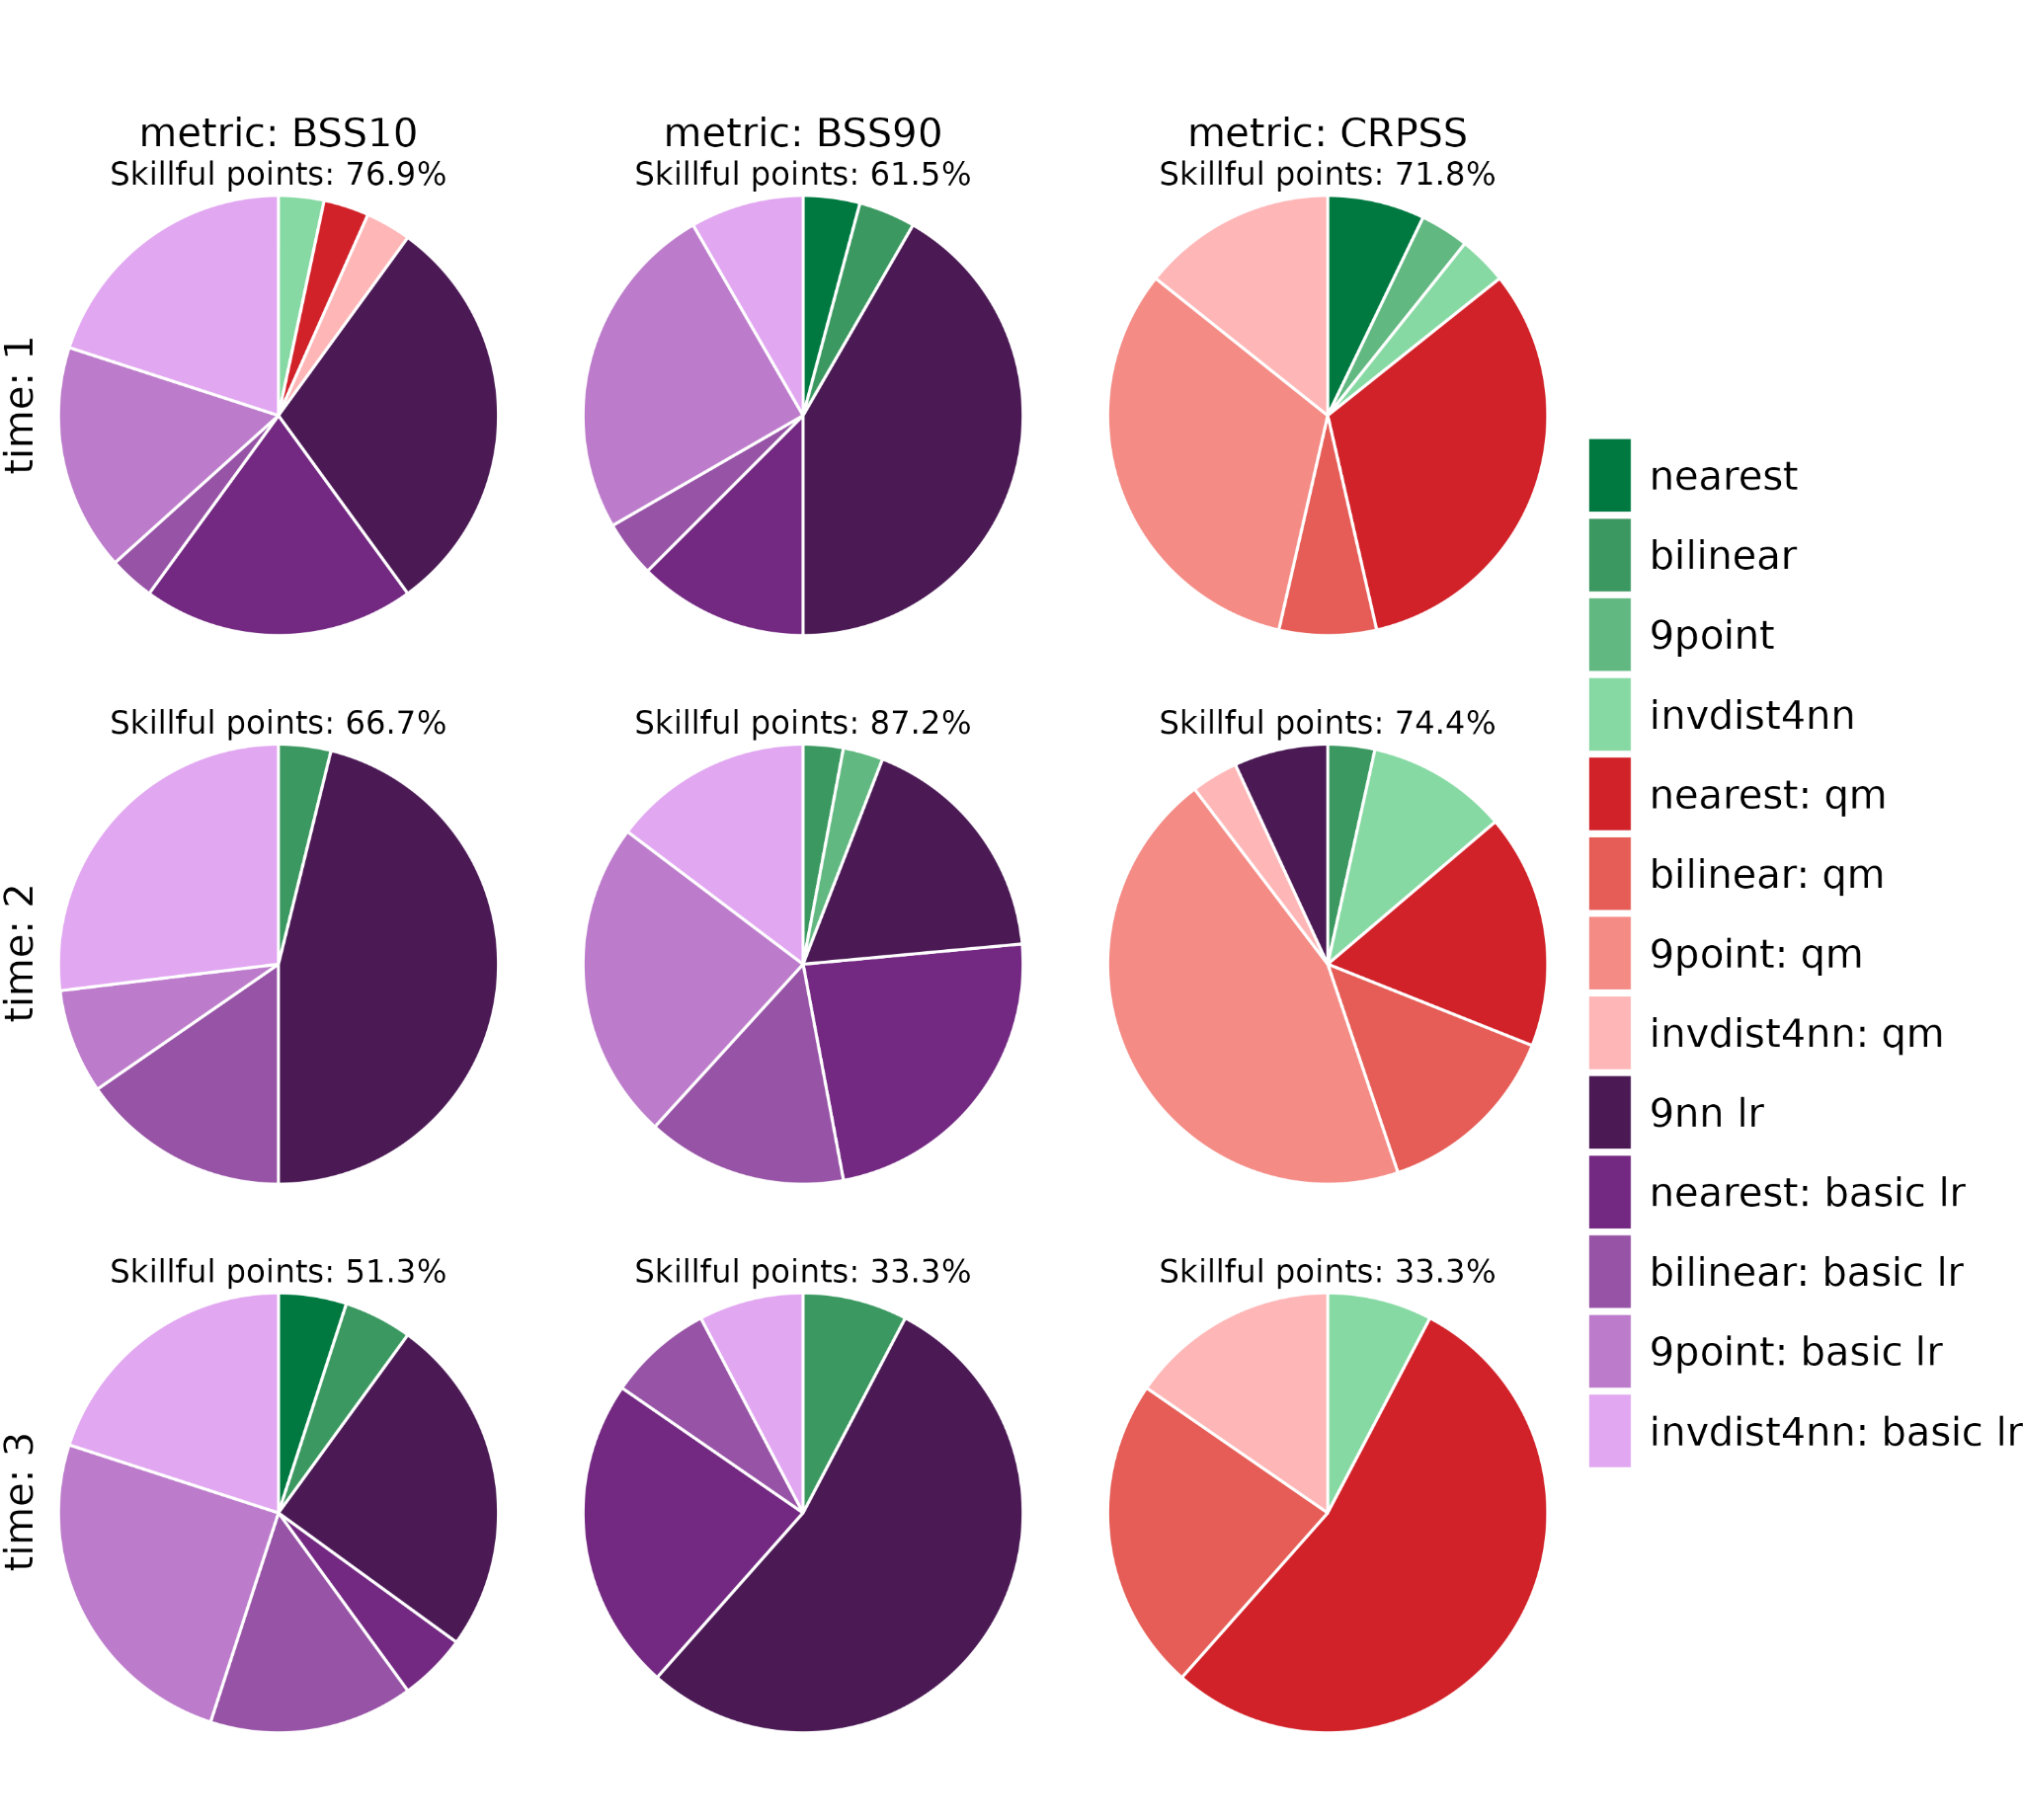
Figure 29: the most skilful downscaling method for precipitation across Colombia, for hindcasts initialised in January 1981-2016 and 3 lead times corresponding to January, February, and March. (top) All weather station locations. If all downscaling methods have skill less than 0, the point is grey. (bottom) The percentage of locations for which each downscaling method is the most skilful. The percentage of skilful locations is also shown.

Brazil
In the Brazilian hotspot, daily minimum, maximum and mean temperature have been recorded from 2011 in one location. This time period is too short to perform a robust statistical downscaling of seasonal forecast data. Instead, we assess the quality of the recorded weather station data in this location. The station temperature record is shown in Figure 30, along with the corresponding reanalysis time series from the closest grid point.

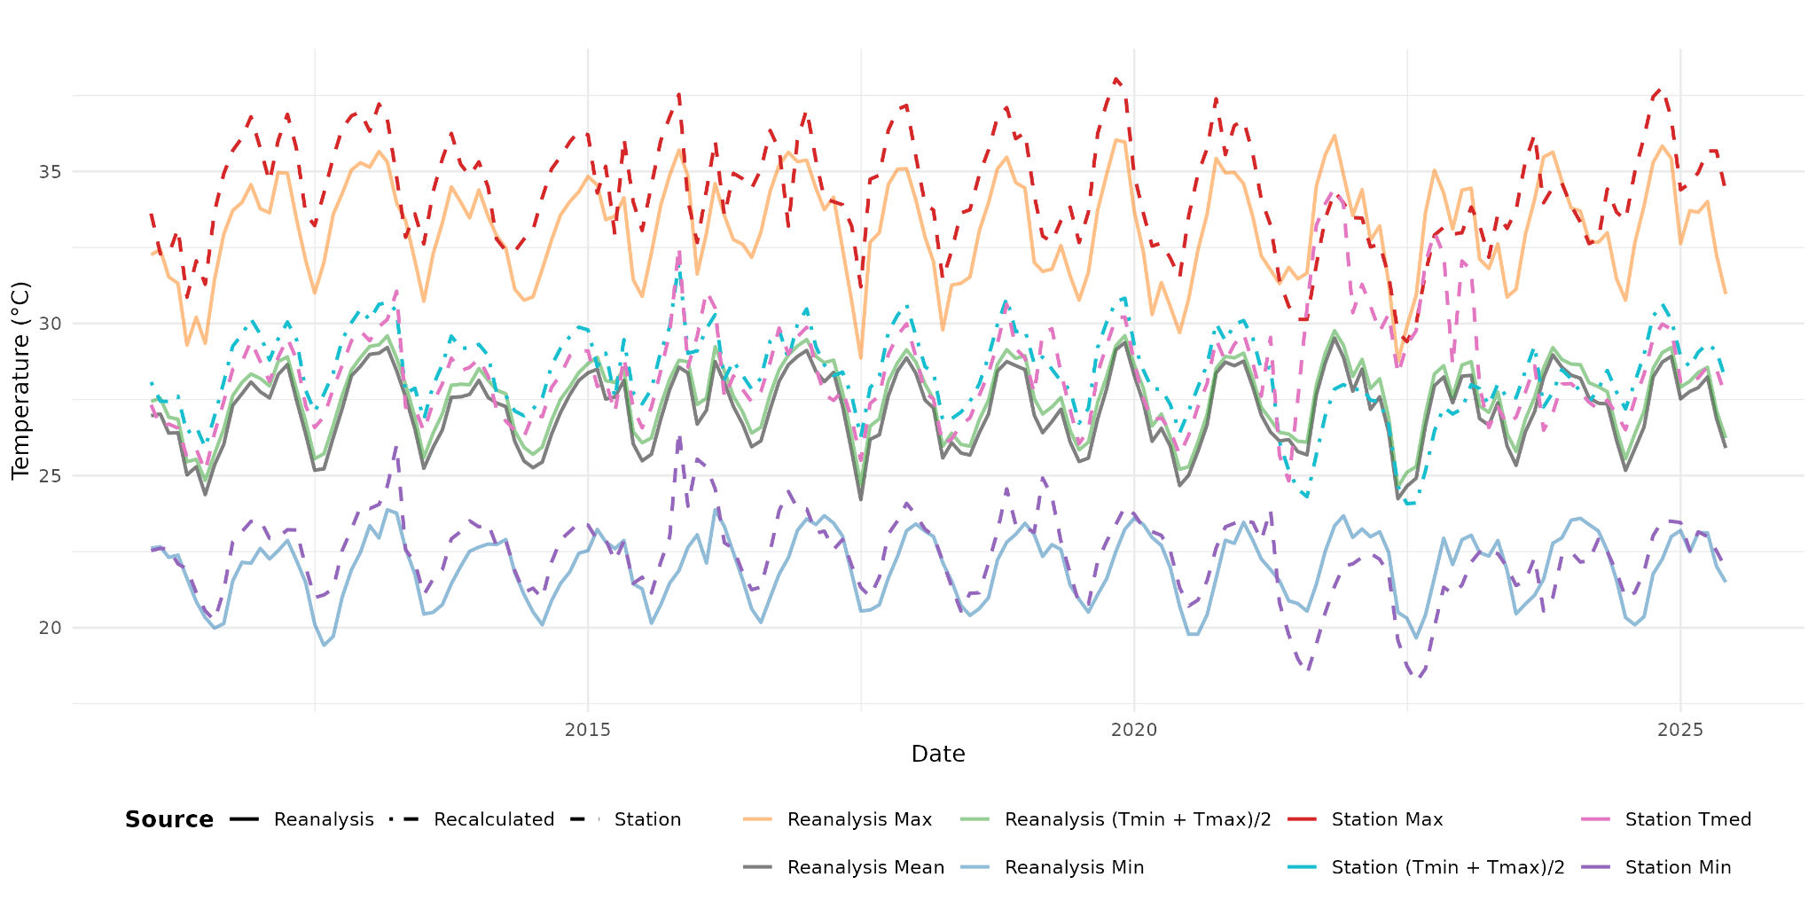
Figure 30: recorded minimum, maximum and median temperatures in Patos, Brazil. Daily data has been aggregated to monthly temporal resolution. Reanalysis (solid lines) and station (dashed lines) data are shown.

It is noted that between 2021 to 2023, the recorded median temperature (Station Tmed in Figure 30) is implausibly high (in this period, there are many days where the median temperature recorded is greater than the maximum). For this reason, a recalculated mean (from daily maximum and daily minimum) is also shown (Station (Tmin+Tmax)/2 in Figure 31).

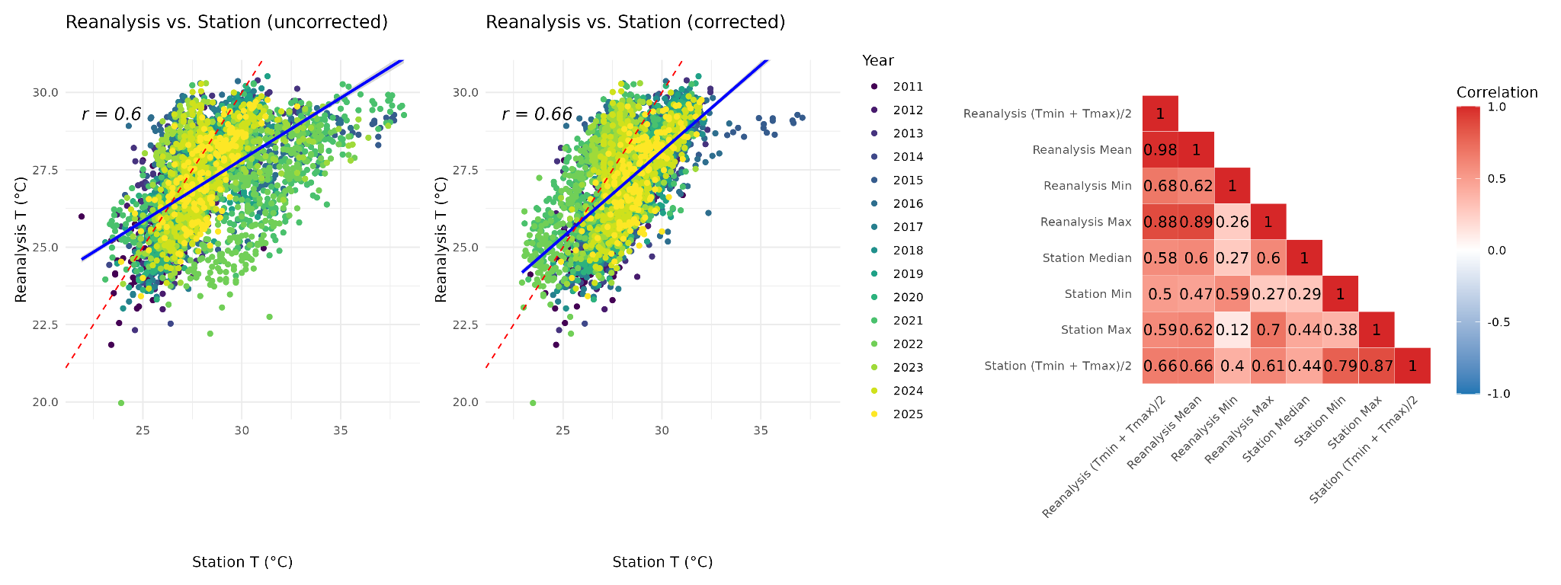
Figure 31: a) scatter plot of recorded station temperature vs. reanalysis daily mean temperature. b) scatter plot of re-calculated daily mean station temperature vs. recalculated reanalysis daily mean temperature. c) correlation matrix of the temperature indices, using a two-sided Pearson correlation coefficient.

Overall, the station data and reanalysis data are rather poorly correlated (the highest Pearson correlation coefficient is between the station and reanalysis daily maximum temperatures, at 0.7), and the quality of the station data between 2021-2023 is limited.

Peru
In Peru, daily mean temperature has been collected from 2023 in six locations (Figure 32). This time period is too short to perform a robust statistical downscaling of seasonal forecast data. Instead, we briefly assess the quality of the station data in these locations. The station temperature records are shown in Figure 33, along with the corresponding reanalysis time series from the closest grid points.
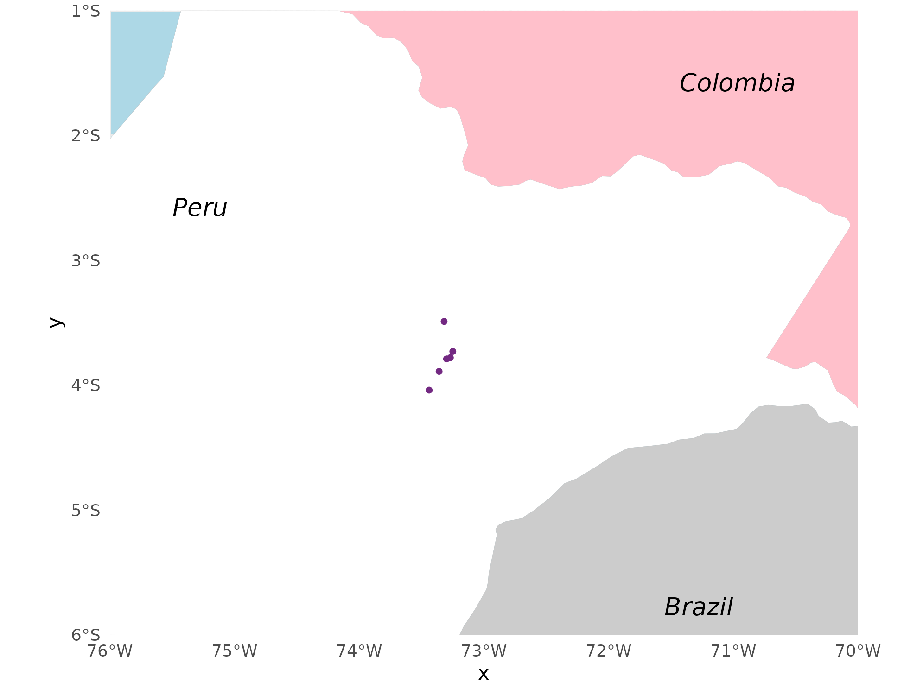
Figure 32: location of the HARMONIZE weather stations in Peru.

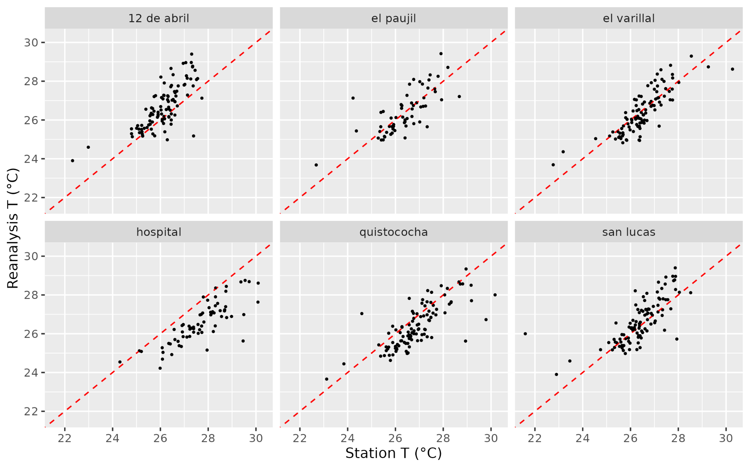
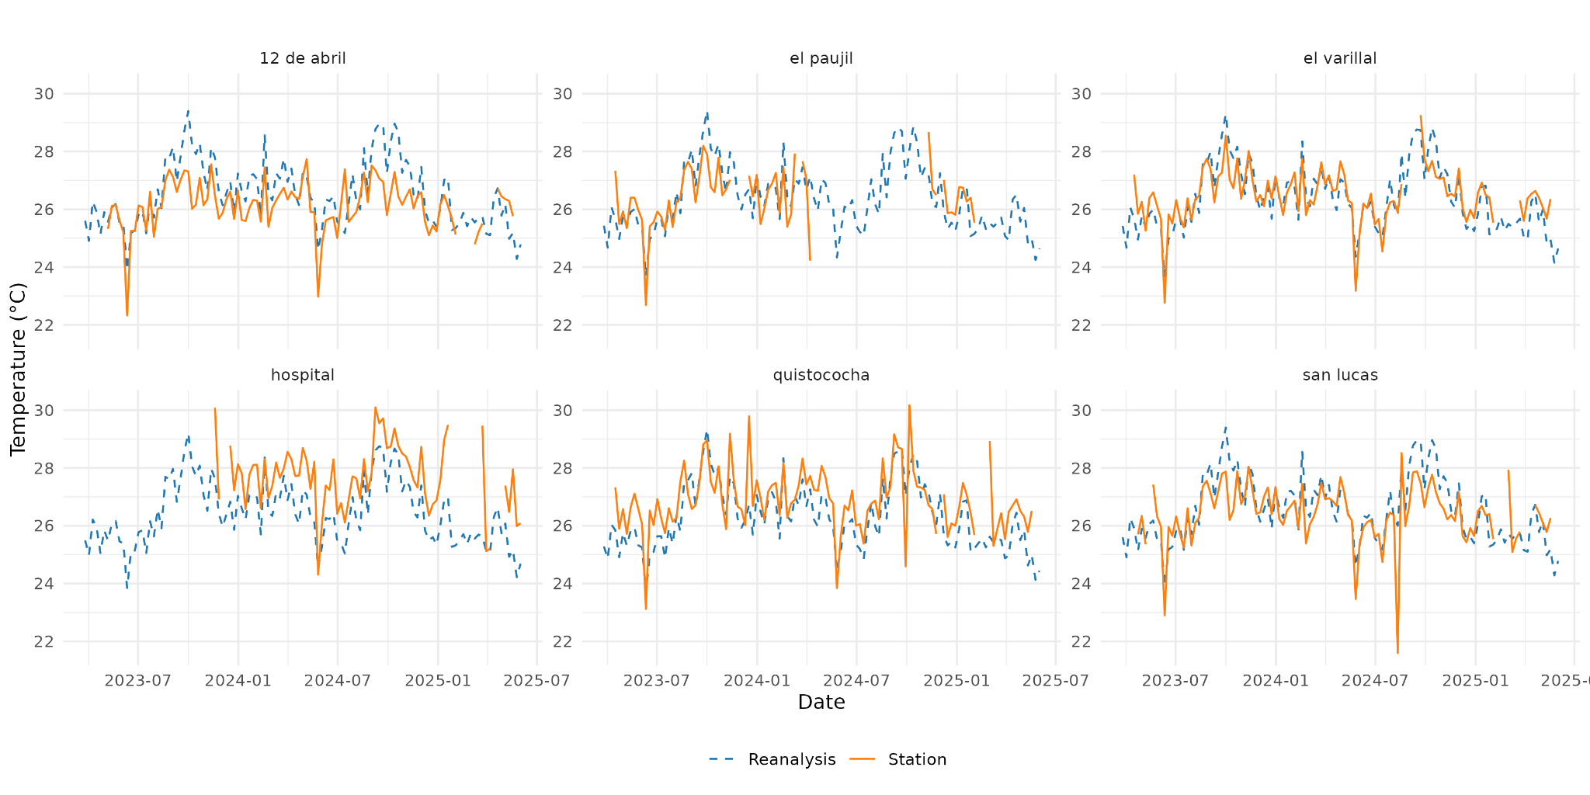 Figure 33: Temperature recorded in the 6 weather stations in Peru, compared with temperature in the nearest gridcell in the reanalysis (ERA5-Land).

Overall, the reanalysis captures the variability in temperature seen by the stations in Peru (Figure 33). The two data sources are reasonably well-correlated and biases low, although there are periods of missing data in all of the stations (Figure 33).

Dominican Republic
Local weather station data has been recorded across the Dominican Republic, with most stations recording temperature from 2014 onwards and two stations providing over 70 years of daily precipitation data (Punta Cana and San Jose de Ocoa, as shown in Figure 34).

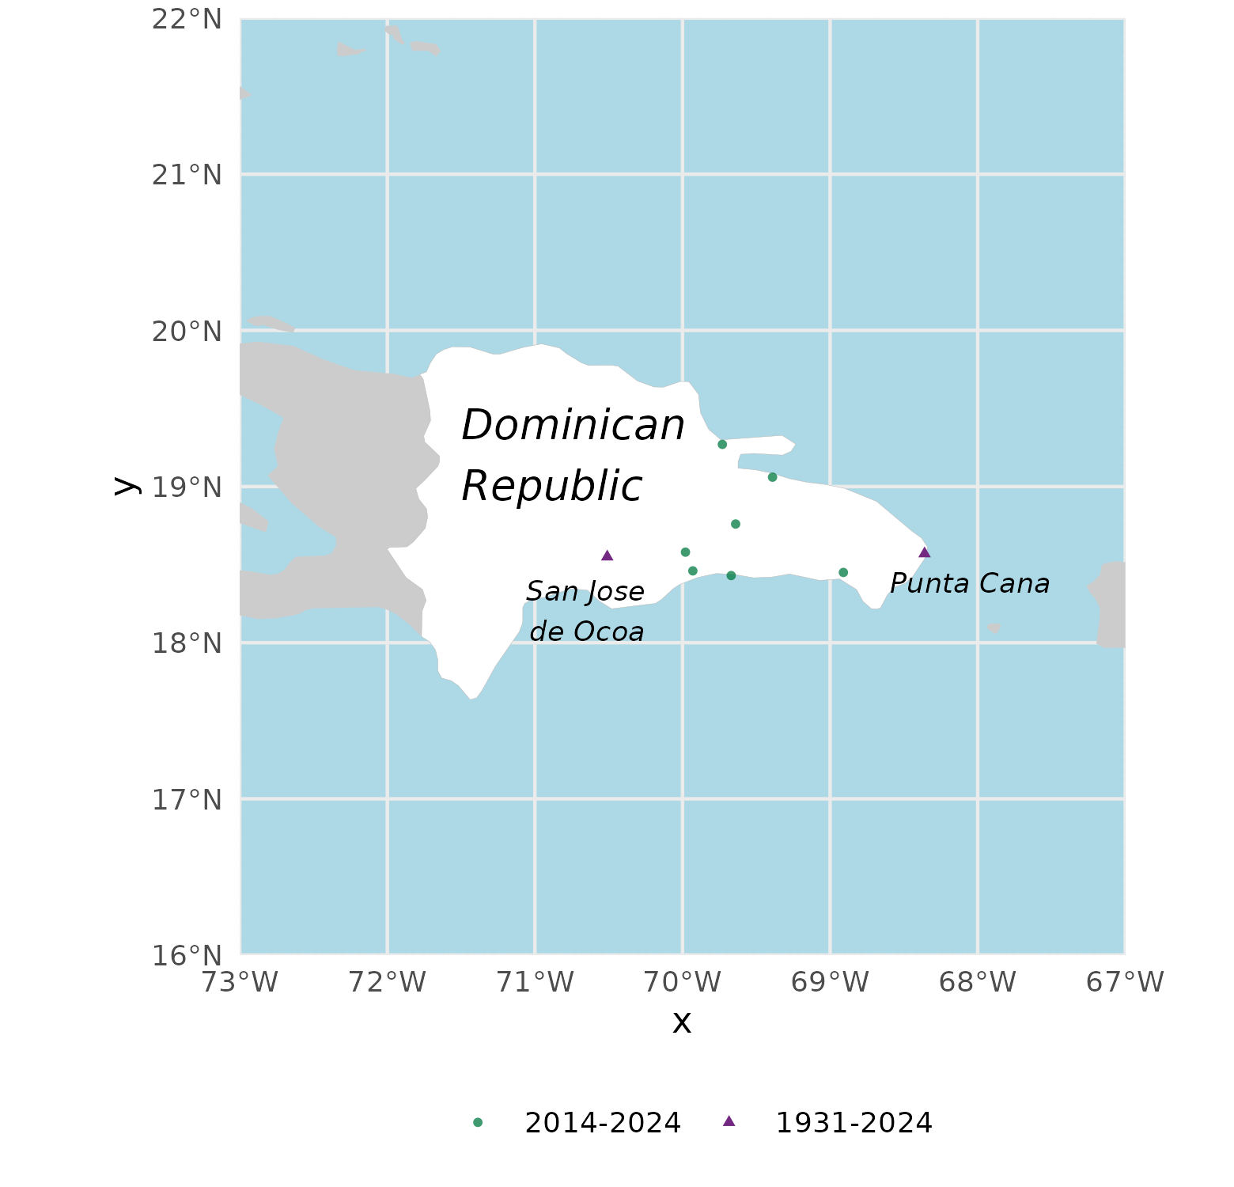
Figure 34: Location of weather stations in the Dominican Republic. Stations with more than ten years of data (San Jose de Ocoa and Punta Cana) are shown in purple.

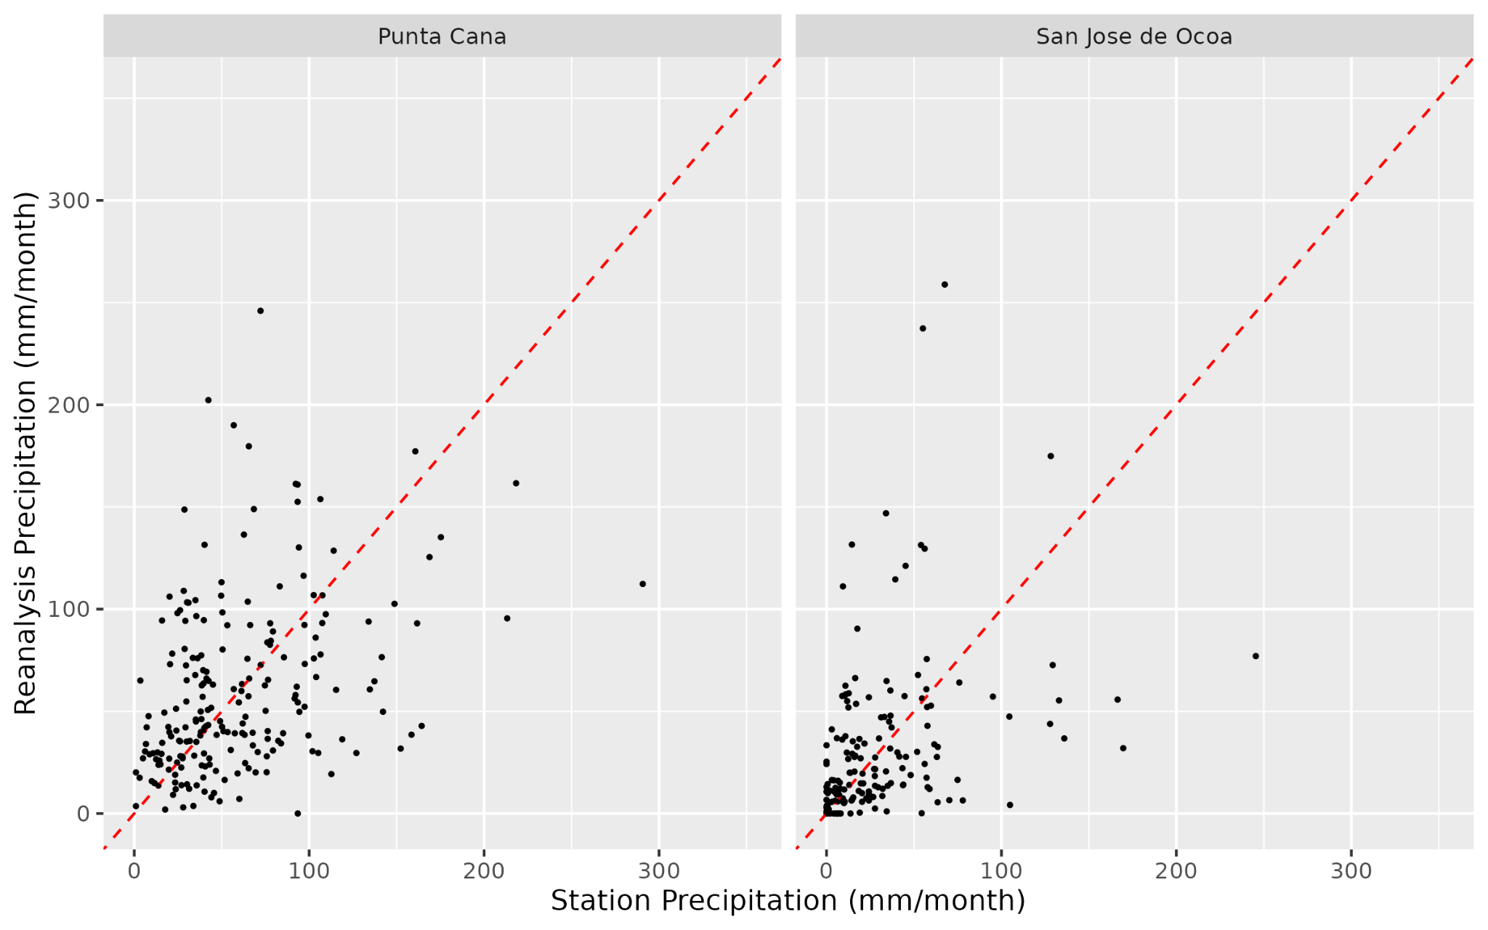
Figure 35: Station and reanalysis monthly total precipitation (for January - March) from 1951.

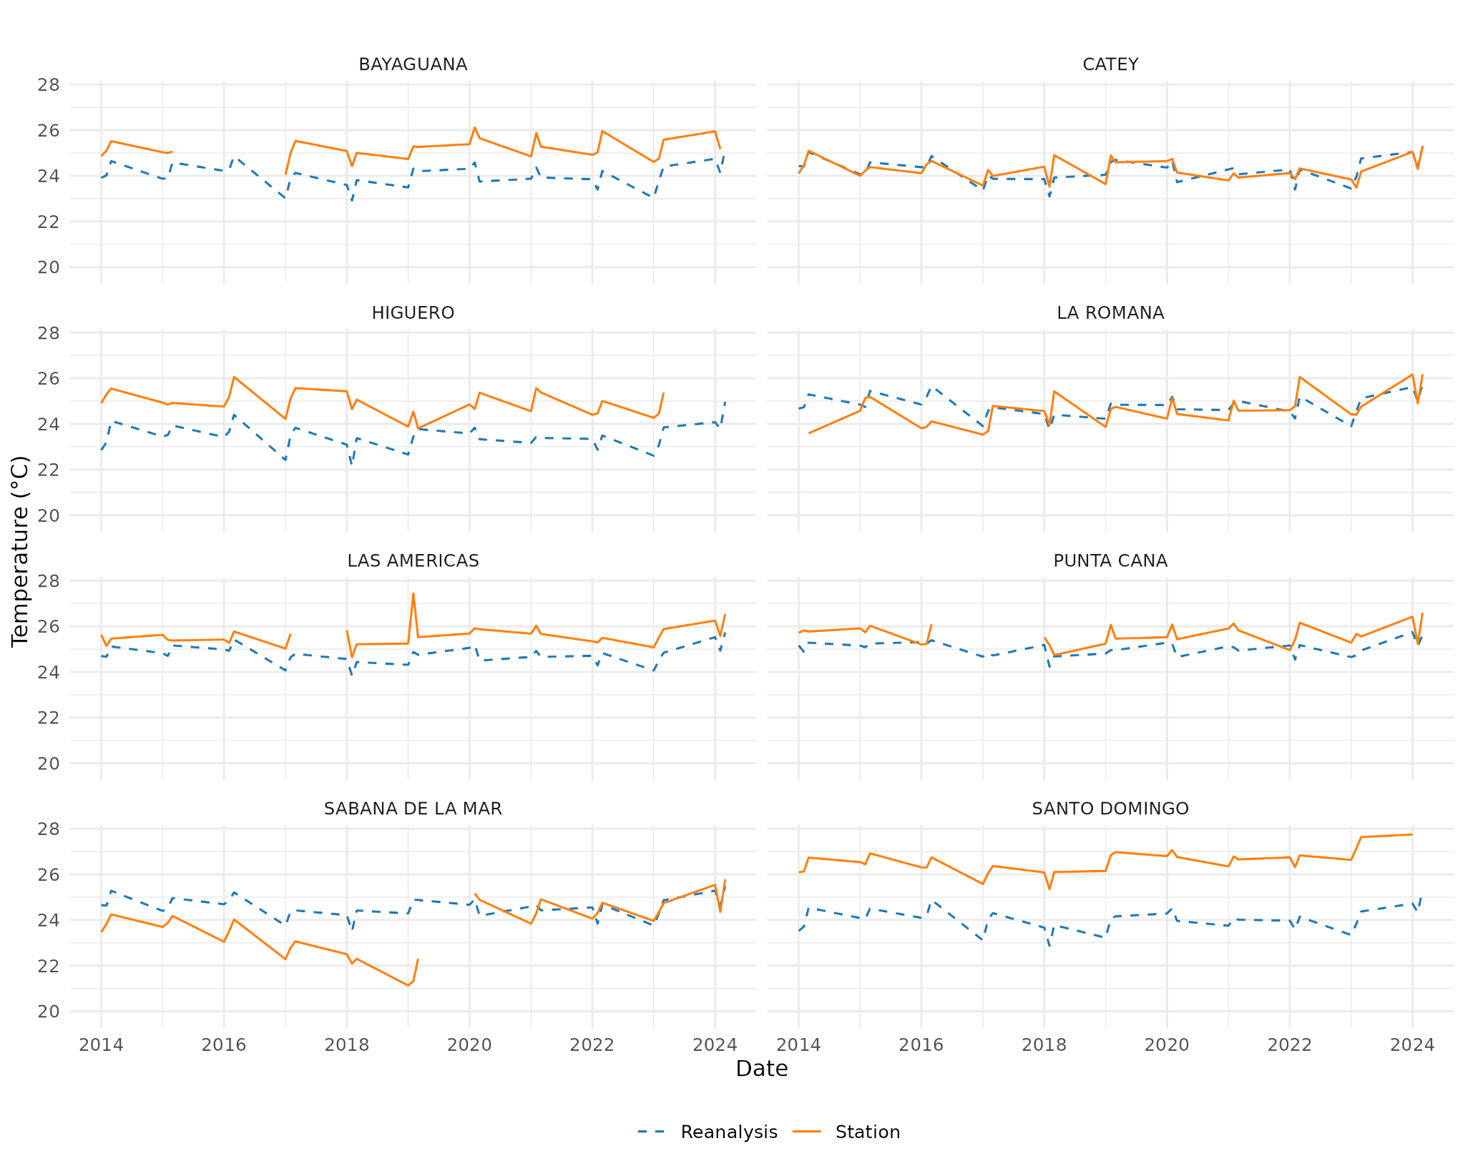
Figure 36: Monthly mean temperature (for January to March) from reanalysis and stations in the Dominican Republic.

Overall, the quality of the data in the Dominican Republic appears good under initial investigation. Monthly total precipitation values in January to March from 1951 to present at Punta Cana and San Jose de Ocoa are well-correlated between the weather stations and reanalysis (Figure 35). There are biases between recorded temperature from the weather stations compared to the reanalysis, but for most stations the two datasets are well-correlated (Figure 36). In the Sabana de la Mar station, the quality of the temperature data is poor before 2020, and it would not be recommended to use this data.

