**bar.jpg**

**Deliverable D13.1: Initial report on evaluation/verification activities**

|  |  |
| --- | --- |
| **Work package no** | **WP*13*** |
| **Deliverable no.** | **D13*.1*** |
| **Lead beneficiary** | **ECMWF** |
| **Deliverable type** | vR (Document, report) |
|  | DEC (Websites, patent fillings, videos, etc.) |
|  | OTHER: please specify **..............................................** |
| **Dissemination level** | vPU (public) |
|  | CO (confidential, only for members of the Consortium, incl Commission) |
| **Estimated delivery date** | **Month *21*** |
| **Actual delivery date** | ***dd/mm/yyyy*** |
| **Version** | **Draft** |
| **Comments** |  |

**D13.1: Initial report on evaluation/verification activities**

**13.1.1. INTRODUCTION**

Various model evaluation and verification activities fall under the umbrella of the Joint Research Activity 3 (JRA). Those can be broadly divided into activities that are aimed at the verification of forecast models in near-real-time (NRT) for which timeliness of observations is very important (less than 1 day) and activities that are aimed at the evaluation of long-term model datasets (such as reanalysis) as well as climate models which operate on longer time-scale. For these activities consistent, long-term, quality controlled data are more important and quick delivery is less crucial.

This report presents examples of both activities that have been funded in ACTRIS-2 WP13 to facilitate data uptake and usage from operational and research centres which engage in aerosol modelling and forecasting activities.

**13.1.2 Evaluation of model-derived dust vertical profiles on the sds-was Northern africa-middle east-europe regional center** (Sara Basart, Enza Di Tomaso and Oriol Jorba, BSC)

One of the most important activities of the World Meteorological Organization’s Sand and Dust Storm Warning Advisory and Assessment System - Northern Africa-Middle East-Europe Regional Center (WMO SDS-WAS NAMEE RC, http://sds-was.aemet.es) is the dust model verification and evaluation, which is deemed an indispensable service to the users and an invaluable tool to assess model skills. Currently, the Center collects daily dust forecasts from twelve models run by different partners (BSC, ECMWF, NASA, NCEP, SEEVCCC, EMA, CNR-ISAC, NOA, FMI, TNO and UK Met Office). Multi-model ensembles have also been set-up to provide added-value aerosol products to the users. The current routine evaluation of dust predictions is focused on total-column dust optical depth (DOD) and uses remote-sensing retrievals from sun-photometric (AERONET) and satellite (MODIS) measurements. However, the Regional Center started working in the establishment of a near-real-time (NRT) model monitoring/evaluation dust profile system.

Ground- and satellite-borne lidar and last generation of ceilometers are the only tools capable of inquiring about the vertical profiles of aerosol-related variables. Therefore, information provided by them may potentially be used to evaluate the vertical component of the dust fields. On the one hand, research activities are indispensable, e.g., to improve our understanding of interactions of aerosols and clouds, and to develop advanced remote sensing techniques (fundamentally based on lidars systems) for the assessment of optical and microphysical aerosol properties. As a consequence of the complexity of the lidar systems, those systems are quite expensive; thus their number is limited, and many of them are operated by research institutes only occasionally or during dedicated field campaigns. On the other hand, infrastructures must be implemented to monitor aerosols also to validate and improve aerosol and pollution forecasting with high spatial and temporal coverage as well as, with low-cost and low-maintenance instruments. Significant progress in range-resolved aerosol characterization is accomplished using lidar technology as they can provide quantitative range-resolved aerosol parameters. However, currently, costs for investment and maintenance of advanced near-real-time lidar systems are prohibitive for establishing dense networks. Despite their differences from more advanced and more powerful lidars, low construction and operation cost of ceilometer, originally designed for cloud base height monitoring, have fostered their use for the quantitative study of aerosol properties (i.e. Wiegner et al., 2014; Madonna et al. 2016). A large number of ceilometers available worldwide represent a potential observational dataset for operational dust model evaluation purposes. Additionally, ceilometer measurements can benefit from ACTRIS/EARLINET lidars for calibration (Weigner et al., 2014).

Currently, a lidar (monoaxial Cimel Micro-Pulsed Lidar, CAML CE-370) located in Dakar (Senegal, U. Lille) and three ceilometers in Santa Cruz de Tenerife (Canary Islands, Spain, CIAI-AEMET), Granada (Spain, UGR) and Montsec (Barcelona, Spain, CSIC-IDAEA) provide NRT extinction profiles of aerosols to the WMO SDS-WAS NAMME RC (see Figure D13.1.1).

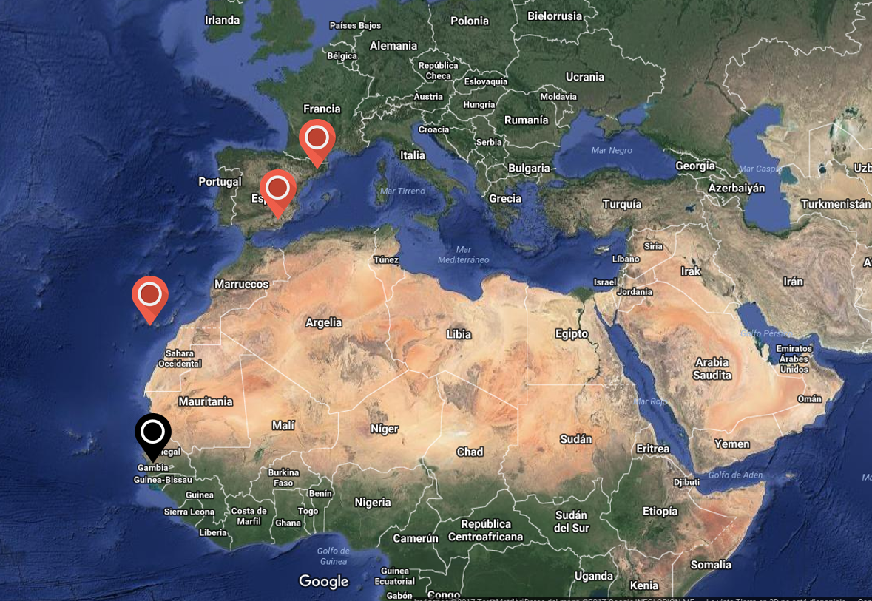

*Figure D13.1.1: Location of those sites that are providing NRT extinction profiles to the SDS-WAS NAMEE RC. Lidars are shown in black and ceilometers in red.*

Moreover, the exchange of forecast model products (and consequently, data harmonisation) is recognised as a core part of the WMO SDS-WAS NAMEE RC and as a basis for the model inter-comparison and evaluation. Within this objective, a protocol has been defined for model data exchange. The format for data exchange is NetCDF, with one file per model run and includes the resulting interpolated model outputs from a list of stations (which includes all the ACTRIS/EARLINET sites and additional key locations). The NetCDF format has been developed and maintained at Unidata, which is part of the U. S. University Corporation for Atmospheric Research (UCAR). It allows data compression while preserving characteristics of numerical fields that have a very large dynamical range. The action will consider forecasts with lead times up to 72 h, based on 00 UTC or 12 UTC runs on 3-hourly basis. The variables to be provided are: dust concentration, dust extinction (at 550 nm) and the corresponding height of each model layer. Currently, the BSC-DREAM8b and the NMMB/BSC-Dust models provide operational dust forecast profiles. The CAMS and the NMME-DREAM models will be added during the next months, and this is expected to be extended soon to other models/institutions.

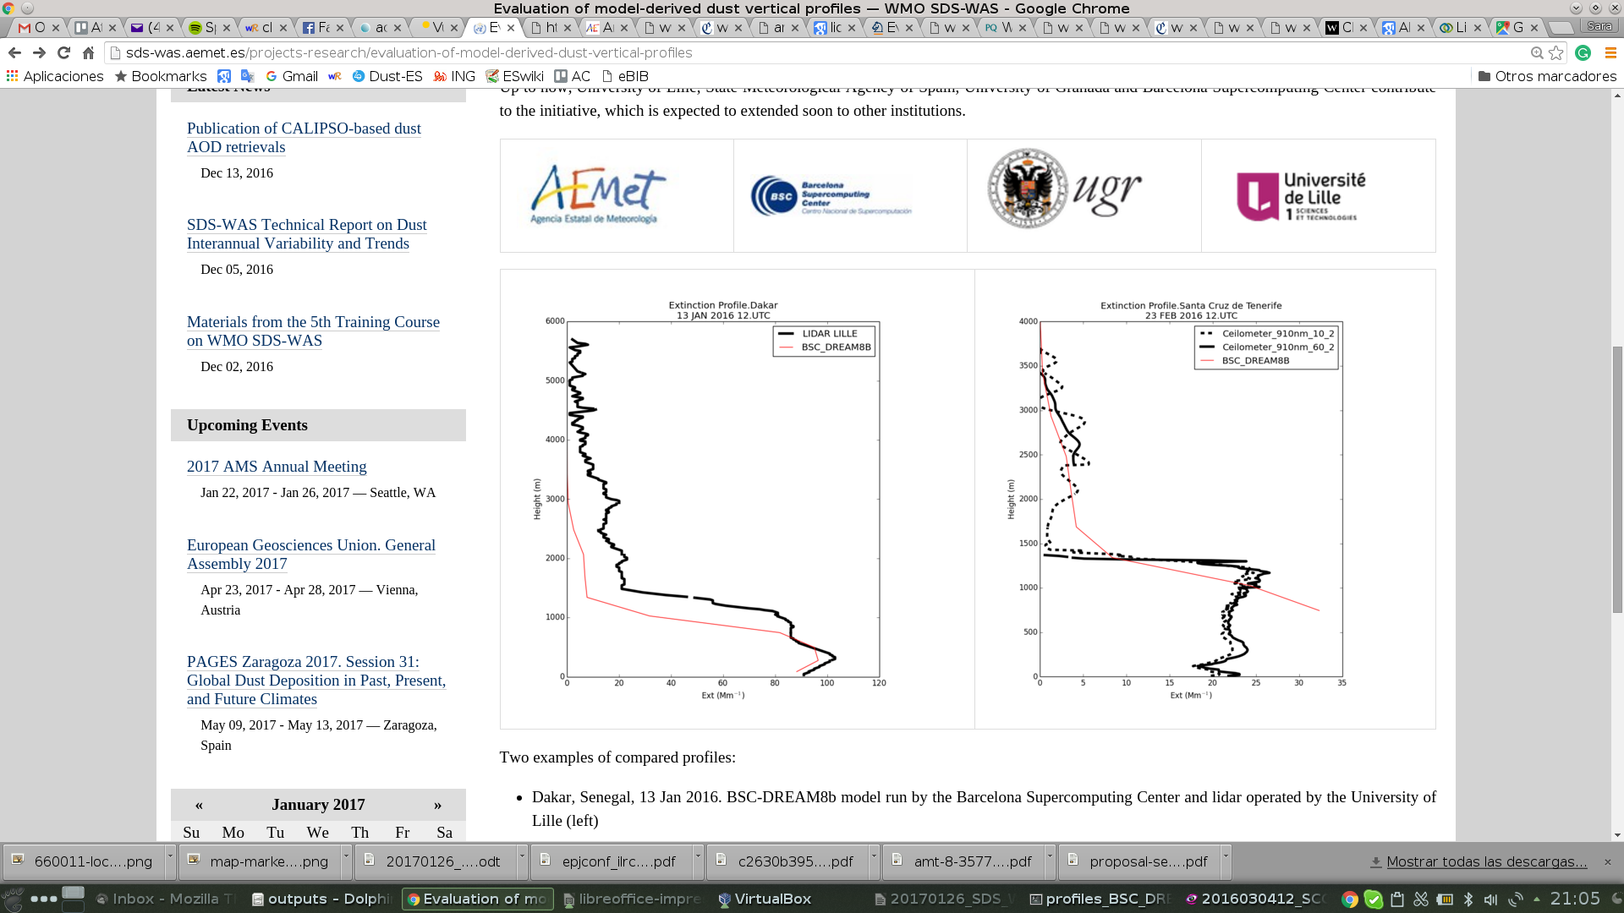

*Figure D13.1.2; Two examples of compared profile from the SDS-WAS NAMEE RC website. Left: Dakar, Senegal, 13 Jan 2016. BSC-DREAM8b model run and lidar operated by the University of Lille. Right: Santa Cruz de Tenerife, Spain, 23 Feb 2016. BSC-DREAM8b model and ceilometer operated by the Izana Atmospheric Reseach Center - AEMET.*

As a first approach, all the available data is routinely used to generate qualitatively comparison plots for each specific location (see Figure D13.1.2). This is a first step to check the consistency of the received data. All the numerical data is available through the SDS-WAS NAMEE RC website (<http://sds-was.aemet.es/projects-research/evaluation-of-model-derived-dust-vertical-profiles>).

Next steps include the development of a quantitative evaluation methodology which makes considerations for the selection of a suitable data set and appropriate metrics for the exploration of the results. Many of dust model evaluation analysis have focused on a limited number of case studies (e.g., Pérez et al., 2006a; Heinold et al., 2009; Granados-Muñoz et al., 2016). In other studies, long-term observations of aerosol optical properties have been compared with modelled dust optical profiles. For example, Gobbi et al. (2013) compared the lidar dust extinction profiles with those modelled by BSC-DREAM8b over Rome, Italy during the 2001–2004 period. Similarly, Mona et al. (2014) have presented a systematic examination of BSC-DREAM8b modelled dust distribution over Potenza, Italy, for the 2000–2012 period, using lidar-derived backscatter and extinction profiles. Moreover, Mona et al. (2014) found that the dust layer centre of mass (CoM) is likely the most suitable geometrical parameter for evaluating the capability of the dust model to reproduce the vertical dust layering. Recently, Binietoglou et al. (2015) introduced a methodology for the examination of dust model data using volume concentration profiles retrieved using the synergy of lidar and sun photometer. The approach was demonstrated for four regional dust transport models participating in the SDS-WAS Regional Node (BSC-DREAM8b v2, NMMB/BSC-DUST, DREAMABOL, DREAM8-NMME-MACC) using dust observations performed at 10 ACTRIS/EARLINET stations for the period between 2011-2013.

Modelled and observed data will be interpolated to a reference standard vertical profile for comparisons. This definition will also allow generation of multi-model products. The model evaluation will focus on two main features: the description of the aerosol layering (peak altitude and shape of the profile) and the aerosol concentrations for all the models. A set of selected statistics adequate for the model evaluation will be applied. The proposed approach will adapt previous experience from SDS-WAS NAMEE RC (i.e. Mona et al., 2014; Binietoglou et al., 2015).

**Acknowledgements.** The authors wish to thank the following people for contributing to this research:

GERARDO GARCÍA-CASTRILLO (State Meteorological Agency of Spain, AEMET), EMILIO CUEVAS (Izaña Research Atmospheric Center-State Meteorological Agency of Spain, CIAI-AEMET), PHILIPPE GOLOUB (University of Lille), ALBERTO CAZORLA (Andalusian Institute for Earth System Research and Department of Applied Physics, University of Granada), ANDRÉS ALASTUEY (Institute of Environmental Assessment and Water), AGUSTIN MORTIER (Norwegian Meteorological Institute) and ENRIC TERRADELLAS (State Meteorological Agency of Spain, AEMET)

**13.1.3. VERIFICATION ACTIVITIES AT ECMWF** (Julie Letertre-Danczak, Luke Jones and Angela Benedetti, ECMWF)

In the frame of ACTRIS-2 verification activities, ECMWF has started to compare ACTRIS-2 observations of aerosol light scattering from nephelometers with the output from C-IFS which is forecast model for atmospheric composition at ECMWF.

The first step involved being able to read the files from the data provider. NILU established an ftp link with ECMWF. Via this ftp ECMWF is collecting data every day since October 5th 2016 and archiving them. A code was developed to convert the file which are in NDACC format into NETCDF format. While running the code, it was noticed that some files were corrupted and some duplications were observed inside the file. Moreover, some files had separated information as a function of the size PM1, PM2.5 or PM10 while others contained multi- information. ECMWF informed NILU about the file inconsistencies and those were fixed on November 22 2016. To avoid any problem in the automatic conversion and reading of the files, we have started an automatic verification of the data format from December 1 2016.

The second step was to extract the information from the model. Changes had to be done to extract the information near the surface (where nephelometer are measuring) for different relative humidity values rather than ambient humidity, in order to compare with the nephelometer measurements which are usually provided at a RH lower than 40%. Moreover, the nephelometer is measuring on a particular site at a particular time and there could be a large difference between the humidity of the closest grid points and the local humidity. C-IFS was modified to output the aerosol light scattering, absorption and extinction coefficients for 50, 40, 30, 20, 10 and 0% of relative humidity. After extracting this output, it was noticed the system is in fact limited by the ambient humidity which can induce saturation (sometimes the coefficients are equal at 0, 10 and 20% RH for example). Another issue is the topography as the altitude of the grid points around the site can be different than the real altitude when the measurement was taken. Investigations are ongoing to reduce the impact of this bias.

The objectives of ACTRIS-2 are similar to other current project such as TO-PROF, in consequence a workshop was organized at the beginning of December to discuss comparisons between lidar or ceilometer observations and model profiles. It was discovered at the time a problem in the C-IFS model connected with the humidity during the transport of sea salt particles. This was reported to the CAMS team which is responsible for the maintenance and development of C-IFS and it should be fixed in the near future.

Despite these issues, the automatic verification has started. A prototype of website (shown Figure D13.1.3) has been developed by Luke Jones and will be in public access soon. On the website one can find the different locations of the stations and observations at different wavelengths. For example Figure D13.1.4 shows the location of the nephelometers that were operational between December 1 and December 31, 2016. Three sites at different elevations have been selected (Melpitz, 86m, Granada, 680m and Puy de Dôme, 1465m) to evaluate the impact of the altitude on model-observation agreements. Figure D13.1.5 shows the aerosol light scattering in function of the time for the model (green at 0% of humidity, red at 50% of humidity) and the observations (blue). A good agreement is observed for the station at 86m of altitude. However there are some large differences for the nephelometer situated on the mountain site. Similar results have also been obtained independently in the context of the AEROCOM INSITO inter-comparison of aerosol climate models. This result confirms the necessity to address the problem of altitude in order to make a valid comparison. For low elevation sites, however, the model agrees remarkably well with observations.

Next scientific next steps will include a comparison with ground based lidar observations for the full vertical profile followed by the development of an operational assimilation of lidar measurements.

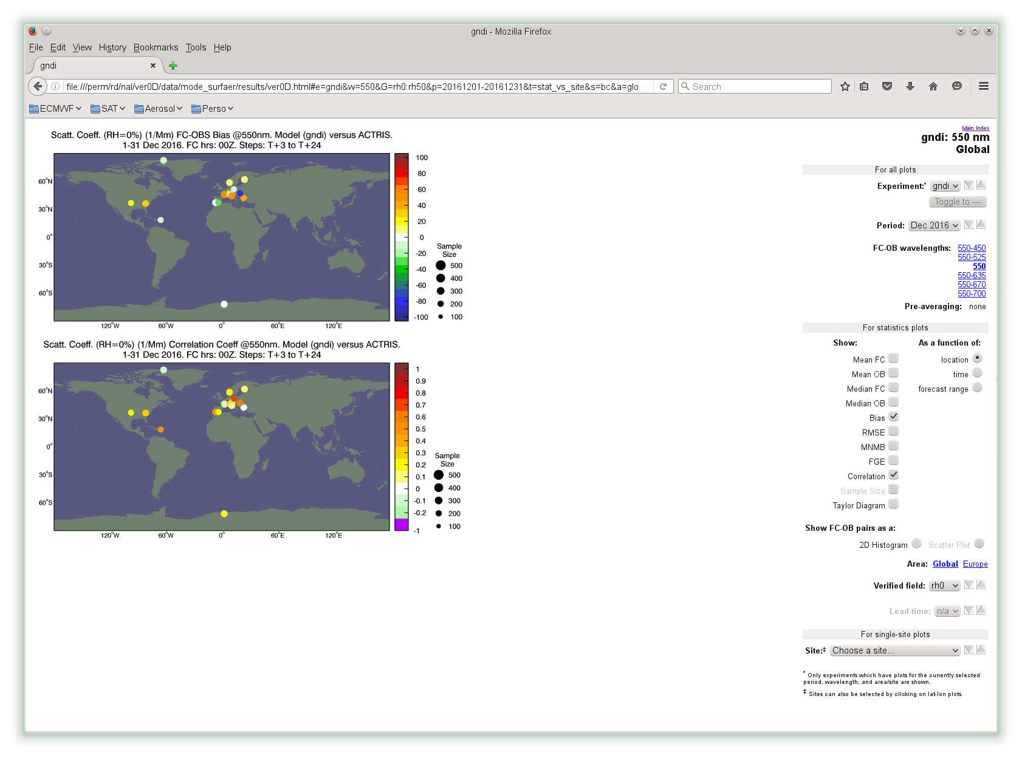

*Figure D13.1.3.Website prototype showing the location of the ACTRIS-2 nephelometers and time series of the scattering coefficient at different wavelengths compared to the model scattering coefficients at 550nm. Credits: Luke Jones.*



*Figure D13.1.4. Stations equipped with nephelometers measuring light scattering coefficient at 550nm.*

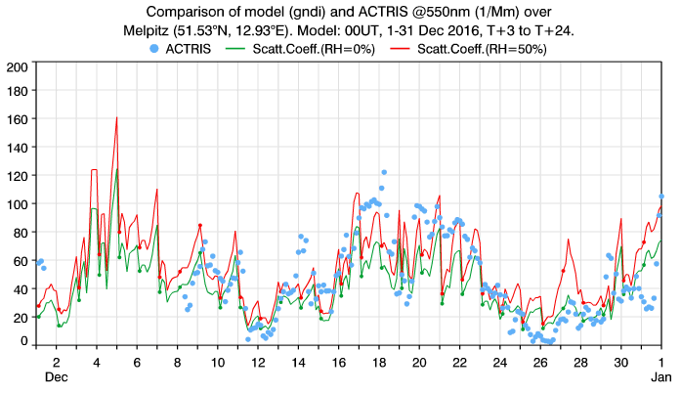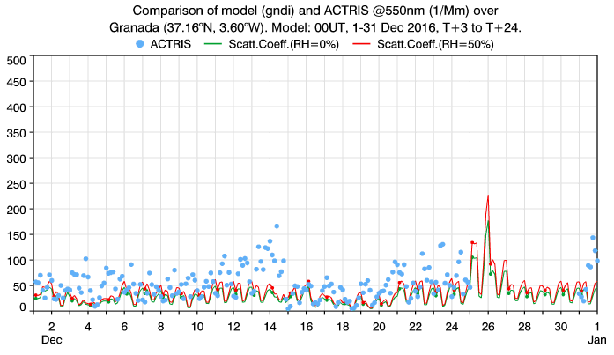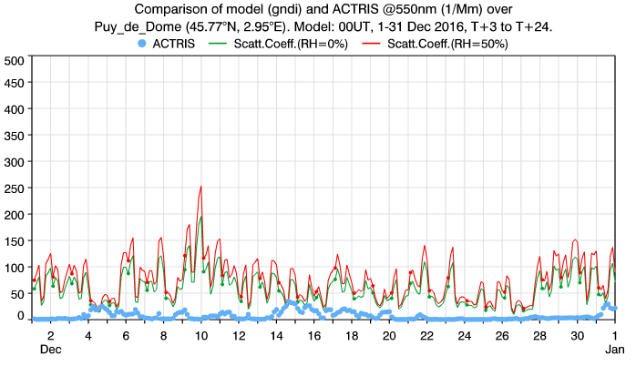

*Figure D13.1.4. Aerosol Light Scattering at 550nm from the nephelometers (blue) and C-IFS (green for 0% humidity and red for 50% humidity) at three different stations (top to bottom: Melpitz, Granada and Puy de Dome).*

**13.1.4 VERIFICATION ACTIVITIES AT METNO** (Michael Schulz, Augustin Mortier, Jan Griesfeller)

ACTRIS data are used by MetNo for different evaluation activities. The Copernicus Atmospheric Monitoring Service (CAMS) with its global and regional chemical weather forecast model results are quality checked every three months. Preliminary CAMS reanalysis data have been checked before the final complete reanalysis is launched, which will describe the evolution of atmospheric composition from 2003-2016. In a more broad setting, AeroCom model results delivered for different AeroCom experiments, are evaluated against a consistent dataset from ACTRIS-EBAS. Also - new algorithms from ESA’s CCI-aerosol project exploiting the European satellite data from ATSR2/AATSR are evaluated against the Aeronet/ACTRIS data of ground based aerosol optical properties.

For the evaluation activities technical preparations were needed. New structures in the ACTRIS/EBAS database required considerable recoding of the reading routines used to interpret the database extract. The new multi-column format allows now finding consistent data in a better way, eg scattering at different angles from a multi-wavelength nephelometer. At the same time file names were no longer sufficient to identify the content of the dataset stored in a file. A metadata database was produced by NILU, which was then used via a data query function by MetNo to select the data of interest. AERONET and EARLINET data on the other hand have a different format and required extra reading routines to be developed. Finally, secondary datasets such as those accompanying the synthesis ACTRIS publications (eg Collaud Coen et al, 2013) have yet another format, requiring extra coding efforts. Discussions had been started with the ACTRIS data center for a more general secondary dataset format.

Visualization of MetNo’s evaluation work using ACTRIS data has been put in place by firstly maintaining and improving the traditional AeroCom web interface and secondly developing a trend web interface. The AeroCom web interface shows now a large variety of statistical parameters. It has been used with great success for regular CAMS model version evaluations and for CCI-aerosol satellite retrieval optimization. The trend web interface developed specifically for ACTRIS-2 shows those observable parameters, which are core to ACTRIS. It combines a simplified access to station data via a map, with statistical evaluations showing trends and the underlying data. While work is under way to include more model data, some important models such as the C-IFS and EMEP models and one satellite dataset from CCI-aerosol are already included. Seasonal trends for different periods can be inspected.

The trend interface (http://aerocom.met.no/trends/) allows in particular also a valuable check of historic data. It invites the observational community to inspect station data in a new way. The interface is simple enough to zoom into regions and find station data and discover trend statistics. Consistency both along a time horizon, with neighboring stations and against reference models can be investigated. Figure D13.1.6 shows the parameters included at this stage. Figures D13.1.7 and D13.1.8 shows two exemplary comparisons against the CAMS model and the cci-aerosol satellite dataset via the trend interface.

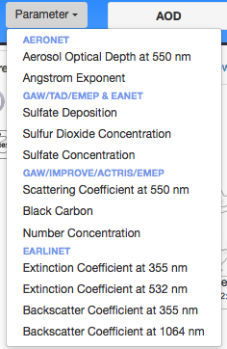

*Figure D13.1.6: Parameters accessible via MetNos trend web interface*.

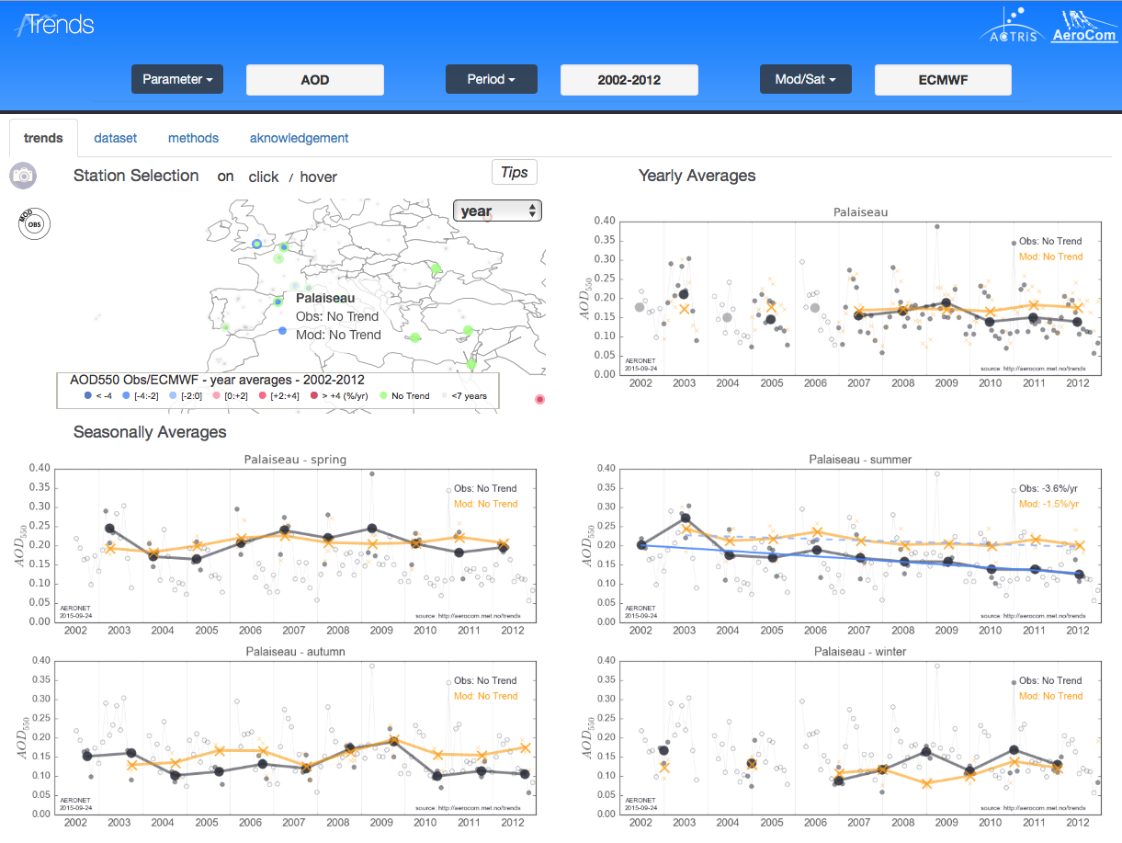

*Figure D13.1.7: Comparison of annual and seasonal trend of AOD at Palaiseau between AERONET sun photometer data and collocated MACC reanalysis (CAMS predecessor).*

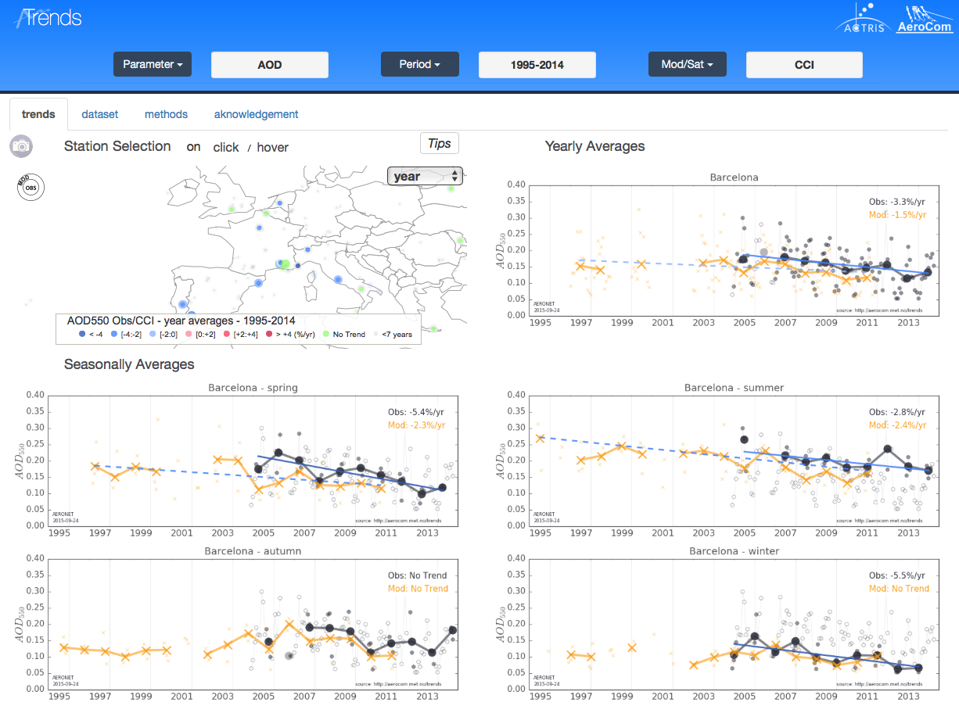

*Figure D13.1.8: Comparison of annual and seasonal trend of AOD at Barcelona between a Aeronet sun photometer and collocated cci-aerosol ATSR2/AATSR satellite data (Named “Mod”).*

**REFERENCES**

Binietoglou, I., Basart, S., Alados-Arboledas, L., Aridimis, V., Argyrouli, A., Baars, H., and Burlizzi, P. (2015). A methodology for investigating dust model performance using synergistic EARLINET/AERONET dust concentration retrievals.

Collaud Coen, M., Andrews, E., Asmi, A., Baltensperger, U.,Bukowiecki, N., Day, D., Fiebig, M., Fjaeraa, A., Flentje, H.,Hyvarinen, A., Jefferson, A., Jenning, S. G., Kouvarakis, G., Lihavainen, H., Lund Myhre, C. L., Malm, W. C., Mihapopoulos, N., Molenar, J. V., O’Dowd, C., Ogren, J., Schichtel, B. A., Sheridan, P., Virkkula, A., Weingartner, E., Weller, R., and Laj, P. (2013): Aerosol decadal trends – Part 1: In-situ optical measurements at GAW and IMPROVE stations, Atmos. Chem. Phys., 13, 869–894,doi:10.5194/acp-13-869-2013.

Gobbi, G. P., Angelini, F., Barnaba, F., Costabile, F., Baldasano, J. M., Basart, S., and Bolignano, A. (2013). Changes in particulate matter physical properties during Saharan advections over Rome (Italy): a four-year study, 2001–2004. Atmospheric Chemistry and Physics, 13(15), 7395-7404.

Granados-Muñoz, M. J., Navas-Guzmán, F., Guerrero-Rascado, J. L., Bravo-Aranda, J. A., Binietoglou, I., Pereira, S. N., and Comerón, A. (2016). Profiling of aerosol microphysical properties at several EARLINET/AERONET sites during the July 2012 ChArMEx/EMEP campaign. Atmospheric Chemistry and Physics, 16(11), 7043-7066.

Heinold, B., Tegen, I. N. A., Esselborn, M., Kandler, K., Knippertz, P., Müller, D., and Althausen, D. (2009). Regional Saharan dust modelling during the SAMUM 2006 campaign. Tellus B, 61(1), 307-324.

Madonna, F., Amato, F., Rosoldi, M., Hey, J. V., & Pappalardo, G. (2016). Ceilometer Aerosol Profiling versus Raman Lidar in the Frame of Interact Campaign of Actris. In EPJ Web of Conferences (Vol. 119, p. 27006). EDP Sciences.

Mona, L., Papagiannopoulos, N., Basart Alpuente, S., Baldasano Recio, J. M., Binietoglou, I., Cornacchia, C., & Pappalardo, G. (2014). EARLINET dust observations vs. BSC-DREAM8b modeled profiles: 12-year-long systematic comparison at Potenza, Italy. Atmospheric chemistry and physics, 14(16), 8781-8793.

Pérez, C., Nickovic, S., Pejanovic, G., Baldasano, J. M., & Özsoy, E. (2006). Interactive dust‐radiation modeling: A step to improve weather forecasts. Journal of Geophysical Research: Atmospheres, 111(D16).

Wiegner, M., Madonna, F., Binietoglou, I., Forkel, R., Gasteiger, J., Geiß, A., andThomas, W. (2014). What is the benefit of ceilometers for aerosol remote sensing? An answer from EARLINET. Atmospheric Measurement Techniques, 7(7), 1979.