ECMWF
Copernicus
Procurement
Invitation to Tender
COPERNICUS PROJECT

Response from HYGEOS to the tender CAMS_43 Global aerosol aspects

ISSUED BY:
ECMWF
Administration Department
Procurement Section
Date: 30 October 2018
Version: Final
Table of Contents
1 Track Record 3
2 Quality of Resources to be Deployed 3
2.1 Description of Resources 3
2.2 CV’s of Key Personnel 4
3 Technical Solution Proposed 4
3.1 Introduction 4
3.2 Sub-section 1, 2, 3 … 4
3.3 Summary of equipment 4
3.4 References 4
4 Management and implementation plan 4
4.1 Introduction 4
4.2 Organigram 5
4.3 Gantt chart and PERT chart 5
4.4 Work package description 5
4.5 Key Performance Indicators 6
4.6 Risk management 6

The main contractor is HYGEOS.
The sub-contractors are:
- Météo-France, France
- KNMI, Netherlands
- Met.No, Norway
- University of Leeds, United Kingdom
- Barcelona Supercomputing Center, Spain
- OB consulting, France

Executive summary
CAMS_43 is a project that requires experience and expertise in several domains: global aerosol modelling, physics and chemistry of the atmosphere, data assimilation and its computational aspects, as well as a detailed knowledge on the architecture and functioning of the IFS. Our proposal is a continuation and an extension of what was achieved during phase 1 of CAMS_43. It will be carried out by essentially the same scientists and engineers who successfully delivered during phase 1, but with some changes to the main Contractor and some Sub-Contractors to account for the evolving employment of key team members. Our team is composed of experts who not only cover all of the scientific aspects of the ITT, but also have already worked together on many of the deliverables of phase 1 of CAMS_43: our group will thus be immediately operational and ready to deliver from the first day of phase 2. We describe below the work programme for work packages 43.1 to 43.5 in general terms. A more detailed description is available in the technical solution Section.
Our proposal for the work package 43.1, modelling aspect, is ambitious. A dynamical Secondary Organic Aerosol (SOA) module was successfully implemented during phase 1. It will be complexified and evaluated against speciated observations in phase 2. The current operational simpler scheme that does not require a coupling to the chemistry will also be improved on the basis of using a precursor gas for both anthropogenic and biogenic SOA. A review of the new nitrate aerosol module that was recently implemented will be carried out and compared against other available schemes. Following this, some improvement will be proposed and implemented. A new sea-salt emission scheme that uses the inputs and/or outputs of the wave model of the IFS (e.g., surface salinity, wave height and roughness Reynolds number) will be implemented. Black carbon, an important species through its radiative properties, has been barely touched by the developments of phase 1: a full review of the skill of the IFS for black carbon concentrations will be carried out using data from surface networks and field campaigns. The opportunity to include brown carbon as a new species will be discussed with ECMWF and tested in an experimental mode. The optical properties that are used will be reviewed, especially for dust. Experimental tests with a more detailed dust mineralogy will be carried out and potential modifications of the dust optical and physical properties will be proposed to ECMWF. All of these developments will be combined, where possible, for both IFS-AER and IFS-GLOMAP. Some of the developments that do not necessitate chemical input will be considered and evaluated both in standalone aerosol configuration and coupled with the chemistry.
IFS-GLOMAP has been a major focus of the first phase of CAMS_43, with the objective of improving its skill for the headline Aerosol Optical Depth score. Now that this objective is within reach, a more diversified evaluation of IFS-GLOMAP is due, especially concerning the speciated aerosol concentrations and the simulated size distribution. From this evaluation, a number of improvements specific to IFS-GLOMAP will be envisaged and experimented, discussed with ECMWF and experimented. A major achievement of phase 1 has been to implement a new version of GLOMAP that includes the stratospheric aerosol capacity and then to develop the combined IFS-CB05-BASCOE-GLOMAP system that is able to represent both tropospheric and stratospheric aerosols and chemistry. This complex system and the simpler IFS-AER will be evaluated in quiescent mode and against several tropospheric and stratospheric volcanic eruptions. This evaluation will provide directions for new developments that will be proposed and carried out. The opportunity to implement a more complex stratospheric sectional aerosol scheme in IFS-AER, with semi-prognostic chemical inputs, will be discussed with ECMWF.
For work package 43.2, we will continue to provide with the high level of assistance in the merging of new developments into operational branches and in the evaluation of the various configurations possible for operational runs. The CAMS_43 team will propose configurations for testing, run test simulations and evaluate them against a range of observations to help ECMWF in deciding which configuration is optimal for operational purposes. In case of problems in the e-suite, as happened with the implementation of operational cycle 45R1, our team will quickly analyse problems and provide possible fixes if necessary. These activities will start with the planned launch of operational cycle 46R1 in June 2019.
Work package 3 is the most experimental of all work packages. In the first phase of CAMS_43, we have set up a benchmarking exercise to assess both the accuracy and computational speed of clear-sky shortwave radiance calculations (30) in order to assess trade-off between these two requirements. In the second phase of CAMS_43, we plan to extend the 1D-VAR model so as to evaluate the potential benefits of multi-wavelength radiance assimilation on the analysis of the aerosol vertical profile. This will be performed in three steps. First we will choose in agreement with ECMWF a suitable radiative transfer code which we will implement into our standalone 1D-Var assimilation system. We will then investigate the potential benefit of multi-wavelength radiance assimilation using synthetic observations with a view on understanding how it can improve the representation of the aerosol vertical profile under different situations of surface versus lofted aerosol layers, and different situations of systematic errors on the surface characteristics, aerosol types, and top-of-atmosphere aerosol radiances. We will then test and evaluate the 1D-Var assimilation system using real MODIS and VIIRS reflectances. This work will inform ECMWF on how to introduce a 1D-Var or 4D-Var assimilation of aerosol radiances in the IFS by the end of the project.
The service evolution work package (43.4) is a combination of two distinct tasks: to operate and improve the aerosol alert service and to provide validated dry and wet deposition products. The dry and wet deposition parameterizations have been reviewed and upgraded during the first phase of CAMS_43. The limited evaluation that was carried out then will be expanded using a larger range of observational datasets. This evaluation work can in turn give indications on potential improvements of the parameterization. Dry deposition products in particular can be of interest to many users in the energy community because of their impact on the soiling of solar panels. Interaction with CAMS72 (solar radiation) and potential users can be organized with ECMWF. In the service evolution, the CAMS_43 team would also like to experiment, with the assistance of CAMS81 (emissions) with dynamical emissions for anthropogenic emissions, as a function of meteorological parameters. This has been shown to have a beneficial impact on the skill of forecasts, over Europe in particular, where there is a strong correlation between heating of buildings and associated emissions of aerosols and aerosol precursors with surface temperature.
Work package 43.5 consists of two tasks: documentation and user support. User support has been provided all along the first phase of CAMS_43 and will continue during phase 2, using the ECMWF user ticket system and also through direct contact. Attention will be paid to use high standards for the editorial quality of the deliverable reports, so that they will be easy to disseminate and re-use in the CAMS documentation. The CAMS_43 team will participate to the documentation efforts undertaken by ECMWF.
Finally, management will mostly follow the template setup during phase one, which witnessed smooth communication between ECMWF and the CAMS_43 team, and between the main contractor and the subcontractors. In addition to that, bimonthly teleconferences will be organized to coordinate the subcontractors. We expect improvements on the administrative running of the proposal, with a more reactive administrative department behind the CAMS_43 team.

Track Record

Our response to the CAMS_43 tender involves a team of thirteen experienced research scientists (one acting as consultant) from six European institutes and private companies. Our proposed team has an outstanding knowledge and experience in aerosol modelling, both within predecessor projects such as GEMS, MACC and as part of other projects, with a wide range of models. Our team is the continuation and an extension of the work force who successfully led the first phase of CAMS_43: the main contributors of the first phase are all here; and two new partners: the Barcelona Supercomputing Center (BSC) and KNMI are now part of our answer. BSC hosts Jeronimo Escribano, who was the main contributor to work package 43.3 during first phase and who will work on the same work package during the second phase. BSC also has very useful expertise on regional and global aerosol modelling as well as in aerosol data assimilation. KNMI was a very useful partner during the first phase of the project, as the interaction between aerosol and chemistry grew more and more important. The fact that KNMI enters the CAMS_43 team formalizes the close collaboration that already exists. The expertise in atmospheric radiative transfer, which was provided by the Université of Lille in the first phase of CAMS_43, will now come from Hygeos and OB consulting, although it should also be recognized that it is less critical to the CAMS_43 extension.
The team members have already worked together during the first phase of CAMS_43, and more generally on aerosol related aspects, which ensures a smooth start once the project begins. The track record section details the expertise of each of the team members and institutions involved. As team members have complementary experience and skills spanning several aspects of the project, a brief summary of the main research domains of each of the participants is proposed here:
- Global aerosol modelling: Remy, Boucher, Mann, Michou, Nabat, Di Tomaso, Schulz, Perez Garcia Pando
- Global chemistry modelling: Huijnen, Boucher
- Knowledge of the IFS code: Remy, Huijnen, Boucher
- Data assimilation: Escribano, Di Tomaso, Rémy, Boucher
- Atmospheric radiative transfer: Escribano, Boucher, Rémy
- Stratospheric aerosol modelling and evaluation: Mann, Rémy, Boucher, Huijnen, Sengupta, Shallcross
- Aerosol alert system: Mortier, Schulz
- Links to international projects (e.g. Climate Model Intercomparison Project, Aerocom, SPARC stratospheric aerosol initiative, ESA Climate Change Initiative) and climate assessments (e.g. Intergovernmental Panel on Climate Change): Boucher, Mann, Schulz, Huijnen, Perez Garcia-Pando

Track record of HYGEOS

Founded in 2001 and based in Lille, HYGEOS is a worker cooperative company specialized in processing, analysis and validation of Earth Observation data. HYGEOS carries out research and development activities in optical remote sensing. Thanks to its expertise in radiative transfer in the atmosphere, in the ocean and over land, HYGEOS performs prospective studies to help define system requirements of future satellite missions and develops in-house methods, software, tools and products to exploit the satellite imagery information.
HYGEOS is constantly innovating in connection with research institutes and academic world. This strong association guarantees state-of-the-art scientific algorithms supported by the most recent technologies to process large datasets. HYGEOS is also investing in the training of Ph.D students. HYGEOS is participating in environment monitoring projects focusing on open ocean and coastal water, land ecosystem, solar energy, air quality, meteorology and climate.
HYGEOS has agreed to host the CAMS_43 project; its CEO, Didier Ramon, is personally committed to the success of this project. HYGEOS focuses on satellite retrievals and on product for the energy sector, which all involve aerosols. HYGEOS has expertise in atmospheric radiative transfer for satellite retrievals and also works in close collaboration with the Université de Lille on these matters. The Université de Lille has several experts in radiative transfer applied to aerosols such as Philippe Dubuisson and Laurent Labonnote, who participated to the first phase of CAMS_43, and can be consulted if needed. This collaboration and expertise in satellite products will be useful for work package 43.3. HYGEOS is already involved in Copernicus, as a subcontractor to VITO in the Copernicus Climate Change Service (C3S). HYGEOS’s share of the project funding is 49%.
Dr. Samuel Rémy, our proposed Prime Investigator and service manager, has twelve years of experience in atmospheric and meteorological research. Since all administrative hurdles have already been ironed out, he will be able to join HYGEOS on April 1st, 2019 for this project. Samuel is the current service manager of the phase 1 of CAMS_43. He has been responsible for the timely and satisfactory delivery of a number of deliverables of Work Packages 0, 1, 2 and 4, and is in sole charge of Work Package 2. Having worked in an operational environment previously, at ECMWF and Météo-France, Samuel is well aware of the reliability and timing constraints associated with running an operational model. He has been maintaining and upgrading the current aerosol models IFS-AER and IFS-GLOMAP for nearly five years, first at ECMWF within the Chemical Aspects section and then remotely from CNRS (initially at LMD then at IPSL), in the MACC-II, MACC-III and then CAMS_43 projects. Samuel has authored or co-authored more than 40 articles published in peer-reviewed journals, and is responsible for the aerosol section of the BAMS State of the Climate publication since 2015. In summary Samuel has an all-round knowledge not only of both aerosol schemes currently implemented in IFS, but also of the whole IFS system, including the IFS meteorological model and the 4D-var assimilation system. During his three years of PhD at the Météo-France research centre, Samuel maintained and upgraded a 1D assimilation system associated with a 1D boundary layer model. Several novel assimilation algorithms were tested and successfully implemented; this experience will be very useful in managing the Work Package dedicated to aerosol data assimilation. Samuel can draw on his managing experience during phase 1 of CAMS_43, during his time at Météo-France as well as in Hexaflux where he was involved in project, software and staff management.

Track record of Météo-France

Météo-France is the governmental French meteorological and climatological national service. Its primary mission is to ensure the safety of people and goods, as far as weather is involved. Météo-France-CNRM (or MF-CNRM) is the department of Météo-France responsible for conducting the largest part of the meteorological research activities. Primarily oriented towards the requirements of the users in the area of meteorology, its research encompasses the atmosphere, extending to, and including, closely related scientific domains, such as atmospheric chemistry, the upper ocean, physics and dynamics of the snow cover, and surface hydrology. To carry out its missions, MF-CNRM hosts approximately 225 permanent positions, and 45 students and visitors. MF-CNRM has been conducting research and development activities concerning air composition modelling for more than 20 years, which encompasses chemistry/aerosols climate-interaction studies, air quality modelling and data assimilation. These activities are mostly carried out using the CNRM-CM and MOCAGE modelling systems. Météo-France and MF-CNRM are based in Toulouse, where the services will be provided; its share of the project funding is 13%.
Dr. Pierre Nabat, from Météo-France-CNRM, is specialized in aerosol modelling and the study of aerosol-climate interactions. During his PhD, his work has been focused on the Mediterranean region, showing the essential role of aerosols in regional climate. He has notably adapted the IFS-AER aerosol scheme into the regional climate system of the CNRM, CNRM-RCSM. Now he contributes further to the development of this aerosol module in the global model CNRM-CM, whose atmospheric component is a climate version of the Numerical Weather Prediction (NWP) model ARPEGE-IFS. His work on sea-salt and dust emissions in CNRM-CM was very useful during CAMS_43 phase 1. His expertise on the aerosol module of CNRM-CM will be helpful for Work Package 43.1.
Dr. Martine Michou, from Météo-France-CNRM, has been involved in chemistry and aerosol modelling in global models for about 15 years. She first developed the module in charge of the surface interactions of the gaseous species described in the MOCAGE Chemistry Transport Model of CNRM. She also contributed to the evaluation of the chemistry module included in CNRM-CM. Finally, she led the implementation and routine use of the C-IFS-AER aerosol module within CNRM-CM. She is strongly involved in the evolution of this module within CNRM-CM, and as such will be very useful in Work Package 43.1.

Track record of MET Norway

MET Norway is the meteorological service of Norway, based in Oslo. It provides meteorological forecasts and warnings for the general public as well as civil services and the military. The research department of MetNo is composed of approximatively 70 scientists and meteorologists; it focuses on meteorology, oceanography, remote sensing, environmental research and climate modelling. As part of its research activities, it has operated the aerosol alert service of the MACC and CAMS_43 projects for more than three years now, with results available for all major global regions via a dedicated website (http://Aerocom.met.no/cgi-bin/Aerocom/surfobs_annualrs.pl?Parameter0=ALERT_AER). Case by case validation was done and MetNo has recently shown that the contingency statistics can be usefully established for aerosol alerts using Aeronet data. MetNo was also involved in the overall validation activity of the MACC and CAMS projects. MET Norway’s share of the project funding is 14%.

Dr. Michael Schulz from MetNo, our proposed co-manager of Work Package 43.4, is the coordinator of the Aerocom project (59, 13, 73 and 106 among others), which aims at a better understanding of aerosols and their impacts on climate. He designed and coded a modal aerosol scheme in the INteraction with Chemistry and Aerosol (INCA) model while working for the Laboratoire des Sciences du Climat et de l’Environnement (LSCE) in France. He has also been a participant of the VAL sub-project of the GEMS and MACC projects; he is involved in the AEROSOL_CCI and ACTRIS projects among others. Within the MACC-II and MACC-III projects, Michael has also been responsible for the maintenance and development of an aerosol alert service based on the output from IFS-AER in the MACC series of projects and then in CAMS_43 phase 1. He is ideally suited to pursue this effort within CAMS_43 phase 2. With his long experience in global aerosol modelling, and being in contact with a large variety of aerosol modelling approaches through the Aerocom project, he will also be in a perfect position to provide some guidance on aerosol modelling work.
Augustin Mortier from MetNo has a long experience on aerosol model evaluation within the AEROCOM project. He has been responsible for the maintenance and the development of the aerosol alert system; this expertise will be invaluable for the success of the transfer of the aerosol alert service to the Global Service Provider in the framework of Work Package 43.4.

Track record of the University of Leeds

The School of Earth and Environment at the University of Leeds (ULEEDS) has very strong research interests in wide-ranging areas of atmospheric science, and in the 2014 UK Research Excellence Framework (REF2014) 90% of its research was graded as world-leading or internationally excellent. Leeds hosts the NERC National Centre for Atmospheric Science (NCAS) directorate. The University of Leeds has been involved in the MACC projects (integration of GLOMAP into the IFS) and then in the first phase of CAMS_43. The University of Leeds will receive 11% of the project funding.
Dr. Graham Mann is a Lecturer in Atmospheric Science at the University of Leeds, part-funded by the UK National Centre for Atmospheric Science. Dr. Mann co-ordinates the development of the GLOMAP-mode aerosol microphysics scheme (72), which was originally developed in the TOMCAT chemistry transport model and re-calibrated (74) for improved agreement with the more sophisticated sectional GLOMAP-bin scheme (110). Dr. Mann oversaw the implementation of GLOMAP into the IFS during MACC-II (75, 76, 77 and 78) and further development during MACC-III via coupling to the TM5 chemistry scheme within the IFS. Dr. Mann led the aerosol microphysics intercomparison (73) during the 2nd phase of the international Aerocom activity and co-leads the ISA-MIP interactive stratospheric aerosol model intercomparison (116), one component of the current SPARC initiative “Stratospheric Sulphur and Its Role in Climate” (SSiRC).
Kamalika Sengupta is a Researcher (PhD) with over 6 years' experience in scientific data analysis. Proficient in programming in IDL, R, MATLAB to process, analyse and interpret data. Kamalika is experienced in aerosol microphysics modelling, organic aerosol and size distribution evaluation.
Sarah Shallcross is currently in the final year of her PhD at the University of Leeds. As part of her research she gathered ground-based lidar observations of the Mt Pinatubo volcanic aerosol plume from Mauna Loa and several mid-latitude sites, and used these datasets to evaluate interactive stratospheric aerosol model simulations

Track record of the Barcelona Supercomputing Center (BSC)

The Barcelona Supercomputing Centre (BSC) is the Spanish national supercomputing facility and a hosting member of the PRACE distributed supercomputing infrastructure. The Centre houses MareNostrum, one of the most powerful supercomputers in Europe. The mission of BSC is to research,develop and manage information technologies in order to facilitate scientific progress. BSC combines HPC service provision, and R&D into both computer and computational science (life, earth andengineering sciences) under one roof. The BSC Earth Sciences Department (ES-BSC) focuses on high-resolution air quality and meteorological modelling, global and regional mineral dust modelling as well as global and regional climate modelling. The department has a wide experience in running operational atmospheric forecasting systems and delivering timely and quality forecasts, observations, information and knowledge to users. The ES-BSC currently hosts the CALIOPE air quality forecast system (http://www.bsc.es/caliope), the Barcelona Dust Forecast Centre (http://dust.aemet.es) and the WMO Regional Center Northen Africa-Middle
East-Europe for the Sand and Dust Storm Warning Advisory and Assessment System (SDS-WAS) (http://sds-was.aemet.es). The department also facilitates knowledge and technology transfer of state-of-the-art research and develops services for renewable energy, urban development, infrastructure, transport, insurance, health and agriculture. Another major activity in the ES-BSC is the development of the online multi-scale NMMB/BSC Chemical Transport Model, which has participated in the AQMEII-Phase2 intercomparison exercise and provides routine products of global aerosols to the ICAP multi-model ensemble. BSC is part of the CAMS84 (validation), CAMS81 (emissions) and CAMS95 projects. BSC’s share of the project is about 7%.

Jeronimo Escribano has completed his PhD on the inversion of regional dust aerosol fluxes over Northern Africa in 2016. Since then, he worked in the first phase of CAMS_43, on work package 43.3, which aims at studying the potential of radiance assimilation for aerosols. His unique blend of data assimilation, radiation and aerosol expertise enabled him to successfully carry out the ambitious program of this work package. Jeronimo has joined BSC in the summer of 2018 and is now working on aerosol lidar data assimilation there.

Enza di Tomaso is a researcher in the Atmospheric Composition Group specialized on mineral dust and data assimilation. Enza was a leading force behind the implementation of the data assimilation system of one of BSC’s aerosol model, NMMB-MONARCH. Before that, during her stay at ECMWF, she specialized in radiance assimilation.

Carlos Perez Garcia Pando is the leader of the Atmospheric Composition group at the Earth Science department of BSC. Carlos is also an AXA Professor on Sand and Dust Storms. Carlos’s internationally recognized expertise on dust modelling will be very useful to the project.

Track record of the Royal Netherlands Meteorological Institute (KNMI)

The Royal Netherlands Meteorological Institute (KNMI) is the Dutch national weather service and centre for climate research. The institute combines in house operational as well as strategic research tasks. As an integral part of the Ministry of Infrastructure and Environment KNMI provides advice on weather and climate to national, regional and local authorities on a day-to-day basis. KNMI is participating in many European projects on both climate and space research and keeps close ties with many of its stakeholders.
Within the division Research and Development, Weather and Climate Modelling, the TM5 chemistry and aerosol model (http://tm.knmi.nl) has been developed and maintained, which forms an important building block in many modelling and retrieval applications. As part of a Europe-wide consortium KNMI is one of the lead developers of EC-Earth, an Earth System Model to study future climate, with contributions to international climate change projections such as CMIP5.
KNMI has a long-standing experience and expertise with satellite missions observing atmospheric composition, and has been involved during phases of the CAMS development. KNMI is currently leading the CAMS_42 tender on Global Reactive Gases, CAMS_84 tender on Global and Regional a posteriori Validation. Furthermore, it is subcontractor in CAMS_50 (regional air quality production), contributes to a CAMS_95 use case to provide city-scale air pollution forecasts. KNMI further hosts the Principal Investigator for the Sentinel-5 Precursor (TROPOMI).
KNMI’s offices are in De Bilt (Netherlands); KNMI’s share of the project is about 5%.

Vincent Huijnen is a senior scientist within the section Research and Development, Weather and Climate modelling, working in the field of atmospheric composition modelling. Vincent has built up about a decade of research experience in the field of atmospheric chemistry and leads the CAMS_42 tender, recently in particularly close collaboration with the aerosol modelling component in CAMS. Prior to this, Vincent has played a major role in the development the integrated chemistry within the IFS using the chemistry from TM5. As part of the MACC global validation subproject Vincent has coordinated the production of near-real time validation reports.

Track record of OB consulting

Olivier Boucher, consultant with a special focus on providing guidance for WP43.3, was the project leader of the first phase of CAMS_43. Olivier is a recognized international authority on almost all aspects of aerosol modelling with 25 years of experience in aerosol research. Olivier has contributed to the development of several aerosol models (LMD model, described in 85; M7, described in 121 and the S3A stratospheric aerosol model, described in 61). He designed the current aerosol scheme of the IFS (IFS-AER) with J.-J. Morcrette and has co-ordinated the AEROSOL sub-project of the EU funded Global and regional Earth-system Monitoring using Satellite and in-situ data (GEMS, from 2005 to 2009) and Monitoring Atmospheric Composition and Climate (MACC-I,-II and –III, from 2009 to 2015) projects. He is the author or co-author of more than 200 peer-reviewed publications covering many aspects of aerosol-radiation-cloud-precipitation-vegetation-climate interactions. Olivier has a strong management experience both from his previous job as Head of the Climate, Chemistry and Ecosystems team at the Met Office and his current job in France (e.g. as responsible of the IPSL Climate Modelling Centre, see https://cmc.ipsl.fr). He has led or participated to numerous scientific projects related to aerosol modelling, aerosol-radiation-cloud interactions, atmospheric composition and their impacts on meteorology and climate. He has published a reference textbook entitled “Atmospheric Aerosols: Properties and Climate Impacts” (Springer, 350 pp., 2015). Olivier was listed among the world’s most influential scientific minds (Thomson-Reuters) in 2014 and the Highly Cited Researchers (Clarivate Analytics) every year since 2014. He also received the outstanding young scientist awards from the EGU in 2004, the Met Office leadership award in 2010, the Harry Otten prize for meteorology in 2015. He is a regular contributor to the IPCC work, including recently as Coordinating Lead Author of the “Clouds and Aerosols” chapter of the Fifth Assessment Report, and as such contributed to the Nobel Peace Prize received by the IPCC in 2007.
Olivier will contribute to the CAMS_43 extension in a responsive manner through OB consulting as self-employed. Olivier is based in Paris and his share of the project’s funding is around 1%.

Quality of Resources to be Deployed

Description of Resources
Our proposed team is mostly a continuation of the team who led successfully the first phase of CAMS_43: as such it is well-placed to deliver on all components of the development of global aerosol aspects. The team has already a solid experience with aerosol model developments from the CAMS_43, MACC and GEMS projects. It has also been reshaped to match as best as possible the requirements for this project. The team members have a long experience in working together and with the Global Service Provider. MF-CNRM and the Global Service Provider share the same IFS code, which is used in different configurations in the two institutes. Furthermore HYGEOS and KNMI already collaborate on a number of common topics between aerosol and chemical models in the IFS (wet and dry deposition, sulfates, nitrates, secondary organics). The partners are thus able to mobilize the resources and skills required for the implementation of the CAMS_43 developments relating to aerosol modelling, data assimilation and atmospheric radiative transfer.
Our core team is composed of thirteen research scientists from six research centres: Samuel Rémy, Olivier Boucher, Michael Schulz, Augustin Mortier, Graham Mann, Kamalika Sengupta, Sarah Shallcross, Jeronimo Escribano, Enza Di Tomaso, Carlos Perez Garcia Pando, Pierre Nabat, Martine Michou and Vincent Huijnen. Our team was designed to be small enough to be united, while covering all aspect of the CAMS_43 tender: aerosol parametrization and modelling, knowledge of the IFS system, data assimilation, radiative transfer, modelling of chemical processes and aerosol alert service. Our team is also well connected to and collaborates with several other aerosol and air quality modelling teams such as IPSL/LSCE, NASA, University of Lille, University of Reading, and Met Office and can draw on their expertise in relevant domains. The administrative and financial aspects of the projects that concern HYGEOS will be taken care of by Silvia Jacob. Silvia can draw on nearly 10 years’ experience in managing projects for, among others, the European Space Agency (ESA), the European Commission and several French research funding agencies.
Samuel Remy will be our team leader and prime investigator. He will devote all of his time to CAMS_43 and will manage work packages 43.0, 43.2 and 43.5. He will also co-manage work packages 43.1, 43.3 and 43.4 and will contribute to most of the deliverables of the project. His involvement in the aerosol subprojects of MACC-II and III as well as his experience in CAMS_43 phase 1 provided him with an in-depth knowledge of user requirement for aerosol products, the current state of the IFS and aerosol modelling around the world. As such, he is ideally suited to the position of prime investigator and to lead a team that will propose and implement a roadmap towards an improvement of the aerosol modelling and data assimilation system, with the aim of providing state-of-the-art aerosol developments that form the bedrock of the CAMS aerosol products and services. Samuel is also a core member of the InDust COST action, which ensures a strong connexion to the dust observation and modelling communities.
Olivier Boucher will provide overall guidance and general advice, but will also be responsible of the quality assurance of the deliverables, especially but not exclusively for work package 43.3. His solid experience in aerosol modelling, data assimilation and radiative transfer, together with his experience as the coordinator of the first phase of CAMS_43, will ensure a smooth transition to the second phase of CAMS_43.
Vincent Huijnen possesses a strong expertise in modelling of chemical processes, in running simulations with the IFS and coupled aerosol with chemistry, and in working in the ECMWF environment. He is also the coordinator of CAMS42 (global chemical aspects): his experience of chemistry modelling and of how it impacts and is impacted by aerosols will be useful for several deliverables that involve work on both the chemistry and aerosol modules of the IFS. His knowledge of the IFS code also ensures that the developments at the interface between aerosols and chemistry will be smoothly implemented and tested.
Pierre Nabat has been involved in aerosol modelling for about seven years, in different climate models including interactive aerosol schemes (RegCM, CNRM-RCSM, CNRM-CM). These last two models use an implemented version of the IFS-AER aerosol module.
Martine Michou has been working on atmospheric composition modelling for about 15 years, first on gaseous chemistry then on aerosols. Since about 5 years, she uses the CNRM climate system, CNRM-CM, whose most recent version CNRM-CM6 is based on cycle 37 of the IFS NWP model. She is familiar with the IFS-AER aerosol module, as she implemented a version of it in CNRM-CM. Since this implementation, she has been mainly working on aerosol modelling at CNRM. Martine and Pierre’s experience and interest in the development of the aerosol scheme of IFS-AER will contribute to the success of Work Package 43.1.
Dr. Graham Mann has over 18 years professional research experience in atmospheric science and has an established track record of research direction, having been lead or co-supervisor of 4 previous and 3 current PhD studentships and providing ongoing training and support to a range of researchers in the global aerosol and chemistry modelling groups at the University of Leeds. He co-ordinates the development of the GLOMAP-mode aerosol microphysics scheme, as implemented in the TOMCAT chemistry transport model, the UM-UKCA composition-climate model and within the IFS.
Jeronimo Escribano has been behind the success of work package 43.3 during the first phase. Jeronimo agreed to spend a significant fraction of his time on the same work package during the second phase.
Enza Di Tomaso is an experienced researcher and has a strong expertise in aerosol modelling, in aerosol data assimilation and in radiance assimilation. Jeronimo and Enza are working closely together and will share expertise on work package 43.3.
Michael Schulz is in an ideal position to deliver on the aerosol warning service that is part of Work Package 43.4, as he is currently responsible for the aerosol alert service in the first phase of CAMS_43. His 20 years’ experience in aerosol model development and his links with the CAMS project dedicated to validation of the products of the Global and Regional projects will be invaluable, as are his links with various aerosol modelling communities through the AEROCOM project which he co-manages. This direct link to AEROCOM will ensure that the WP43.1 can have quick feedbacks on aerosol model development and also help the participation to the AEROCOM experiments.
Augustin Mortier has been the main researcher and developed working on the aerosol alert service during phase 1. His experience and skill in upgrading this system will ensure that the deliverables associated with the aerosol alert service will be successfully carried out.
The personnel involved in phase 2 of CAMS_43 are:
- HYGEOS: Samuel Remy and Silvia Jacob
- Météo-France: Pierre Nabat and Martine Michou
- KNMI : Vincent Huijnen
- BSC : Jeronimo Escribano, Enza Di Tomaso and Carlos Perez Garcia Pando
- MET Norway: Michael Schulz and Augustin Mortier
- University of Leeds: Graham Mann, Kamalika Sengupta and Sarah Shallcross
- OB Consulting: Olivier Boucher

A summary of the HR profiles of each of these contributors and their qualifications are detailed in Table 1.
Table 1: HR Profiles
Title | Broad description of work in relation to Service | List of personnel who fit the profile and whose CVs are submitted with tender | Qualifications | Effort / engagement in months
Prime Investigator – Service manager | Coordinator and service manager of the project. Link to users and with ECMWF. Manager of WP43.0, 2 and 5. Co-manager of WP43.1, 3 and 4. | Samuel Remy, HYGEOS | Service manager and full time contributor to CAMS_43 phase 1. Involved in the AER sub-project of MACC-II and III. Strong aerosol and IFS expertise | 33
Senior team member | Co-manager of WP43.1; responsible or involved in the deliverables with a chemical component | Vincent Huijnen, KNMI | Expert on chemical modelling and on the IFS system. Coordinator of the CAMS42 project; involved in MACC. | 3.36
Senior team member | Involved or responsible of IFS-GLOMAP and stratospheric deliverables | Graham Mann | Expert in tropospheric and stratospheric aerosol modelling | 1.65
Contributor | Co-manager of WP43.3 | Olivier Boucher | Coordinator of the AER sub-project of the GEMS, MACC, MACC-II and MACC-III projects. Strong aerosol expertise. | 0.75
Contributor | Co-manager of WP43.4 | Michael Schulz | Manager of the current aerosol alert service in CAMS_43 phase 1 and co-manager of Aerocom | 1.2
Contributor | WP43.4 | Augustin Mortier | Aerosol modelling expert; main developed of the aerosol alert service during CAMS_43 phase 1 | 7.7
Contributors | WP43.1 | Pierre Nabat  Martine Michou  Météo-France non permanent junior scientist | Aerosol modelling expert  Aerosol modelling expert | 1.3  1  12
Contributor | WP43.3 | Jeronimo Escribano  Enza Di Tomaso | Aerosol data assimilation experts; main contributor to WP3 during CAMS_43 phase 1 (Jeronimo) | 7.75
Contributor | WP43.1 | Kamalika Sengupta  Sarah Shalcross |  | 2  2
Administrator | WP43.0 | Silvia Jacob, HYGEOS | Administrator at HYGEOS | 3.3

CV’s of Key Personnel

List of CVs of the key personnel involved in the proposal for CAMS_43 phase2:
- HYGEOS : Samuel REMY
- OB consulting : Olivier BOUCHER
- KNMI : Vincent HUIJNEN
- MET Norway : Michael SCHULZ
- MET Norway : Augustin MORTIER
- Météo-France : Pierre NABAT
- Météo-France : Martine MICHOU
- ULeeds : Graham MANN
- ULeeds : Kamalika Sengupta
- BSC : Jeronimo ESCRIBANO
- BSC : Enza DI TOMASO
- BSC : Carlos Perez Garcia Pando

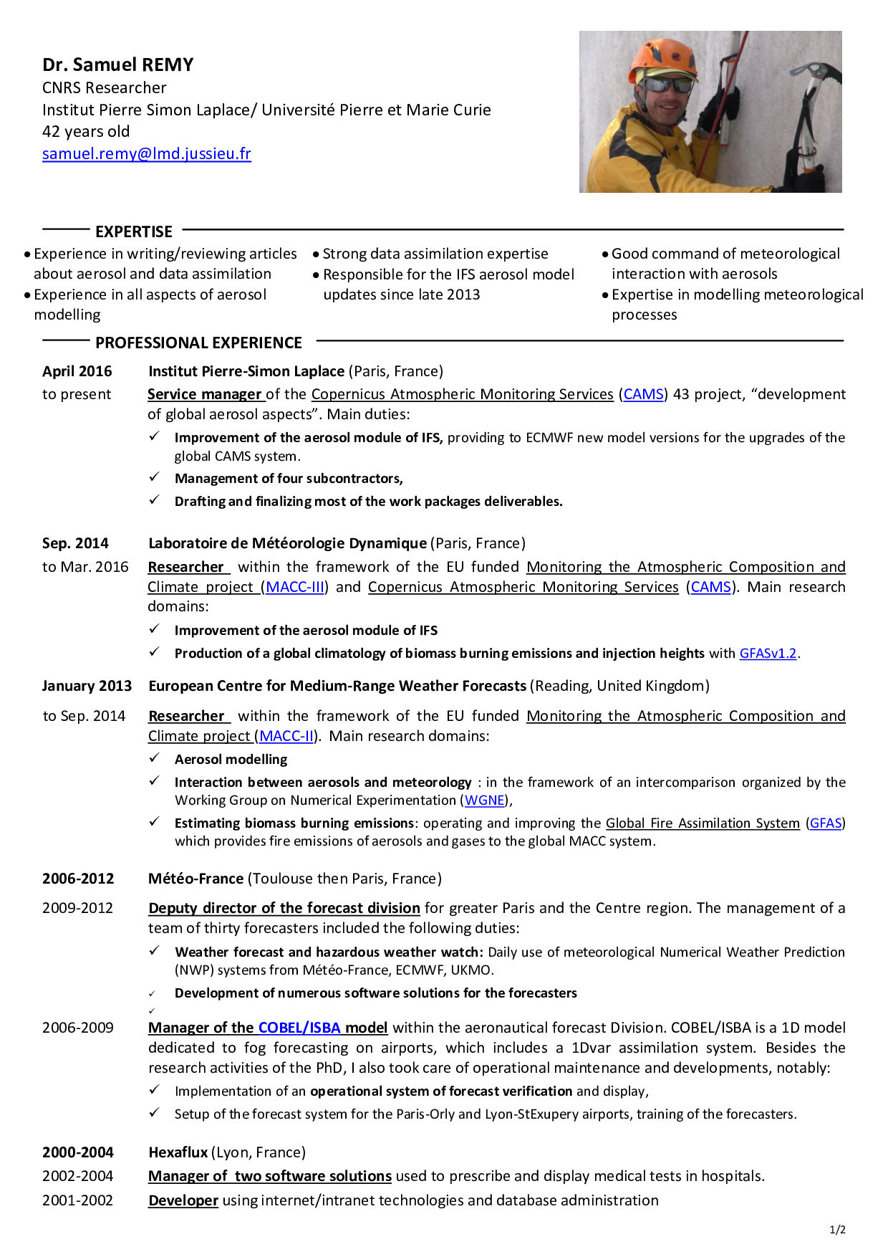

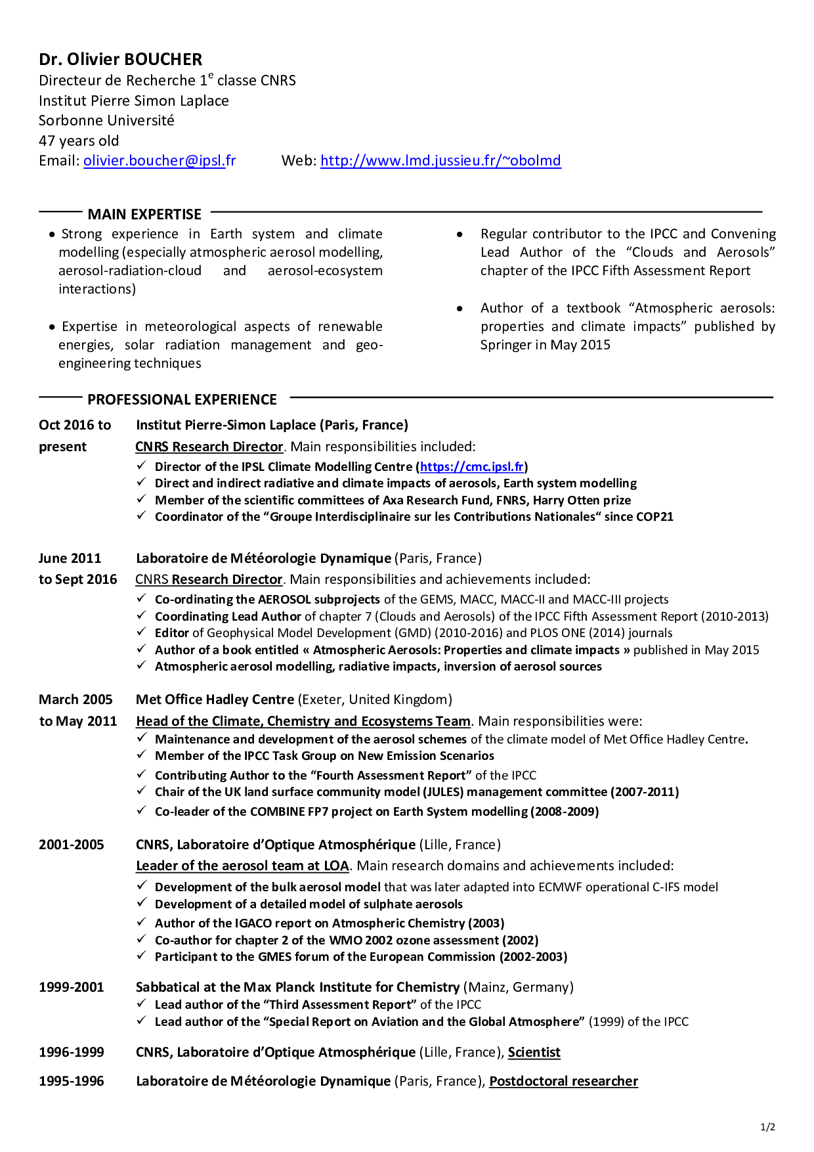

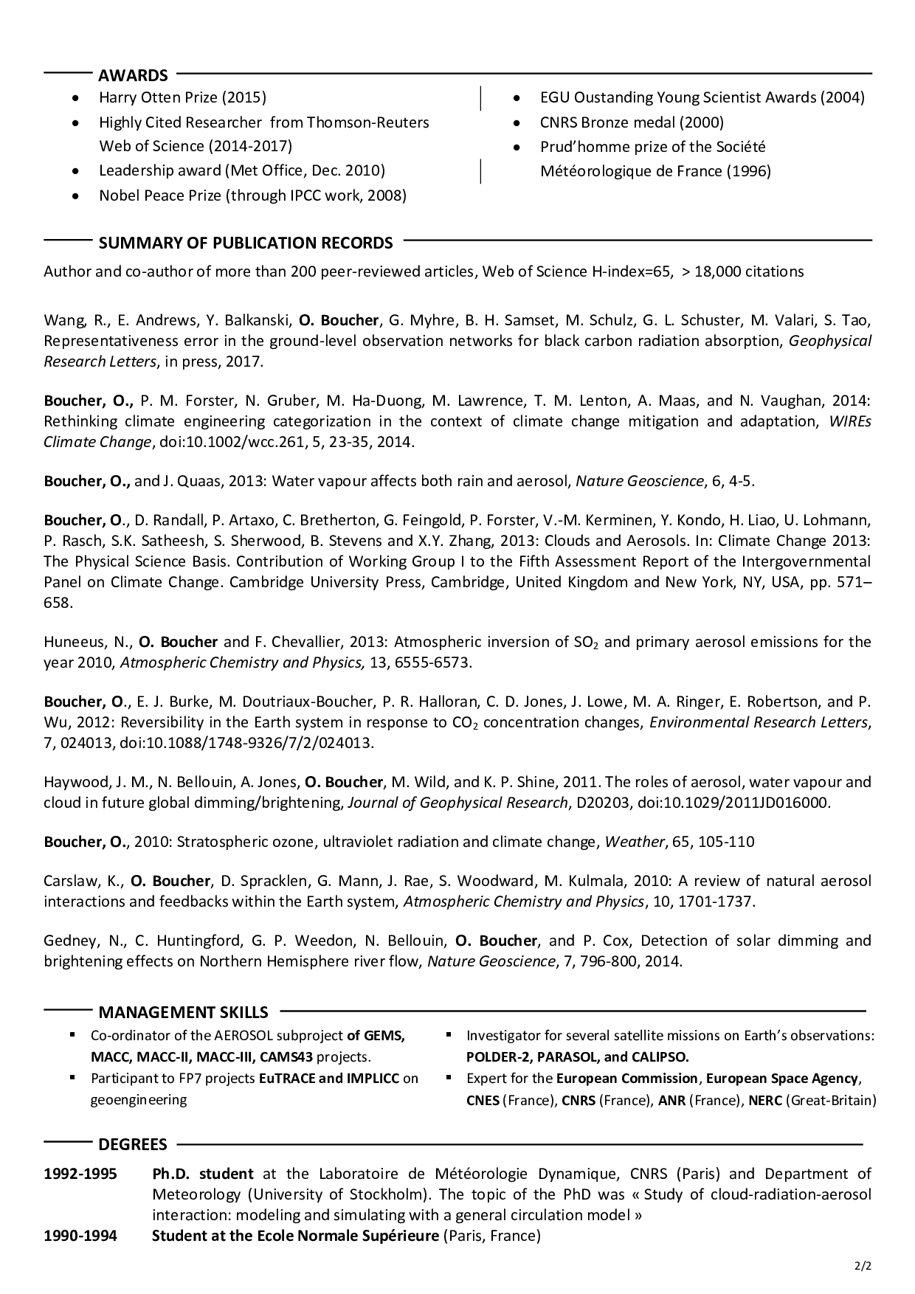

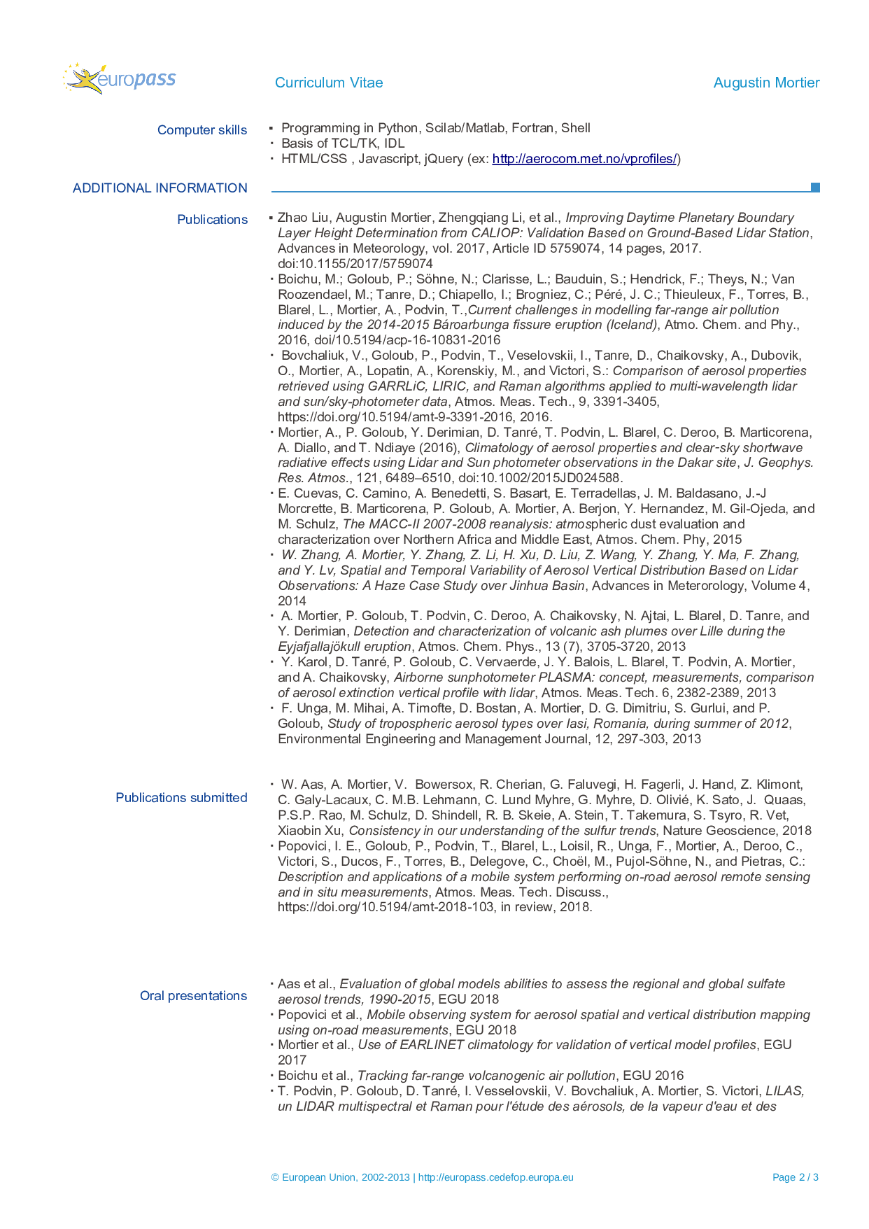

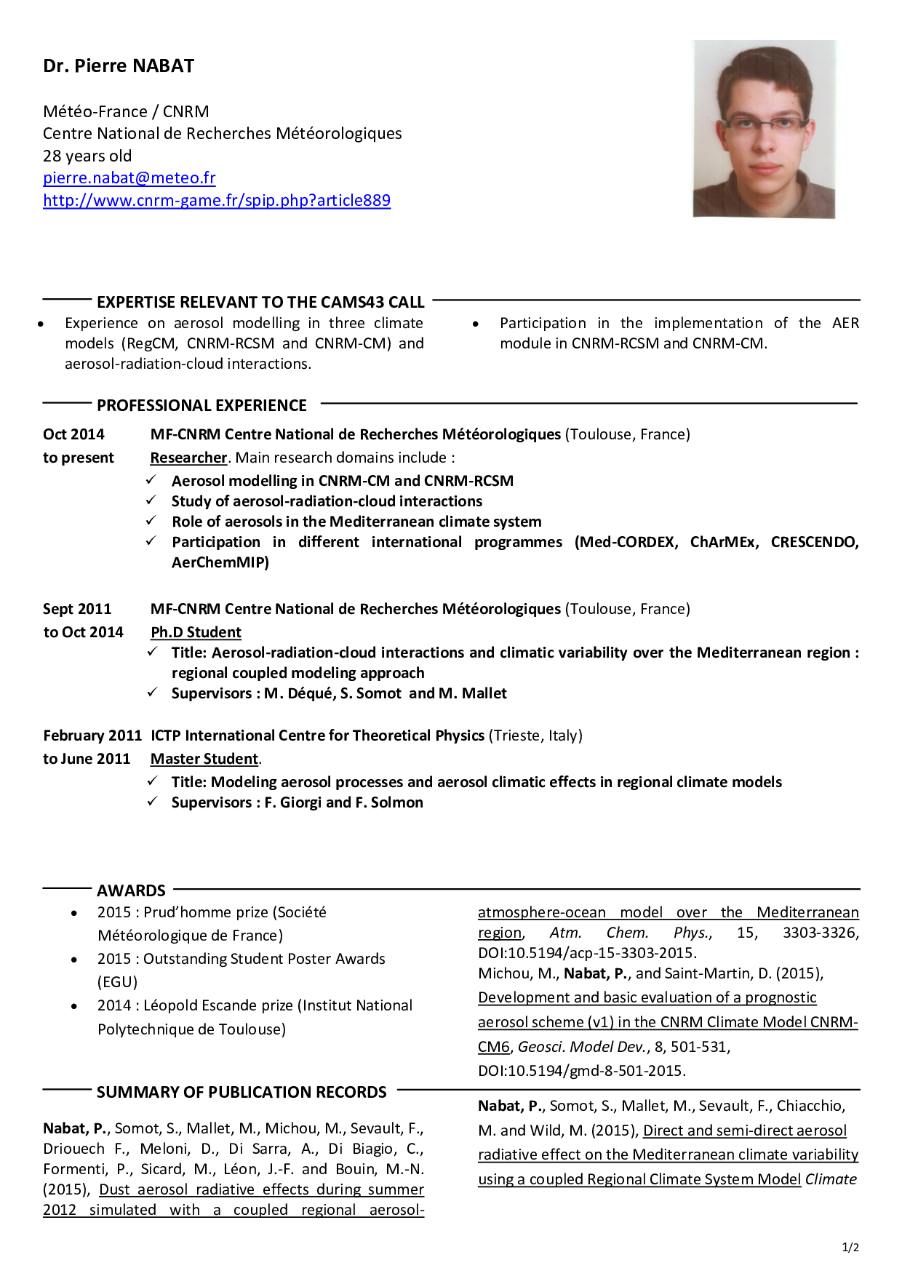

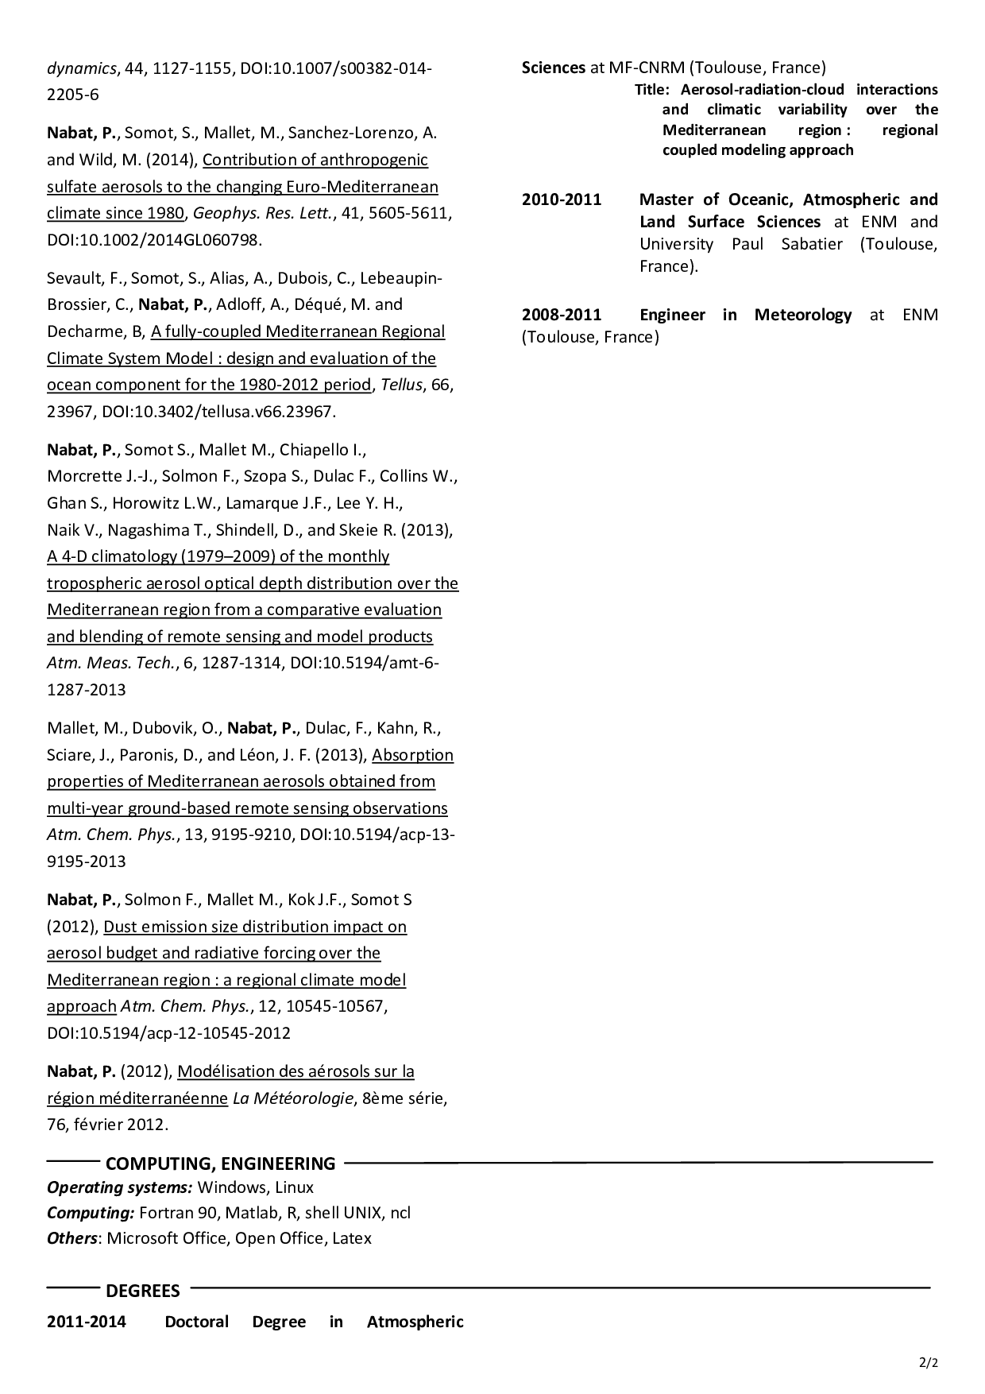

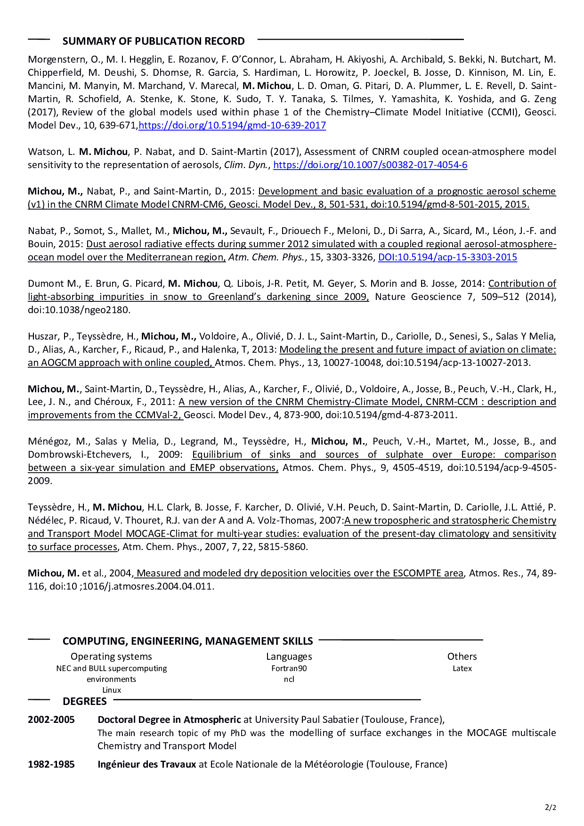

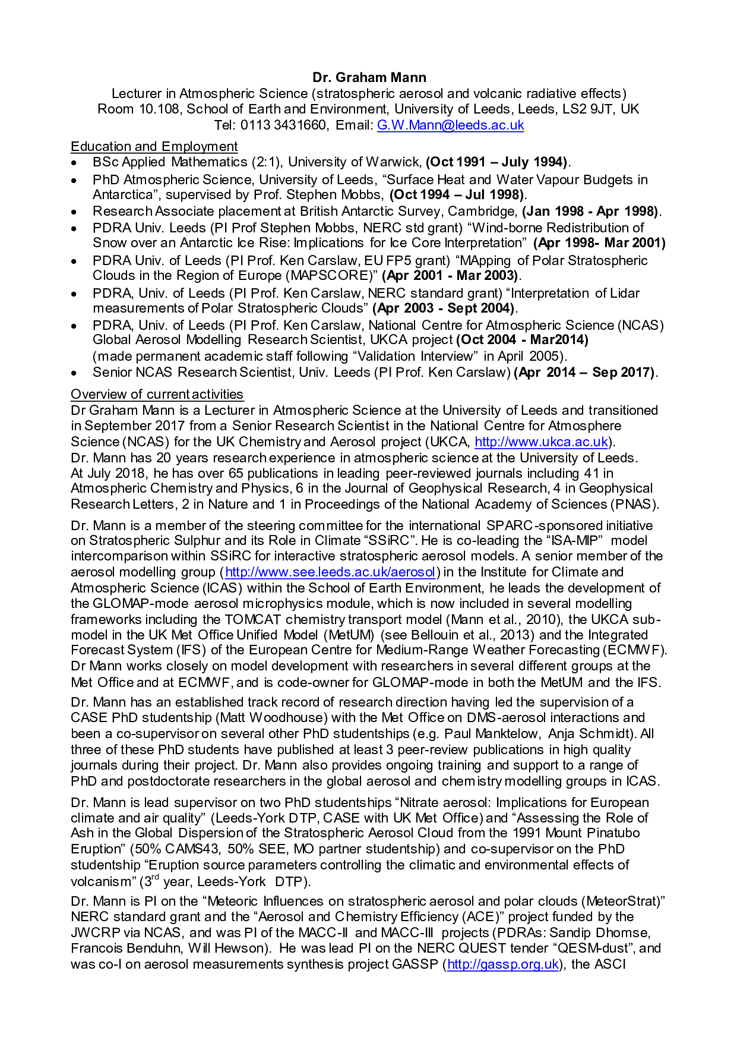

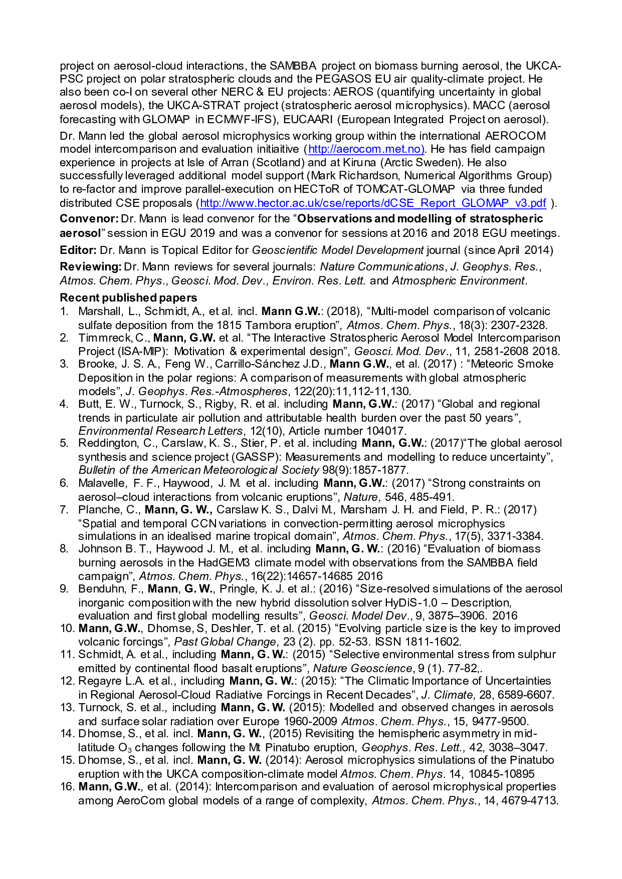

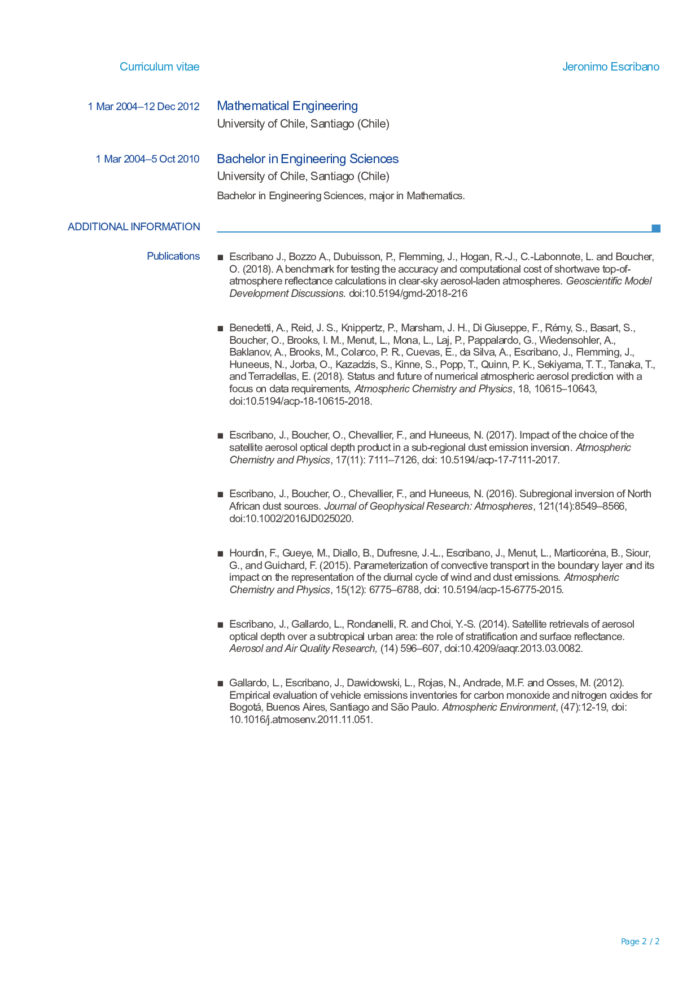

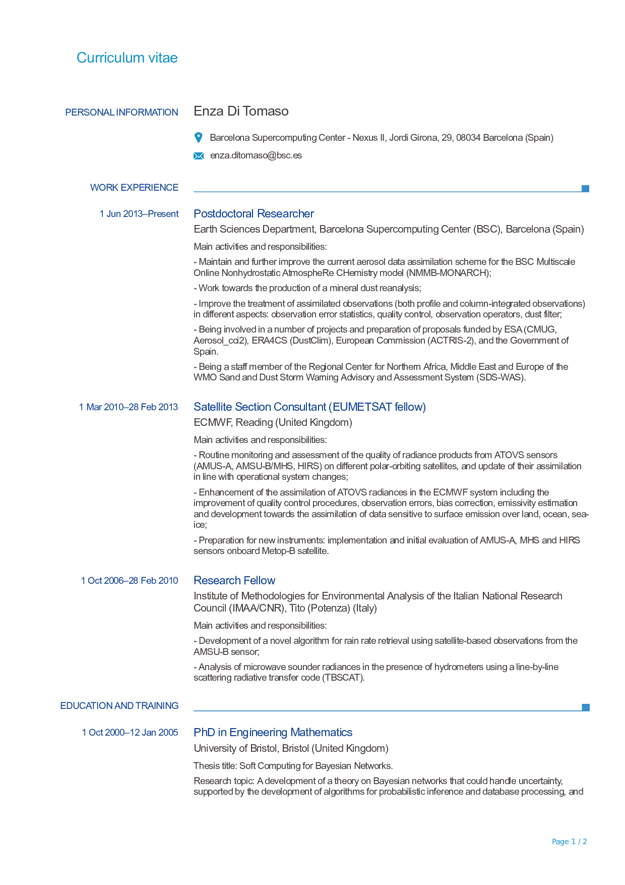

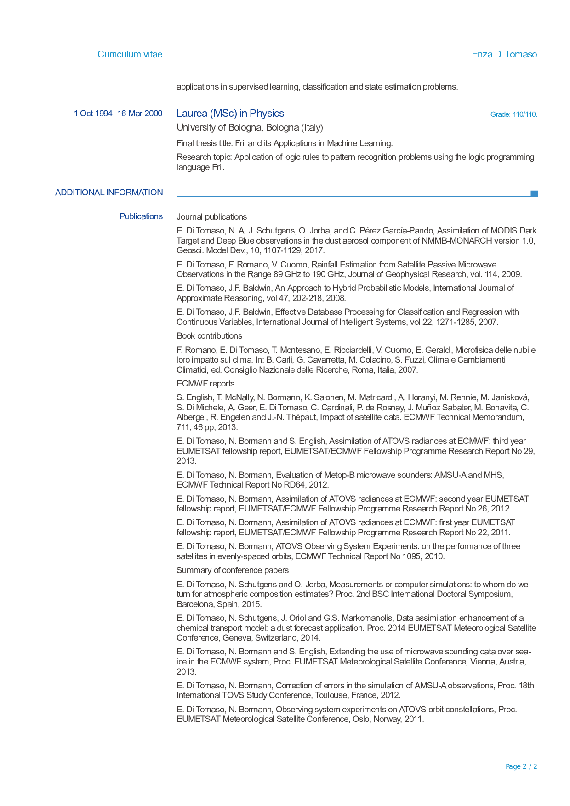

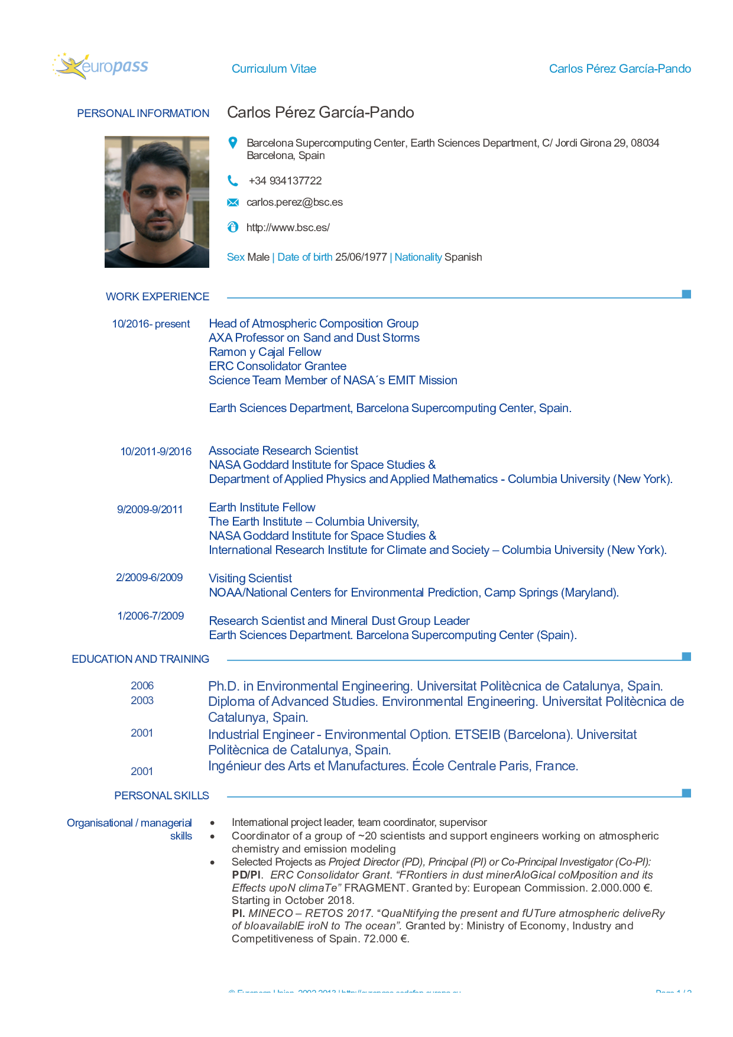

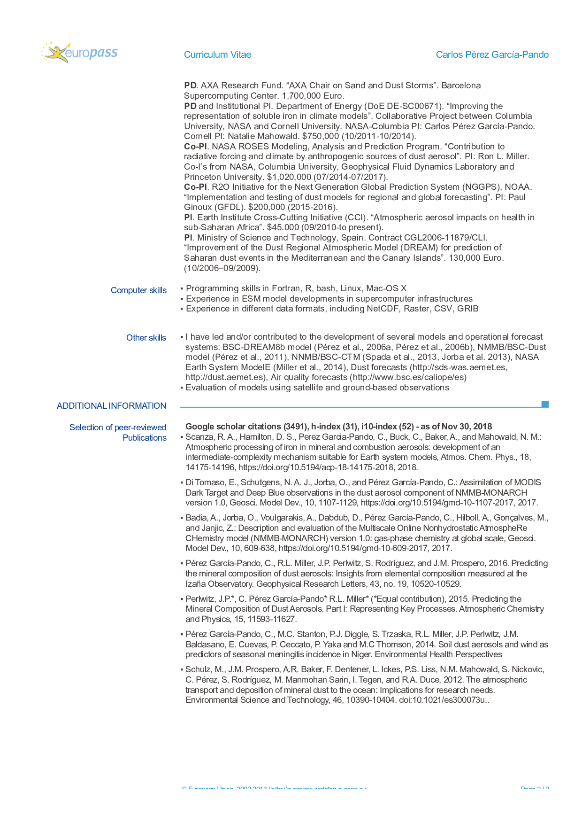

Technical Solution Proposed

Introduction
The Copernicus Atmospheric Monitoring Service (CAMS) is a key element of the Copernicus program of the European Union. It is operated through a delegation agreement by ECMWF (alongside the Copernicus Climate Change Service or C3S) and delivers high quality forecasts, analysis and re-analysis of atmospheric composition to a wide range of users, available at https://atmosphere.copernicus.eu/. These are used in many ways: providing air quality analysis and forecasts to individuals and companies, supplementing observations where they are not available, as input for regional and local modelling communities, news network, monitoring of extreme events such as the fires in the US in the summer 2018 or the fires associated with the El Niño event of the autumn 2015 (48), etc. As such, the CAMS program benefits citizens in and outside Europe, who can access freely to atmospheric composition forecasts and analysis; the atmospheric composition and climate scientific community, who use these products, and also businesses who can propose high-end products to specific users based on CAMS products. Fostering a business ecosystem based on CAMS products is one of the objectives of the program. The User Exhibition session during the CAMS 3rd general assembly in Lisbon proved that this objective is progressing well and fast.
CAMS provides both global atmospheric composition products, using the Integrated Forecasting System (IFS) of ECMWF, and regional European products, provided by an ensemble of seven regional models (79). CAMS uses data assimilation techniques to blend in a large range of observations (ground based, and from satellites, radiosondes, ships, buoys, etc.) with simulations (12, 51 and 52). The analysis and re-analysis products provided by CAMS can be described as an optimal combination of model and observations, associating the strengths of both: the global availability in both time and space of modelled values with the information about the state of the atmosphere contained in observations. The IFS uses a 4Dvar data assimilation algorithm to provide initial conditions and analysis. For aerosols, the current operational data assimilation uses observations of Aerosol Optical Depth (AOD) at 550 nm, from the MODIS sensors on-board NASA’s Aqua and Terra satellites (100, 105), and more recently from the Polar Multi-sensor Aerosol Product (PMAP). Other aerosol products such as the optical depth provided by Sentinel 3 or from the Visible Infrared Imaging Radiometer Suite (VIIRS; 53 and 127) sensor are being monitored for future assimilation.
Within the framework of CAMS, ECMWF delivers routinely a near-real time (NRT) global analysis and forecast of a set of atmospheric composition products with forecast times up to 120 h. Global reanalysis are also performed every few years. The CAMS Reanalysis (CAMSRA) is the latest such reanalysis and cover the years 2003 to 2017 (52); it has been made available to the public in September 2018. It follows the CAMS interim Reanalysis (31) and the MACC Reanalysis (51). As global homogeneous datasets, the CAMS reanalyses find numerous research and non-research applications.
While CAMS is operated by ECMWF, a number of subcontractors assist ECMWF in the various tasks involved. During the first phase of CAMS, ECMWF subcontracted activities related to, among others, the operation of regional models (CAMS50, coordinated by Météo-France), the validation of global and regional products (CAMS84, led by KNMI), the production of global and regional emission datasets (CAMS81, led by CNRS), the development of fire emission products (CAMS44, led by MPI-M), the development of global reactive gases aspects (CAMS42, led by KNMI), and the development of global aerosol aspects (CAMS_43, led by CNRS). The subcontractors work with ECMWF and also collaborate between themselves, such as the very fruitful collaboration developed between CAMS42 and CAMS_43 during the first phase. These contracts are currently being extended or re-advertised through dedicated ITTs.
Most of the activities of CAMS_43 relate directly or indirectly to the Integrated Forecasting System (IFS). The IFS is the Numerical Weather Prediction of ECMWF and contain extensions for predicting aerosol, trace gases and greenhouse gases. For aerosols, two schemes are available: IFS-AER, a simple bulk-bin scheme that is used for operational products, and the more complex modal scheme IFS-GLOMAP. IFS-AER simulates five aerosol species – dust, sea-salt, organic matter, black carbon and sulphate – and 12 prognostic variables, as described in 85. Emissions are computed dynamically for dust and sea-salt; provided by the Global Fire Assimilation System (GFAS; 57) for biomass burning emissions of black and organic carbon, or prescribed by ancillary datasets for other emissions. Three new species: nitrate, ammonium and Secondary Organic Aerosols (SOA) have been recently included. IFS-AER can be coupled with IFS-CB05 (32 and 46 for CB05), the latter providing the concentration of precursor gases for nitrate and SOA and the sulfate oxidation rates, the former providing input for heterogeneous chemical reactions at the surface of aerosols. During the first phase of CAMS_43, almost all of the components of IFS-AER have been reviewed and improved, which resulted in improvements of the operational global aerosol products delivered by ECMWF, from the NRT system and the CAMS reanalysis.
GLOMAP is a modal aerosol microphysics scheme and is comprehensively described in 72 as implemented in the TOMCAT chemistry transport model. GLOMAP includes gaseous and aqueous chemistry and provides mixing ratios and number concentration of aerosols, but additionally includes microphysical processes such as new particle formation, coagulation, condensation and cloud processing, known to be key to capturing aerosol radiative forcings in the troposphere stratosphere (e.g. 26). GLOMAP is also implemented in the UM-UKCA composition-climate model and was integrated into the IFS during the 1st two phases of the MACC project. Since then, the IFS-GLOMAP has been regularly ported to successive cycles until it was included in the operational cycle 45R2 branch, with assistance from CAMS_43. A number of improvements in source and sink processes were brought to IFS-GLOMAP as part of CAMS_43, which increased its skill in forecasting AOD close to the levels reached by IFS-AER. The code was also optimized, leading to a drastic decrease of the computing cost associated with running IFS-GLOMAP.
Aerosols released by volcanic eruptions can be simulated with both IFS-AER and IFS-GLOMAP, with different levels of complexity. The integration of IFS-GLOMAP in the volcanic aerosol framework was achieved during the first phase of CAMS_43, and the two schemes were tested and compared with two cases of volcanic eruptions.
Our philosophy when developing the IFS aerosol schemes is guided by three main principles:
- Developments are made with a possible operational application in mind, and must result in an improvement of the skill scores against observations,
- Achieve a convergence between the IFS-AER and IFS-GLOMAP codes where it is relevant. The idea is to maintain one bin scheme (IFS-AER) and one modal scheme (IFS-GLOMAP) but share as much as possible the other components of these two aerosol schemes.
- Establish a stronger coupling between the aerosol and chemistry schemes. This concerns the precursor gases as well as production rates provided by the chemistry scheme, but also processes such as dry and wet deposition which are physically close in the two schemes.
The content of CAMS_43 has been organized in five Work Packages, as prescribed by the Global Service Provider in the tender document, plus one Work Package dedicated to management. The work schedule and Work Package deliverables are detailed in the implementation section. Each of the Work Packages has been divided into tasks, which constitute coherent work units. A set of Key Performance Indicators (KPI) has been defined; these indicators will be detailed in the management and implementation section.

Work Package 43.1 – Modelling aspects

General aspects
In the organization of the activities of this Work Package, detailed below, we will try to share work as much as possible on the two aerosol schemes IFS-AER and IFS-GLOMAP. Special emphasis will be put on validating the proposed modifications in free running mode against observations of AOD, particulate matter (PM), and speciated surface concentration where available. Some of the proposed improvements will be first tested and implemented in CNRM-CM, which also includes an aerosol scheme adapted from IFS-AER, and then transferred and validated within the IFS.
Most of the planned developments are intended for possible operational use and thus requires an in-depth evaluation to ensure that the skill of the model is improved. The evaluation of the new developments will be carried out by the CAMS_43 team using observations of PM2.5, PM10, AOD and speciated surface concentrations. Comparisons against speciated aerosol mass mixing ratio collected during the Atmospheric Tomography Mission (ATom) field campaign (66) will be used to provide evaluation on the vertical distribution of speciated aerosols. This information will help preventing improving AOD while degrading individual aerosol species. During phase 2, ECMWF will have the possibility to operate the aerosol evaluation tools from CAMS84 (validation); this will be very useful to evaluate the new developments in a way entirely consistent with the CAMS84 validation reports. Finally, CAMS_43 will encourage participation to model intercomparison exercises such as the ones carried out in the Aerocom program. Michael Schulz is the PI of Aerocom and will keep the CAMS_43 team informed of the future AEROCOM experiments. In particular, participation to the Aerocom control 2019 experiment with simulations from IFS-AER and IFS-GLOMAP will be very beneficial to assess the strengths and weakness of both schemes as compared to their international peers.
Figure 2 summarizes the work flow between the different entities in Work Package 1. HYGEOS will be centralizing the contributions from all the subcontractors, except KNMI who also can contribute directly to the IFS.
IFS-AER @ ECMWF
IFS-GLOMAP @ECMWF
IFS-CB05 @ ECMWF
TM5
KNMI

AER in CNRM-CM
Météo-France

GLOMAP in UKCA-UM
ULeeds
AER and GLOMAP in IFS
HYGEOS

Figure 2: Schematic of the model parameterization work.

Task 1.1: Improvement of primary aerosol sources
The dust schemes of IFS-AER and IFS-GLOMAP have been updated during the first phase following the approach described in (88). The new scheme is based on the brittle fragmentation theory of (62) for the size distribution of dust particles at emission, and on the scheme from (81) for the saltation process. The dust scheme will be updated following two directions. The first will be to adapt, implement and test the more recent dust emission scheme of (62) which offers several potential advantages. Its only inputs are the friction velocity and the soil’s threshold friction velocity. This scheme accounts for two processes missing from most existing parameterizations: a soil's increased ability to produce dust under saltation bombardment as it becomes more erodible, and the increased scaling of the dust flux with wind speed as a soil becomes less erodible. Since this scheme is known to be more sensitive to surface moisture, special care will be taken to assess the impact of this input the scheme. The current formulation of the friction velocity used as an input of the dust scheme takes into account the impact of the wind variability at scales comparable to or lower than the model resolution (the so-called wind gustiness). Wind gustiness is currently estimated through the surface sensible and latent heat fluxes. An important source of dust emissions caused by cold pools or haboobs (e.g. 42) is not currently taken into account. Use of information from the convection schemes of the IFS in the estimation of wind gustiness in order as to better represent the dust emission from cold pools will be attempted, following the work of (91) and (92). Comparisons to very high resolution simulations with the IFS, in which the resolved part of convection is higher, will also be carried out.
The sea-salt aerosol emission schemes of IFS-AER and IFS-GLOMAP follow the approach of (36), as implemented during the first phase of CAMS_43. The emissions are parameterized as a function of surface wind and sea-surface temperature. However, the underlying physical phenomena leading to the formation of sea-salt aerosols are usually described as a function of the whitecap fraction (69; 80). Most sea-salt aerosol schemes, including the current and former operational schemes, estimate the whitecap unit area as a function of surface wind. There is however increasing evidence that neither the production of aerosol per unit area whitecap nor the lifetime of a whitecap are independent of the scale of wave breaking or other water properties (24, 89 and others). A more direct parameterization to estimate the whitecap unit area using wave characteristics provided by the WAve Model of the IFS (WAM) can be envisaged. How to relate the output of WAM to the whitecap unit area will be investigated; an approach similar to the one described in (90), based on the wave roughness, could be tested. The simulated whitecap unit area and its relation to surface winds will be compared to observational datasets from Quickscat as in (2) and (18). This work could form the basis for an entirely new sea-salt aerosol emission scheme. The sea-salt aerosol emissions can further be modulated by the surface salinity, which could be provided by the NEMO ocean model. The evaluation of this potential new scheme will be carried out using observations of AOD, PM2.5 and PM10 and also surface concentration of Na⁺ from the EMEP and CASTNET networks.
Carbonaceous aerosols are divided in the IFS, and in most aerosol schemes, between black carbon, which is supposed to be absorbing, and organic carbon, which is supposed to be mostly scattering. Recent studies (3) showed that a fraction of organic carbon could absorb solar radiation, especially at ultra violet wavelengths (below 400 nm). A recent paper (123) estimated that this fraction, which has been called “brown carbon”, contributes around 40% of seasonal absorption at 440nm. A large part of brown carbon appears to be emitted by biomass-burning (41). Two recent attempts are modelling brown carbon, in GEOS-CHEM (54, 124) and in CAM5 (16, 102, 103), the latter playing only on optical properties of organic matter. A review of the literature will be carried out and several options will be proposed to ECMWF and discussed. These will include (but may not be limited to): adding a prognostic brown carbon species, review of the optical properties of the organic matter species, which are already slightly absorbing, to take better into account the brown carbon radiative contribution as estimated in (123).

Task 1.2: Improvement of secondary aerosol sources
During the first phase of CAMS_43, a new Secondary Organic Aerosol (SOA) species was implemented, with distinct optical properties and sinks. This new species is currently fed by emissions that are scaled on CO emissions following (111). During phase 2, the SOA formation to both IFS-AER and IFS-GLOMAP will be provided through coupling to the chemistry module provided by CAMS42. For this, the chemistry module will be extended as needed to include parameterizations for the degradation of aromatics, and a solver to describe the equilibrium between secondary organic precursor gases and the corresponding aerosol.
This implementation will be optimized for operational application, through limiting the amount of aerosol precursor gases to three. The production efficiency of secondary aerosol will be benchmarked against literature such as (43), (118) and (109), and its implementation evaluated against surface observations where available. These speciated observations will include surface organic carbon observations from the Interagency Monitoring of Protected Visual Environments (IMPROVE network) over continental USA as well as from the European Monitoring and Evaluation Programme (EMEP, 127) over Europe. These observations include both primary and secondary organics. Surface measurements of organic aerosol (OA) from the aerosol mass spectrometer (AMS) global network (https://sites.google.com/site/amsglobaldatabase/aircraft; 40) are available for the 2000-2008 period (131). A further analyzis has divided these measurements into two key organic aerosol type: oxygenated OA and hydrocarbon-like OA. The latter type is assumed to be directly comparable with model predicted SOA (43) and will be used for evaluation. AMS observations from selected flight campaigns that are available in the AMS global database will also be used.
The current simple SOA scheme uses direct emissions, scaled on non-biomass-burning CO emissions. This has brought an improvement in skill in AOD simulations over heavily populated areas, but also caused some extreme overestimation in PM forecasts in regions where CO emissions are high such as India and China, and could be the cause of an overestimation of intensity of the PM2.5 diurnal cycle. A rearrangement of this simple scheme will be carried out, with the introduction of a single, lumped SOA precursor gas, fed by static emissions, and converted into a single SOA prognostic variable using an e-folding time to be determined. A choice to use a single or two precursor and SOA prognostic variables, in order to account for biogenic and anthropogenic pathways will have to be made in discussion with ECMWF. The static emissions would then be based on SOA biogenic emissions from EDGAR for biogenic SOA, and from emissions scaled on CO for anthropogenic SOA. The final configuration for the SOA species will then look very much alike what is in place for the SO₂/SO₄ couple: when the IFS is run coupled with the chemistry, the SOA tracers are fed by dynamical emissions provided by the chemistry, when run uncoupled, an additional precursor gas is added and fed by static emissions. The aim of this modification is to try to retain the benefits of this SOA source in terms of AOD forecasts while limiting the impact on PM simulations.
During phase 1, a nitrate scheme adapted from (38), which represents both nitrate and ammonium production from gas partitioning, and coarse nitrate production from heterogeneous reactions, has been implemented in IFS-AER and IFS-GLOMAP. This scheme will be further evaluated, with a focus on the precursor gases, ammonia using satellite and ground observations, as in (120), and nitric acid. Its output will be also compared to a recent phase of Aerocom dedicated to nitrate (12) and to results presented in (9). Recent evaluation against observations of surface concentration of nitrate aerosol from EMEP and CASTNET also showed a generally high bias. Increasing the deposition of nitrate to account for the near-surface volatilization of ammonium nitrate, following (94) could help reducing this high bias.

Task 1.3 Stratospheric aerosol
This task is divided in two deliverables: evaluation and improvement of background stratospheric aerosols, and of stratospheric aerosols following a large eruption. The combined atmospheric system IFS-CB05-BASCOE-GLOMAP will be used for these tests. This complex system is able to represent both aerosols and chemistry, in the troposphere as well as in the stratosphere, and interactions between all of these components. The BASCOE chemistry (47) in this system has been extended to include the stratospheric Sulphur cycle (see Figure 3), following (26).
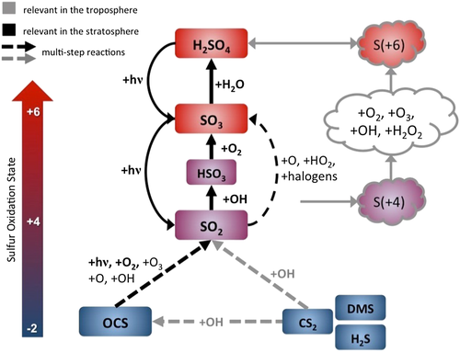
Figure 3: Primary atmospheric sulfur species and conversion reactions in gas (left part) and aqueous phase (right part). Grey arrows represent conversions mainly relevant in the troposphere, while black arrows indicate mainly stratospheric reactions. Important reactions are highlighted in bold. Figure from (67).
This system can be updated in two ways during the second phase of CAMS_43. Both concern the critical nucleation process whereby stratospheric sulfuric acid, a prognostic variable of BASCOE, is transformed into sulfate particles. This process is parameterized following (119). A newer parameterization is available from (71), which will be implemented in the system and tested. Nucleation takes place at time scales much shorter than the model time step, and in competition with condensation; which means that a time splitting scheme to represent the interaction of the two processes. A dynamical time splitting scheme to represent stratospheric nucleation and condensation in the Sectional Stratospheric Sulfate Aerosol (S3A) has been implemented by (61) into LMDZ; replacing the current fixed time-splitting scheme of GLOMAP with this scheme will be envisaged. It should be noted that the interaction with the radiation doesn’t exists yet in IFS-CB05-BASCOE-GLOMAP. This interaction is important for accurate simulations of stratospheric plumes; this work is however outside of the scope of CAMS_43. It is expected that ECMWF will carry out this task, with the assistance of CAMS_43.
To evaluate the skill of IFS-GLOMAP in simulated background stratospheric aerosols, we will assess stratospheric aerosol extinction in the mid-visible (550 nm) and near-infrared (1020 nm) in model simulations without any stratospheric injection of volcanic SO₂ emissions. The SAGE-II solar occultation instrument provides an excellent test for stratospheric aerosol models in this period, see for example chapter 6.5 of the SPARC Assessment of Stratospheric Aerosol Properties (ASAP report, 2006). The Particle size distribution in the quiescent stratospheric aerosol layer will also be compared to balloon-borne size distributions measurements from Laramie (NH mid-latitude) for the 1998-2002 quiescent period (25) and also to assess the Antarctic stratospheric aerosol layer in springtime above McMurdo station as in (19).
It is now established that the stratospheric aerosol layer comprises a large fraction of particles with
a refractory, non-volatile core (e.g. 87 and 125). The stratosphere-troposphere configuration of IFS-GLOMAP is able to represent heterogeneously nucleated particles
forming on meteoric smoke particles (MSPs) on the sixth mode, and only requires the monthly-varying 2D climatology of MSP number and mass mixing ratio to be included to
enable IFS-GLOMAP to also represent the true mix of particles in the stratospheric
aerosol layer. This climatology will be added as part of this deliverable and test the
fraction of non-volatile particles comparing to measurements of refractory aerosol number concentration from (127) that were already gathered by the University of Leeds to test simulations in UM-UKCA.
The Pinatubo eruption of June 1991 was the most important stratospheric volcanic eruption of the 20th century. Simulations of this eruptions from IFS-GLOMAP and IFS-AER will be assessed against several benchmark observational datasets of the volcanically-perturbed stratospheric aerosol layer, already gathered by the University of Leeds. This evaluation will focus on:
- The variation in global burden of SO₂ and sulfate in the model.

The first step to understanding the progressing of interactive stratospheric aerosol simulations of the Pinatubo volcanic cloud is to test the progression of the SO₂ as it oxidises into sulphuric acid aerosol. The satellite datasets from (37) test the oxidation and transport of the SO₂ whilst the analysis of the operation High-resolution Infrared Sounder (HIRS) measurements from (6) tests the production and global transport of the particulate sulphuric acid aerosol.

- Post-Pinatubo SAGE-II measurements of stratospheric aerosol extinction
The 1991-1993 time-series of stratospheric aerosol extinction in the NH and SH mid-latitudes provides a strong test for models that simulate stratospheric aerosol interactively, and this is the primary observational dataset to test the IFS-GLOMAP and IFS-AER Pinatubo case studies. The Leeds group already applied these datasets for Pinatubo case study in the UM-UKCA composition-climate model (see 26 and 78) and we will apply these similarly here to test the evolving volcanic cloud through the first 3 years after the eruption.
- 1991-1992 ground-based lidar observations in the tropics and NH mid-latitudes.
The Mauna Loa ground-based lidar provides the only observational dataset
to test the progression of the tropical reservoir of the Pinatubo major volcanic aerosol plume, from which the mid-latitude stratospheric aerosol enhancements in both hemispheres stem from. During the first phase of CAMS_43, Leeds PhD student Sarah Shallcross has gathered the MLO lidar soundings during the first 9 months after the June 1991 eruption. Combining the MLO profiles with those from NH mid-latitude lidar sites in France (Alpes de Haute Provence) and North America (Table Mountain and Toronto), the datasets provide a strong test of the progression of the plume from an initially tropically-confined reservoir of volcanic aerosol to a globally-dispersed veil of enhanced aerosol cooling the surface and perturbing the chemistry of the stratosphere. This dataset will be used to provide a benchmark test for the extent and global dispersion of the Pinatubo volcanic aerosol cloud simulated by IFS-GLOMAP and IFS-AER.

Depending on the result of these evaluations, simple corrective steps will be brought to the combined IFS-CB05-BASCOE-GLOMAP and IFS-AER systems; the impact of these modifications will also be evaluated. A shorter evaluation against the observations of the 2015 Calbuco eruption (7, 93, 113 and 132) as well as against other simulations of this eruption carried out during the first phase of CAMS_43, and by ECMWF using data assimilation of column SO₂ from GOME-2 will be carried out.

Task 1.4 Size distribution and optical properties
The IFS-GLOMAP size distribution will be evaluated against the observational datasets and multi-model “central diversity-range” from the Aerocom microphysics intercomparison following (73). The observational datasets are listed below:
- Total particle number concentration (also known as Cloud Nuclei - CN concentrations) at Global Atmospheric Watch (GAW) sites
Here, we will compare the model to observations different measurements and switch-on the organic-mediated boundary layer nucleation parameterization (83) which is generally the default option to include in addition to the main binary homogeneous nucleation always switched on in the model.
- Size-resolved number concentrations compared to European supersite observations (EUSAAR, GUAN)
Aligned with the EUCAARI European integrated field campaign in 2008 (65), observations at several “aerosol supersites” produced a long-term record of particle size distribution that provides an ideal test for IFS-GLOMAP simulations across Europe (see 4 and 5).
We will test the seasonal variation in the particle size distribution in IFS-GLOMAP, and
understand how the coupling to the TM5 tropospheric chemistry (46) impacts the simulated seasonal cycle in Aitken and accumulation mode particle concentrations across Europe.
- Vertical profile of particle size distribution in continental Europe and marine regions
In this part of the workplan we will evaluate the simulated vertical profile in particle concentrations from IFS-GLOMAP, comparing to conditions from field campaign measurements in EUCAARI LONGREX and to previous campaigns (e.g. from Lindenberg Aerosol Characterization Experiment, 92). We will also test the IFS-GLOMAP simulated particle concentrations over marine regions comparing to aircraft observations over the Pacific and test particle concentrations BC profile over the Pacific, comparing to measurements from the global climatologies established from the HiPPO series of field campaigns (107 and 108).
There are currently six boundary layer nucleation options implemented in IFS-GLOMAP: the impact of these options on the particle size distribution will be evaluated, and recommendations for future use depending on the result of this evaluation will be issued. Following this evaluation, simple corrective actions can be carried out if it appears that some problems with the size distribution can be easily remedied. The impact of these possible modifications will also be evaluated.
The aerosol optical properties in IFS-AER are currently computed using look-up tables of mass extinction, single scattering albedo and asymmetry factor computed using Mie Theory with assumptions of size distribution, density, hygroscopic growth and using a single refractive index for each species (varying with the water content). In IFS-GLOMAP, the UKCA_RADAER module computes dynamically the refractive index for each mode, using as input the refractive indexes of each species in the mode and their mass mixing ratio as well as the water content. Mass extinction, absorption and asymmetry factor are then retrieved in a look-up table that uses refractive indexes and size as entries. HYGEOS will assist ECMWF in reviewing the assumptions done when generating the look-up tables used in IFS-AER, and in particular to check if they are consistent with the size distribution assumptions used elsewhere in the model.
The large uncertainty in mineral dust composition (e.g. 21) means that it is difficult to represent the radiative properties of this species with a single refractive index fitting different part of the world. A number of refractive indexes exist and have been tested in the IFS (29, 126). Recent studies (27 and 28) showed that the dust long wave refractive index depends on the mineralogy or the composition of dust itself, which is different for each dust source regions. A climatology of the main constituents of dust exists (55). This climatology will be used in an experimental version of the IFS to compute a climatology of airborne dust mineralogy, which can then be used in the IFS to provide information on the mineralogy of dust particles, in order to modulate the optical properties as a function of dust mineralogy. Moreover, although dust aerosols are supposed to be hydrophobic in both IFS-AER and IFS-GLOMAP, it has been shown the water uptake on dust aerosols becomes important, if air pollution interacts with dust outbreaks (1). This is consistent with observations of layers of activated dust observed over Germany, for example in October 2017 (Harald Flentje, in CAMS84 validation report of the o-suite for SON 2017). This again calls for the possibility of dynamically changing the optical properties of dust depending on its environment.
For brown carbon, as already mentioned, one possible direction for future development is to modulate the optical properties, as done in CAM5 (102). Black carbon in the atmosphere is most of the time internally mixed with other species: sulfate, organic, carbon, nitrate, which are added as layers of coating to the black carbon core. Even if these layers are not absorbing in the visible, they can act as a “focusing lens” (e.g. 103) for the incoming light and result in an increased absorption for the same unit mass of black carbon. Recent estimates of the absorption enhancement factor associated with this “lensing effect”, as a function of the degree of internal mixing have been produced (20). However using these would mean to make the optical properties of black carbon vary depending on the amount of other aerosol species present in the environment.
All of this suggests that adding a layer of complexity to better represent the variability of aerosol optical properties in the IFS is desirable, with the possibility of using the current assumption of external mixing and also, if some condition are met, to compute optical properties with a degree of internal mixing, following the approach of (23). Finding the appropriate conditions for shifting from external to internal mixing when computing the optical properties is a key part of this task: several conditions will be tested, such as the relative abundance of black carbon (proxy of coating formation), of sulfate, using the NOx/NO₂ ratio (proxy of photochemical aging), or the ratio between the hydrophilic and hydrophobic fraction of black carbon and organic matter, which is a good measure of aging as it is parameterized in the model.
Tests with dynamically computed refractive indexes, aimed at better representing the dust, black carbon and possibly brown carbon optical properties, using code adapted from ECRAD or from the UKCA_RADAER component of IFS-GLOMAP will be carried out. To achieve this, look–up tables of mass absorption, extinction and asymmetry as function of real and imaginary refractive index and particle diameter will be generated using ECRAD. The use of dynamically computed refractive indexes would have consequences also on the data assimilation side, since an adjoint and tangent linear versions of this eventual code would need to be developed by ECMWF. This would not be very different from the tangent linear and adjoint code of ukca_radaer developed recently by ECMWF when integrating IFS-GLOMAP into the 4Dvar data assimilation framework.

Task 1.4 Targeted improvements
We provision some manpower in this task to make targeted improvement to the IFS-AER and/or the IFS-GLOMAP aerosol schemes as requested by the Global Service Provider in response to identified weaknesses or user requirements. This Task is preferentially scheduled for the third year of the project.

Task 1.5 Article submission
These developments will be presented and summarized in an article that will be submitted at the end of phase 2 in a peer-reviewed review such as Geophysical Model Developments (GMD).

Work Package 43.2 – Support for operational system upgrades
This Work Package describes how we aim to contribute to the operational model upgrades. There is an expectation that our effort is matched by a similar effort on the Global Service Provider side.

Task 2.1: Assistance to the Global Service Provider in setting up operational model cycles
This Task consists mainly in assisting the Global Service Provider in preparing and assessing new model cycles. This Work Package is closely linked with Work Package 43.1. In collaboration with the Global Service Provider, the Tenderer will set up model branches that include the latest updates of the aerosol model, based on the most up-to-date model cycle. Experiments will be carried out to evaluate these branches, both in near-real-time and in delayed mode. These experiments will be run without the data assimilation component of the IFS; tests in data assimilation mode are also needed but will be left to ECMWF because of the very high computational cost. Running in forecast-only mode allows a better understanding of the impact of the modifications brought by the Tenderer. Running with the full IFS allows to evaluate how the model changes and the data assimilation algorithm interact with each other, and to assess how the end product of IFS is affected by the modifications of the aerosol model.
Budgets of aerosols species and their precursors will be monitored all along the duration of the second phase of the CAMS_43 project for both the e-suite and o-suite.
These experiments will be evaluated against surface observations of Aerosol Optical Depth (AOD) from the AERONET network (44), against PM observations provided by the Airnow and EEA networks, against observations of concentration at surface of speciated aerosols and finally against profiles of speciated aerosols obtained during the Atmospheric Tomography Mission (ATom) field campaign (66). Depending on the content of the updates, specific situations, such as desert storms or biomass burning situations for example, will also be simulated. Once this validation step is done, the model branch will be delivered to the Global Service Provider for inclusion into next model cycle. Assistance will be provided for this step and for the setting up of experimental suites. All the changes to the aerosol model will be documented, together with the results of the evaluation.

Work package 43.3 – Data assimilation aspects

General aspects
Accurate calculations of top-of-atmosphere radiances (or equivalently reflectances) in the shortwave spectrum for an aerosol-laden clear-sky atmosphere are critical for passive remote sensing of aerosol properties using observations from spaceborne spectroradiometers such as MODIS, MISR, POLDER or VIIRS. The aerosol vertical profile is often prescribed in such satellite retrievals and a typical profile decreasing exponentially with height from the surface is usually assumed. This is because i) most of the aerosol optical depth is usually located in the boundary layer (i.e., lofted layers are the exception more than the norm) and ii) in first approximation clear-sky radiances in the shortwave spectrum do not depend ``too much’’ on the aerosol vertical profile. However, there are many documented occurrences of lofted layers, in particular for biomass burning and dust plumes (56, 95). Stratospheric aerosols can also be responsible for more complex aerosol profiles in periods following a large volcanic eruption (68). Moreover, the relative insensitivity of radiances to the aerosol vertical profile is known to break down for the shortest wavelengths and in the case of two layers of aerosols of different types (especially when one aerosol type is more absorbing and one aerosol type is more scattering). It is becoming important to quantify this dependence because there is a growing interest in assimilating clear-sky radiances to constrain aerosol properties in numerical atmospheric composition prediction models (11). Since such models contain a priori information on the aerosol vertical profile, it makes sense to use such information in the data assimilation operator that converts the model variables (aerosol concentrations and properties on the model vertical levels) into the observables (top-of-atmosphere radiances at a number of wavelengths). Furthermore this would allow synergetic use of several types of observations, e.g. radiances in both the shortwave spectrum and in the infrared, or radiances and a lidar attenuated backscatter signal. Since both radiances in the infrared and the lidar signal depend critically on the aerosol vertical profile, it makes sense to tease out any dependency that may also arise in the shortwave spectrum, even if it is small.
Radiance assimilation in a 1D-Var scheme could be beneficial and overpass the current assumptions of AOD assimilation only if the observation operator is able to deal with the complexity of several aerosol species and vertical profiles. Additionally, the information provided by the observations has to be balanced with the choice of the control variables and the information provided by the prior. The control vector must be defined depending on the quality and quantity of the observations and of the prior.

Task 3.1: Selection of a radiative transfer code and implementation into a standalone 1D-Var assimilation system for aerosol
This task concerns the choice of the short-wave radiative transfer model to be used in the 1D-Var. Three potential radiative transfer models (RTMs) candidates are already available at ECMWF: Radiative Transfer for TOVs (RTTOV; 104), Forward-Lobe Two-Stream Radiance Model (FLOTSAM, developed at ECMWF by R. Hogan and A. Bozzo), and Oxford RAL Aerosol and Cloud (ORAC, 114).
RTTOV includes short-wave radiative transfer calculations and is suited for variational assimilation. However, as it is based on the discrete ordinate method, it is not expected to be sufficiently fast for reflectance assimilation, as shown during the benchmarking exercise carried out during the first phase of CAMS_43 (30).
The ORAC model is an interesting candidate. ORAC is a fast RTM based on look-up-tables (LUTs) of pre-calculated radiances. The quantity and the size of LUTs to be used depend on the needs of the Global Service Provider. For example, large size LUTs it is expected to be needed to retrieve aerosol vertical profile information in the 1D-Var scheme. Similarly, this would be the case also if one had to control the aerosol size distribution or multiple aerosol species. Additionally, in case of being selected, ORAC inputs that fit with the IFS configuration have to be provided by the Global Service Provider.
FLOTSAM is a fast and relatively accurate RTM and is therefore very suited for this task as shown in the benchmarking exercise (30). Tangent linear and adjoint codes for FLOTSAM have been already implemented, which makes it a strong candidate for the implementation in the 1D-Var. Furthermore, FLOTSAM does not require LUTs.
The choice between implementing FLOTSAM or ORAC in the 1D-Var will be discussed with ECMWF. The standalone 1D-Var assimilation setup developed by this task will be based on the 1D-Var code developed in the first phase of CAMS_43, which is presented in Figure 4. The interface between the 1D-Var scheme and the selected RTM will be developed in collaboration with the Global Service Provider.
Meteorological and chemical input from IFS

Model level aerosol mass mixing ratio
Modelled TOA reflectances and error B
Radiative scheme – H matrix

Observed TOA reflectances with error R
1D-Var minimization

Analyzed aerosol field

Figure 4: schematic view of the aerosol 1D-Var retrieval algorithm

Task 3.2: Report on multi-wavelength data assimilation
Multi-wavelengths data assimilation is a promising endeavour since it can potentially provide information about the aerosol vertical profile and aerosol size distribution. In this task, the 1D-Var system will be applied to synthetic observations with known truth values of aerosol profiles and aerosol types (including size distribution). Synthetic observations will be generated either with the selected radiative transfer code or with DISORT (or CDISORT). Experiments related to this task will include tests regarding the gain of using multi-wavelength or multi-geometry observations against a single wavelength or a single viewing geometry.
The following minimum set of experiments will be performed:
- For a single and mono-modal aerosol type, the median radius of the size distribution will be controlled. The vertical profile and aerosol optical depth will be assumed as truth.
- For a bi-modal externally mixed aerosol, AOD per aerosol type will be controlled. The vertical profile and aerosol optical depth will be assumed as truth.
- For a single aerosol type, the vertical profile of the aerosol optical thickness will be controlled. The size distribution will be assumed as truth.
For these cases, the quality of the analyses will be estimated and reported as a function of the prescribed observational error, the number of wavelengths and viewing geometries.
Given the non-convexity of the cost function in the reflectance assimilation problem (due to the non-linearity of the observation operator), we expect that a 1D-Var assimilation might not succeed when the aerosol size distribution is taken into account. In this case, if the prior is not close to the truth, the most common gradient-based minimization algorithms such as the Broyden-Fletcher-Goldfarb-Shanno (BFGS; 17) or conjugate-gradient methods will likely retrieve a local minimum different from the expected global minimum (supposedly close to the truth). For this reason, this task is crucial in defining an appropriate control vector for the 1D-Var scheme, and to evaluate the trade-off between considered multi-wavelength or multi-geometry observations.

Task 3.3 Test and validation of the 1D-Var retrieval algorithm with real MODIS and VIIRS reflectances
The 1D-Var system will be applied to a selection of cases with observed clear-sky radiances from MODIS and VIIRS sensors. The RTM used will be selected in Task 3.1. Observational errors will be prescribed, and the surface reflectance will be taken from IFS. If needed, surface reflectance will be added to the control vector. Depending on the results of Task 3.2, the control vector will include total AOD, aerosol optical thickness per layer and possibly aerosol size distribution parameters (contributions from different bins of the IFS aerosol model for dust and sea-salt). Prior aerosol fields will be extracted from IFS simulations. The error covariance matrix will be designed according to the selection of the control vector.
The aforementioned RTMs require information about the surface reflectance, the atmosphere and optical properties of the atmosphere itself, i.e. of aerosols and molecules for a clear-sky simulation. Aerosol optical properties such as single scattering albedo, mass extinction efficiency and phase function or phase function decomposition will be prescribed according to the values used in the IFS. An additional part of this task will be dedicated to compute the molecular optical properties from the atmospheric profile from IFS. For this, it is proposed to use simple and fast parameterizations of molecular absorption and scattering.
In principle, we will rely in the MODIS and VIIRS cloud mask to select clear-sky columns where the assimilation will be performed. We will ask the Global Service Provider to provide us with the MODIS cloud mask used for operational data assimilation of MODIS AODs.
A validation strategy will be discussed with the Global Service Provider. It could be based on the use of the validation tools developed in CAMS 84 (validation). The analysed AOD can be compared with independent AERONET observations and with collocated MODIS or VIIRS AOD retrievals, which will also give an idea of the quality of the AOD provided by the 1D-Var as compared to the retrievals that use the same radiances.

Work Package 43.4 – Service evolution
This Work Package is dedicated to service evolution and is composed of two components: development, validation and operational running of an aerosol alert service on one hand, and delivery/evaluation and improvement of aerosol deposition products

Task 4.1: Automated aerosol alert system
Met Norway is responsible for the development of the Aerosol Alert Service in the first phase of CAMS 43. Global and regional alert maps are computed every day and are available via a web interface (CAMS-Aerocom aerosol alert interface). These maps show the aerosol alert level calculated with the global o-suite CAMS model, using the AOD output as compared to the climatology, and classified in four different alert classes (no event, high, very high and extreme events). During the first phase, Met Norway developed a score for assessing the model skill in reproducing and forecasting the aerosol events, globally. This evaluation revealed an improvement of the model skill thanks to the different CAMS model updates between 2013 and 2016, with however contrasted performances within the different regions submitted to distinct types of aerosol events. The tenderer, through Met Norway, will continue to operate this automated aerosol alert system and pursue its development by focusing on three different points:
- Graphical user interface improvement
The planned enrichment of the alert service with multiple types of aerosol alerts (species and air quality) will require a more flexible interface, both for the development phase and the front-end use. User feedback shall be captured and incorporated. Documentation of previous alerts shall also give added value to the service. Validation of the alerts shall be made visible for the users. Met Norway will take benefits of its recent experience in the development of dynamic web-tools (for example http://aerocom.met.no/trends) to develop a user-friendly interface with a navigation to the different products available within dynamic maps, using the openlayers library.
- Speciation of the alerts
The current aerosol alert system relies on total AOD only. AOD is a vertically integrated parameter and is appropriate to detect any kind of extra-ordinary aerosol event since it is sensitive to aerosol events occurring in any altitude (dust storms, biomass burning particles, surface aerosol haze and pollution episodes), though it may fail to represent very high surface concentrations of aerosol, being present only at low levels. The AOD is also very suitable for validation purposes, with AERONET, providing harmonized worldwide AOD observations in near real time. Met Norway will continue the development of the alert service with a specification of the aerosol alerts by using the type-resolved optical depth provided by the IFS model (dust, organic aerosol, black carbon, sea-salt and sulfate aerosols). These aerosol-typed alerts will allow triggering more specific alerts depending on the user interest.
- Surface air quality (PM) alert using global and regional model output
Ground-level aerosol parameters will be used to complement the AOD based alert, to warn with respect to air quality deterioration. The Tenderer will provide an air quality alert using the PM fields of the o-suite model. This alert will be computed, on one hand using absolute thresholds using WMO Air quality guidelines, and on the second hand and similarly to the AOD alerts, using exceedances of climatological PM values. The evaluation of this air quality alert will be performed at some key locations, to be determined, using Airbase PM in situ measurements maintained by the EEA’s European Topic Centre on Air pollution and Climate Change mitigation (ETC/ACM). Pollution episodes being generally associated to mesoscale patterns and hourly timescale, the air quality alerts will also be computed with CAMS regional models that provide PM output at a finer resolution both in time and space.

Task 4.2: Aerosol deposition products
IFS-AER provides global averages and global dry and wet deposition (in-cloud and below-cloud) fluxes. During the first phase of CAMS_43, IFS-GLOMAP has been modified to provide output global averages of dry deposition fluxes, as well as below-cloud and in-cloud scavenging fluxes. IFS-GLOMAP will be modified so as to provide global fluxes for these three quantities. A first evaluation of dry and wet deposition fluxes has taken place during the first phase of CAMS_43. This evaluation, and the comparison to the chemical online dry deposition, suggested a number of possible improvements of the aerosol online dry deposition scheme and a better coupling with the surface scheme of the IFS. These improvements, which consist in moving the online dry deposition routine out of the aerosol routines to place it just after the call to the surface scheme, so as to use updated inputs from the surface scheme for friction velocity (the most important parameter for dry deposition), aerodynamical resistance and Leaf Area Index (LAI). Also, the two recently implemented online dry deposition schemes described in (129) and (130) will be compared, with the objective to find a scheme that combines the strengths of both approaches. A new approach for dry deposition, such as the one described in (35) will also be tested.
The dry and wet deposition fluxes and velocities of a number of species (sulfate, nitrate, ammonium, dust, sea-salt) will be compared against a range of observations from the CASTNET, EMEP, Dust Sahel Transect and Charmex datasets. Their impact on vertical distribution will be evaluated against profiles of speciated aerosols obtained during the Atmospheric Tomography Mission (Atom) field campaign (66), and from HIPPO (107 and 108), with a focus on BC for the latter field campaign as in (122). Some specific observations provided by field campaigns measuring dry deposition velocities over different types of surfaces will also be used. A selection of these datasets is presented in (58). They consist in 29 measurement studies covering five Land Use Categories (LUC). The five LUCs include grass, deciduous and coniferous forests (rough surfaces), and natural water and ice/snow (smooth surfaces). The additional dry deposition observational dataset of (22) over grass surfaces will also be considered for comparison.
To evaluate wet deposition fluxes, observations from the CASTNET and EMEP networks will be used, as well as from other networks that will be searched for. Also, the validity of the scavenging fluxes can be assessed by evaluating the lifetime of species that are subjected nearly only to wet deposition, such as lead (Pb 210), and for which observations of lifetime are available. This follows the approach of (71) with GEOS-CHEM. Pb210 is a species of the chemistry, so this evaluation work would mean to carry out developments in a specific branch in order to apply aerosol wet deposition to this tracer. The Pb210 budgets can be compared to the values obtained with GEOSCHEM, which are publicly available.

Task 4.3: Test with dynamical anthropogenic emissions
The emissions datasets of anthropogenic quantities (OC, BC, SO₂, SOA scaled on CO emissions) provided by the CAMS81 and used as an input in the IFS simulations are usually monthly averages. These anthropogenic emissions have a great impact on the skill of the forecasts; a significant fraction of them, associated with transport and heating for example, are known to be highly dependent on the meteorology or to exhibit a weekly cycle; see (86) and (98) for example. The CAMS81 project provides formulae to modulate their anthropogenic emissions; these will be implemented in the IFS and their impact evaluated. Following (98), a weekly cycle will also be implemented for the relevant emissions (transport over continents) and its impact on AOD, PM and surface sulfate concentration will be assessed.

Work Package 43.5 – User support and documentation of services

Task 5.1: User support
CAMS is a user-oriented service, and as such, answering quickly and adequately the questions and remarks from users has been a priority during the first phase. We will continue this policy during the second phase by providing fast and accurate technical and scientific support to users, through direct contact, but preferably within the CAMS Service Desk Facility. Meeting this requirement is included as a Key Performance Indicator of CAMS_43. Samuel Remy already answered to user queries through the ECMWF Service Desk during the first phase of CAMS_43, so the setting-up of the specialised Service Desk is already established.

Task 5.2: Documentation
All of the deliverables of the project will be accompanied with detailed deliverable reports, specifying the scientific and technical documentation of the developments, and also accompanied with the evaluation results. These reports will be delivered in format suitable for online publishing. A yearly report summarizing the developments carried out in the preceding year will be produced in 2019, 2020 and 2021.

Work Package 43.0 - Management
This Work Package will be performed by the Prime Investigator, in close collaboration with the Work Package managers and the Sub-contractors’ managers.

Task 0.1: Coordination of the project
This task includes various housekeeping items such setting up mailing lists for the project, setting up the sub-contracts for the partners, paying invoices to sub-contractors and submitting invoices to the Global Service Provider, organizing the recruitment of the non-permanent staff. More importantly it also consists of coordinating the project team.
Teleconferences will be organized on a bimonthly basis by the coordinator. During these teleconferences, each partner will present the work they have done since the last teleconference, and a review of the status of the planned deliverables will be done. If, for some reason, the work is experiencing some delays, teleconferences will be organized twice a month with the partners involved in the work, in order to find efficient solutions to the problems encountered. At the end of each teleconference, the coordinator will write a summary of the discussions and the decisions taken. These summaries will be made available to all partners.
The Risk register and contingency plans, as listed in the Implementation document, will be updated on a yearly basis. The CAMS 43 team will meet for a kick off during the 2019 CAMS General Assembly and annually later on. Progress will be discussed regarding the five WPs described above, including opportunities for service evolution. Work plans will also be adapted regularly to as to deal with potential issues arising, changes in the IFS, or new development in aerosol science.

Task 0.2: Performance monitoring and reporting
This management Task will ensure the timely production and delivery of code and reports as agreed with the Global Service Provider. As part of this task, quarterly and annual reports (D43.0.1) will also be provided to the Global Service Provider to feed into quarterly and annual reporting to the European Commission. As requested each quarterly report will provide information on the performed activities for the previous period, list the achieved Deliverables and Milestones, and provide reasons for deviation from the implementation plan, where relevant. Performance within the project will be monitored against the Key Performance Indicators listed in this proposal and agreed with the Global Service Provider.

Task 0.3: Update of the model development plan in agreement with the GSP
A three-year development plan will be produced and updated annually following a discussion between WP1 partners and the Global Service Provider. This Task is dealt with in Work Package 43.0 rather than in Work Package 43.1 so as to ensure a global view and appropriate liaison with the other three Work Packages. Activities of this task will also include interaction with the Global Service Provider, especially about the timing and content of the planned upgrades of the global production system (Work Package 43.2). This will allow a smooth integration and testing of our planned updates in the Global Service Provider’s development plans.

Task 0.4: Interactions and coordination with users and other CAMS projects
The activities described in Work Packages 43.1 to 43.5 entail close interactions with the CAMS dedicated to global fire emissions (CAMS44), to global and regional anthropogenic emissions (CAMS81), and to validation of the global production chain (CAMS84). There will also be more occasional interaction with the CAMS dedicated to regional air quality modelling aspects (CAMS61), to the development of global reactive gases aspects (CAMS42). In order to ensure a smooth transfer of information between these projects, the prime investigator will occasionally feedback to these projects (e.g. input to the validation reports). This task will be made easier by the fact that the CAMS_43 team is currently part of several over CAMS projects (BSC in CAMS81, 84 and 95; KNMI in CAMS42 and 84). The overall aim of this task is twofold: to inform other CAMS of the progress of CAMS_43, and to be aware of the developments taking place in other CAMS.

Task 0.5: Update of the User Requirements DataBase (URDB) and of the Service Product Portfolio (SPP)
The tenderer will assist in updating the User Requirements Database (URDB), using feedback from users. The tender will also assist ECMWF in updating the Service Product Portfolio (SPP)

Summary of equipment
The equipment that is needed for the provision of services are listed in Table 2.
Table 2: Equipment (including hardware and software) to be used for provision of the Service
Equipment | Describe Relevant Function | List each work package for which equipment will be used | Owned / To be Purchased / To be Leased
Access to ECMWF HPCF and linux cluster (including computing time and storage). Computing time on the ECMWF HPC | To run experiments, and carry out diagnostics and statistical analysis. | WP43.1, 2, 3, 4, 5 | Owned by ECMWF
Access to the latest version of the pre-operational IFS code, on ECMWF machines | To be able to analyse and upgrade the current version of IFS, and to work within the framework of the source code management at ECMWF | WP43.1, 2, 3, 4, 5 | Owned by ECMWF
Local linux clusters @ BSC | To develop, run and test stand-alone routines and the 1D-VAR assimilation system | WP43.3 | Owned by BSC
MF-CNRM will use the METEO-France HPCF (including computing time and storage) and linux clusters | To run CNRM-CM experiments, and carry out diagnostics and statistical analyses. | WP43.1 | Owned by Météo-France
Local linux server @ MET Norway | To provide and further develop the aerosol alert system | WP43.4 | Owned by MET Norway
Access to the CAMS Service Desk facility | To provide answers to user queries | WP43.5 | Owned by ECMWF

It is understood by the contractor that the computing resources allocated to CAMS projects are limited. The contractor however needs a significant amount of resources to carry out the integration and evaluation of the developments, especially in pre-operational configurations and to measure the KPI. The ECMWF HPC resources shall be used only for simulations that of direct use and concern of CAMS_43 deliverables. It should be noted that only the contractor will use the ECMWF HPC; sub-contractors will use their own computing resources.
In order to minimize the use of computing resource, the following protocol is proposed:
- For the development, integration and testing of resources, simulations in forecast only mode can be run on the ECMWF HPC by the contractor without prior authorization by the Global Service Provider,
- As much as possible, developments will be finalized and evaluated in a cycling forecast configuration before being tested in a data assimilation framework,
- Simulations using data assimilation can be done by the Global Service Provider.

Frequent interactions between the contractor and the Global Service Provider will ensure that the ECMWF computing resources that are consumed in CAMS_43 do not exceed a reasonable amount as defined by the Global Service Provider, and allow the contractor to carry out his contractual duties as agreed.

References

- Abdelkader, M., Metzger, S., Mamouri, R. E., Astitha, M., Barrie, L., Levin, Z., and Lelieveld, J.: Dust–air pollution dynamics over the eastern Mediterranean, Atmos. Chem. Phys., 15, 9173-9189, https://doi.org/10.5194/acp-15-9173-2015, 2015.
- Albert, M. F. M. A., Anguelova, M. D., Manders, A. M. M., Schaap, M., and de Leeuw, G.: Parameterization of oceanic whitecap fraction based on satellite observations, Atmos. Chem. Phys., 16, 13725-13751, https://doi.org/10.5194/acp-16-13725-2016, 2016.
- Alexander, D.L., Crozier, P.A. and J.R. Anderson, Brown Carbon Spheres in East Asian Outflow and Their Optical Properties, Science, 321, Issue 5890, pp. 833-836, DOI: 10.1126/science.1155296, 2008.
- Asmi, A., Wiedensohler, A., Laj, P., Fjaeraa, A.-M., Sellegri, K., Birmili, W., Weingartner, E., Baltensperger, U., Zdimal, V., Zikova, N., Putaud, J.-P., Marinoni, A., Tunved, P., Hansson, H.-C., Fiebig, M., Kivekäs, N., Lihavainen, H., Asmi, E., Ulevicius, V., Aalto, P. P., Swietlicki, E., Kristensson, A., Mihalopoulos, N., Kalivitis, N., Kalapov, I., Kiss, G., de Leeuw, G., Henzing, B., Harrison, R. M., Beddows, D., O'Dowd, C., Jennings, S. G., Flentje, H., Weinhold, K., Meinhardt, F., Ries, L., and Kulmala, M.: Number size distributions and seasonality of submicron particles in Europe 2008–2009, Atmos. Chem. Phys., 11, 5505-5538, https://doi.org/10.5194/acp-11-5505-2011, 2011.
- Asmi, A., Collaud Coen, M., Ogren, J. A., Andrews, E., Sheridan, P., Jefferson, A., Weingartner, E., Baltensperger, U., Bukowiecki, N., Lihavainen, H., Kivekäs, N., Asmi, E., Aalto, P. P., Kulmala, M., Wiedensohler, A., Birmili, W., Hamed, A., O'Dowd, C., G Jennings, S., Weller, R., Flentje, H., Fjaeraa, A. M., Fiebig, M., Myhre, C. L., Hallar, A. G., Swietlicki, E., Kristensson, A., and Laj, P.: Aerosol decadal trends – Part 2: In-situ aerosol particle number concentrations at GAW and ACTRIS stations, Atmos. Chem. Phys., 13, 895-916, https://doi.org/10.5194/acp-13-895-2013, 2013.
- Baran, J.B. and J. Foot: New application of the operational sounder HIRS in determining a climatology of sulphuric acid aerosol from the Pinatubo eruption, Journal of Geophysical Research Atmospheres, 99(D12):25673-25679, DOI: 10.1029/94JD02044, 1994
- Bègue, N., Vignelles, D., Berthet, G., Portafaix, T., Payen, G., Jégou, F., Benchérif, H., Jumelet, J., Vernier, J.-P., Lurton, T., Renard, J.-B., Clarisse, L., Duverger, V., Posny, F., Metzger, J.-M., and Godin-Beekmann, S.: Long-range transport of stratospheric aerosols in the Southern Hemisphere following the 2015 Calbuco eruption, Atmos. Chem. Phys., 17, 15019-15036, https://doi.org/10.5194/acp-17-15019-2017, 2017.
- Bellouin, N., J. Quaas, J.-J. Morcrette, and O. Boucher, Estimates of aerosol radiative forcing from the MACC re-analysis, Atmos. Chem. Phys., 13, 2045-2062, 2013.
- Bellouin, N., J. Rae, A. Jones, C. Johnson, J. Haywood, and O. Boucher, Aerosol forcing in the Climate Model Intercomparison Project (CMIP5) simulations by HadGEM2-ES and the role of ammonium nitrate, J. Geophys. Res., 116, D20206, doi: 10.1029/2011JD016074, 2011.
- Benedetti, A., J.-J. Morcrette, O. Boucher, A. Dethof, R. J. Engelen, M. Fisher, H. Flentje, N. Huneeus, L. Jones, J. W. Kaiser, S. Kinne, A. Mangold, M. Razinger, A. J. Simmons, M. Suttie, Aerosol analysis and forecast in the European Centre for Medium-Range Weather Forecasts Integrated Forecast System: 2. Data assimilation, J. Geophys. Res., 114, D13, 2009.
- Benedetti, A., Reid, J. S., Knippertz, P., Marsham, J. H., Di Giuseppe, F., R´emy, S., Basart, S., Boucher, O., Brooks, I. M., Menut, L., Mona, L., Laj, P., Pappalardo, G., Wiedensohler, A., Baklanov, A., Brooks, M., Colarco, P. R., Cuevas, E., da Silva, A., Escribano, J., Flemming, J., Huneeus, N., Jorba, O., Kazadzis, S., Kinne, S., Popp, T., Quinn, P. K., Sekiyama, T. T., Tanaka, T., and Terradellas, E. (2018). Status and future of numerical atmospheric aerosol prediction with a focus on data requirements. Atmospheric Chemistry and Physics, 18,10615–10643.
- Bian, H., Chin, M., Hauglustaine, D. A., Schulz, M., Myhre, G., Bauer, S. E., Lund, M. T., Karydis, V. A., Kucsera, T. L., Pan, X., Pozzer, A., Skeie, R. B., Steenrod, S. D., Sudo, K., Tsigaridis, K., Tsimpidi, A. P., and Tsyro, S. G.: Investigation of global particulate nitrate from the AeroCom phase III experiment, Atmos. Chem. Phys., 17, 12911-12940, https://doi.org/10.5194/acp-17-12911-2017, 2017.
- Boucher, O., and M. Pham, History of the sulfate aerosol radiative forcings, Geophys. Res. Lett., 29, 1308, 2002.
- Boucher, O., Pham, M. and C Venkataraman: Simulation of the atmospheric sulfur cycle in the laboratoire de météorologie dynamique general circulation model : Model description, model evaluation, and global and european budgets. Note scientifique de l’IPSL, 21, 2002.
- Boucher, O., Randall, D., Artaxo, P., Bretherton, C., Feingold, G., Forster, P., Kerminen, V.-M., Kondo, Y., Liao, H., Lohmann, U., Rasch, P., Satheesh, S., Sherwood, S., Stevens, B., and Zhang, X. (2013). Clouds and aerosols. In Climate Change 2013: The Physical Science Basis. Contribution of Working Group I to the Fifth Assessment Report of the Intergovernmental Panel on Climate Change. T.F. Stocker, D. Qin, G.-K. Plattner, M. Tignor, S.K. Allen, J. Doschung, A. Nauels, Y. Xia, V. Bex, and P.M. Midgley, Eds., pages 571–657. Cambridge University Press.
- Brown, H., Liu, X., Feng, Y., Jiang, Y., Wu, M., Lu, Z., Wu, C., Murphy, S., and Pokhrel, R.: Radiative Effect and Climate Impacts of Brown Carbon with the Community Atmosphere Model (CAM5), Atmos. Chem. Phys. Discuss., https://doi.org/10.5194/acp-2018-676, in review, 2018.
- C. G. Broyden, « The Convergence of a Class of Double-rank Minimization Algorithms », Journal of the Institute of Mathematics and Its Applications, 6,‎ 1970, p. 76-90.
- Brumer, S., Zappa, C.J., Brooks, I.M., Tamura, H., Brown, S.M., Blomquist, B.W., Fairall, C.W. and A. Cifuentes-Lorenzen: Whitecap Coverage Dependence on Wind and Wave Statistics as Observed during SO GasEx and HiWinGS, Journal of Physical Oceanography, 47, issue 9, pp. 2211-2235
- Campbell, P., and T. Deshler: Condensation nuclei measurements in the midlatitude (1982–2012) and Antarctic (1986–2010) stratosphere between 20 and 35 km, J. Geophys. Res. Atmos., 119, 137–152, doi: 10.1002/2013JD019710, 2014.
- Chakrabarty, R.K. and W.R. Heinson: Scaling Laws for Light Absorption Enhancement Due to Nonrefractory Coating of Atmospheric Black Carbon Aerosol, Phys. Rev. Lett. 121, 218701, 2018

- Colarco, P. R., E. P. Nowottnick, C. A. Randles, B. Yi, P.Yang, K.-M. Kim, J. A. Smith and C. G. Bardeen: Impact of radiatively interactive dust aerosols in the NASAGEOS-5 climate model: Sensitivity to dust particle shape and refractive index, J. Geophys. Res. Atmos., 119, 753-786,doi:10.1002/2013JD020046, 2014.
- Connan, O., Pellerin, D., Maro. D., Damay, P., Hébert, D., Roupsard, M., Rozet, M. and P. Laguionie: Dry deposition velocities of particles on grass: Field experimental data and comparison with models, Journal of Aerosol science, 126, 58,67, 2018.
- Gabriele Curci: Combining external and internal mixing representation of atmospheric aerosol for optical properties calculations: focus on absorption properties over Europe and North America using AERONET observations and AQMEII simulations, Geophysical Research Abstracts, 19, EGU2017-19387, 2017.
- de Leeuw, G., E. L. Andreas, M. D. Anguelova, C. W. Fairall, E. R. Lewis, C. O'Dowd, M. Schulz, and S. E. Schwartz, Production flux of sea‐spray aerosol, Rev. Geophys., 49, RG2001, doi:10.1029/2010RG000349, 2011
- Deshler, T., M. E. Hervig, D. J. Hofmann, J. M. Rosen, and J. B. Liley: Thirty years of in situ stratospheric aerosol size distribution measurements from Laramie, Wyoming (41°N), using balloon‐borne instruments, J. Geophys. Res., 108, 4167, doi: 10.1029/2002JD002514, D5., 2003.
- Dhomse, S.S., Emmerson, K.M., Mann, G.W., Bellouin, N., Carslaw, K.S., Chipperfield, M.P., Hommel, R., Abraham, N.L., Telford, P., Braesicke, P., Dalvi, M., Johnson, C.E., O’Connor, F., Morgenstern, O., Pyle, J.A., Deshler, T., Zawodny, J.M. and Thomason, L.W.: Aerosol microphysics simulations of the Mt Pinatubo eruption with the UM-UKCA composition-climate model, Atmos. Chem. Phys., 14, 11221-11246, 2014.
- Di Biagio, C., Boucher, H., Caquineau, S., Chevaillier, S., Cuesta, J., and Formenti, P.: Variability of the infrared complex refractive index of African mineral dust: experimental estimation and implications for radiative transfer and satellite remote sensing, Atmos. Chem. Phys., 14, 11093-11116, https://doi.org/10.5194/acp-14-11093-2014, 2014.
- Di Biagio, C., Formenti, P., Balkanski, Y., Caponi, L., Cazaunau, M., Pangui, E., Journet, E., Nowak, S., Caquineau, S., Andreae, M. O., Kandler, K., Saeed, T., Piketh, S., Seibert, D., Williams, E., and Doussin, J.-F.: Global scale variability of the mineral dust long-wave refractive index: a new dataset of in situ measurements for climate modelling and remote sensing, Atmos. Chem. Phys., 17, 1901-1929, https://doi.org/10.5194/acp-17-1901-2017, 2017.
- Dubovik, O., B. Holben, T. Eck, A. Smirnov, Y. Kaufman, M. King,D. Tanré, and I. Slutsker, 2002: Variability of Absorption andOptical Properties of Key Aerosol Types Observed in Worldwide Locations., J. Atmos. Sci., 59, 590-608, doi: 10.1175/1520-500469(2002), 2002.
- Escribano, J., Bozzo, A., Dubuisson, P., Flemming, J., Hogan, R., C.-Labonnote, L., and Boucher, O. (2018). A benchmark for testing the accuracy and computational cost of radiative transfer calculations of shortwave top-of- atmosphere reflectances in clear-sky aerosol-ladden atmospheres. Geophysical Model Development Discussions, doi: 10.5194/gmd-2018-216, in review.
- Flemming, J., Benedetti, A., Inness, A., Engelen, R. J., Jones,L., Huijnen, V., Remy, S., Parrington, M., Suttie, M., Bozzo,A., Peuch, V.-H., Akritidis, D., and Katragkou, E.: The CAMS interim Reanalysis of Carbon Monoxide, Ozone and Aerosol for 2003-2015, Atmos. Chem. Phys., 17, 1945-1983,doi:10.5194/acp-17-1945-2017, 2017.
- Flemming, J., Huijnen, V., Arteta, J., Bechtold, P., Beljaars, A.,Blechschmidt, A.-M., Diamantakis, M., Engelen, R. J., Gaudel,A., Inness, A., Jones, L., Josse, B., Katragkou, E., Marecal, V.,Peuch, V.-H., Richter, A., Schultz, M. G., Stein, O., and Tsikerdekis, A., 2015, Tropospheric chemistry in the Integrated Forecasting System of ECMWF, Geosci. Model Dev.,8, 975-1003, doi:10.5194/gmd-8-975-2015.
- Forbes, R.M., Tompkins, A.M. and Untch A.: A new prognostic bulk microphysics scheme for the IFS. ECMWF Tech. Memo. 649, 2011.
- Fouquart, Y., Bonnel, B., Brogniez, G., Buriez, J.C., Smith, L. and J.J. Morcrette: Observations of Saharan Aerosols: Results of ECLATS Field Experiment. Part II: Broadband Radiative Characteristics of the Aerosols and Vertical Radiative Flux Divergence, Journal of Climate and Applied Meteorology, 26, 38-52, 1987.
- M. Giardina and P. Buffa: A new approach for modelling dry deposition velocity of particles, Atmospheric Environment, 180, 11-22, 2018.
- Grythe, H., Ström, J., Krejci, R., Quinn, P., and Stohl, A.: A review of sea-spray aerosol source functions using a large global set of sea salt aerosol concentration measurements, Atmos. Chem. Phys., 14, 1277-1297, doi:10.5194/acp-14-1277-2014, 2014.
- Guo, S., G. J. S. Bluth, W. I. Rose, I. M. Watson, and A. J. Prata (2004), Re‐evaluation of SO2 release of the 15 June 1991 Pinatubo eruption using ultraviolet and infrared satellite sensors, Geochem. Geophys. Geosyst., 5, Q04001, doi: 10.1029/2003GC000654, 2004.
- Hauglustaine, D. A., Balkanski, Y., and Schulz, M.: A global model simulation of present and future nitrate aerosols and their direct radiative forcing of climate, Atmos. Chem. Phys., 14, 11031-11063, 2014.
- Haustein, K., Washington, R., King, J., Wiggs, G., Thomas, D.S.G., Eckardt, F.D., Bryant, R.G. and Menut, L.: Testing the performance of state-of-the art dust emission schemes using DO4Models field data, Geosci. Model Dev., 8, 341-362, 2015
- Heald, C. L., Coe, H., Jimenez, J. L., Weber, R. J., Bahreini, R., Middlebrook, A. M., Russell, L. M., Jolleys, M., Fu, T.-M., Allan, J. D., Bower, K. N., Capes, G., Crosier, J., Morgan, W. T., Robinson, N. H., Williams, P. I., Cubison, M. J., DeCarlo, P. F., and Dunlea, E. J.: Exploring the vertical profile of atmospheric organic aerosol: comparing 17 aircraft field campaigns with a global model, Atmos. Chem. Phys., 11, 12673–12696, doi:10.5194/acp-11-12673-2011, 2011.
- Hecobian, A., Zhang, X., Zheng, M., Frank, N., Edgerton, E. S., and Weber, R. J.: Water-Soluble Organic Aerosol material and the light-absorption characteristics of aqueous extracts measured over the Southeastern United States, Atmos. Chem. Phys., 10, 5965-5977, https://doi.org/10.5194/acp-10-5965-2010, 2010.
- Heinold, B., Knippertz, P., Marsham, J., Fiedler, S., Dixon, N., Schepanski, K., Laurent, B., and Tegen, I.: The role of deep convection and nocturnal low-level jets for dust emission in summertime West Africa: Estimates from convection-permitting simulations, J. Geophys. Res.-Atmos., 118, 4385–4400, 2013.
- Hodzic, A., Kasibhatla, P. S., Jo, D. S., Cappa, C. D., Jimenez, J. L., Madronich, S., and Park, R. J.: Rethinking the global secondary organic aerosol (SOA) budget: stronger production, faster removal, shorter lifetime, Atmos. Chem. Phys., 16, 7917-7941, https://doi.org/10.5194/acp-16-7917-2016, 2016.
- Holben, B.N., T.F. Eck, I. Slutsker, D. Tanré, J.P. Buis, A. Setzer, E. Vermote, J.A. Reagan, Y.J. Kaufman, T. Nakajima, F. Lavenu, I. Jankowiak, A. Smirnov, AERONET—A Federated Instrument Network and Data Archive for Aerosol Characterization, Remote Sensing of Environment, 66, 1-16, 1998.
- Hourdin, F., Gueye, M., Diallo, B., Dufresne, J.-L., Escribano, J., Menut, L., Marticoréna, B., Siour, G., and Guichard, F.: Parameterization of convective transport in the boundary layer and its impact on the representation of the diurnal cycle of wind and dust emissions, Atmos. Chem. Phys., 15, 6775-6788, 2015.
- Huijnen, V., Williams, J., van Weele, M., van Noije, T., Krol, M., Dentener, F., Segers, A., Houweling, S., Peters, W., de Laat, J., Boersma, F., Bergamaschi, P., van Velthoven, P., Le Sager, P., Eskes, H., Alkemade, F., Scheele, R., Nédélec, P., and Pätz, H.-W.: The global chemistry transport model TM5: description and evaluation of the tropospheric chemistry version 3.0, Geosci. Model Dev., 3, 445-473, https://doi.org/10.5194/gmd-3-445-2010, 2010.
- Huijnen, V., Flemming, J., Chabrillat, S., Errera, Q., Christophe, Y., Blechschmidt, A.-M., Richter, A., and Eskes, H.: C-IFS-CB05-BASCOE: stratospheric chemistry in the Integrated Forecasting System of ECMWF, Geosci. Model Dev., 9, 3071-3091, https://doi.org/10.5194/gmd-9-3071-2016, 2016.
- Huijnen, V., Wooster, J.M., Kaiser, J.W., Gaveau, D.L.A., Flemming, J., Parrington, M., Inness, A., Murdiyaso, D., Main, B. and M. van Welle: Fire carbon emissions over maritime southeast Asia in 2015 largest since 1997, Scientific Reports, 6, Article number: 26886, 2016.

- Huneeus, N. : Assimilation variationnelle d’observations satellitaires dans un modèle atmosphérique d’aérosols, PhD Thesis, 225 pp., Univ. des Sci. et Technol. de Lille, Lille, France, 2007.
- Huneeus, N., and O. Boucher, One-dimensional retrieval of extinction coefficient from synthetic lidar and radiometric measurements, J. Geophys. Res., 112, D14303, doi:10.1029/2006JD007625, 2007.
- Inness, A., Baier, F., Benedetti, A., Bouarar, I., Chabrillat, S., Clark, H., Clerbaux, C., Coheur, P., Engelen, R. J., Errera, Q., Flemming, J., George, M., Granier, C., Hadji-Lazaro, J., Huijnen, V., Hurtmans, D., Jones, L., Kaiser, J. W., Kapsomenakis, J., Lefever, K., Leitão, J., Razinger, M., Richter, A., Schultz, M. G., Simmons, A. J., Suttie, M., Stein, O., Thépaut, J.-N., Thouret, V., Vrekoussis, M., Zerefos, C., and the MACC team: The MACC reanalysis: an 8 yr data set of atmospheric composition, Atmos. Chem. Phys., 13, 4073-4109, 2013.
- Inness, A., Ades, M., Agusti-Panareda, A., Barré, J., Benedictow, A., Blechschmidt, A.-M., Dominguez, J. J., Engelen, R., Eskes, H., Flemming, J., Huijnen, V., Jones, L., Kipling, Z., Massart, S., Parrington, M., Peuch, V.-H., Razinger, M., Remy, S., Schulz, M., and Suttie, M.: The CAMS reanalysis of atmospheric composition, Atmos. Chem. Phys. Discuss., https://doi.org/10.5194/acp-2018-1078, in review, 2018.
- Jackson, J., H. Liu, I. Laszlo, S. Kondragunta, L. A. Remer, J. Huang, H-C. Huang: Suomi-NPP VIIRS Aerosol Algorithms and Data Products, J. Geophys. Res. 118(22), 12673-12689. doi: 10.1002/2013jd020449, 2013.
- Jo, D. S., Park, R. J., Lee, S., Kim, S.-W., and Zhang, X.: A global simulation of brown carbon: implications for photochemistry and direct radiative effect, Atmos. Chem. Phys., 16, 3413-3432, https://doi.org/10.5194/acp-16-3413-2016, 2016.
- Journet, E., Balkanski, Y., and Harrison, S. P.: A new data set of soil mineralogy for dust-cycle modeling, Atmos. Chem. Phys., 14, 3801-3816, https://doi.org/10.5194/acp-14-3801-2014, 2014.
- Kahn, R. A., Chen, Y., Nelson, D. L., Leung, F.-Y., Li, Q., Diner, D. J., and Logan, J. A. (2008). Wildfire smoke injection heights: Two perspectives from space. Geophysical Research Letters, 35:L04809.
- Kaiser, J. W., Heil, A., Andreae, M. O., Benedetti, A., Chubarova, N., Jones, L., Morcrette, J.-J., Razinger, M., Schultz, M. G., Suttie, M., and van der Werf, G. R.: Biomass burning emissions estimated with a global fire assimilation system based on observed fire radiative power, Biogeoscience, 9, 527-554, 2012.
- Khan, T. R. and Perlinger, J. A.: Evaluation of five dry particle deposition parameterizations for incorporation into atmospheric transport models, Geosci. Model Dev., 10, 3861-3888, https://doi.org/10.5194/gmd-10-3861-2017, 2017.
- Kinne, S., M. Schulz, C. Textor, S. Guibert, Y. Balkanski, S.E. Bauer, T. Berntsen, T.F. Berglen, O. Boucher, M. Chin, W. Collins, F. Dentener, T. Diehl, R. Easter, J. Feichter, D. Fillmore, S. Ghan, P. Ginoux, S. Gong, A. Grini, J. Hendricks, M. Herzog, L. Horowitz, I. Isaksen, T. Iversen, A. Kirkevåg, S. Kloster, D. Koch, J.E. Kristjansson, M. Krol, A. Lauer, J.F. Lamarque, G. Lesins, X. Liu, U. Lohmann, V. Montanaro, G. Myhre, J. Penner, G. Pitari, S. Reddy, Ø. Seland, P. Stier, T. Takemura, and X. Tie: An Aerocom initial assessment optical properties in aerosol component modules of global models, Atmos. Chem. Phys., 6, 1815-1834, 2006.
- Kipling, Z., P. Stier, J. P. Schwarz, A. E. Perring, J. R. Spackman, G. W. Mann et al.: Constraints on aerosol processes in climate models from vertically-resolved aircraft observations of black carbon, Atmos. Chem. Phys., 13, 5969-5986, 2014.
- Kleinschmitt, C., Boucher, O., Bekki, S., Lott, F., and Platt, U.: The Sectional Stratospheric Sulfate Aerosol module (S3A-v1) within the LMDZ general circulation model: description and evaluation against stratospheric aerosol observations, Geosci. Model Dev., 10, 3359-3378, https://doi.org/10.5194/gmd-10-3359-2017, 2017.
- Kok, J. F.: Does the size distribution of mineral dust aerosols depend on the wind speed at emission?, Atmos. Chem. Phys., 11, 10149-10156, https://doi.org/10.5194/acp-11-10149-2011, 2011.
- Kok, J.F., Mahowald, N.M., Fratini, G., Gillies, J.A., Ishizuka, M., Mikami, M., Park, M.S., Park, S.U., Van Pelt, R.S. and Zobeck, T.M.: An improved dust emission model – part 1: Model description and comparison against measurements, Atmos. Chem. Phys., 14, 13023-13041, 2014.
- Kok, J. F., Albani, S., Mahowald, N. M., and Ward, D. S.: An improved dust emission model – Part 2: Evaluation in the Community Earth System Model, with implications for the use of dust source functions, Atmos. Chem. Phys., 14, 13043-13061, https://doi.org/10.5194/acp-14-13043-2014, 2014.
- Kulmala, M. et al. : General overview: European Integrated project on Aerosol Cloud Climate and Air Quality interactions (EUCAARI) - integrating aerosol research from nano to global scales, Atmospheric Chemistry and Physics, 11, 13 061–13 143, doi:10.5194/acp-11-13061-2011, 2011.
- Kupc, A., et al. (2018), Modification, calibration, and performance of the Ultra-High Sensitivity Aerosol Spectrometer for particle size distribution and volatility measurements during the Atmospheric Tomography Mission (ATom) airborne campaign, Atmos. Meas. Tech., 11, 369-383, doi:10.5194/amt-11-369-2018.
- Kremser, S., et al.: Stratospheric aerosol—Observations, processes, and impact on climate, Rev. Geophys., 54, 278–335, doi: 10.1002/2015RG000511, 2016
- Lafrance, B. and Herman, M. (1998). Correction of the stratospheric aerosol radiative influence in the POLDER measurements. IEEE Transactions on Geoscience and Remote Sensing, 36(5):1599–1608.
- Lewis, E. R., Schwartz, S. E., Lewis, E. R. and Schwartz, S. E. (2013) Sea Salt Aerosol Production: Mechanisms, Methods, Measurements and Models (eds E. R. Lewis and S. E. Schwartz). doi:10.1002/9781118666050
- Liu, H., D.J. Jacob, I. Bey, and R.M. Yantosca, Constraints from 210Pb and 7Be on wet deposition and transport in a global three-dimensional chemical tracer model driven by assimilated meteorological fields, J. Geophys. Res., 106, 12,109-12,128, 2001
- Määttänen, A., Merikanto, J., Henschel, H., Duplissy, J., Makkonen, R., Ortega, I. K., & Vehkamäki, H.: New parameterizations for neutral and ion‐induced sulfuric acid‐water particle formation in nucleation and kinetic regimes. Journal of Geophysical Research: Atmospheres, 1269–1296. https://doi.org/10.1002/2017JD027429, 2018
- Mann, G. W., Carslaw, K. S., Spracklen, D. V., Ridley, D. A., Manktelow, P. T., Chipperfield, M. P., Pickering, S. J., and Johnson, C. E.: Description and evaluation of GLOMAP-mode: a modal global aerosol microphysics model for the UKCA composition-climate model, Geosci. Model Dev., 3, 519-551, 2010.
- Mann, G. W., Carslaw, K. S., Reddington, C. L., Pringle, K. J., Schulz, M., Asmi, A., Spracklen, D. V., Ridley, D. A., Woodhouse, M. T., Lee, L. A., Zhang, K., Ghan, S. J., Easter, R. C., Liu, X., Stier, P., Lee, Y. H., Adams, P. J., Tost, H., Lelieveld, J., Bauer, S. E., Tsigaridis, K., van Noije, T. P. C., Strunk, A., Vignati, E., Bellouin, N., Dalvi, M., Johnson, C. E., Bergman, T., Kokkola, H., von Salzen, K., Yu, F., Luo, G., Petzold, A., Heintzenberg, J., Clarke, A., Ogren, J. A., Gras, J., Baltensperger, U., Kaminski, U., Jennings, S. G., O'Dowd, C. D., Harrison, R. M., Beddows, D. C. S., Kulmala, M., Viisanen, Y., Ulevicius, V., Mihalopoulos, N., Zdimal, V., Fiebig, M., Hansson, H.-C., Swietlicki, E., and Henzing, J. S.: Intercomparison and evaluation of global aerosol microphysical properties among Aerocom models of a range of complexity, Atmos. Chem. Phys., 14, 4679-4713, 2014.
- Mann, G. W., K. S. Carslaw, D. A. Ridley, D. V. Spracklen et al.: Intercomparison of modal and sectional aerosol microphysics representations in the same 3-D global chemical transport model, Atmos. Chem. Phys., 12, 4449-4476, 2012
- Mann, G. W., Hewson, W., Woodhouse, M. T., Carslaw, K. S., Benduhn, F. et al. : Assessment of the extended tropospheric aerosol code including nitrate , MACC-II Deliv Report D62.5 (July 2014)
- Mann, G. W., Carslaw, K. S. and Woodhouse, M. T.: Assessment of the optimised and simplified aerosol scheme, MACC-II Deliverable Report D62.7 (July 2014)
- Mann, G. W., S. Dhomse, J. Flemming, R. Engelen and F. Benduhn : Test and evaluation of the “stand-alone” and “coupled to C-IFS” configurations of IFS-GLOMAP, the latter also with nitrate-extended GLOMAP, MACC-III Deliverable Report D26.4 (June 2015).
- Mann, G. W., Young, S., M. Cope, S. Lee, K. Emmerson, M. Woodhouse and N. Bellouin: Comparison of vertical profile and surface extinction coefficient against observations, MACC-III Deliverable Report D65.3 (June 2015).
- Marécal, V., V.-H. Peuch, C. Andersson, S. Andersson, J. Arteta, M. Beekmann, A. Benedictow, R. Bergström, B. Bessagnet, A. Cansado, F. Chéroux, A. Colette, A. Coman, R. L. Curier, H. A. C. Denier van der Gon, A. Drouin, H. Elbern, E. Emili, R. J. Engelen, H. J. Eskes, G. Foret, E. Friese, M. Gauss, C. Giannaros, J. Guth, M. Joly, E. Jaumouillé, B. Josse, N. Kadygrov, J. W. Kaiser, K. Krajsek, J. Kuenen, U. Kumar, N. Liora, E. Lopez, L. Malherbe, I. Martinez, D. Melas, F. Meleux, L. Menut, P. Moinat, T. Morales, J. Parmentier, A. Piacentini, M. Plu, A. Poupkou, S. Queguiner, L. Robertson, L. Rouïl, M. Schaap, A. Segers, M. Sofiev, L. Tarasson, M. Thomas, R. Timmermans, A. Valdebenito, P. van Velthoven, R. van Versendaal, J. Vira, and A. Ung: A regional air quality forecasting system over Europe: the MACC-II daily ensemble production, Geosci. Model Dev., 8, 2777-2813, 2015.
- Martensson, E. M., E. D. Nilsson, G. de Leeuw, L. H. Cohen and H.-C. Hansson: Laboratory simulations and parameterization of the primary marine aerosol production, J. Geophys. Res., 108 (D9), 4297, doi:10.1029/2002JD002263, 2003.
- Marticorena, B., and G. Bergametti, Modelling the atmospheric dust cycle: 1. Design of a soil-derived dust emission scheme, J. Geophys. Res., 100, 16415–16430, 1995.
- Menut, L., Bessagnet, B., Khvorostyanov, D., Beekmann, M., Blond, N., Colette, A., Coll, I., Curci, G., Foret, G., Hodzic, A., Mailler, S., Meleux, F., Monge, J.-L., Pison, I., Siour, G., Turquety, S., Valari, M., Vautard, R., and Vivanco, M. G.: CHIMERE 2013: a model for regional atmospheric composition modelling, Geosci. Model Dev., 6, 981-1028, 2013.
- Metzger, A., Verheggen, B., Dommen, J., Duplissy, J., Prevot, A. S., Weingartner, E., Riipinen,I., Kulmala, M., Spracklen, D. V., Carslaw, K. S., and Baltensperger, U.: Evidence for the roleof organics in aerosol particle formation under atmospheric conditions, Proc. Nat. Acad. Sci.107, doi/10.1073/pnas.0911330107, 2010.
- Michou, M., Nabat, P., and Saint-Martin, D. (2015), Development and basic evaluation of a prognostic aerosol scheme (v1) in the CNRM Climate Model CNRM-CM6, Geosci. Model Dev., 8, 501-531, 2015.
- Morcrette, J.-J., O. Boucher, L. Jones, D. Salmond, P. Bechtold, A. Beljaars, A. Benedetti, A. Bonet, J. W. Kaiser, M. Razinger, M. Schulz, S. Serrar, A. J. Simmons, M. Sofiev, M. Suttie, A. M. Tompkins, and A. Untch, 2009: Aerosol analysis and forecast in the ECMWF Integrated Forecast System. Part I: Forward modelling, J. Geophys. Res., 114D, D06206, 2009.
- Mues, A., Kuenen, J., Hendriks, C., Manders, A., Segers, A., Scholz, Y., Hueglin, C., Builtjes, P., and Schaap, M.: Sensitivity of air pollution simulations with LOTOS-EUROS to the temporal distribution of anthropogenic emissions, Atmos. Chem. Phys., 14, 939-955, https://doi.org/10.5194/acp-14-939-2014, 2014.
- Murphy, D. M., Froyd, K. D., Schwarz, J. P. and Wilson, J. C: Observations of the chemical composition of stratospheric aerosol particles. Q.J.R. Meteorol. Soc., 140: 1269-1278. doi:10.1002/qj.2213, 2014.
- Nabat, P., Solmon F., Mallet M., Kok J.F., Somot S (2012), Dust emission size distribution impact on aerosol budget and radiative forcing over the Mediterranean region : a regional climate model approach, Atm. Chem. Phys., 12, 10545-10567, DOI:10.5194/acp-12-10545-,2012.
- Norris, S. J., Brooks, I. M., Moat, B. I., Yelland, M. J., de Leeuw, G., Pascal, R. W., and Brooks, B.: Near-surface measurements of sea spray aerosol production over whitecaps in the open ocean, Ocean Sci., 9, 133–145, https://doi.org/10.5194/os-9-133-2013, 2013a.
- Norris, S. J., Brooks, I. M., and Salisbury, D. J.: A wave roughness Reynolds number parameterization of the sea spray source flux, Geophys. Res. Lett., 40, 4415–4419, 2013b.
- Pantillon, F., Knippertz, P., Marsham, J. H., and Birch, C. E.: A parameterization of convective dust storms for models with massflux convection schemes, J. Atmos. Sci., 72, 2545–2561, 2015.
- Pantillon, F., Knippertz, P., Marsham, J. H., Panitz, H.-J., and Bischoff-Gauss, I.: Modelling haboob dust storms in large-scale weather and climate models, J. Geophys. Res.-Atmos., 121, 2090–2109, 2016.
- Pardini, F., Burton, M., Arzilli, F., La Spina, G., and Polacci, M.: Satellite-derived SO2 flux time-series and magmatic processes during the 2015 Calbuco eruptions, Solid Earth Discuss., https://doi.org/10.5194/se-2017-64, 2017.
- Paulot, F., Ginoux, P., Cooke, W. F., Donner, L. J., Fan, S., Lin, M.-Y., Mao, J., Naik, V., and Horowitz, L. W.: Sensitivity of nitrate aerosols to ammonia emissions and to nitrate chemistry: implications for present and future nitrate optical depth, Atmos. Chem. Phys., 16, 1459-1477, https://doi.org/10.5194/acp-16-1459-2016, 2016.
- Peyridieu, S., Chédin, A., Capelle, V., Tsamalis, C., Pierangelo, C., Armante, R., Crevoisier, C., Crépeau, L., Siméon, M., Ducos, F., and Scott, N. A. (2013). Characterisation of dust aerosols in the infrared from iasi and comparison with parasol, modis, misr, caliop, and aeronet observations. Atmospheric Chemistry and Physics, 13:6065–6082.
- Petzold, A., M. Fiebig, H. Flentje, A. Keil, U. Leiterer, F. Schröder, A. Stifter, M. Wendisch, and P. Wendling, Vertical variability of aerosol properties observed at a continental site during the Lindenberg Aerosol Characterization Experiment (LACE 98), J. Geophys. Res., 107(D21), 8128, doi: 10.1029/2001JD001043, 2002.
- Pringle, K. J.: Aerosol-cloud interactions in a global model of aerosol microphysics, Ph.D. thesis, University of Leeds, UK, 2006.
- Quaas, J., Boucher, O., Jones, A., Weedon, G. P., Kieser, J., and Joos, H.: Exploiting the weekly cycle as observed over Europe to analyse aerosol indirect effects in two climate models, Atmos. Chem. Phys., 9, 8493-8501, https://doi.org/10.5194/acp-9-8493-2009, 2009.
- Reddy, M. S., O. Boucher, N. Bellouin, M. Schulz, Y. Balkanski, J.-L. Dufresne and M. Pham, Estimates of global multi-component aerosol optical depth and direct radiative perturbation in the Laboratoire de Meteorologie Dynamique general circulation model, Journal of Geophysical Research, 110, D10S16, doi:10.1029/2004JD004757, 2005
- Remer, L. A., and Coauthors: The MODIS aerosol algorithm, products and validation. J. Atmos. Sci., 62, 947–973, doi:10.1175/JAS3385.1., 2005.
- Remy, S. and Kaiser, J. W.: Daily global fire radiative power fields estimation from one or two MODIS instruments, Atmos. Chem. Phys., 14, 13377-13390, 2014.
- Saleh, R., M. Marks, J. Heo, P. J. Adams, N. M. Donahue, and A. L. Robinson: Contribution of brown carbon and lensing to the direct radiative effect of carbonaceous aerosols from biomass and biofuel burning emissions, J. Geophys. Res. Atmos., 120, 10,285–10,296, doi: 10.1002/2015JD023697, 2015
- Saleh, R, Robinson, E. S., Tkacik, D. S., Ahern, A. T., Liu, S., Aiken, A. C., Sullivan, R. C., et al.: Brownness of Organics in Aerosols from Biomass Burning Linked to Their Black Carbon Content, Nat. Geosci., 7(9), doi:10.1038/ngeo2220, 2014.
- Saunders, R., Hocking, J., Turner, E., Rayer, P., Rundle, D., Brunel, P., Vidot, J., Roquet, P., Matricardi, M., Geer, A., Bormann, N., and Lupu, C.: An update on the RTTOV fast radiative transfer model (currently at version 12), Geosci. Model Dev., 11, 2717-2737, https://doi.org/10.5194/gmd-11-2717-2018, 2018.
- Sayer, A. M., L. A. Munchak, N. C. Hsu, R. C. Levy, C. Bettenhausen, and M.-J. Jeong: MODIS Collection 6 aerosol products: Comparison between Aqua's e-Deep Blue, Dark Target, and “merged” data sets, and usage recommendations. J. Geophys. Res. Atmos., 119, 13,965–13,989, doi:10.1002/2014JD022453, 2014.
- Schulz, M., Chin, M., Kinne S., The Aerosol Model Comparison Project, Aerocom, Phase II: Clearing Up Diversity, IGAC Newsletter, No 41, May 2009.
- Schwarz, J. P., J. R. Spackman, R. S. Gao, L. A. Watts, P. Stier, M. Schulz, S. M. Davis, S. C. Wofsy, and D. W. Fahey: Global‐scale black carbon profiles observed in the remote atmosphere and compared to models, Geophys. Res. Lett., 37, L18812, doi:10.1029/2010GL044372, 2010.
- Schwarz, J. P., B. H. Samset, A. E. Perring, J. R. Spackman, R. S. Gao, P. Stier, M. Schulz, F. L. Moore, E. A. Ray, and D. W. Fahey (2013), Global‐scale seasonally resolved black carbon vertical profiles over the Pacific, Geophys. Res. Lett., 40, 5542–5547, doi:10.1002/2013GL057775, 2013.
- Shrivastava, M., et al, Recent advances in understanding secondary organic aerosol: Implications for global climate forcing, Rev. Geophys., 55, 509–559, doi: 10.1002/2016RG000540, 2017
- Spracklen, D. V., K. J. Pringle, K. S. Carslaw, M. P. Chipperfield, and G.W. Mann: A global off-line model of size-resolved aerosol microphysics: I. Model development and prediction of aerosol properties. , Atmos. Chem. Phys., 5, 2227–2252, 2005.
- Spracklen, D. V., Jimenez, J. L., Carslaw, K. S., Worsnop, D. R., Evans, M. J., Mann, G. W., Zhang, Q., Canagaratna, M. R., Allan, J., Coe, H., McFiggans, G., Rap, A., and Forster, P.: Aerosol mass spectrometer constraint on the global secondary organic aerosol budget, Atmos. Chem. Phys., 11, 12109-12136, 2011.
- Stier, P., N. A. J. Schutgens, N. Bellouin, H. Bian, O. Boucher, M. Chin, S. Ghan, N. Huneeus, S. Kinne, G. Lin, X. Ma, G. Myhre, J. E. Penner, C. A. Randles, B. Samset, M. Schulz, T. Takemura, F. Yu, H. Yu, and C. Zhou, Host model uncertainties in aerosol forcing estimates: Results from the Aerocom Prescribed Intercomparison Study, Atmospheric Chemistry and Physics, 13, 3245-3270, 2013.
- Stone, K. A., Solomon, S., Kinnison, D. E., Pitts, M. C., Poole, L. R., Mills, M. J., … Hagiya, S.: Observing the impact of Calbuco volcanic aerosols on South Polar ozone depletion in 2015. Journal Geophysical Research Atmospheres, 122, 11,862–11,879. https://doi.org/10.1002/2017JD026987, 2017.
- Thomas G.E., Carboni E., Sayer A.M., Poulsen C.A., Siddans R., Grainger R.G.: Oxford-RAL Aerosol and Cloud (ORAC): aerosol retrievals from satellite radiometers. In: Kokhanovsky A.A., de Leeuw G. (eds) Satellite Aerosol Remote Sensing over Land. Springer Praxis Books. Springer, Berlin, Heidelberg, 2009.
- Thomason, L. and Peter, T. (Eds.): SPARC Assessment of Stratospheric Aerosol Properties, WCRP-124, WMO/TD-No. 1295, SPARC Report No. 4, Toronto, Canada, (see also: http://www.atmosp.physics.utoronto.ca/SPARC/index.html), 2006.
- Timmreck, C., Mann,G., Aquila, V., Hommel, R., Lee, L., Schmidt, A., Brühl, C., Carn, S., Chin, M., Dhomse, S., Diehl, T., English, J., Mills, M., Neely, R., Sheng, J., Toohey, M. and D. Weisenstein: "The Interactive Stratospheric Aerosol Model Intercomparison Project (ISA-MIP): motivation and experimental design", Geosci. Model Dev., 11, 2581-2608, 2018
- Turnock, S. T., D. V. Spracklen, K. S. Carslaw, G. W. Mann, M. T. Woodhouse et al.: Modelled and observed changes in aerosols and surface solar radiation over Europe between 1960 and 2009, Atmos. Chem. Phys., 15, 9477-9500, 2015.
- Tsimpidi, A. P., Karydis, V. A., Pandis, S. N., and Lelieveld, J.: Global combustion sources of organic aerosols: model comparison with 84 AMS factor-analysis data sets, Atmos. Chem. Phys., 16, 8939-8962, https://doi.org/10.5194/acp-16-8939-2016, 2016.
- Vehkamäki, H., M. Kulmala, I. Napari, K. E. J. Lehtinen, C. Timmreck, M. Noppel, and A. Laaksonen, An improved parameterization for sulfuric acid–water nucleation rates for tropospheric and stratospheric conditions, J. Geophys. Res., 107(D22), 4622, doi: 10.1029/2002JD002184, 2002.
- M. Van Damme, L. Clarisse, E. Dammers, X. Liu, J. B. Nowak, et al.. Towards validation of ammonia (NH3) measurements from the IASI satellite. Atmospheric Measurement Techniques, 8 (3), pp.1575-1591, 2015
- Vignati, E., J. Wilson, and P. Stier (2004), M7: An efficient size‐resolved aerosol microphysics module for large‐scale aerosol transport models, J. Geophys. Res., 109, D22202, 2004.
- Wang, Q., D. J. Jacob, J. R. Spackman, A. E. Perring, J. P. Schwarz, N. Moteki, E. A. Marais, C. Ge, J. Wang, and S. R. H. Barrett: Global budget and radiative forcing of black carbon aerosol: Constraints from pole‐to‐pole (HIPPO) observations across the Pacific, J. Geophys. Res. Atmos., 119, 195–206, doi: 10.1002/2013JD020824, 2014.
- Wang, X., Heald, C. L., Sedlacek, A. J., de Sá, S. S., Martin, S. T., Alexander, M. L., Watson, T. B., Aiken, A. C., Springston, S. R., and Artaxo, P.: Deriving brown carbon from multiwavelength absorption measurements: method and application to AERONET and Aethalometer observations, Atmos. Chem. Phys., 16, 12733-12752, https://doi.org/10.5194/acp-16-12733-2016, 2016.
- Wang, X., Heald, C. L., Liu, J., Weber, R. J., Campuzano-Jost, P., Jimenez, J. L., Schwarz, J. P., and Perring, A. E.: Exploring the observational constraints on the simulation of brown carbon, Atmos. Chem. Phys., 18, 635-653, https://doi.org/10.5194/acp-18-635-2018, 2018.
- Weigel, R., Volk, C. M., Kandler, K., Hösen, E., Günther, G., Vogel, B., Grooß, J.-U., Khaykin, S., Belyaev, G. V., and Borrmann, S.: Enhancements of the refractory submicron aerosol fraction in the Arctic polar vortex: feature or exception?, Atmos. Chem. Phys., 14, 12319-12342, https://doi.org/10.5194/acp-14-12319-2014, 2014.
- Woodward, S.: Modelling the atmospheric life cycleand radiative impact of mineral dust in the Hadley Centre climate model,J. Geophys. Res., 106(D16), 18155-18166,doi:10.1029/2000JD900795, 2001.
- Yttri, K. E., Aas, W., Bjerke, A., Cape, J. N., Cavalli, F., Ceburnis, D., Dye, C., Emblico, L., Facchini, M. C., Forster, C., Hanssen, J. E., Hansson, H. C., Jennings, S. G., Maenhaut, W., Putaud, J. P., and Tørseth, K.: Elemental and organic carbon in PM10: a one year measurement campaign within the European Monitoring and Evaluation Programme EMEP, Atmos. Chem. Phys., 7, 5711–5725, doi:10.5194/acp-7-5711-2007, 2007.
- Zhang, H., S. Kondragunta, I. Laszlo, H. Liu, L. A. Remer, J. Huang, S. Superczynski, and P. Ciren: An enhanced VIIRS aerosol optical thickness (AOT) retrieval algorithm over land using a global surface reflectance ratio database, J. Geophys. Res., 121, 10,717-10,738, doi:10.1002/2016JD024859, 2016.
- Zhang, L., Gong, S., Padro, J. and Barrie, L.: A size-segregated particle dry deposition scheme for an atmospheric aerosol model. Atmospheric Environment. 35. 549-560. 10.1016/S1352-2310(00)00326-5, 2001
- Zhang, L. and He, Z.: Technical Note: An empirical algorithm estimating dry deposition velocity of fine, coarse and giant particles, Atmos. Chem. Phys., 14, 3729-3737, https://doi.org/10.5194/acp-14-3729-2014, 2014.
- Zhang, Q., and co-authors : Ubiquity and dominance of oxygenated species in organic aerosols in anthropogenically-influenced Northern Hemisphere midlatitudes, Geophys. Res. Lett., 34, L13801, doi:10.1029/2007gl029979, 2007.
- Zhu, Y., Toon, O. B., Kinnison, D., Harvey, V. L., Mills, M. J., Bardeen, C. G., et al.: Stratospheric aerosols, polar stratospheric clouds, and polar ozone depletion after the Mount Calbuco eruption in 2015. Journal of Geophysical Research: Atmospheres, 123. https://doi.org/10.1029/2018JD028974, 2018

Management and implementation plan

Management of resources
The service shall be managed at HYGEOS by the Prime Investigator/Service Manager Samuel Rémy. Samuel will work full time for CAMS_43; he will focus on the strategic orientation of the project, staying in close contact with the Global Service Provider, the contributors, and some known users. Samuel will also be responsible or contribute to a significant fraction of the deliverables from all work packages. He will be co-manager of work packages 43.1, 43.3, 43.4 and will be sole manager of work packages 43.2, 43.5 and 43.0. This configuration ensures that management, development, implementation and interaction with the Global Service Provider are well connected.
HYGEOS will subcontract some of the tasks within Work Packages 43.1, 43.3 and 43.4 to the consortium members but will remain responsible for the timely delivery of the various items associated with the tasks listed in the Technical solution section. Also, HYGEOS will provide expertise and a significant amount of workforce to each of the Work Packages, thus minimizing the risks of the management losing touch with implementation.
Vincent Huijnen will be responsible for the deliverable that aims to implement a dynamical production of Secondary Organic Aerosols (SOA) from the chemistry. He will devote around 10% of his time to CAMS_43 and is one of the senior team members. Vincent will also contribute and advise on all aspects of CAMS_43 that relate to the chemistry scheme: nitrate, secondary organics and also the IFS-CB05-BASCOE-GLOMAP system used for stratospheric forecasts. As he is involved or his expertise will be useful in a number of deliverables, and also because he is the only one beside Samuel to be able to work directly on the IFS, Vincent is a co-manager of Work Package 43.1
Olivier Boucher will work as a consultant during phase 2 of CAMS_43. He will be co-manager of work package 43.3, which he managed already during phase 1. His thorough expertise in radiative transfer, data assimilation and aerosol modelling will be also useful for the rest of the project. His general expertise in project management will also be an asset.
Jeronimo Escribano and Enza Di Tomaso will devote a quarter of their time (combined) to work package 43.3. This work package requires skills in aerosol modelling, data assimilation and remote sensing, which is an unusual combination. Jeronimo was very successful in implementing the activities of work package 43.3 during the first phase of the project. Enza is a specialist in aerosol modelling and data assimilation at BSC, and they work closely together: the expertise needed for a successful completion of work package 43.3 will be shared between the two.
Graham Mann will devote about 5% of his time to the project to advise on the IFS-GLOMAP developments and evaluation to be carried out in Work Package 43.1. He is our second senior team member. The main Leeds contributions to CAMS_43 will be on stratospheric aerosol evaluation and modelling in three deliverables of work package 43.1: improvement of the size distribution in GLOMAP, evaluation and improvement of background stratospheric aerosols, and of stratospheric aerosols in response to a large volcanic eruption. Graham will be responsible for the first two of these deliverables with Kamalika Sengupta contributing to the background size distribution and size distribution evaluation (1 month PDRA on each, likely staged over 3 months at 0.33 Full Time Equivalent) and Sarah Shallcross contributing 2 months for the evaluation of the Pinatubo case study in the large volcanic eruptions. The actual coding work on IFS-GLOMAP will be carried out by Samuel Remy, assisted by Graham. Prof. Ken Carslaw will also give additional overall guidance on the GLOMAP development activities at no cost to the project.
Pierre Nabat and Martine Michou will devote around 5% of their time to the project. Their contribution are expected to be concentrated in the second half of the project since an upgrade of Météo-France’s supercomputing facility, combined with a new version of CNRM-CM, will make it difficult for them to be actively contributing before the second half of 2020. Pierre Nabat will bring his expertise in in dust and sea-salt modelling and Martine Michou in general aerosol modelling. They will also supervise the work of the person recruited for WP43.1 at MF-CNRM.
Michael Schulz and Augustin Mortier are part of the same team and work closely on the tools needed to analyse and improve the aerosol alert system. Both have full access to data and software and can back-up if one of them is temporarily unavailable. MET Norway will be responsible for delivery of the deliverables associated with the aerosol alert system, and Michael is the co-manager of work package 43.4.
Each of the subcontractors will work on their own computing resources, using their versioning system (Git for Météo-France, GitHub for Met.No and subversion for University of Leeds). In the framework of WP43.1, 43.2 and 43.4, HYGEOS will work on the Global Service Provider computing system and use its versioning system (github). HYGEOS will centralize into the Global Service Provider versioning system, integrate and evaluate all of the model developments carried out in the WP43.1 and 43.4 into the IFS, which guarantees the early detection of conflicts between different development streams. This also ensures the full traceability of all the developments that will be implemented into IFS, and the possibility to easily revert to earlier versions.
Samuel Rémy will be in close contact with the co-managers of the work packages (Olivier Boucher, Vincent Huijnen, Michael Schulz) and will coordinate the work of the rest of the team. Bimonthly project teleconferences will be held with the participation of all team members. Monthly teleconferences (“Service Level Board”) will also be held with the Global Service Provider for monitoring the project. A kick-off meeting and annual project meetings will be held with the Global Service Provider. Bilateral meetings will also be held when necessary within each WP and across WP. Samuel will also be in close contact with a designated scientific and technical contact person at the Global Service Provider.
Interaction between the management of CAMS_43 and the Global Service Provider, through the monthly teleconferences as well as with the scientific and technical contact person will ensure that the developments carried out within CAMS_43 interact smoothly with the developments carried out at the Global Service Provider and at other CAMS.

Implementation plan
As requested by the tender document, activities are organised into five Work Packages, plus an additional Work Package dedicated to management of the whole project:
- Work Package 43.1: Modelling aspects
- Work Package 43.2: Support for operational system upgrades
- Work Package 43.3: Data assimilation aspects
- Work Package 43.4: Service evolution
- Work Package 43.5: User support and Documentation
- Work Package 43.0: Management
The activities of Work Package 43.1 are divided into five tasks:
- Task 1.1: Improvement of primary aerosols sources
  - Development of a new dust emission scheme
  - Development of a new sea-salt aerosol emission scheme using inputs from the WAM and NEMO wave and ocean models
  - Study of the different possibilities to taken into account brown carbon
- Task 1.2: Improvement of secondary aerosols sources
  - Improvement of secondary organic aerosol formation processes
  - Modification of the simple secondary aerosol scheme
  - Evaluation and improvement of the nitrate-ammonium cycle
- Task 1.3: Stratospheric aerosols
  - Evaluation and improvement of background stratospheric aerosol
  - Evaluation and improvement of stratospheric aerosols response to a large volcanic eruption
- Task 1.4: Size distribution and optical properties
  - Evaluation and improvement of the size distribution of IFS-GLOMAP
  - Review, improvement and possible dynamical computation of aerosol optical properties
- Task 1.5: Targeted improvements as requested by the Global Service Provider or users
- Task 1.6: Article submission to peer-reviewed journal
The activities of Work Package 43.2 consist of one task:
- Task 2.1: Assistance to the Global Service Provider in setting up operational model cycles
  - Development and validation of model branches to be included in the 6-monthly operational system upgrades
  - Support in the validation of experimental suites
The activities of Work Package 43.3 are divided into three tasks:
- Task 3.1: Implementation of a suitable radiative transfer code into a standalone 1D-Var assimilation system for aerosol
- Task 3.2: Report on the potential benefits of multi-wavelengths radiance assimilation
- Task 3.3: Evaluation of this 1D-Var assimilation system using real MODIS and VIIRS reflectances
The activities of Work Package 43.4 are divided into three tasks:
- Task 4.1: Maintenance and development of an automated aerosol alert system
  - Improvement of the Graphical User Interface (GUI)
  - Speciation of the AOD alerts
  - Global PM alert system
  - Regional PM alert system
- Task 4.2: Evaluation and improvement of dry and wet deposition fluxes
- Task 4.3 Test with dynamical anthropogenic emissions
The activities of Work Package 43.5 are divided into two tasks:
- Task 5.1: User support
- Task 5.2: Documentation
The activities of Work Package 43.0 consist of four tasks:
- Task 0.1: Coordination of the project
- Task 0.2: Performance monitoring and reporting
- Task 0.3: Update of the model development plan in agreement with the GSP
- Task 0.4: Interactions and coordination with users and other CAMS
- Task 0.5: Update of the User Requirements Database and of the Service Product Portfolio
Table 3 summarizes the deliverables and associated resources.
Table 3: Summary of Work Packages and Deliverables
Work Package | Deliverable Reference | Effort in person-months
WP43.1 Modelling aspects
 | D43.1.1.1 Development of a new dust emission scheme | 5
 | D43.1.1.2 Development of a new sea-salt emission scheme using inputs from WAM and NEMO | 5
 | D43.1.1.3 Study of the different possibilities to take into account brown carbon | 2
 | D43.1.2.1 Improvement of the secondary organic aerosol formation processes | 4.56
 | D43.1.2.2 Modification of the simple SOA emission scheme | 1.5
 | D43.1.2.3 Evaluation and improvement of the nitrate-ammonium cycle | 2
 | D43.1.3.1 Evaluation and improvement of background stratospheric aerosol | 2.95
 | D43.1.3.2 Evaluation and improvement of stratospheric aerosol response to a large volcanic eruption | 5.5
 | D43.1.4.1 Evaluation and improvement of the size distribution of IFS-GLOMAP | 3.8
 | D43.1.4.2 Review, improvement and possible dynamical computation of aerosol optical properties | 4.5
 | D43.1.5.1 Targeted improvements as requested by the Global Service Provider or users | 1.5
 | D43.1.6.1 Article submission to a peer-reviewed journal | 1
Total WP43.1 Effort |  | 39.31
WP43.2 Support for operational system upgrades
 | D43.2.1.1 Assistance to the Global Service Provider in setting up operational model cycles (recurring task) | 3.3
Total WP43.2 Effort |  | 3.3
WP43.3 Data assimilation aspects | D43.3.1.1 Implementation of a suitable radiative transfer code into a standalone 1D-Var assimilation system for aerosol | 5
 | D43.3.2.1 Report on the potential benefits of multi-wavelengths radiance assimilation | 0.8
 | D43.3.3.1 Evaluation of this 1D-Var assimilation system using real MODIS and VIIRS reflectances | 6
Total WP43.3 Effort |  | 11.8
WP43.4 Service evolution | D43.4.1.1 Improvement of the Graphical User Interface of the alert system | 0.9
 | D4.4.1.2 Speciation of AOD alerts | 2
 | D4.4.1.3 Global PM alert system | 3
 | D4.4.1.4 Regional PM alert system | 3
 | D43.4.2.1 Evaluation and improvement of dry and wet deposition fluxes | 5.1
 | D43.4.3.1 Test with dynamical anthropogenic emissions | 2
Total WP43.4 Effort |  | 16
WP43.5 User support and documentation | D43.5.1.1 User support | 1
 | D43.5.2.1 Documentation | 0.65
Total WP43.5 Effort |  | 1.65
WP43.0 Management | D43.0.2.1-2019Q2 to 2021Q4 Quarterly implementation report | 1.75
 | D43.0.2.2-2019 to 2021 Annual implementation reports | 0.75
 | D43.0.2.3-2019 and 2020 Copy of prime contractor’s general financial statements and audit report | 0.25
 | D43.0.2.4-2019 and 2020 Letter auditor’s opinion specific to CAMS most recent Annual implementation report | 0.25
 | D43.0.2.5-2019 and 2020 Preliminary financial information | 0.25
 | D43.0.3.1-2021 Draft implementation plan for the year 2021 | 0.3
 | D43.0.3.2-2022 Potential plan for 2022 | 0.2
 | D43.0.3.3-2020 and 2021 Final implementation plan for year 2020 and 2021 | 0.5
 | D43.0.5.1-2019 to 2021 Update of the URDB | 0.1
 | D43.0.5.2-2019 to 2021 Update of the SPP | 0.1
 | D43.0.3.4 Final report | 0.4
 | D43.0.3.5 Update of the KPIs | 0.1
Total WP43.5 Effort |  | 4.95
TOTAL |  | 77.01

HYGEOS will be responsible for the timely delivery of all the deliverables agreed with the Global Service Provider. In detail, table 4 below indicates which institution will be carrying out the activities of each deliverable. The Gantt diagram of table 5 shows how the WP and tasks will be scheduled in the thirty three months covered by the second phase of CAMS_43 by the different partners.
Table 4: Details of the distribution of activities
Deliverable Reference | Main contributor
D43.1.1.1 Development of a new dust emission scheme | MF-CNRM with assistance from HYGEOS for the implementation in the IFS
D43.1.1.2 Development of a new sea-salt emission scheme using inputs from WAM and NEMO | HYGEOS
D43.1.1.3 Study of the different possibilities to take into account brown carbon | MF-CNRM with assistance from HYGEOS for the implementation in the IFS
D43.1.2.1 Improvement of the secondary organic aerosol formation processes | KNMI with assistance from HYGEOS
D43.1.2.2 Modification of the simple SOA emission scheme | HYGEOS
D43.1.2.3 Evaluation and improvement of the nitrate-ammonium cycle | HYGEOS with assistance from KNMI
D43.1.3.1 Evaluation and improvement of background stratospheric aerosol | ULEEDS with assistance from HYGEOS and KNMI
D43.1.3.2 Evaluation and improvement of stratospheric aerosol response to a large volcanic eruption | HYGEOS with assistance from ULEEDS and KNMI
D43.1.4.1 Evaluation and improvement of the size distribution of IFS-GLOMAP | ULEEDS with assistance from HYGEOS
D43.1.4.2 Review, improvement and possible dynamical computation of aerosol optical properties | HYGEOS with assistance from MF-CNRM
D43.1.5.1 Targeted improvements as requested by the Global Service Provider or users | HYGEOS
D43.1.6.1 Article submission to a peer-reviewed journal | HYGEOS with assistance from all partners
D43.2.1.1 Assistance to the Global Service Provider in setting up operational model cycles (recurring task) | HYGEOS
D43.3.1.1 Implementation of a suitable radiative transfer code into a standalone 1D-Var assimilation system for aerosol | BSC with assistance from Olivier Boucher and HYGEOS
D43.3.2.1 Report on the potential benefits of multi-wavelengths radiance assimilation | BSC with assistance from Olivier Boucher and HYGEOS
D43.3.3.1 Evaluation of this 1D-Var assimilation system using real MODIS and VIIRS reflectances | BSC with assistance from Olivier Boucher and HYGEOS
D43.4.1.1 Improvement of the Graphical User Interface | MET Norway
D4.4.1.2 Speciation of AOD alerts | MET Norway
D4.4.1.3 Global PM alert system | MET Norway
D4.4.1.4 Regional PM alert system | MET Norway
D4.4.2.1 Evaluation and improvement of dry and wet deposition fluxes | HYGEOS with assistance from KNMI
D4.4.3.1 Test with dynamic anthropogenic emissions | HYGEOS
All D43.5 deliverables | HYGEOS
All D43.0 deliverables | HYGEOS

Organigram
The architecture of the consortium with the reporting lines is described in Figure 1.

University of Leeds – Graham Mann
Météo-France – Pierre Nabat
Met.No – Michael Schulz

Assistance in writing the quarterly/yearly reports; financial information
Assistance in writing the quarterly/yearly reports; financial information

HYGEOS – Samuel Remy
KNMI – Vincent Huijnen

Quarterly and yearly reporting; monthly teleconferences

BSC – Jeronimo Escribano
Olivier Boucher
ECMWF

Figure 5: Organigram of the consortium with reporting lines

Gantt chart

A PERT chart was not deemed to be useful here, since there are very few dependencies between the deliverables, and the work packages are entirely independent. The only dependency links are:
D43.1.3.2 (Evaluation and improvement of stratospheric aerosol response to a large volcanic eruption), which depends on D43.1.3.1 (Evaluation and improvement of background stratospheric aerosol).
And
D43.3.3.1 (Evaluation of the 1D-Var assimilation system using real MODIS and VIIRS reflectances) which depends on D43.3.1.1 (Implementation of a suitable radiative transfer code into a standalone 1D-Var assimilation system for aerosol).

In the Gantt chart presented in Table 5 below, for a better readability, the 3 periods for the service contracts are shown:
SC1: April 1st to December 31st 2019
SC2: January 1st to December 31st 2020
SC3: January 1st to December 31st 2021

Table 5: Schedule of Work Packages and tasks. Institutions are color-coded as: HYGEOS, KNMI, BSC, MF-CNRM, Uleeds, OB consulting and MetNo.
 | SC1: 2019 |  |  | SC2: 2020 |  |  |  |  | SC3: 2021
 | Q2 | Q3 | Q4 | Q1 |  | Q2 | Q3 | Q4 | Q1 | Q2 | Q3 | Q4
WP43.1
T1.1
T1.2
T1.3
T1.4
T1.5
T1.6
WP43.2
T2.1
WP43.3
T3.1
T3.2
T3.3
WP43.4
T4.1
T4.2
T4.3
WP43.5
T5.1
T5.2
WP43.0
T0.1
T0.2
T0.3
T0.4
T0.5

Work package description
Work Package 43.1 |  |  |  |  | Start/End date |  | M1-M33
Work Package title |  | Modelling aspects
Budget (k€) |  | 400683,78
Participants (person months) |  | Samuel Rémy, 16.5 person months  Vincent Huijnen, 2.86 person months  Pierre Nabat, 1.3 person months  Martine Michou, 1 person months  Aerosol modeller at MF-CNRM, 12 person months  Graham Mann, 1.65 person months  Kamalika Sengupta, 2 person-months  Sarah Shalcross, 2 person-months
Other main direct cost elements |  | Travel
Main objectives
This Work Package aims at the maintenance and further improvement of the aerosol schemes of the IFS.
Description of activities
Task 1.1: Improvement of primary aerosols sources
Task 1.2: Improvement of secondary aerosols sources
Task 1.3: Stratospheric aerosols
Task 1.4: Size distribution and optical properties
Task 1.5: Targeted improvements as requested by the Global Service Provider or users
Task 1.6: Article submission to peer-reviewed journal
All of the code produced in this work package will be delivered with an accompanying documentation and evaluation.
Deliverables
# | Responsible |  | Nature | Title |  | Due
D43.1.1.2 | Tenderer |  | Code and report | Development of a new sea-salt emission scheme using inputs from WAM and NEMO |  | M9
D43.1.2.2 | Tenderer |  | Code and report | Modification of the simple SOA emission scheme |  | M9
D43.1.4.1 | ULeeds |  | Code and report | Evaluation and improvement of the size distribution of IFS-GLOMAP |  | M9
D43.1.3.1 | ULeeds |  | Code and report | Evaluation and improvement of background stratospheric aerosol |  | M16
D43.1.2.1 | KNMI |  | Code and report | Improvement of the secondary organic aerosol formation processes |  | M18
D43.1.2.2 | KNMI |  | Code and report | Evaluation and improvement of the nitrate-ammonium cycle |  | M21
D43.1.1.3 | Tenderer |  | Code and report | Study on possible ways to take into account brown carbon |  | M21
D43.1.1.1 | Tenderer |  | Code and report | Development of a new dust emission scheme |  | M27
D43.1.3.2 | Tenderer |  | Code and report | Evaluation and improvement of stratospheric aerosol response to a large volcanic eruption |  | M27
D43.1.4.2 | Tenderer |  | Code and report | Review, improvement and possible dynamical computation of aerosol optical properties |  | M27
D43.1.6.1 | Tenderer |  | Article | Article submission to a peer-reviewed journal |  | M27
D43.1.5.1 (as needed) | Tenderer |  | Code/report | Eventual developments asked by the Global Service Provider |  | Depending on the Global Service Provider
Milestones
# | Responsible |  | Title | Means of verification |  | Due
M43.1.4.1 | ULeeds |  | Size distribution | First evaluation of the size distribution of IFS-GLOMAP |  | M9
M43.1.2.1 | Tenderer |  | Secondary organic aerosol improvement | Final architecture of the SOA module with options to run coupled and uncoupled with the chemistry |  | M21
M43.1.1.1 | Tenderer |  | Primary sources improvement | Improvement of primary emissions of the IFS; Improvement of skill scores |  | M27

Work Package 43.2 |  |  |  |  | Start/End date |  | M1-M33
Work Package title |  | Support for operational system upgrades
Budget (k€) |  | 36709,2 euros
Participants (person months) |  | Samuel Rémy, 3.3 person months
Other main direct cost elements
Main objectives
Support to the Global Service Provider with the preparation and testing of new model cycles.
Description of activities
Task 2.1: Assistance to the Global Service Provider in setting up operational model cycles
Deliverables
# | Responsible |  | Nature | Title |  | Due
D43.2.1.1 | Tenderer |  | Code | Assistance to the Global Service Provider in setting up operational model cycles (recurring task |  | At each release of a new operational cycle
Milestones
# | Responsible |  | Title | Means of verification |  | Due
M43.2.1.1 | Tenderer |  | New model cycle | Improvement of the scores of IFS against observations |  | Each release of a new operational cycle

Work Package 43.3 |  |  |  |  | Start/End date |  | M1-M33
Work Package title |  | Data assimilation aspects
Budget (k€) |  | 105268,48 euros
Participants (person months) |  | Jeronimo Escribano and Enza Di Tomaso, 7.75 person months  Olivier Boucher, 0.75 person months  Samuel Remy, 3.3 person months
Other main direct cost elements |  | Travel
Main objectives
Development of a 1D-Var retrieval method that estimates Aerosol Optical Depth from satellite observed reflectances in the visible part of the electromagnetic spectrum.
Description of activities
Task 3.1: Implementation of a suitable radiative transfer code into a standalone 1D-Var assimilation system for aerosol
Task 3.2: Evaluation of this 1D-Var assimilation system using real MODIS and VIIRS reflectances
Task 3.3: Report on the potential benefits of multi-wavelengths radiance assimilation

All of the code produced in this work package will be delivered with an accompanying documentation and evaluation.
Deliverables
# | Responsible |  | Nature | Title |  | Due
D43.3.1.1 | BSC |  | Code and report | Choice and implementation of a radiative transfer code into the 1D-Var assimilation system |  | M9
D43.3.3.1 | BSC |  | Code and report | Report on the potential benefits of multi-wavelengths radiance assimilation |  | M21
D43.3.2.1 | BSC |  | Code and report | Evaluation of the 1D-Var assimilation system using real MODIS and VIIRS reflectances |  | M27
Milestones
# | Responsible |  | Title | Means of verification |  | Due
M43.3.1.1 | Tenderer |  | 1D-Var system complete with radiative transfer code | Test of the system with synthetic observations |  | M9

Work Package 43.4 |  |  |  |  | Start/End date |  | M1 -M33
Work Package title |  | Service evolution
Budget (k€) |  | 177848,32 euros
Participants (person months) |  | Michael Schulz, 1.2 person months  Augustin Mortier, 7.7 person months  Samuel Rémy, 6.6 person months  Vincent Huijnen, 0.5 person months
Other main direct cost elements |  | Travel, computing
Main objectives
This Work Package covers the research and development activities to provide the following service evolutions: a global aerosol warning system; delivery, evaluation and improvement of deposition fluxes; experimental study on dynamical anthropogenic emissions.
Description of activities
Task 4.1: Maintenance and development of an automated aerosol alert system
Task 4.2: Evaluation and improvement of dry and wet deposition fluxes
Task 4.3: Test with dynamical anthropogenic emissions
Deliverables
# | Responsible |  | Nature | Title |  | Due
D43.4.1.1 | MET Norway |  | Report | Improvement of the Graphical User Interface (GUI) of the aerosol alert service |  | M9
D43.4.1.2 | MET Norway |  | Report | Implementation of a global PM aerosol alert system |  | M21
D43.4.1.3 | MET Norway |  | Report | Implementation of a global speciated AOD aerosol alert system |  | M21
D43.4.1.4 | MET Norway |  | Report | Implementation of a regional PM alert system |  | M27
D43.4.2.1 | Tenderer |  | Code and report | Evaluation and improvement of dry and wet deposition fluxes |  | M27
D43.4.3.1 | Tenderer |  | Code and report | Test with dynamical anthropogenic emissions |  | M16
Milestones
# | Responsible |  | Title | Means of verification |  | Due
M43.4.1.1 | MET Norway |  | Aerosol alert service using global PM | Contingency scores |  | M21
M43.4.1.2 | MET Norway |  | Aerosol alert service using regional PM | Contingency scores |  | M27

Work Package 43.5 |  |  |  |  | Start/End date |  | M1-M33
Work Package title |  | User support and documentation
Budget (k€) |  | 18354,6 euros
Participants (person months) |  | Samuel Remy, 1.65 person months
Other main direct cost elements
Main objectives
This Work Package covers the user support and documentation activities of CAMS_43.
Description of activities
Task 5.1: User support
Task 5.2: Documentation

Deliverables
# | Responsible |  | Nature | Title |  | Due
D43.5.1.1 | Tenderer |  | Report | Specialised user support via the CAMS service desk |  | Continuous
D43.5.1.2-2019 to 2021 | Tenderer |  | Report | Specialised user support 2019 to 2021 |  | M9-M21-M33
D43.5.2.1-2019 to 2021 | Tenderer |  | Report | Documentation of global aerosol developments |  | M9-M21-M33
Milestones
# | Responsible |  | Title | Means of verification |  | Due
M43.5.1.1 | Tenderer/Global Service Provider |  | Link with CAMS User Support team established; service desk set-up completed | Specialised Service Desk up and running |  | M2

Work Package 43.0 |  |  |  |  | Start/End date |  | M1/33
Work Package title |  | Management
Budget (k€) |  | 38154,6 euros
Participants (person months) |  | Samuel Remy, 1.65 person months  Silvia Jacob, 3.3 person months
Other main direct cost elements |  | Travel
Main objectives
This Work Package covers the management activities of CAMS_43.
Description of activities
Task 0.1: Coordination of the project. This includes setting up mailing lists for the project, setting up the sub-contracts for the partners, paying invoices and submitting invoices to the Global Service Provider, organizing the recruitment of the non-permanent staff, coordinating the project team, organizing and chairing the monthly teleconferences, holding regular discussions with the Global Service Provider (monthly teleconferences will be held with the Global Service Provider for monitoring the contract), and preparing the annual meetings with the Global Service Provider
Task 0.2: Performance monitoring and reporting. As part of this task, quarterly and annual reports will be provided to the Global Service Provider to feed into quarterly and annual reporting to the European Commission. As requested each quarterly report will provide information on the performed activities for the previous period, list the achieved Deliverables and Milestones, and provide reasons for deviation from the implementation plan, where relevant.
Task 0.3: Update of the model development in discussion with WP1 partners and the Global Service Provider (this task belongs to WP0 rather than WP1 in order to make sure all aspects of the aerosol system are considered when preparing the model development plan).
Task 0.4: Interactions and coordination with users and other CAMS. This task will consist of regular contact with the relevant CAMS project teams, among them, the CAMS dedicated to global fire emissions (CAMS44), global and regional anthropogenic emissions (CAMS81), regional air quality modelling aspects (CAMS61) and the development of global reactive gases aspects (CAMS42).
Task 0.5: update of the User Requirement Database (URDB) and of the Service Product Portfolio (SPP)
Deliverables
# | Responsible |  | Nature | Title |  | Due
D43.0.2.1-2019Q2 to 2021Q4 | Tenderer |  | Report | Quarterly Implementation report |  | 15/4/7/10 2019  15/1/4/7/10 2020  15/1/4/7/10 2021
D43.0.2.2-2019 and 2020 | Tenderer |  | Report | Annual implementation reports |  | 28/2 2020 and 2021
D43.0.2.3-2018,2019 and 2020 | Tenderer |  | Report | Copy of prime contractor’s general financial statements and audit report |  | 30/6/2019, 2020 and 2021
D43.0.2.4-2019 and 2020 | Tenderer |  | Report | Letter auditor’s opinion specific to CAMS most recent annual implementation report |  | 30/6/2020 and 2021
D43.0.2.5-2019 and 2020 | Tenderer |  | Report | Preliminary financial information |  | 15/1/2020 and 2021
D43.0.3.1-2021 | Tenderer |  | Report | Draft implementation plan for 2021 |  | 28/2/2020
D43.0.3.2-2022 | Tenderer |  | Report | Potential plans for 2022 draft 1 and 2 |  | 28/2/2021 and 31/10/2021
D43.0.3.3-2020 and 2021 | Tenderer |  | Report | Final implementation plan for 2020 and 2021 |  | 31/10/2019 and 2020
D43.0.3.4 | Tenderer |  | Report | Final report |  | 28/2/2022
D43.0.3.5 | Tenderer |  | Report | Update of the KPIs after review with ECMWF |  | 31/12/2019
D43.0.5.1-2019 to 2021 | Tenderer |  | Report | Update of the User Requirements DataBase |  | 31/12/2019,2020 and 2021
D43.0.5.2-2019 to 2021 | Tenderer |  | Report | Update of the Service Product Portfolio |  | 31/12/2019,2020 and 2021
Milestones
# | Responsible |  | Title | Means of verification |  | Due
M43.0.1.1 | Tenderer/Global Service Provider |  | CAMS general assembly | Participation to the meeting |  | Annually
M43.0.1.2 | Tenderer/Global Service Provider |  | Monthly teleconference meeting with ECMWF | Participation to meeting |  | Monthly
M43.0.2.1 | Tenderer/Global Service Provider |  | Progress review meetings with ECMWF/Payment milestones | Minutes of meeting |  | 31/12/2019; 1/7/2020; 31/12/2020; 1/7/2021; 31/12/2021
M43.0.1.1 | Tenderer/Global Service Provider |  | Kickoff meeting | Minutes of meeting |  | At the first CAMS General Assembly
M43.0.1.1 | Tenderer/Global Service Provider |  | Internal face to face project meeting | Minutes of meeting |  | Annually
M43.0.1.1 | Tenderer/Global Service Provider |  | Internal project bimonthly teleconferences | Meetings happened |  | Bimonthly

Key Performance Indicators
A set of Key Performance Indicators (KPI) has been defined. As the tasks are very diverse in nature, ranging from pre-operational to research activities, these indicators were modulated so as to reflect the different expectations from the Global Service Provider.
Table 5: Key Performance Indicators
KPI # | KPI Title | Performance Target and Unit of Measure | Frequency of Delivery | Explanations / Comments
1 | Improvement of MNMB and FGE of forecast only AOD from operational branches | MNMB : absolute value < 0.2  FGE: < 0.5 | At each operational upgrade | These objectives should be measured over a period of 3 months or more.
2 | Improvement of MNMB and FGE of forecast only PM2.5 and PM10 from operational branches | MNMB : absolute value < 0.2  FGE: < 0.5 | At each operational upgrade | These objectives should be measured over a period of 3 months or more.

Risk management
The risks and contingency plans for each Work Package are detailed in Table 6. Please note that a table covering the General risks (shared by the entire project for the entire period) is also included.
Table 6: Risk Register for each Work package
General risks
Risk Name | Description | Likelihood | Impact | Response Strategy
Loss of staff | The risk of losing expertise and key staff members | 1 | 4 | The risk is minimal as the (project and service) management and most of the work will be carried out by permanent staff or team members working for CAMS_43. Periodical detailed reporting of activities and regular meetings with the Global Service Provider to transfer expertise will help minimize further this risk.
Loss of numerical code | The risk of losing numerical code of the IFS-AER, IFS-GLOMAP and of the aerosol alert services | 1 | 4 | The IFS-AER and IFS-GLOMAP numerical code are stored in the source management system of the Global Service Provider, which is backed up and boasts a very high level of safety. Numerical code of the aerosol alert system is backed up daily at Met.No.
Non-delivery | The risk of not being able to deliver scientifically or technically at the expected level | 2 | 4 | Proven expertise and delivery in the predecessor projects reduces this risk. Our key team members are accustomed to work on the code of IFS and in the technical environment provided by the Global Service Provider, which ensure that no transition time will be needed at the beginning of the project. Moreover the scientific solutions chosen for aerosol parameterizations or data assimilation aspects usually rely on a body of scientific literature.
IT communication problem | The risk of an IT problem preventing or slowing access to the Global Service Provider supercomputing facilities | 2 | 4 | This problem was highly infrequent in the past four years, with only a few occurences.  The impact is minimized through communication by the Global Service Provider on work sessions on the High Performance Computing Facility (HPCF) and software upgrades that may affect connectivity. In case of a longer disruption (e.g. in case of a shutdown due to a cyber-attack on one side or the other), the risk can be mitigated by travelling physically to the Global Service Provider for performing time-critical work.
Lack of communication with other CAMS projects | The risk of not being aware of developments of IFS from the Global Service Provider or from other CAMS that may concern the aerosol module | 2 | 3 | This risk will be reduced by regular interactions with the Global Service Provider and with other CAMS projects, as detailed in the Technical solution section. Assistance from the Global Service Provider is also asked to help mitigate this risk, because of its privileged position overseeing all CAMS projects. The fact that several team members are also part of other CAMS projects also minimizes this risk.
Late delivery | The risk of not delivering in time, inherent to any R&D endeavor since there is always a level of uncertainty associated with the implementation of new components into the IFS | 2 | 3 | The risk is minimized for each important development by a careful review of all possible options before implementation; it is also mitigated by the fact that only components with proven and documented skill will be added. The experience of the Tenderer in working on the C-IFS code, involving awareness of the strengths and weaknesses of the various parameterizations, will be useful to mitigate this risk, as well as the links to other aerosol modelling communities.

Work Package: 43.1
Risk Name | Description | Likelihood | Impact | Response Strategy | Year of Service
IFS-AER and IFS-GLOMAP computing time | The risk of the computing time of IFS-AER and IFS-GLOMAP to be worse than expected | 3 | 3 | CAMS_43 will assist ECMWF in assessing the computational cost of each routine of IFS-AER and IFS-GLOMAP, and will propose possible solutions in case this assessment highlights some particularly costly routines | 0-3
Scores degradation | Risks of the scores of the operational IFS to be degraded or not improved due to faulty or inefficient modifications/additions into the code of IFS | 2 | 4 | Risk will be reduced through:  - careful testing and validation of each component added  - keeping several options possible  - careful choice of the algorithms implemented | 0-3
Inconsistency | Improvement of the scores for CNRM-CM and degradation in IFS-AER | 3 | 4 | This risk will be reduced by a careful implementation and validation of the developments carried out in CNRM-CM into IFS-AER | 0-3
Incompatibility | Score degradation through the combination of various developments which, taken separately, improve the skill of the IFS-AER/GLOMAP | 3 | 3 | Mitigation actions consist of careful testing of all proposed developments separately, and taken together. Developments will also be tested in cycling forecast and data assimilation configurations of the forecasting system, with assistance from ECMWF, since it happened in the past that developments that improved scores in cycling forecast mode had an adverse impact in data assimilation mode. | 0-3

Work Package: 43.2
Risk Name | Description | Likelihood | Impact | Response Strategy | Year of Service
Late delivery | Risk of delays in providing code that may result in delays in implementing new operational model branches | 2 | 3 | Risk will be reduced through a careful planning of development and validation of the components that are to be added in operational model branches. Manpower can be redirected to WP43.2 when required. The Global Service Provider is expected to inform the Tenderer well in advance of its schedule for new operational model branches. | 0-3

Work Package: 43.3
Risk Name | Description | Likelihood | Impact | Response Strategy | Year of Service
Computing time | Risk of the 1D-Var retrieval to be too slow for implementation within the 4D-Var algorithm of IFS | 3 | 3 | The risk is mitigated by the fact that numerical cost will be the most important criterion for the choice of a radiative code, and that it will be recoded so as to make it as cheap as possible in terms of computing resources. Risk can be mitigated by additional sampling of clear-sky reflectances to be assimilated in the system. | 1-3
Delay because of third party | Risk of a delay caused from a third party (the radiative transfer codes and their tangent linear and adjoint code are provided by entities external to CAMS_43) | 3 | 3 | The risk will be estimated as much as possible in advance through exchanges with the providers of the radiative code (R. Hogan for FLOTSAM; G. Thomas for ORAC). The Global Service Provider will be warned in advance in case of possible delays | 1-3

Work Package: 43.4
Risk Name | Description | Likelihood | Impact | Response Strategy | Year of Service
Quality of aerosol alert service | Risk of bugs in the implementation of the aerosol alert service at the Global Service Provider that may result in lower quality aerosol alert service | 2 | 3 | Risk is reduced through close collaboration with the Global Service Provider in implementing the aerosol alert service, and in careful and prolonged test over past periods of time. | 0-3

Work Package: 43.5
Risk Name | Description | Likelihood | Impact | Response Strategy | Year of Service
User dissatisfaction with CAMS products | Risk of users being dissatisfied with CAMS aerosol products | 2 | 3 | Risk is reduced by disseminating widely the known limitations and issues associated with CAMS aerosol products and also about the ongoing actions to reduce these. Also by answering promptly to the user queries | 0-3
User not knowing where to ask | Risk of users with questions not knowing whom to ask them | 2 | 2 | Risk is reduced by advertising the CAMS service help desk | 0-3

Work Package: 43.0
Risk Name | Description | Likelihood | Impact | Response Strategy | Year of Service
Disconnection of management and implementation | Risk of lack of communication between the team that may result in management being out of touch with implementation | 2 | 4 | Risk is reduced through frequent and planned interactions between the team members and management, and between team and Global Service Provider | 0-3
Disconnection with other CAMS projects connected to CAMS_43 | Risk of lack of communication between CAMS_43 and other CAMS resulting in a loss of coherence between the various CAMS projects | 2 | 3 | Reduce through participation in the reviewing processes of other CAMS, participation to the Service Level Board, and through participation of CAMS_43 team to other CAMS projects | 0-3

e.g. Contract Manager, Team Leader, Scientist, Analyst etc.
Figures included here should be consistent with the ones in other tables throughout this document, as well as with the ones in Volume IIIA (Pricing Table).
For this Tender, dates can be indicated in months starting from T0.
For this Tender, the actual budget numbers in this table can be omitted.
Please describe the nature of the Deliverable. Possible options are Report, Data, Graphics, Other.
For this Tender, dates can be indicated in months starting from T0.
For this Tender, the actual budget numbers in this table can be omitted.
Please describe the nature of the Deliverable. Possible options are Report, Data, Graphics, Other.
For this Tender, dates can be indicated in months starting from T0.
For this Tender, the actual budget numbers in this table can be omitted.
Please describe the nature of the Deliverable. Possible options are Report, Data, Graphics, Other.
For this Tender, dates can be indicated in months starting from T0.
For this Tender, the actual budget numbers in this table can be omitted.
Please describe the nature of the Deliverable. Possible options are Report, Data, Graphics, Other.
For this Tender, dates can be indicated in months starting from T0.
For this Tender, the actual budget numbers in this table can be omitted.
Please describe the nature of the Deliverable. Possible options are Report, Data, Graphics, Other.
For this Tender, dates can be indicated in months starting from T0.
For this Tender, the actual budget numbers in this table can be omitted.
Please describe the nature of the Deliverable. Possible options are Report, Data, Graphics, Other.

